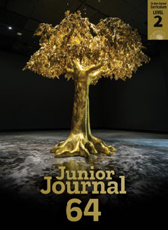Trees and Us
by Phillip Simpson

Junior Journal 64
Level 2
Purple 2

The Learning Progression Frameworks (LPFs) describe significant signposts in reading and writing as ākonga develop and apply their literacy knowledge and skills with increasing expertise from school entry to the end of year 10. This teacher support material describes the opportunities in “Trees and Us” for ākonga to develop this expertise.

Overview
This report builds on the information about trees in “What Is a Tree?” and “Tree Facts” and goes on to explore
how we use and think about trees. It provides many opportunities for ākonga to make connections to other texts in this journal, and to the intriguing photo of “The Golden Bearing” on page 22, and to their own knowledge and experiences. “Trees and Us” also connects with the theme of kaitiakitanga in “The Sticky, Sticky Pine”.
A PDF of this article and an audio version as an MP3 file are available at www.juniorjournal.tki.org.nz For texts related to the topic, see the TSM “All about Trees”.
LPFs | Curriculum links
- Making sense of text: using knowledge of text structure and features  - Making sense of text: vocabulary knowledge  - Acquiring and using information and ideas in informational texts | - English  - Science: The Living World  - Social Sciences  - Technology

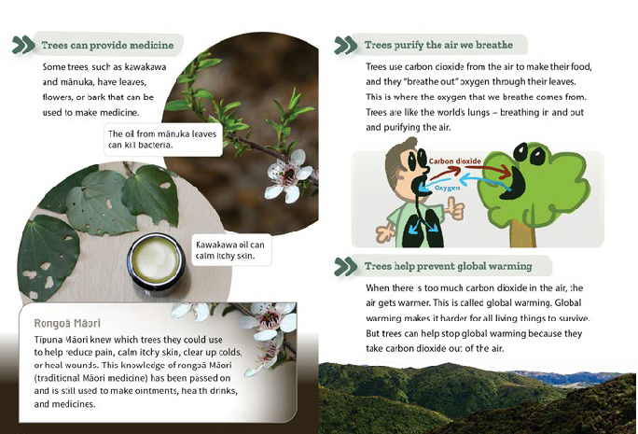
The New Zealand Curriculum
Key text features
“Trees and Us” includes the following characteristics that help ākonga develop the reading behaviours expected at Purple and build their awareness of the features of non-fiction.
The above spread:
Text copyright © Crown 2022
For copyright details for the images, see the student book.
TEACHER SUPPORT MATERIAL FOR “TREES AND US”, JUNIOR JOURNAL 64, 2022
Copyright © Crown 2022 Accessed from www.juniorjournal.tki.org.nz
1

Language features typical of non-fiction:
- definitions in parentheses
- the use of bullet points (linked to the heading “Why are trees special? and, on page 29, connected to a stem sentence)
- noun phrases (for example, “huge, straight trunk”, “living things”, “musical instruments”, “Tīpuna Māori”, “traditional Māori medicine”, “health drinks”, “global warming”)
The simile comparing trees to lungs and the inverted commas for “breathe out” to indicate personification – giving the leaves human qualities
Some possibly unfamiliar topic-specific vocabulary (for example, “atua”, “created”, “waka”, “slabs”, “whakairo”, “history”, “entrance”, “representing”, “tupuna”, “tangata whenua”, “Earth”, “provide”, “creatures”, “nectar”, “protect”, “enrich”, “prevent”, “fertile”, “furniture”, “musical instruments”, “ornaments”, “medicine”, “bacteria”, “calm”,
“Rongoā Māori”, “Tīpuna Māori”, “reduce”, “heal”, “wounds”, “knowledge”, “traditional”, “ointments”, “health”, “purify”, “breathe”, “carbon dioxide”, “oxygen”, “global warming”, “survive”, “diseases”, “imagine”) and tree names, requiring ākonga to use their processing systems
Design features typical of non-fiction: headings and subheadings, photographs, captions, a text box, bullet points, illustrations, and a diagram
The structure of the text as a report with an introduction, a series of main points, and a conclusion

Possible reading purposes | Possible learning goals
What can ākonga expect to find out or think about as a result of reading this text?  - To find information about why trees are special  - To think about how we can help care for trees. | What opportunities does this text provide for ākonga to learn more about how to “read, respond to, and think critically” about texts?  This text provides opportunities for ākonga, over several readings, to:  - make connections between the text and visual language features to track information  (summarise)  - ask questions and look for or think about possible answers  - identify and discuss main ideas  - make connections between this article and other texts in this journal  - monitor their reading and, when something is unclear, take action to solve the problem.
Sounds and Words
The Literacy Learning Progressions

Introducing the report

- It would be best for ākonga to have read and discussed “What Is a Tree?” and/or “Tree Facts” first so they have some prior knowledge of the topic and key vocabulary.
- Read the title and first paragraph and ask ākonga to recall some special things they know about trees. (You might want to use the photograph on the facing page of “The Golden Bearing”, either now or after reading, as a way of drawing out ideas about how people think about trees.)
- Read and discuss the rest of page 23 together, encouraging ākonga to make connections to their knowledge, for example, of Tāne, te
ao Māori, whakairo, tōtara. They may also make a connection to the name Tāne Mahuta for the kauri tree in “What Is a Tree?”
- Browse through the article, using the headings and captions as a guide to what ākonga will find out. Provide support with vocabulary as needed. You could add to or create a new KWL vocabulary chart as
described in the TSM for “What Is a Tree?”
- Discuss the use of bullet points for the subheadings on pages 24–27 and explain their link to the page 24 heading, Why are trees special? Clarify also the link to the stem sentence for the bullet points on page 29.
- Draw attention to the cartoon on page 27. Prompt ākonga to notice the labels for oxygen and carbon dioxide and to make connections to what they have learned from “What Is a Tree?” about how trees use carbon dioxide. Remind ākonga that “air is a mixture of gases” to clarify any misconceptions about humans breathing in only oxygen and trees “breathing out” only carbon dioxide.
- Introduce and explain the term “global warming”.
- Together, set a reading purpose.
- Give ākonga sticky notes to mark questions or ideas that arise as they read or to note aspects they might want to return to or discuss later.

Reading the report
Encourage ākonga to read the report by themselves, intervening only if needed. The focus of the first reading is for ākonga to identify key information and ideas relevant to the initial reading purpose. (For examples of possible reading behaviours to look for and support, see the TSM for “What Is a Tree?”) Allow for several sessions to read and discuss the text, to investigate other reading purposes, and explore ideas and language features more deeply.
Deliberate acts of teaching
How you can support individual ākonga (if needed).
- Prompt ākonga to draw on their phonics knowledge and other word-solving strategies, for example:
‒ when decoding:
» breaking words into chunks or syllables (“a-tu-a”, “wha-kai-ro”, “pro-vide”, “nec-tar”, “en-rich”, “pre-vent”, “fer-tile”, “music-al”, “fire- places”)
» drawing on their knowledge of variations in the sounds of letters and letter combinations (“Earth”, “medicine”, “reduce”, “wounds”, “knowledge”, “oxygen”, “imagine”)
‒ when working out meanings of words and phrases:
» recognising the root word (en-rich, carv(e)-ing, glob(e)-al)
» using the context of the sentence and/or the surrounding sentences
» looking for supporting information, such as definitions in parentheses, photographs, captions
» rereading or reading on to look for further information.
- Remind them to note things they are not sure about or that are of particular interest and tell them that you will discuss their questions and ideas after the reading. Reassure them that when reading non-fiction, they may sometimes need to read more slowly, reread parts, and/or check aspects like photos or captions to build their understanding.
TEACHER SUPPORT MATERIAL FOR “TREES AND US”, JUNIOR JOURNAL 64, 2020 2
Copyright © Crown 2020
Accessed from www.juniorjournal.tki.org.nz

The following suggestions provide a starting point for some of the many ideas ākonga could explore after reading this text (and others in this journal). Several of the suggestions can be explored further as independent reading activities.
- Encourage ākonga to share their responses to the article and connections to their own prior knowledge and experiences. For example:
‒ their understandings about Tāne and/or rongoā Māori. You could also discuss the connection to Matariki and Tupuārangi – the star associated with food that grows above our heads in the ngahere (forest) – and with birds, berries, and other natural resources from the forest.
‒ their knowledge of uses of trees in countries other than Aotearoa, for example, the use of banana, palm, and coconut trees in the Pacific.
- Ask ākonga to share any new questions they thought of as they were reading and answers they found. Provide an opportunity for them to find out more as an after-reading activity.
- Support ākonga to locate and summarise information. Focus on the bullet points in the section “Why are trees special?” on pages 24–27 and ask ākonga to find the supporting detail for each bullet point. They could use highlighters on a printout of the text.
- Return to the KWL vocabulary chart (if created before reading) and ask ākonga to share what they have found out. Find and read the sentences that include these words and discuss ways the meanings are supported. Add new topic words ākonga have discovered from their reading.
- Support ākonga to think critically, making connections to their own knowledge and experience and to other texts, for example:
‒ Discuss the big ideas on page 27, making connections also to pages 8–9 of “What Is a Tree?” Why does the author describe trees as “the world’s lungs”?
‒ Encourage ākonga to imagine a world without trees. How would our lives be different? Alternatively, you could discuss why trees can’t live without us.
‒ Explore the theme of kaitiakitanga, making connections also to “The Sticky, Sticky Pine”.
‒ Prompt ākonga to notice the four main headings in the article. What are the main ideas about trees that the author wants us to think about?
‒ Enjoy comparing the information about trees with the ideas of “Professor Clever” (JJ 57).

Building language knowledge
As ākonga reread and discuss the text, note opportunities for explicit instruction and to explore language features in more detail. For example:
- how ākonga worked out new vocabulary (or tried to)
- how the meanings of unfamiliar words and phrases are supported in the text (through definitions, the context of the sentence or paragraph, or the photographs). Draw attention also to some examples of noun phrases (“thick bark”, “living things”, “tree flowers”, “Tīpuna Māori”, “health drinks”, “special gifts”) to show how reading on to the end of the phrase helps to clarify meaning.
- the prefix in “enrich”. Read the sentence where “enrich” occurs to clarify its meaning (to make richer). Add the “en” prefix to other words (for example, “endanger”, “enlist”, “enable”, “encase”, “encircle”) and support ākonga to use the words in oral sentences. You could also explore examples of words with the suffix “al” as in “musical”, “traditional” and “global”) and generate others (“accidental”, “occasional”, “universal”, “electrical”, “personal”).
- Provide further practice in locating information and summarising by giving out question cards based on some of the headings. Have ākonga work in pairs, using key words to locate the headings or subheadings linked to the information they need to answer the questions. Question cards could
include: How do trees provide food for people? How do trees protect and enrich the soil? How do people use the wood from trees? Why are some trees in danger? How can people care for trees?
- Have traditional stories available about Ranginui and Papatūānuku and their children and Tāne Mahuta and his children. Acknowledge that ākonga might bring knowledge of these stories and ask them to share their knowledge, if they are comfortable doing so.
- Support ākonga to find out more about whakairo, for example, by viewing Rarangi Matihiko Kōrero Juniors (which explores the idea of whakairo telling stories) or viewing a video clip showing the carving process. You could invite a local carver to talk to ākonga or they might investigate the features of the carving patterns at their local marae. They could refer to the Arts Online Whakairo poster to explore the meaning of some of the symbols.
- Encourage ākonga to talk with whānau about the article. You could invite someone from the local community to talk with ākonga about rongoā Māori and/or food gathered from the forest. Ākonga could also share what they know about food from trees in the Pacific and other countries.
- Explore examples of artwork about trees or leaves or artworks made of wood. Enjoy viewing and discussing “The Golden Bearing”, including what messages the artist might be wanting to communicate and how the artwork does this. Find out more at: https://christchurchartgallery.org.nz/exhibitions/ reuben-paterson-the-golden-bearing and https://govettbrewster.com/exhibitions/reuben-paterson-the-golden-bearing
- Explore the theme of kaitiakitanga. Support ākonga to find examples of how people are caring for trees, including in the JJ 63 article “Volunteers”. Ākonga could make a plan for something they would like to do or find out how they might become involved in any local tree planting activities.
For further suggestions, see the TSM for “What is a Tree?”
For English language learners, SELLIPS and the Teaching Strategies section of ESOL Online also have ideas for purposeful and relevant tasks.

ISBN 978-1-77690-797-7 (PDF)
ISBN 978-1-77690-801-1 (WORD)
The above spread:
Text copyright © Crown 2022
For copyright details for the images, see the student book.
TEACHER SUPPORT MATERIAL FOR “TREES AND US”, JUNIOR JOURNAL 64, 2022
Copyright © Crown 2022 Accessed from www.juniorjournal.tki.org.nz
3

