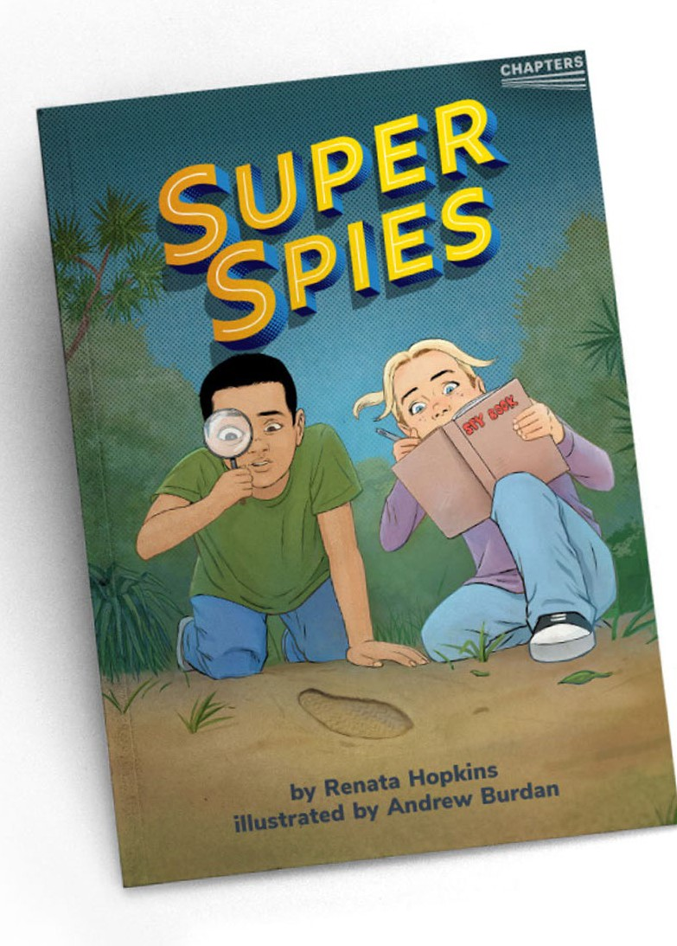

G R O W I N G R E A D E R S

THE YEAR 3

SERIES

Research data consistently reveals a positive relationship between the amount of reading ākonga do and their reading achievement. New Zealand’s National Monitoring Study of Student Achievement (2019) shows that in year 4, differences in the amount of home reading can account for as much

as one year of progress (rising to two years by year 8).

The literacy landscape in Aotearoa New Zealand (2020) notes “the increasing importance of independent reading and writing, especially outside of school” for ākonga from year 3 onwards (page 35). For older students, PISA 2018 shows a strong

link between the length of texts students read as part of their classroom instruction and their reading performance.

While reading for pleasure can involve many different types of texts, chapter-book reading is often a key step in developing an independent, personal reading habit. For many ākonga, this transition happens smoothly, but some require more support in fostering both the ability and the desire to read longer texts.

The Ministry of Education is publishing three early chapter books in 2022–24 (one each year) to support the transition to reading longer texts. The books are accompanied by audio versions and teacher support materials (TSM). The TSM provide suggestions about how to support all year 3 ākonga, including those who might be reading below expected levels, to read and enjoy these books. As ākonga build their reading mileage, engagement, and independence, they will move on to making their own reading selections.

The first

book to be published is ***Super Spies***.

This was a wonderful text for these

students – a very engaging story. They wanted to

read more like it.

The children loved the humour – Sophie’s joke at the start and her strategies to stop hiccups.

**When *Super Spies* was trialled in schools, teachers commented:**

The move to reading chapter books is a big step in a child’s literacy journey. Early chapter books smooth the pathway, helping ākonga build agency and take charge of their own reading choices.

These three early chapter books add to the suite of Ministry materials designed to build ākonga confidence in chapter-book reading.

Previous publications are:

Students felt they had achieved something by finishing a chapter book – a sense of success.

A great introduction to chapter books for children.

*•*

*The Thief* (Ready to Read Gold). The 2022 chapter book, *Super Spies*, is about the same characters.

“Zapped!” a science fiction story published in four chapters across

*Junior Journals* 52–55.

•

The kids loved it. That the mystery was a goat made them laugh. They liked that it wasn’t too scary.

It hooked in these boys so well – I would use it again in a

heartbeat!

The new chapter books are designed to:

•

support ākonga in developing an independent reading habit (to read for pleasure)

build ākonga agency so they see themselves as successful, independent readers by providing access to texts they might otherwise not attempt

raise teacher awareness of how they can foster personal independent reading

build awareness of and enthusiasm for books and language

help build communities of readers.

•

Children found the whole idea of children of their age being spies and trying to

solve a mystery very fascinating.

•

•

•

**GROWING READERS: YEAR 3 CHAPTERS SERIES**

Copyright © Crown 2022 Accessed from [instructionalseries.tki.org.nz](https://instructionalseries.tki.org.nz/)

**1**

The above spread:

Text copyright © <author> Illustrations copyright © Crown 2020

**Becoming readers**





Any year 3 class will have ākonga reading across a range of levels. While many will become chapter-book readers without explicit support, others will need some level of guidance along the way.

The first chapter of a book is often a hurdle for newly independent readers, and may need more focused discussion before (and possibly, during) the reading. The introduction to a new book should support ākonga to clarify who, where, when, what and to generate their questions and predictions about the story. Often, this is all that is needed to motivate readers through their first foray into chapter book reading.

Teachers can offer extra support through reading the book

(or sections of it) to ākonga, making the audio version available for them to listen to, or shared reading, all with ākonga following the text.

Further suggestions are provided in the TSM for each book.

They were highly engaged – I started with ten in the group and three more chose to join.

The children chose to read both *The Thief* and *Super Spies* independently at silent reading time.

They read the book over several days, and each day we would have a check in to discuss what had happened in each chapter.

Chapter-book reading is a highly personal process and teacher judgement is important in deciding how much support ākonga need so as not to overly intrude on the reading experience. First attempts at reading a chapter book may be at a lower level of accuracy than when reading guided texts, but as ākonga gain momentum with their reading, many word-level errors are likely to gradually and naturally disappear. It is important, however, for teachers to help ākonga establish self-monitoring processes to ensure they are noticing when they need help. For example, ākonga might use sticky notes to mark challenges in the text.

Teachers, too, need to develop ways of “checking in”. Touching base regularly with ākonga as they read and sharing their enthusiasm for the story is a good way to build up their confidence and engagement and also helps to gauge how ākonga are managing. Asking ākonga to refer back to the text and read short sections aloud during after-reading discussions provides opportunities for teachers to monitor and provide on-the- spot explicit instruction as required. The TSM for the individual chapter books includes many further suggestions .

Early chapter books add to the rich mix of materials ākonga will be reading in year 3. A lively, robust classroom programme will include reading to, shared reading, guided reading, independent reading, and rereading of familiar texts, in a variety of genres and text

types. Suggestions for creating a classroom climate that fosters motivation and enthusiasm for chapter-book reading include:

•

encouraging ākonga to talk about what they are reading and to share preferences

creating a classroom or school blog for book reviews and recommendations

ākonga running their own book club or book chat with others reading the same book

teachers introducing and promoting books to entice readers, for example, reading the blurb, sharing their own opinions or wonderings about the story, and reading excerpts or the first chapter

•

supporting ākonga to develop their book selection skills and find other early chapter books in the school or local public library

providing opportunities for ākonga to read chapter books or other self-chosen material in class time

including whānau in book conversations

encouraging whānau to continue reading to their children, even when they are able to read chapter books for themselves.

•

•

•

•

•

•

Make the most of your school library, local public library, and National Library Services to Schools.

CHAPTERS in the TKI instructional series catalogue [instructionalseries.tki.org.nz](http://instructionalseries.tki.org.nz/)

National Library Services to Schools: [Reading engagement](https://natlib.govt.nz/schools/reading-engagement/)

ISBN 978-1-77690-783-0 (PDF)

ISBN 978-1-77690-784-7 (WORD)

**GROWING READERS: YEAR 3 CHAPTERS SERIES**

Copyright © Crown 2022 Accessed from [instructionalseries.tki.org.nz](https://instructionalseries.tki.org.nz/)

**2**

The above spread:

Text copyright © <author> Illustrations copyright © Crown 2020

**Where can I find out more?**

**The classroom literacy programme**

**A personal journey**

**How can teachers support early chapter-book reading?**