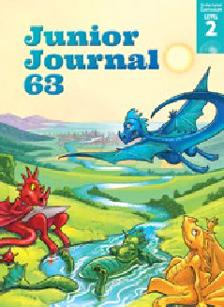
Volunteers
by Bronwen Wall
Junior Journal 63
Level 2
Gold 1

The Learning Progression Frameworks (LPFs) describe significant signposts in reading and writing as ākonga develop and apply their literacy knowledge and skills with increasing expertise from school entry to the end of year 10. This teacher support material describes the opportunities in “Volunteers” for ākonga to develop this expertise.
Overview

All the texts in this journal are linked around the theme of community. They explore what communities are, how people contribute to communities, and how communities affect our lives. In “Volunteers”, Bronwen Wall interviews three young volunteers to find out what they do in their communities and why they do it.
This article provides opportunities to explore the themes of awhi mai-awhi atu – helping others, mahi tahi – working together for a common purpose, and kaitiakitanga – guardianship of the
community, its people and natural resources, protecting it for future generations.

The New Zealand Curriculum
LPFs | Curriculum links
- Making sense of text: using knowledge of text structure and features  - Making sense of text: vocabulary knowledge  - Acquiring and using information and ideas in informational texts | - English  - Social Sciences

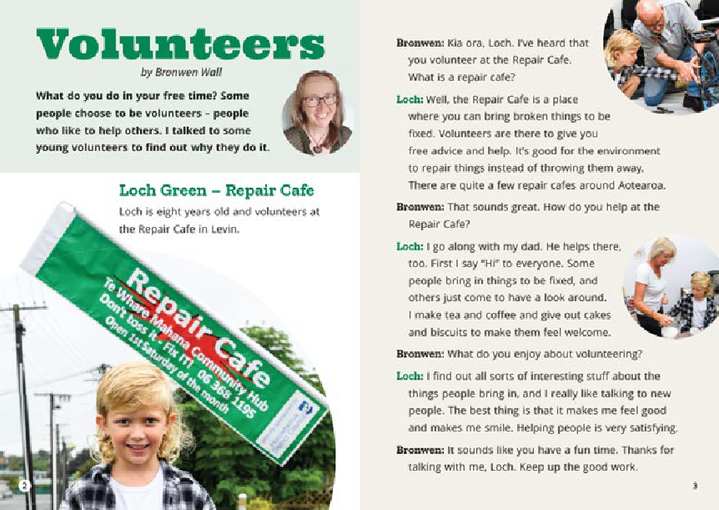
Key text features
“Volunteers” includes the following characteristics that help ākonga develop the reading behaviours expected at Gold and build their awareness of the features of different text forms.

A variety of sentence structures requiring ākonga to notice and use linking words, phrases, and punctuation to clarify the connections between ideas. Specific features include:
- indicators of time and place
- cause and effect sentences
- the use of dashes to link ideas.
Some possibly unfamiliar words and phrases, including words in te reo Māori (for example, “volunteers”, “Repair Cafe”, “free advice”, “environment”, “biscuits”, “satisfying”, “Charitable Trust”, “local”, “pōhutukawa”, “organisation”, “rōpū”, “whenua”, “native plant nursery”, “seedlings”, “identify”, “taiao”, “natural”, “climate”, “community”, “council”,
“government”, “future”) and proper nouns, requiring ākonga to use their processing systems
Features typical of non-fiction: headings, photographs, captions, definitions, and a glossary
The structure of the text as a report with an introduction, examples (in the form of interviews), and a conclusion

Sounds and Words
Related Texts

Texts about helping others: Helping at the Marae (RTR Blue); Easy Peasy, Isobel’s Garden (RTR Turquoise); Duckling Palace, Guide Dogs
(RTR Purple); “Garden Angels” (JJ 59); “Getting the Message Across” (JJ 62)

Possible reading purposes | Possible learning goals
What can ākonga expect to find out or think about as a result of reading this text?  - To find out what these volunteers do and why they do it  - To think about why volunteering is important to communities  - To think about how these volunteers help the environment | What opportunities does this text provide for ākonga to learn more about how to “read, respond to, and think critically” about texts?  This text provides opportunities for ākonga, over several readings, to:  - use information in the text and visual language features to identify and track information  (summarise)  - make connections to their prior knowledge and between information in the article to make inferences  - ask questions and look for or think about possible answers  - identify and discuss main ideas  - monitor their reading and, when something is unclear, take action to solve the problem.

The Literacy Learning Progressions

Introducing the article
Use your knowledge of your ākonga to ensure that your introduction to the article builds or activates their prior knowledge and provides appropriate support for a successful first reading. Several options are provided below for you to select from and adapt. A short video on the importance of introducing the text is available at https://vimeo.com/142446572  For English language learners, you can find further information about features of texts that may need support at ELLP.  - Before introducing this text, you can familiarise yourself with the pronunciation of any te reo Māori vocabulary that is new  to you by listening to the audio version.  - Read the title and ask ākonga to share what they know about volunteering and why people do it. You could make a connection to the work of volunteers in your school or local community  (for example, workers in a foodbank or Op shop or collectors on Daffodil Day) or in the RTR book Isobel’s Garden.  - Point out the photo of Bronwen on page 2 and read the introductory paragraph to establish the focus and structure of the article. Explain what an interview is and clarify that Bronwen is the person asking the questions. | - Share the reading purpose(s). This TSM suggests an initial “To find out” purpose to build background knowledge, followed by one or two deeper purposes (“To think about …”) when rereading.  - Browse through the article, using the headings to introduce the names of the children and key words about the focus of their volunteering. Use the photographs to discuss what the children are doing. Share ideas about what a repair cafe might be. Briefly explain what a charitable trust is (page 5) and tell ākonga they will find more information about the trust as they read.  - Provide support with te reo Māori vocabulary as required. Demonstrate how to split the te reo Māori names on page 4 into syllables ending with a vowel. Ākonga may notice that Te Ranginui-a-Ihu Ngariki is referred to by the first part of his name  in the interview. Draw attention to the words in bold print and the glossary on page 5.  - Give ākonga sticky notes to mark aspects they might want to return to or discuss later. Explain that when reading non-fiction, they may sometimes need to read more slowly, reread parts, and/or check aspects such as photos or captions to build their understanding.

Reading the article
Encourage ākonga to read the article by themselves, intervening only if needed. Much of the processing ākonga do at this level is “inside their heads” and may not be obvious until the discussion afterwards. The focus of the first reading is for ākonga to identify key information and ideas relevant to the initial reading purpose. Allow for several sessions to read and discuss the text, to investigate other reading purposes, and explore ideas and language features more deeply.
Reading behaviours to look for
Examples of the sorts of behaviours (often overlapping and developed over several readings) that will support ākonga to meet the reading purpose(s)
Ākonga use information in the text and visual language features to identify and track information.  - They use the headings and layout to track the sections and the questions and answers within the sections.  - They look for key words (from the introductory discussion) and use them as a guide to finding information to meet the reading purpose.  - They use the photographs to find supporting detail.  - They notice words in bold print linked to the glossary.  They make connections to their prior knowledge and between information in the article to make inferences.  - They use the descriptions and photographs on page 3 to visualise what a repair cafe might be like.  - They infer from words and phrases, such as “free time”, “choose”, “help others”, “free advice”, that volunteering work is unpaid.  - They make connections to their own knowledge of conservation and climate change to infer why Eulie feels so strongly about her volunteer work.  - They infer from the examples in the article and their own prior knowledge that volunteering involves a wide range of activities.  - They use the comments from the volunteers, including words about feelings, to infer why people volunteer. | They ask questions and look for or think about possible answers.  - They use their sticky notes to record questions (and possibly, answers) and ideas. For example, they might wonder about:  ‒ if there is a repair cafe in their local community  ‒ how the children in the article first got interested in volunteering  ‒ people they know who volunteer  ‒ what Te Wairoa Charitable Trust is (page 4) and notice further information about it on page 5.  They demonstrate self-monitoring and problem solving.  - They use a range of word-solving strategies. For example, they:  ‒ break words into chunks or syllables  ‒ rerun to clarify the use of “water” as a verb on page 5 (“we water seedlings”)  ‒ search for further information, for example, definitions in the glossary and photographs to support word meanings.  - They mark words, phrases, and ideas they want to come back to.  You can find further information about the reading behaviours that English Language Learners need to develop proficiency with at this stage, on the ELLP Pathway.
Deliberate acts of teaching
How you can support individual ākonga (if needed)
- Remind ākonga of strategies they can use for word solving (for example, looking for the biggest known word chunk; applying their knowledge of letters, sounds, and word structure) and for clarifying meaning (rereading or reading on, referring to the photographs, and thinking about the overall meaning of the sentence). If necessary, provide specific support, for example, with the proper nouns.
Thinking, talking, rereading
You can revisit this article several times providing opportunities for ākonga to build comprehension, vocabulary, and fluency. Select from and adapt the following suggestions. Some of the suggestions overlap, and several can be explored further as independent reading activities. For some suggestions, you may find it helpful to project the PDF of the article so that you can zoom in on relevant sections.
- Invite ākonga to share their initial responses and connections to any experiences they have with volunteering. Discuss any new questions or ideas arising from their sticky notes.
- Remind ākonga of the initial reading purpose and have them record what they have found out on a summary table, such as the one below. To provide support, you could work through one of the examples together, using highlighter pens on a printout of the article to identify the information that they need. Ākonga could work in pairs on the other two examples.
Who What Where Why
Loch helps out in the Repair Cafe says “Hi”, Repair Cafe in Levin makes tea and coffee, gives out cake
and biscuits
Te Ranginui

Eulie

You could use this as an opportunity to draw attention to the use of cause-and-effect sentences – where one part of a sentence describes an action and the rest of the sentence explains why. For example:
‒ I make tea and coffee and give out cakes and biscuits to make them feel welcome.
‒ The Matariki event was held so that people from my community …
‒ I help with beach clean-ups and climate change because I think it’s important …
For ākonga who need extra support in locating information, you could have them work with pages 6 and 7, which has a very clear structure with Eulie’s volunteer work listed on page 6 and the reasons why she does it on page 7.
- Build understanding of topic vocabulary associated with communities and local government (for example, volunteers, Repair Cafe, Charitable Trust, rōpū, connect, taiao, organisation, community, action, climate change, council meetings, government, committee, events, Matariki, support). Together, read the sentences that include the words and discuss their meanings and how they connect to each other.
- Explore main ideas about volunteers and communities. Draw out the idea that communities are made up of people and that people contribute to communities in different ways. Have ākonga use the examples of the three children and draw on their own prior knowledge to think critically. For example:
‒ Discuss the theme of kaitiakitanga and how each of the volunteers are demonstrating this.
‒ Why is volunteering important to communities? Prompt ākonga to refer to the “why” column in the table as well as other information in the article, and their own experiences.
‒ The author writes that these volunteers are “doing great things to make Aotearoa New Zealand a better place to live.” How are these volunteers making New Zealand better, and what would it mean if they did not do these things?
‒ How might the people in the volunteers’ local communities feel about the work the volunteers are doing?

Building language knowledge
As ākonga reread and discuss the article, note opportunities for explicit instruction and to explore language features in more detail. For example:
  - how ākonga worked out new vocabulary (or tried to), including the use of the glossary
  - how the meanings of unfamiliar words and phrases are supported in the text (through definitions in running text, the glossary, the context of the sentence or paragraph, the photographs)
  - the use of dashes to link ideas. Together, identify and read examples in the article. Draw out the idea that dashes are a way of showing there is more information to come and that, within a sentence, they signal a pause, which gives the extra information more impact. Look for opportunities to demonstrate this during shared writing.
  - the use of irregular past-tense verb forms. Explicit teaching about this aspect of English is particularly helpful for English language learners. Explain that not all verbs in English have “ed” added in the past tense. Read and discuss examples from the article and list their present and past tense forms (hear/heard; speak/spoke/spoken; send/sent; hold/held). Create oral sentences together using the verbs.

- Ākonga can build their comprehension and fluency by listening to the audio version as they reread the article.

Audio versions are particularly supportive for English language learners because, as well as clarifying pronunciation, they provide good models of the prosodic features of English, such as intonation and phrasing.
- Ask ākonga to write and draw about something they do for others or that they would like to do as a volunteer. Use a website such as Seek volunteer or Do Something.org to generate ideas.
- Have ākonga work together to find answers to questions about a familiar community event or project: Who did this? Who is it for? Why is it important?
- Find out more about the organisations mentioned in this article by searching their websites.
- Have ākonga work in pairs or small groups to find out about local voluntary organisations and present the information to the rest of the class.
- Ākonga could interview a family member or someone else they know about their experiences with volunteering.
- Look for opportunities for ākonga to do some volunteering in the class, the school, or the community.
- Have ākonga work in pairs to create a flow chart or bubble diagram that shows how they or a volunteer they know helps others. Arrows might be pointing both ways in some situations showing how the people being helped might also help the volunteer.

For English language learners, SELLIPS and the Teaching Strategies section of ESOL Online also have ideas for purposeful and relevant tasks.

ISBN 978-1-77690-606-2 (PDF)
ISBN 978-1-77690-762-5 (WORD)

