

School Journal

Level 4, May 2021

Year 7

# Reducing our Footprint

by Sarah Connor

The[Learning Progression Frameworks](https://curriculumprogresstools.education.govt.nz/lpf-tool/) (LPFs) describe significant signposts in reading and writing as students develop and apply their literacy knowledge and skills with increasing expertise from school entry to the end of year 10.

## Overview

This is the finalarticle in a series that explores climate change. The first explains what it is; the second explores the difficulties in making predictions about it; and this, the third, looks at the ways people have responded to the challenge of climate change. It profiles four different organisations or people: an e-bike company, food recyclers, a scientist who’s developed an app for the agricultural sector, and a hemp farmer.

A PDF of the text is available at [www.schooljournal.tki.org.nz](http://www.schooljournal.tki.org.nz)

## Themes

|  |  |  |  |
| --- | --- | --- | --- |
| * Climate change | * Climate action | * Entrepreneurs |  |

## Related texts

**“Climate Change: Our Biggest Challenge”** SJ L4 June 2018 | **“Feedback”** SJ L4 May 2020

## Strengthening reading behaviours (what to notice)

|  |  |
| --- | --- |
| Text structure and features | Requiring students to: |
| * Technical information and the use of statistics across a variety of contexts: *A 10-kilometre-each-way commute on an e-bike reduces a person’s carbon footprint by almost a tonne of carbon dioxide a year* | * use their maths knowledge to identify and interpret the comparisons, amounts, and calculations to understand the important information and key ideas |
| * Abstract concepts related to the topic of climate change *carbon footprint, stand-out memories, zero food waste, zero food poverty, super-foods* | * use vocabulary knowledge, understanding of figurative language, prior knowledge of the topic, and the context of the article to interpret meanings |
| * The concept of taiao, which is not translated | * infer meaning by using the supporting quote from Isaac: “If our environment is healthy, we’re healthy.” |
| * Quotes within each profile | * use the context and punctuation to identify the speaker and link the information to the main message of the profile. |

|  |  |
| --- | --- |
| Vocabulary | |
| Topic-related terms    Other possibly challenging words | fossil fuels, agriculture, natural element, nitrogen fertiliser, effluent, leach, sustainably, statistics, nutrient-dense, bioplastics, biofuel, carbon sinks, nutrients, harvested, resistant, pesticides  Globally, generated, overwhelming, epiphany, affordable, surplus, refrigerated, charities, absorbs, benefits |
| Helpful prior knowledge (pre-reading and introducing the text) | |
| * There are specific reasons for climate change, and there are many ways its impact will be felt (for example, drought, heatwaves, intense storms, epidemics). * The greenhouse effect causes the atmosphere to warm and is part of climate change. * We need to respond to climate change at an individual and collective level. * Most entrepreneurs need to make a living, but some are also motivated by the desire to do good. * A business is often established a certain way (idea, development, testing, modification, and so on). | |

## Possible reading and writing purposes

* Identify how four individuals have responded to the challenge of climate change
* Explore the actions and impact of each person or organisation on reducing climate change
* Analyse ways in which information about each person or organisation has been conveyed to the reader
* Compare the three articles on climate change to understand the causes, the evidence, and the suggested solutions   
  to combating climate change.

See *Effective Literacy Practice in Years 5–8* for information about teaching comprehension strategies ([Teaching comprehension](https://literacyonline.tki.org.nz/Literacy-Online/Planning-for-my-students-needs/Effective-Literacy-Practice-Years-5-8/Teaching-comprehension))   
and for suggestions on using this text with your students ([Approaches to teaching reading](https://literacyonline.tki.org.nz/Literacy-Online/Planning-for-my-students-needs/Effective-Literacy-Practice-Years-5-8/Approaches-to-teaching-reading)).

## Possible curriculum contexts

This text has links to level 4 of *The New Zealand Curriculum* in: [**ENGLISH**](http://nzcurriculum.tki.org.nz/The-New-Zealand-Curriculum/English)[**SCIENCE**](https://nzcurriculum.tki.org.nz/The-New-Zealand-Curriculum/Science)

## Understanding progress

The following aspects of progress are taken from the [Learning Progression Framework](https://curriculumprogresstools.education.govt.nz/lpf-tool/)s and relate to the specific learning tasks below. See the LPFs for more about how students develop expertise and make progress in these aspects:

* Acquiring and using information and ideas in informational texts
* Reading to organise ideas and information for learning
* Using writing to think and organise for learning
* Creating texts: to influence others; to communicate current knowledge and understanding.

## Strengthening understanding through reading and writing

**Select from the following suggestions and adapt them** according to your students’ strengths, needs, and experiences.   
Note: Most of these activities lend themselves to students working in pairs or small groups.

* Read the introduction together and discuss any questions the students may have or any comments they may wish to make.
* Ask the students to begin a KWL chart by writing down their current knowledge about climate change. They can complete the other two sections when they have finished the article.
* Have the students read the text. This could be done as a whole group, individually, or with the group divided into four with each group reading about one of the ways individuals have responded to climate change and then sharing back to the group.
* To support students who are having difficulty understanding the meaning of the topic-related words, provide a graphic organiser for them to complete. For example, the graphic organiser might include headings such as Word, Definition, Picture or symbol, and Hint (something that helps me remember the meaning).
* Have the students discuss the four different responses to climate change. *What similarities are there in the way that information is organised across all four sections?* Challenge the students to come up with subheadings to categorise the information (for example, Name, Organisation, Situation, Challenge, Solution, Impact) and then create graphic organisers to record the relevant information. Together, explore how representing information graphically can help to compare texts, making it easier to draw conclusions about which is best.  The students could use Google Drawings to create their graphic organisers.
* Ask the students to summarise the article using the **Summarising chart** on page 3 of this TSM. They write the headings of the four people or organisations in the top boxes and their key findings or points of interest in the larger box. Analyse what is similar or different between the people’s ideas and organisations. *What was the reason these people started doing what they did? Was it always a success? What were the challenges? What did they learn along the way?* Consider providing a sentence-frame scaffold to help English language learners write the final summarising sentence using appropriate language.
* This is the third in a series of articles exploring climate change (see Related texts on page 1). Ask the students to use the three articles to locate and summarise information about the causes of climate change, the evidence for it, and the suggested solutions. As they reread each article, ask *What are the main points or key messages in each article? What information is repeated, shared, linked, or built on across all three articles? What is the main purpose of each text? Why do you think this?*
* Support the students to summarise each article. Encourage them to come up with subheadings to organise the information (for example, Causes, Evidence, and Suggested solutions) and to use bullets, notes, keywords, pictures, or diagrams to record the information. Prompt them to add to a bullet based on supporting information from another article (they could do this in another colour). Finally, they could write a summary sentence for each article. Alternatively, they could work in small groups, with each group focusing on one article and then holding a “sharing information session”. Together they could write an introduction and conclusion.  The students could use a shared Google Doc for this task.

|  |
| --- |
| “Reducing our Footprint” Summarising chart |

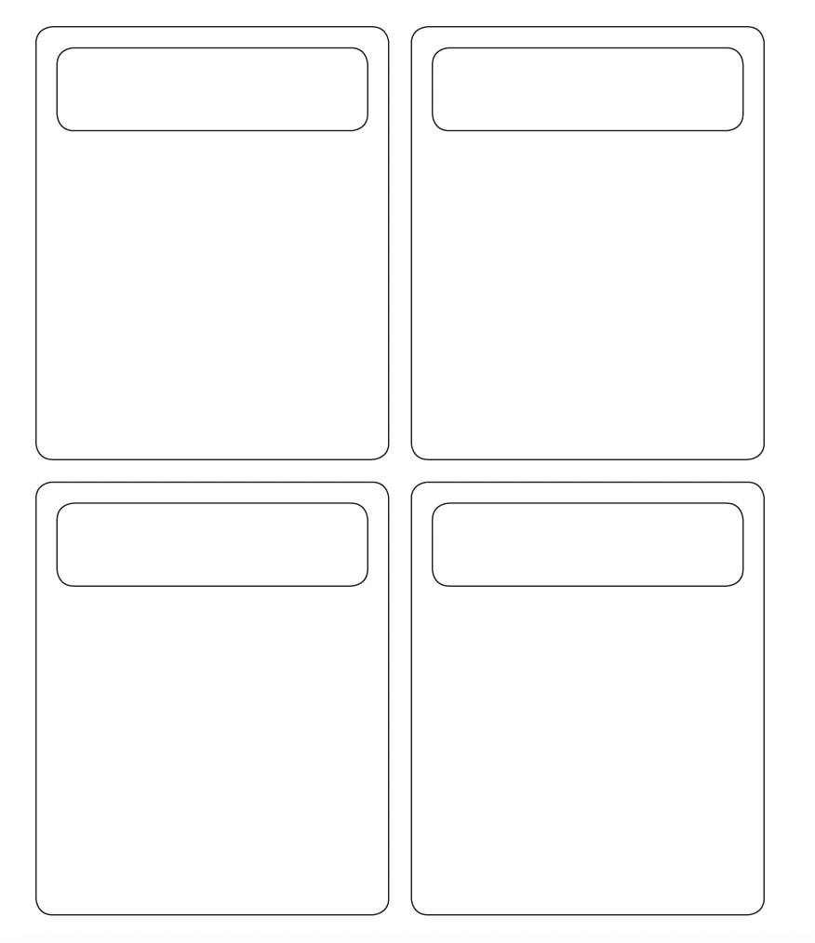

**Write a summary sentence saying which idea you think is best and why.**

|  |
| --- |
|  |

