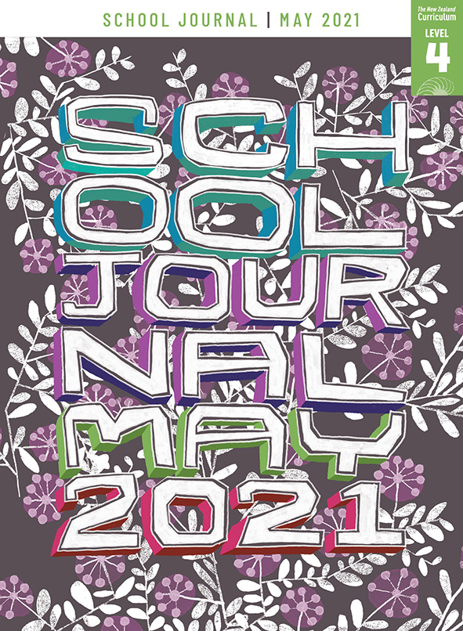
School Journal
Level 4, May 2021
Year 8

Press B
by Paul Mason

The Learning Progression Frameworks (LPFs) describe significant signposts in reading and writing as students develop and apply their literacy knowledge and skills with increasing expertise from school entry to the end of year 10.

Overview
Paul Mason continues his story of a dystopian future, told from the perspective of Tre and Muse, both of whom have spent their young adult lives fighting back against the rulers. This latest instalment in the series is told using a comic format.
A PDF of the text is available at www.schooljournal.tki.org.nz

Themes
- Dystopian future | - Power | - Democracy and revolution

Related texts
“Hushed” SJ L4 May 2017 | “Wind Chimes” SJ L4 Nov 2017 | Wind Chimes SJSL L4 | “Muse” SJ L4 May 2020 |
Reading Comics Teacher Support Material

Strengthening reading behaviours (what to notice)
Text structure and features | Requiring students to:
- Abstract ideas  The idea of the baddies (Enforcers, Examiners, Voids) versus the goodies (Radicals, the council) | - keep track of the time shifts and follow the sequence, using the illustrations and text to identify what each side stood for and whether they were good or bad
- Figurative language  a puzzle of ragtag tarpaulins; call to rebellion seeped through the street like a tide rising through mangroves; gathered up like ripe fruit | - use their vocabulary knowledge, including knowledge of figurative language, the context, the illustrations, and the text to visualise and interpret the meaning of the phrases
- Flashbacks  Numerous flashbacks, with the added challenge that the opening sequence is a flashback in the form of a virtual reality experience, something Tre and Muse have paid for to remember a better time | - use prior knowledge of previous stories about Muse and Tre and the context, as well as visual features (colour denoting time shifts and flashbacks), to keep track of the story as it shifts between the past and future, and use comprehension strategies such as asking questions, making inferences, hypothesising, and summarising as they read to help them monitor their understanding.

Vocabulary
Possibly challenging words  and phrases | swishing, ragtag tarpaulins, sad offerings, throng, cracked electronics, wedged, the shadow of towering concrete, credits, tracker, seeped through, Voids, Radicals, Examiners, Autumn Revolution, patrol, feral, surge, pollen, on the same page, pass on the mantle, contraband, council chamber, looked after its own

Helpful prior knowledge (pre-reading and introducing the text)
- This is another instalment in the Tre and Muse series.
- People or political groups gain and maintain authority through elections and other means.
- Virtual reality is a computer simulation of a scene.
- Dystopian fiction commonly explores certain themes about the future and these often include suffering and injustice.

Possible reading and writing purposes
- Find out what happens to Muse and Tre several years after the revolution
- Analyse and evaluate the choices Paul Mason made in regard to language, structure, and content
- Identify and evaluate the features of a comic
- Compare and evaluate the four stories and discuss how the characters have developed over time.
See Effective Literacy Practice in Years 5–8 for information about teaching comprehension strategies (Teaching comprehension)
and for suggestions on using this text with your students (Approaches to teaching reading).

Possible curriculum contexts
This text has links to level 4 of The New Zealand Curriculum in: ENGLISH SOCIAL SCIENCES

Understanding progress
The following aspects of progress are taken from the Learning Progression Frameworks and relate to the specific learning tasks below. See the LPFs for more about how students develop expertise and make progress in these aspects:
- Reading for literary experience
- Making sense of text: reading critically; using knowledge of text structure and features
- Creating texts for literary purposes
- Using writing to think and organise for learning.

Strengthening understanding through reading and writing
Select from the following suggestions and adapt them according to your students’ strengths, needs, and experiences.
Note: Most of these activities lend themselves to students working in pairs or small groups.
- Before reading this text, have the students reread the previous instalments of this series and then share their prior knowledge of how the characters, settings, plots, and themes have developed so far. Encourage them to reference their comments to the specific text and to use related vocabulary in the discussion, for example, Examiners, Voids, Radicals, and trackers. If necessary, clarify the meaning of dystopia (an imagined place or state, often ruled by a single dictator, where everything is bad) and their understanding of the futuristic/dystopian setting – how society is organised and what the main characters are challenging.
- Ask the students to share their interpretations of this instalment. Ask some discussion questions to support them making inferences, for example, What is happening in the opening illustration and the first three panels? What information do you need from previous instalments? How has the author and illustrator supported us to understand what happened in the past? Why did Tre do what he did? In what ways have any of the characters changed across the instalments? How has society changed? How has the author's message, voice, or style of writing changed? Which text type do you like best? Encourage the students to integrate information by explaining where their ideas came from and by including information from all three texts.
- Have the students select a sentence or phrase that they think is particularly evocative or effective, briefly noting why, and then share this with a partner or the group. Discuss how language can be powerful by evoking images for the reader. Revise any figurative language terms and definitions and find examples from the text, such as personification (“the maunga wears a dusting of snow”), metaphors (“a puzzle of ragtag tarpaulins”, “a jumble of clothes”), similes (“clouds are like horses’ tails, swishing against blue sky”), adjectives (“a pile of tins, a jumble of clothes, bruised apples, cracked electronics, stale loaves of bread”), and precise nouns (“tarpaulins”, “alley”, “throng”, “forearm”). Ask them to review the text again using a writer’s eye, and find other examples that work particularly well, explaining their choice. They could use a simple graphic organiser like the one below to record their opinions.
Figurative language | What it means | Which examples were the most effective, and why
- Explore the comic format with the students. What extra information can you get from the illustrations? How do the illustrations work with the text to make meaning? How do you know which text is the voice of the narrator and which belongs to the characters? How can you distinguish between the different time settings?
- The students could explore how the characters have developed across the three stories and create a timeline to show this. It could develop into an Information transfer task or a Jigsaw task, where each student has part of the information required to complete the timeline and they need to share this with the others in their pair or small group.
- Ask the students to compare the four stories in the series, using the Comparison table at the end of this TSM. Have them discuss these and decide which episode they preferred. Which format was the most interesting or easy to read? Why?
- The students could plan an outline for the next instalment and then write it using the format they prefer.

“Press B” Comparison table

 | Hushed | Wind Chimes | Muse | Press B
Key idea(s), theme

Main characters

Other characters

Setting

Format

