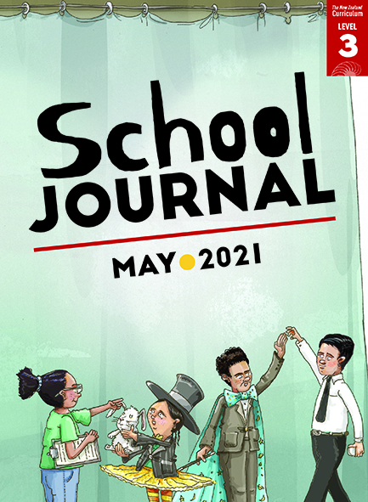

# Grumpy Hungry

by Joanna Cho

School Journal

Level 3, May 2021

Year 5

The[Learning Progression Frameworks](https://curriculumprogresstools.education.govt.nz/lpf-tool/) (LPFs) describe significant signposts in reading and writing as students develop and apply their literacy knowledge and skills with increasing expertise from school entry to the end of year 10.

## Overview

This narrative poem, told in the first person, chronicles being hungry, an experience that intensifies as time passes and which is matched by figurative language that does the same. A good model for student writing.

A PDF of the text is available at [www.schooljournal.tki.org.nz](http://www.schooljournal.tki.org.nz)

## Themes

|  |  |  |  |
| --- | --- | --- | --- |
| * Hunger | * Cooking | * Patience |  |

## Related texts

**“No Sun”** SJ L3 May 2016 | **“Words”** SJ L3 May 2019

## Strengthening reading behaviours (what to notice)

|  |  |
| --- | --- |
| Text structure and features | Requiring students to: |
| * Figurative language – similes and metaphors:  *My stomach’s sounds like distant thunder. My tongue is a salivating water slide My stomach is a thunder storm, and my mouth is a wave pool* | * use what they know about figurative language to recognise the metaphors and similes and interpret their meaning |
| * Narrative structure, including spoken and internal dialogue  *He looks up and smiles. “Dinner’s nearly ready!”* Nearly? *He’s slicing the onions!* | * use punctuation and context to differentiate between the spoken language and the internal thoughts |
| * Sentences spanning line breaks *I close my book and go into the kitchen,  ready for dinner but  instead of bowls steaming with rice, I see Dad hunched over the chopping board.* | * read across stanzas and line breaks to follow the sequence. |

|  |  |
| --- | --- |
| Vocabulary | |
| Possibly challenging words  Korean words | salivating, hunched, interrupts, zucchini, sautéed, sesame, chilli-hot  bibimbap, gochujang |

|  |
| --- |
| Helpful prior knowledge (pre-reading and introducing the text) |
| * Poetry works in a different way from prose. * It can be difficult to wait for a meal when you’re hungry. * Figurative language can be powerful in poetry. * Across cultures, people have their own special dishes and foods. |

## Possible reading and writing purposes

* Enjoy and respond to a poem about an everyday experience
* Identify and evaluate the poet’s choices of language features and structure
* Discuss the writer’s purpose.

See *Effective Literacy Practice in Years 5–8* for information about teaching comprehension strategies ([Teaching comprehension](https://literacyonline.tki.org.nz/Literacy-Online/Planning-for-my-students-needs/Effective-Literacy-Practice-Years-5-8/Teaching-comprehension))   
and for suggestions on using this text with your students ([Approaches to teaching reading](https://literacyonline.tki.org.nz/Literacy-Online/Planning-for-my-students-needs/Effective-Literacy-Practice-Years-5-8/Approaches-to-teaching-reading)).

## Possible curriculum contexts

This text has links to level 3 of *The New Zealand Curriculum* in: [**ENGLISH**](http://nzcurriculum.tki.org.nz/The-New-Zealand-Curriculum/English)

## Understanding progress

The following aspects of progress are taken from the [Learning Progression Framework](https://curriculumprogresstools.education.govt.nz/lpf-tool/)s and relate to the specific learning tasks below. See the LPFs for more about how students develop expertise and make progress in these aspects:

* Reading for literary experience
* Making sense of text: using knowledge of text structure and features
* Using writing to think and organise for learning
* Creating texts for literary purposes.

## Strengthening understanding through reading and writing

**Select from the following suggestions and adapt them** according to your students’ strengths, needs, and experiences.   
Note: Most of these activities lend themselves to students working in pairs or small groups.

* Before they read the poem, discuss when the students have been really hungry and have had to wait for their meal. *What does your mouth do when you think about food? Can you smell the food cooking? How does that make you feel?* Explain that Joanna Cho has written a poem called “Grumpy Hungry”. *What might this poem be about? Why do you think this?*
* Ask the students to read the poem several times so that they are familiar with it. Then, as a group or with a buddy, have them read it aloud and expressively, imagining that they are waiting for dinner. For English language learners, model pronunciation and provide explicit feedback to help them notice the sounds and patterns of English, for example, when to speed up or slow down, when to change pitch or intonation, when to run sounds together, and so on.  The students could record themselves reading the poem to share with whānau.
* Ask the students to retell the poem in their own words as if they were the main character. They could do this orally or in writing. Draw their attention to the narrative form of the poem and how much like a story it is. Ask them to make connections between their prior knowledge and an idea in the poem, such as hunger, patience, or eating this type of meal. This will help them to visualise the thoughts and feelings they should convey to their audience.
* Provide a copy of the poem for the students to annotate. Ask them to highlight words or phrases they liked, a writing feature they noticed, or something that triggered a memory. They could write notes to remind them why they highlighted each aspect. Then have them share and discuss the parts they highlighted with a partner or group. Alternatively, they could share their responses to the poem using a chart like the one provided in the TSM for “Megabyte” (SJ L2 May 2020).
* Review the difference between similes and metaphors and explain how they can be used to help readers visualise. Give out the **Figurative language** template at the end of this TSM and ask the students to use it to explore the figurative language the poet has used to describe her hunger. English language learners may need support to form words that signify changing degrees of intensity.  You could provide the template as a Google Doc for pairs or groups of students to work on together.
* Have the students think about a time when they were hungry, then really hungry. They could use the starters “I feel”, “I see”, “I touch”, “I smell”, “I taste”, “I think”, “I hear”, and “I say” to help them consider other ways to describe hunger. Together, create a metaphor and simile to describe feeling hungry, for example, “I’m as hungry as a starving hyena” or “My stomach is growling”. Then have the students create some of their own.
* Have the students use the poem as a model to write their own poem about a situation where a feeling becomes more intense. They might choose to focus on fear, happiness, sadness, or excitement. Before they start, tell them to imagine the situation, then freeze-frame a particular moment in their minds. Ask them to brainstorm words and phrases that describe what happened, what they saw, how they felt, and so on. Challenge them to include at least one appropriate metaphor and simile.

.

|  |
| --- |
| “Grumpy Hungry” Figurative language |

The poet focuses on how her stomach and mouth feel when she’s hungry and uses figurative language to show the increasing intensity of those feelings. Identify the words she uses to do this.

|  |  |  |
| --- | --- | --- |
|  | **Hungry** | **Really Hungry** |
| **Stomach** | My stomach sounds like distant thunder | Now my stomach is a thunder storm |
| **Mouth** |  |  |

Now use figurative language to create your own description of being hungry and being really hungry.

|  |  |  |
| --- | --- | --- |
|  | **Hungry** | **Really Hungry** |
| **Stomach** |  |  |
| **Mouth** |  |  |

Then try creating some descriptions of other feelings, for example, fear, happiness, sadness, or excitement.   
Try to use both a simile and a metaphor.

|  |  |  |
| --- | --- | --- |
| **Sadness** | **Sad**  I feel like a dull, cloudy day. | **Very sad**  My heart has shrunk to a cold, tiny stone. |
|  |  |  |
|  |  |  |