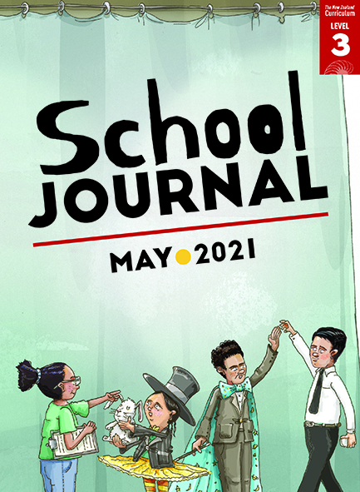

School Journal

Level 3, May 2021

Year 6

# Happy Birthday

by James Brown

The[Learning Progression Frameworks](https://curriculumprogresstools.education.govt.nz/lpf-tool/) (LPFs) describe significant signposts in reading and writing  
as students develop and apply their literacy knowledge and skills with increasing expertise  
from school entry to the end of year 10.

## Overview

The nameless narrator and his friend Jeet, as featured in “The Polterheist”, reappear for another round of humorous high-jinks, this time involving an awkward birthday and a backyard tunnel.

A PDF of the text is available at [www.schooljournal.tki.org.nz](http://www.schooljournal.tki.org.nz)

## Themes

|  |  |  |  |
| --- | --- | --- | --- |
| * Friendship | * Humour | * Separated parents |  |

## Related texts

**“The Polterheist”** SJ L3 Aug 2020 | **“The Duel: The Final Challenge”** SJ L3 Aug 2016| **“The Duel: The Inventors Awaken”** SJ L3 May 2016

## Strengthening reading behaviours (what to notice)

|  |  |
| --- | --- |
| Text structure and features | Requiring students to: |
| * Figurative language  *Kids streamed out the gate like water from our drain when it blocked had drained like a galaxy into a black hole* | * use the context and prior knowledge of how figurative language works to visualise what the author is describing |
| * Dialogue  A large amount of dialogue, some of which moves the plot forward in essential ways and plays an important role as connective tissue for the story as a whole | * track the interactions between the characters, using the punctuation to know who is talking as well as the context and sequence of events, to follow the storyline and plot. |

|  |  |
| --- | --- |
| Vocabulary | |
| Possibly challenging words  and phrases | surprisingly, I groaned inwardly, grouchy, Portioning, emerged, Conducting, Gullibility, participating, meticulously, periscope, surveillance, trench, corrugated-iron, dinky, manicured, sump, veered, resumed, polythene, cactuses, syphon, torrent, subsided, breach, galaxy, Catastrophic, trowel, contraptions, mused |

|  |
| --- |
| Helpful prior knowledge (pre-reading and introducing the text) |
| * It can be a lot of fun to hang out with a close friend. * Having adventures and make-believe is a big part of being a kid. * It’s a special experience being left to your own devices (without adult involvement) and creating something with a friend. * Some people have to juggle between two families when parents are living in different houses. * Sometimes people break promises. |

## Possible reading and writing purposes

* Find out how two friends change plans after a birthday promise mix-up
* Identify how the author builds a sense of friendship and camaraderie between two boys
* Explore and describe the language and structural features the author uses to tell a story
* Evaluate how the author’s language choices build mood and tension.

See *Effective Literacy Practice in Years 5–8* for information about teaching comprehension strategies ([Teaching comprehension](https://literacyonline.tki.org.nz/Literacy-Online/Planning-for-my-students-needs/Effective-Literacy-Practice-Years-5-8/Teaching-comprehension))   
and for suggestions on using this text with your students ([Approaches to teaching reading](https://literacyonline.tki.org.nz/Literacy-Online/Planning-for-my-students-needs/Effective-Literacy-Practice-Years-5-8/Approaches-to-teaching-reading)).

## Possible curriculum contexts

This text has links to level 3 of *The New Zealand Curriculum* in: [**ENGLISH**](http://nzcurriculum.tki.org.nz/The-New-Zealand-Curriculum/English) [**HEALTH AND PHYSICAL EDUCATION**](https://nzcurriculum.tki.org.nz/The-New-Zealand-Curriculum/Health-and-physical-education)

## Understanding progress

The following aspects of progress are taken from the [Learning Progression Framework](https://curriculumprogresstools.education.govt.nz/lpf-tool/)s and relate to the specific learning tasks below. See the LPFs for more about how students develop expertise and make progress in these aspects:

* Reading for literary experience
* Making sense of text: reading critically; using knowledge of text structure and features
* Reading to organise ideas and information for learning
* Creating texts for literary purposes.

## Strengthening understanding through reading and writing

**Select from the following suggestions and adapt them** according to your students’ strengths, needs, and experiences.   
Note: Most of these activities lend themselves to students working in pairs or small groups.

* Before reading, ask the students how they celebrate their birthdays. Be sensitive to students who live in two homes. If they are happy to do so, invite them to share how they celebrate with both parents. The aim is to show that there are many ways to celebrate birthdays and the experience is different for everyone. (Also be mindful that for religious or cultural reasons, not all students celebrate their birthdays.)
* After reading, discuss what happened in the story as a group to draw out the students’ understanding. Use the following questions to prompt their thinking. *What kind of birthday did the boy have? What did the boy end up doing on his birthday? How do you think the boy felt when he was waiting for his dad, or when the boys were at his mum’s house and his mum arrived home? What do you think helped make the boy’s day feel special?* Ask the students to find evidence for their answers in the text.
* Explain that much of what the author is telling us about the characters’ relationships is implied and the reader has to infer what they are thinking and feeling. For example, when the narrator says “Mum threw her tea towel at me”, we can infer that this is in fun and that the boy has a good relationship with his mum. Have the students complete the **Inference chart** at the end of this TSM to identify other examples and to explain what those examples reveal. Reassure them that there is no “right answer”, as long as they can justify their answers using evidence from the text, and other readers might draw different conclusions from the same piece of text.  You could provide the chart as a Google Doc, which students could work on together.
* Have the students work in small groups to explore some of the challenging vocabulary. Give each group four or five words. They write each word in the centre of a square, and around it they write a definition, a synonym and an antonym, a root word or derivation, and a sentence using the word. The groups then share their work with other groups. See the TSM for “Don’t Forget to Vote” (SJ L2 Nov 2020) for a template you could adapt.
* Have the students think critically about the story and why the author wrote it the way he did. *What do you think might have happened if the boy’s father had picked them up after school? What do you think the author wanted us to think about the boy’s mum, his dad, and his friend Jeet? How did the author do that? Why did the author include the tunnel in the story? What do you think the author was trying to tell us about the two boys?* Ask the students to justify their answer(s).
* Have the students find examples of humour in the text and record these on sticky notes. They could then share these with a partner and explain why they think these are funny, noting in particular the language features the author used.
* Have the students share and discuss an aspect of the story that connects to their own experience or is something they can easily visualise or empathise with. You could use hot seating, with students taking the role of the boy or Jeet and answering questions that explore how those characters felt about the events of the day.
* Ask the students to think critically about how the author wants the reader to feel about friendship and separated parents. You could evaluate one of these themes together. Reread the story for references to the theme, and record these on one side of a T-chart. Then analyse them on the other side, discussing the author’s technique and what he is hoping the reader will think or feel. Draw out ideas about language features, such as adjectives, expressive verbs, figurative language, similes, idioms, humour, cliche, dialogue, and sentence length. Ask them to consider how effective these are*.* Then ask the students to explore the other theme.

|  |
| --- |
| “Happy Birthday” Inference chart |

What do you think this text tells you about the characters? Add some more examples in the blank spaces.

|  |  |  |
| --- | --- | --- |
| **Text** | **Inference** | **How I know** |
| Mum threw her tea towel at me. | The boy and his mum have a good relationship. | She did it in fun. You wouldn’t throw a tea towel at someone unless you know them well enough to know they would find it funny too. |
| I felt a weight lift from my shoulders when Mum finally left for work. |  |  |
| It wasn’t like Dad to forget a pick-up. I tried texting. No response.  “Maybe his phone’s out of charge.” |  |  |
| “I went to a movie because I didn’t want to be here by myself on your birthday.” |  |  |
|  |  |  |
|  |  |  |
|  |  |  |

