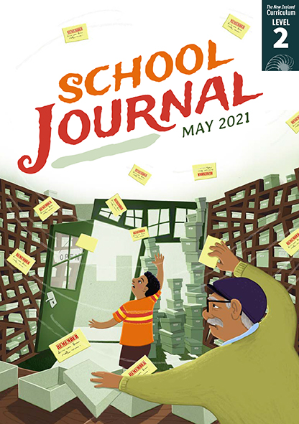

The Memory Bank
by Sarah Johnson
School Journal
Level 2, May 2021
Year 4
The Learning Progression Frameworks (LPFs) describe significant signposts in reading
and writing as students develop and apply their literacy knowledge and skills with increasing expertise from school entry to the end of year 10.

Overview
This is a humorous fantasy story set in a “memory bank”. A breakdown in the filing system leads to confusion when the characters’ reminder notes get mixed up. This story links to the non-fiction text “The Memory Toolbox” and the poem “What Do You Remember?”, which are also in this journal. It provides a model for developing effective characters and storylines.
A PDF of the text is available at www.schooljournal.tki.org.nz

Themes
- Memory | - Humour | - Fantasy | - Magic

Related texts
“The Memory Toolbox”, “What Do You Remember?” SJ L2 May 2021 | “The Choice” SJ L2 Nov 2019 |
“Just in Case” SJ L2 Aug 2018 | “Finders Keepers” SJ L2 Nov 2017 | “The Amazing Humans” SJ L2 May 2017

Strengthening reading behaviours (what to notice)
Text structure and features | Requiring students to:
- Abstract ideas  “Is this really a memory bank?” Anu asked.  “Yes,” said the old man, “and I’m the banker.  This is where people store the important things  that they want to remember.” | - use their prior knowledge of a “bank” as a place where people keep their money safe and the old man’s description to understand the concept of a “memory bank” (where people store and keep safe reminder notes for the things they need to remember)
- Humour  “I thought you looked useful.” He slid the note into  the box, where it settled with a tiny sigh. | - use prior knowledge of humour to interpret the subtle humour. Some students may also infer a connection to the “sorting hat” in the Harry Potter stories.

Vocabulary
Some possibly challenging words  and phrases, including some used in unusual ways or contexts | wonky, blinked, crooked, drifted, stamped, scrawled, havoc, shelves, labelled, banged, strode, liver, settled, fascinated, poodle, groomed, dreamy, Cheryl, stored, disgusting, gust, scrambled, grumpy, shaved, tufts, enormous, sparkly, dyed, styled, sorting, muddle

Helpful prior knowledge (pre-reading and introducing the text)
- Some fantasy stories include magic (such as a shop that wasn’t there before and notes that “sigh”).
- People can forget or confuse their memories.
- A memory bank is a computer component that stores information, but “memory bank” is also used figuratively when talking about the part of your brain that holds memories or things you need to remember.

Possible reading and writing purposes
- Read and respond to a funny story about how the things people need to remember get confused
- Identify the features of the plot and explore how these help to create a satisfying story
- Explore and describe how the author introduces humour into the story.
See Effective Literacy Practice in Years 1–4 for suggestions on using this text with your students (Approaches to teaching reading) and for information about teaching comprehension strategies (Building comprehension and Text processing strategies).

Possible curriculum contexts
This text has links to level 2 of The New Zealand Curriculum in: ENGLISH

Understanding progress
The following aspects of progress are taken from the Learning Progression Frameworks and relate to the specific learning tasks below. See the LPFs for more about how students develop expertise and make progress in these aspects:
- Reading for literary experience
- Making sense of text: reading critically; using knowledge of text structure and features
- Creating texts for literary purposes
- Writing meaningful text: using knowledge of text structure and features.

Strengthening understanding through reading and writing
Select from the following suggestions and adapt them according to your students’ strengths, needs, and experiences.
Note: Most of these activities lend themselves to students working in pairs or small groups.
- Have the students share their responses to the story. Ask them to find a word or phrase that best describes each character and identify what they thought was the funniest mix-up. They could also explain or draw what the bank looked like and identify the words and phrases from the text that helped them visualise it. Do the illustrations match how you visualise it? What’s the same and what’s different? Prompt them to think critically about the story’s theme or main idea. What does the story say about the importance of remembering things? Why might these things need to be in a bank? What things do you need to remember? Which of those things would you bank?
- Support the students to examine the humour in the story. They could draw a two-column chart with words or phrases they find funny in one column and an explanation of why they find them funny in the other column.
Phrase or word | Why it’s funny
it settled with a tiny sigh | The piece of paper has a human reaction.
The door banged and in came the man with the poodle. Its hair had been dyed bright pink and styled into waves. | The poodle was meant to be groomed, but the instructions have been mixed up. You can visualise how strange it would look!
- Explore how this story is structured as a narrative. If necessary, have a group discussion to draw out the students’ understanding of the story. What attracted Anu to the building in the first place? Why did he go inside? What did he see when he went inside? Who did he meet? What was the building used for? Who else came into the bank? What did the other people want? How did the old man help them? What was the problem? Why were the characters confused? Who worked out what the problem was? How did Anu help with the problem? What did the old man do?
- Write the headings Characters, Setting, Plot, Main idea, Problem/conflict, Climax, Resolution/solution. Have the students add details under each heading. Use the Elements of the plot template at the end of this TSM to map the way the story builds drama around the problem. You could use another well-known story as an example, then ask the students to do the same for “The Memory Bank”. Alternatively, they might use a story mountain (see the TSM for “Magō”, SJ L2 Aug 2020) to show the plot development.
- Have the students list each character and the words the author uses to describe them and the way they act. The students could then choose one and write a short character study based on any description in the text, the illustrations, and their imaginations
and add details such as where they live, who their friends and family are, and why their particular thing to remember is important
to them.
- Have the students retell or write their own version of one of the plot points, developing it and adding details. Before they start, brainstorm some useful words and provide a writing focus, for example, include a complex sentence or some descriptive adjectives in their writing. The students could each write about a different plot point and then combine them into a group story.
- The students could make their own “Remember” note and put it into a group box. They could take turns pulling out the notes and asking each other why the things to remember were important.

“The Memory Bank” Elements of the plot

Draw a sketch to represent each of these points in the story.
Introduction: The main characters and setting are introduced.
Rising action: The problem emerges.
Climax: The problem is at its greatest and the tension
is at its highest.
Falling action: The characters identify and begin to sort out
the problem.
Resolution: The problem is solved.

