The Literacy Learning Progressions: Meeting the Reading and Writing Demands of the Curriculum describe the literacy-related knowledge, skills, and attitudes that students need to draw on to meet the demands of the curriculum.  Pā Tūwatawata  and the New Zealand Wars  by Taimana Iverson, John Kingi, Aroha Harris,  and Caitlin Moffat-Young  Connected  Level 4  2020  The Learning Progression Frameworks (LPF) describe significant signposts in reading and writing as students develop and apply their literacy knowledge and skills with increasing expertise from school entry to the end of year 10.  Overview  This article describes the development of pā technology in the nineteenth century, as iwi and hapū defended themselves and their land against invasion. It explains how the basic features of pā technology were adapted in response to invasion by Pākehā – utilising the rich knowledge Māori held about their land.  A Google Slides version of this article is available at www.connected.tki.org.nz | 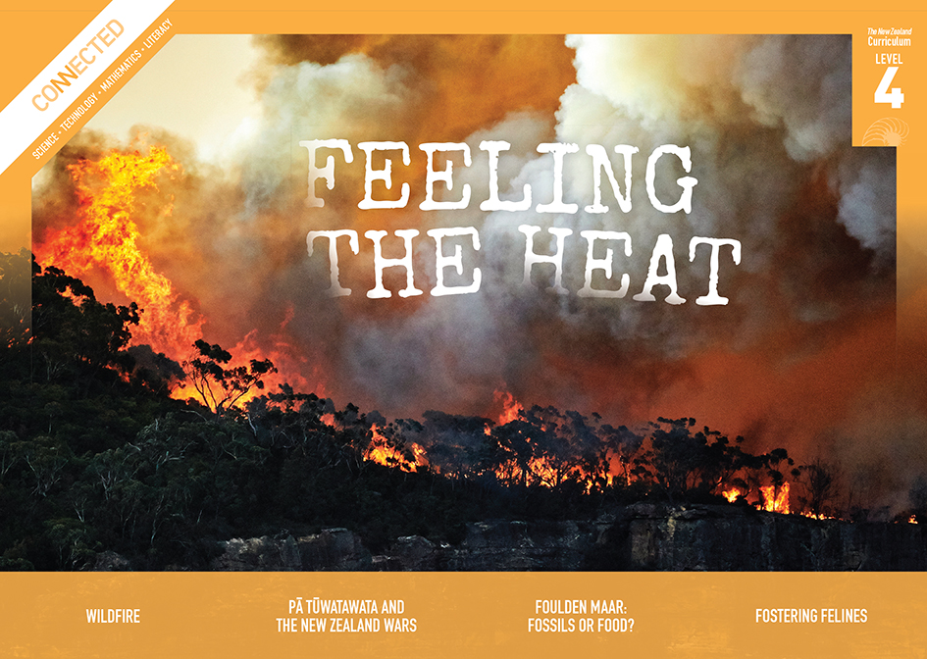  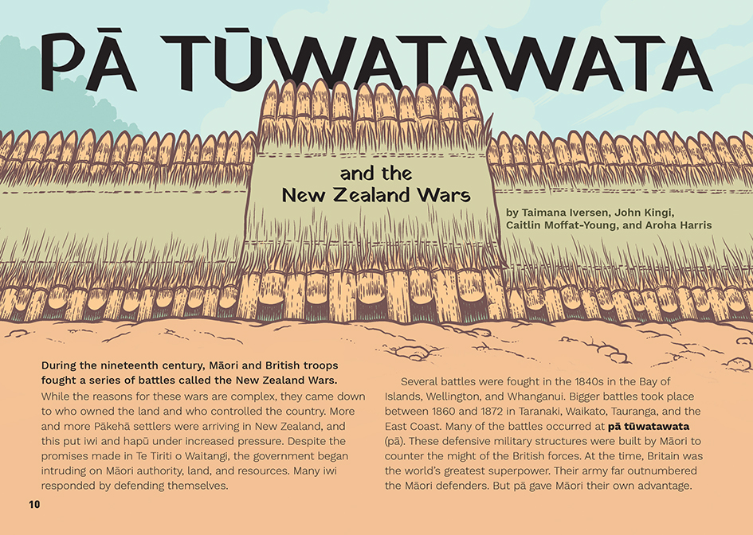
Curriculum contexts

TECHNOLOGY: Nature of Technology: Characteristics of technology  Level 4 – Students will understand how technological development expands human possibilities and how technology draws on knowledge from a wide range of disciplines.  TECHNOLOGY: Technological Knowledge: Technological modelling  Level 4 – Students will understand how different forms of functional modelling are used to explore possibilities and to justify decision making and how prototyping can be used to justify refinement of technological outcomes. | Key technology ideas  - Technological adaptations often arise in response to particular circumstances or needs.  - Māori used their experiences and knowledge of the land to adapt pā construction materials and processes to better protect against invading forces.

ENGLISH: Reading
Level 4 – Ideas: Students will show an increasing understanding of ideas within, across, and beyond texts.
Level 4 – Language features: Students will show an increasing understanding of how language features are used for effect within and across texts.

The New Zealand Curriculum

Meeting the literacy challenges

This is a challenging text that weaves a narrative about the adaptations made to pā technology with a narrative about the New Zealand Wars. To reduce complexity, the overview of the historical narrative is kept brief. However, this requires students to draw on prior knowledge that may be limited. Students are also challenged by the need to track a lot of ideas and information across a lengthy text.  Support is provided through the structure, which first introduces the features of a pā, then uses three examples to demonstrate the innovations Māori made to defend themselves against the military technology of the invaders. It requires students to shift focus out to the wider historical narrative and then into each of the examples. They need to understand that the examples give insights and comparisons, but they do not cover a complete history of the conflict.  Each example of a pā follows the same structure, beginning with a short introduction of the historical context, then providing a detailed description of the pā’s technological features, and finishing with an explanation of what happened when the British attacked. The sections are longer than in most Connected articles, but the subheadings will support students to chunk the information.  The technological descriptions and explanations require long, descriptive sentences, but these are surrounded by shorter, simpler sentences to reduce the load. Detailed infographics enable students to check their understandings. | The instructional strategies below support students to meet the literacy challenges of this text. For each strategy, there are links to the relevant aspect of The Learning Progression Frameworks (Reading). The signposts on each of these aspects provide detailed illustrations on what to notice as your students develop their literacy knowledge and skills for different purposes in different curriculum areas.  There is a considerable amount of vocabulary that will be unfamiliar to many students. These include words related to the New Zealand Wars, building and technology, and combat and war. There are also many words in te reo Māori. Students will be familiar with some of these words, and others are glossed or explained in the text.  The following strategies will support students to understand, respond to, and think critically about the information and ideas in the text.  You may wish to use shared or guided reading, or a mixture of both approaches, depending on the reading expertise of your students and the background knowledge they bring to the text.  After reading the text, support students to explore the activities outlined in the following pages.  Students need a safe space to discuss difficult histories of violence and suppression. They need to be able to express themselves, ask uncomfortable questions, and debate historical ideas. Students need to understand and respect their own and others’ emotions and perspectives.

INSTRUCTIONAL STRATEGIES

Building background knowledge  [LPF Reading: Acquiring and using information and ideas in informational texts]  Have the students read the title and share what they know about pā tūwatawata. They may know about pā, but not pā tūwatawata, and they may not notice that this word is glossed. Have them read the definition. PROMPT them to share what they know about pā, and make inferences about what might be special about the design of a pā tūwatawata. RECORD these for later reference.  Most students will have some prior knowledge of pā, but they may know little about the New Zealand Wars. Consider reading one of the School Journal articles in the “Resource links” section below to provide context. You could also PROMPT awareness, interest, and connections by pointing out a local landmark or place name that has an association with the New Zealand Wars and inviting the students to share what they know about it. If necessary, MODEL how you could go online to find out more. Alternatively, play the brief excerpt from the first episode of James Belich’s series on the New Zealand Wars.  SKIM the article with the students to get a sense of its structure and purpose. PROMPT the students to use the headings and infographics to understand that the text provides an insight into the development of pā tūwatawata within the context of the New Zealand Wars. | Keeping track of key information  [LPF Reading: Reading to organise ideas and information for learning]  DISCUSS how to approach an article with so many layers of information. PROMPT them to notice that while the article spans a broad period, it is chronological.  How could we use that to help us get the big picture before we go into the detail?  What are some of the text features we could use to create an overview of what happened?  Work with the students to decide on an organiser for tracking and recording key facts and events. For example, the students could:  use one of the timeline makers that are available online, such as on TimeGraphics or ReadWriteThink  set up a “What, Where, Who, and Why” template.  Reiterate that the purpose of this first reading is to get an overview of the people, places, times, and events involved. Their graphic organisers are intended to capture this information at an overview level, rather than the detail.
Using visual features to clarify key information  [LPF Reading: Making sense of text: using knowledge of text structure and features]  MODEL how to make connections between the text and the infographics on pages 10–11 to understand the design of pā tūwatawata prior to 1769, unpacking the key features and the purpose of each feature.  Here is the pekerangi, and here is the inner fence. Two fences, and so it is a “dual” palisade. There are the holes through which the fighters can poke their muskets. I see now how the fighter can kneel in the trench to take cover and reload, and then get up to fire back. The pekerangi will give some protection, but I wonder how much?  Work with the students to capture this information in the first row of a table.  Features Purpose  Pā tūwatawata before 1769  Ōhaeawai Pā  Ruapekapeka Pā: The Bats’ Nest  Pukehinahina Pā  Thinking critically  [LPF Reading: Acquiring and using information and ideas in informational texts]  Have the students move into three groups to reread the text, with each group focusing on one of the nineteenth century pā.  Have them identify the technological features of their selected pā and the purpose of these features, then use the diagram and the table to EXPLAIN these to the rest of the class. RECORD each group’s information in the table.  As a class, REVIEW the table to get a sense of how Māori used their knowledge of the land to adapt to the challenge of European combat techniques.  Tamaikoha of Tūhoe is quoted as saying, “The rugged canyons were our stockades; the steep ranges and dense forests were our earthworks.” To what extent is that reflected in the pā tūwatawata we have learned about? How did this change?  The writer says, “As conflict between Māori and the government escalated, rangatira had to adapt. Their modern pā needed to defend against, and take advantage of, this new European technology.” What do you think it means “to adapt” here?  What do we know about the processes of adaptation?  What kind of adaptations did Māori make?  What drove Māori to make these adaptations? What was the impact of these adaptations? | Dealing with unfamiliar vocabulary  [LPF Reading: Making sense of text: vocabulary knowledge]  Have the students create a chart to LIST the topic-specific vocabulary. PROMPT them to notice that the topic-specific words belong to at least four groups: technological terms, historical terms related to the New Zealand Wars, terms associated with combat and war, and words in te reo Māori that may be unfamiliar.  Have the students work in pairs to use information from the text and from their prior knowledge to write definitions of the new terms. Tell them to use print and online dictionaries to revise and improve their definitions, then give an example of each term, either by writing a sentence or drawing an image. Have the pairs of students partner up to critique each other’s charts. When they are confident of their definitions, have each pair present their definitions and examples to the whole class.  Technological terms What we think this means What we now know it means Example  Historical terms What we think this means What we now know it means Example  War and combat terms What we think this means What we now know it means Example  Te reo Māori What we think this means What we now know it means Example
Extension  Focus on the concept of “rangatiratanga” and the statement that “The British had continually undermined Māori rangatiratanga in the north, and Heke’s frustration had boiled over.” PROMPT inquiry into what “rangatiratanga” means and why its loss was so devastating. (See the “Resource links” section for places to start.)  The Māori version of Te Tiriti o Waitangi, The Treaty of Waitangi, guarantees Māori “tino rangatiratanga”. What did Māori expect from this? How does it compare with what actually happened?  The word “rangatiratanga” is often used today. Why is it an important concept?  Evaluating the writer’s choices  [LPF Reading: Making sense of text: reading critically]  PROMPT the students to reflect on the writer’s message and purpose.  The article focuses on the success of the three pā tūwatawata in defending Māori authority, territory, and lives. But on page 18, we learn that eventually, the British forces dominated. What do the writers think or believe about that? Why did they think this was an important story to tell? What makes you think that?  How do you imagine the course of New Zealand history was changed by the loss of Māori land and lives? How do you think that is relevant to us today?  What questions do you have? Where could we find more information? Who could help us understand? | Communicating new understandings  [LPF Writing: Creating texts to communicate current knowledge and understanding]  Give the students printouts of the infographics. PROMPT them to visualise the scene and empathise with the thoughts and feelings of the people portrayed in them.  What do you hear? What do you see? Feel? What is it like when the shells hit the rua?  Who is with you? What are you doing? What are you saying to each other? What are you thinking?  Have the students draw speech and thought bubbles that convey what it might have been like to be in the pā tūwatawata when under attack.

The Learning Progression Frameworks
The Literacy Learning Progressions
Effective Literacy Practice: Years 5–8

Illustrating the key ideas

Māori used their experiences and knowledge of the land to adapt pā construction materials and processes to better protect against invading forces. | 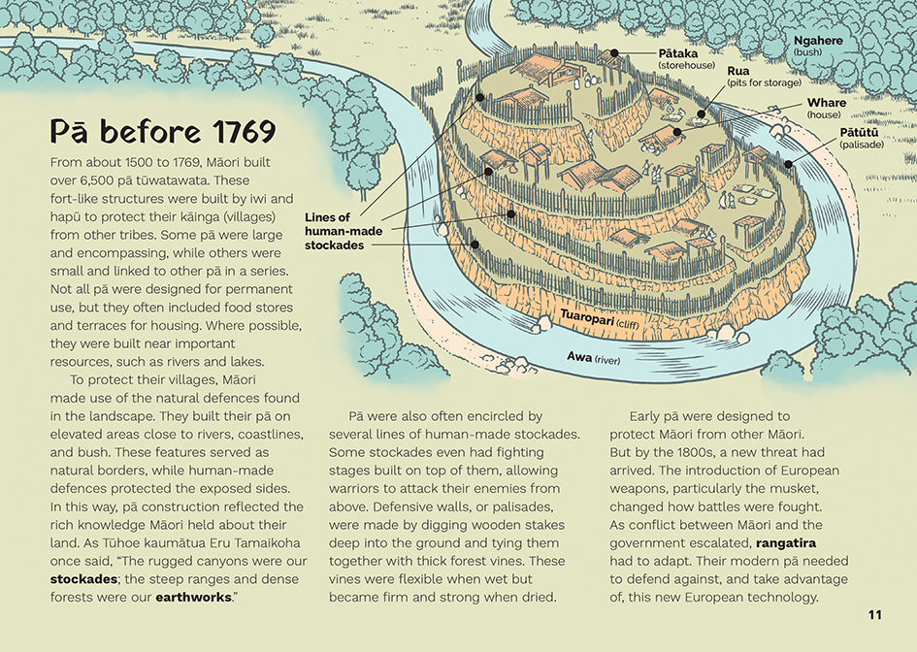  Technological adaptations often arise in response to particular circumstances or needs.  Technological development expands human possibilities and draws on knowledge from a wide range of disciplines.

Learning activities – Exploring the
technology

Activity 1 – Investigating the technology of pā tūwatawata  Tell the students that they are going to make a model of a pā tūwatawata that is adapted to a specific environment and incorporates some of the features they have been learning about. They will prepare for this by using fair-testing principles as they investigate the technology of pā tūwatawata.  Prompt the students to recall the features of a fair test, including the need to:  - determine the factor that they are investigating and work out the changes that they will make to this factor, for example, the kind of material used or the height of walls (the independent variable)  - decide what they will observe or measure to identify the effect of changes to the independent variable (the dependent variable)  - work out ways to keep everything else the same, that is, control any other variables that may affect their investigation and observations  - make and record accurate measurements.  The investigations could include the following:  - Have the students investigate the effect of the woven harakeke on the pekerangi by giving them water balloons and beach towels and having them play the Balloon Toss game.  - What is the best way to catch a water balloon without it bursting in a towel? Is it best with your hands?  - We’re told in the article that the sheets of woven harakeke draped on pekerangi helped stop musket shots. How does this activity help us to understand that?  - Have the students investigate the strongest ways of building the structures. For example, they could work out the strongest arrangements of logs over a rua by placing kindling over cardboard cartons. They could test the arrangement by throwing rocks from a given height.  - The students could make lashings with harakeke and test their strength when wet and when dry. How much resistance can your ropes take?  - You could adapt ideas from Building Science Concepts, Book 51 to explore the relationship between the structure of plants and animals and human technologies. How do you see this relationship in pā tūwatawata?  Have the students return to the descriptions of the pā tūwatawata in the article.  What problems were the people trying to resolve? How did they resolve them?  Now that you have carried out your investigations, what do you notice about the technological expertise and principles Māori used to design and build their pā?  Have the investigations prompted any more questions for you? | The following activities and suggestions are designed as a guide for supporting students to explore and extend their content knowledge across the learning areas. Adapt these activities to support your students’ interests and learning needs.  Have the students move into groups to look for answers to their questions in the “Resource links” below. Then have each group construct a model of a pā tūwatawata. It could be:  - a model of one of the three described in the article  - a model of another pā tūwatawata they know about  - an invented one, built for a site in the local landscape and using local resources.  When they have finished their models, the students can present them to the rest of the class or a wider audience, explaining the purpose of each feature and how it works.  Activity 2 – Compare  Have the students work in groups to learn about the fortifications that were designed, built, and used in other times and places, for example:  - a fortified city in Ancient Greece  - a Roman fort  - a medieval castle in Europe  - India’s Red Fort  - the Forbidden City in Beijing  - the trench systems used in the First World War.  Have the students collate the information on a shared organiser. This should include:  - information about the historical context for the conflict  - information about the physical environment and its advantages and challenges  - information about the material resources and technological knowledge the designers could draw on  - a diagram with labels for the key features  - explanations of how the technological features were intended to function  - a brief summary of how well the fortification worked and why.  Have the students share what they learn. Prompt them to compare Māori fortifications with those of other times and places.  Use the discussion to prompt further thinking about the idea of adaptation. The ways we engage in conflict is shaped by our environment and the resources we have.  - Are there features that are common across all fortifications?  - What are the differences?  - What caused them?  What does this tell us about how humans adapt to their situation and the environment?
Activity 3 – Learning about pā tūwatawata with digital technologies  Have the students research pā in their area to learn about where and when they were built, why they were built, the advantages and challenges of the natural environment, and the technological features that were used for defence and everyday living. Work with local iwi and hapū to understand this history and understand the adaptations made to the land. There may also be local historians with knowledge they can share. There may be place names that provide a hint of the history of the New Zealand Wars and the lives that were affected by them. Take the students on a site visit so that they can learn to read the history that remains etched in the land. (Be aware of tapū and any sensitivities about sites.) | TKI’s “Supporting place-based education with digital technologies” offers ideas for this investigation. The suggestions include apps that students can use to learn about their local history and sites of significance and others they can use to add to the historical record so that others can learn. Students can also learn about and engage in cultural mapping – using mapping tools like Google My Maps to remap locations according to the perspectives of local people. They could even use Minecraft to create virtual tours of a local pā tūwatawata to recreate what they were like and help users understand the technological skills involved in their design.

RESOURCE LINKS

Connected and School Journal  “Ngā Pakanga o Aotearoa / The New Zealand Wars”, School Journal, Level 4, November 2014  “Ngā Tātarakihi o Parihaka”, School Journal, Level 4, May 2016  “Fallen Leaves”, School Journal, Level 4, November 2016  “Life in Aotearoa New Zealand”, Connected 2020, Level 3, Kaitiakitanga  Building Science Concepts  Book 51: Standing Up: Skeletons and Frameworks  Te Ara  New Zealand Wars: https://teara.govt.nz/en/new-zealand-wars  New Zealand Wars: https://teara.govt.nz/en/new-zealand-wars/page-1  The first decades after the treaty – 1840 to 1860: https://teara.govt.nz/en/treaty-of-waitangi/page-3  From Gate Pā (Pukehinahina) to the present: https://teara.govt.nz/en/tauranga-moana/page-3  Gate Pā (Pukehinahina), Tauranga: https://teara.govt.nz/en/new-zealand-wars/page-7  Ruapekapeka  Ruapekapeka reconstructed: https://www.ruapekapeka.co.nz/read/ruapekapeka-reconstructed  The battle of Ruapekapeka: https://www.ruapekapeka.co.nz/read/battle-ruapekapeka  NZ History  Plan of Ōhaeawai Pā: https://nzhistory.govt.nz/media/photo/plan-ohaeawai-pa  New Zealand’s nineteenth century wars: https://nzhistory.govt.nz/war/new-zealands-19th-century-wars/introduction  War in Tauranga: https://nzhistory.govt.nz/war/war-in-tauranga  War in Waikato: https://nzhistory.govt.nz/war/war-in-waikato  The Northern War: https://nzhistory.govt.nz/war/northern-war  Classroom ideas – the Treaty in brief: https://nzhistory.govt.nz/politics/the-treaty-in-brief/classroom-ideas  George Grey: https://nzhistory.govt.nz/media/photo/george-grey-painting  Māori King movement – 1860–1894: https://nzhistory.govt.nz/politics/the-maori-king-movement/troubled-times-1860-94 | YouTube  YouTube: Indigenous rights (Treaty of Waitangi): https://www.youtube.com/watch?v=HRq6K8Z0hvM  Other  Māori History in the NZ Curriculum: http://maorihistory.tki.org.nz/  Te Takanga o te Wā: Māori History Guidelines for Years 1–8: http://maorihistory.tki.org.nz/assets/Uploads/Te-Takanga-o-te-Wa-Maori-History-Guidelines-English-1.pdf  Māori dictionary: https://maoridictionary.co.nz/  New Zealand wars timeline: http://newzealandwars.co.nz/land-wars-timeline/  The New Zealand Wars | Ngā Pakanga o Aotearoa: https://natlib.govt.nz/schools/teaching-and-learning-resources/nz-wars  He Tohu: Cultural interaction: https://natlib.govt.nz/he-tohu/learning/social-inquiry-resources/cultural-interaction  NZOnScreen: The New Zealand Wars 1 – The war that Britain lost (Episode One): https://www.nzonscreen.com/title/the-new-zealand-wars-1998/series  Stuff: https://www.stuff.co.nz/pou-tiaki/300096741/historic-nz-war-site-in-northland-gets-85m-funding-for-restoration  Supporting place-based education with digital technologies: https://elearning.tki.org.nz/Beyond-the-classroom/Place-based-education#js-tabcontainer-1-tab-1  Balloon toss game: https://kidspot.co.nz/activities/balloon-toss/  ReadWriteThink: Timeline (student interactive): http://www.readwritethink.org/classroom-resources/student-interactives/timeline-30007.html  TimeGraphics: Online timeline maker: https://time.graphics  Enabling e-Learning: Using Minecraft as a tool for learning: https://elearning.tki.org.nz/Teaching/Future-focused-learning/Minecraft

