Connected
Level 3
2020

Trees, Seas, and Soil
by Renata Hopkins
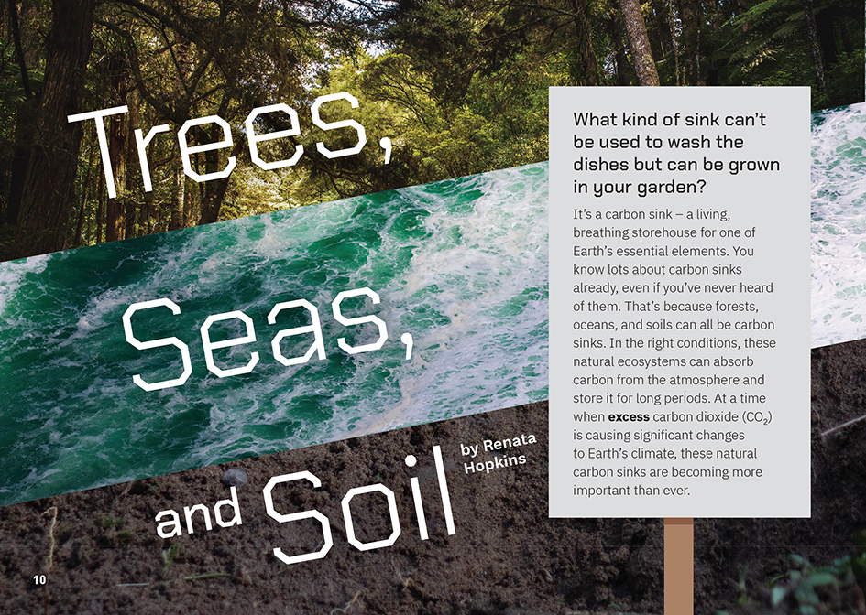

The Literacy Learning Progressions: Meeting the Reading and Writing Demands of the Curriculum describe the literacy-related knowledge, skills, and attitudes that students need to draw on to meet the demands of the curriculum.
The Learning Progression Frameworks describe significant signposts in reading and writing as students develop and apply their literacy knowledge and skills with increasing expertise from school entry to the end of year 10.

Overview
This article examines how different processes combine to affect the balance of carbon in the atmosphere. It explains that the increased level of carbon dioxide in the atmosphere is having a huge effect on climate – an effect that can be reduced, as carbon is finite. Carbon sinks, in the form of forests, the ocean, and the breakdown of leaf litter into humus, could help to balance the carbon levels in the atmosphere. However, each form has a complication. The article concludes that human use of fossil fuels needs to be reduced to protect the carbon sinks around us.
A Google Slides version of this article is available at www.connected.tki.org.nz
Curriculum contexts

SCIENCE: Nature of Science: Investigating in science  Level 3 – Students will build on prior experiences, working together to share and examine their own and others’ knowledge; students will ask questions, find evidence, explore simple models, and carry out appropriate investigations to develop simple explanations.  SCIENCE: Nature of Science: Communicating in science  Level 3 – Students will begin to use a range of scientific symbols, conventions, and vocabulary. | Key Nature of Science ideas  Scientists:  - use models and diagrams to help show relationships within systems in the world around us  - use models and diagrams to consider and test ideas and implications.  Key science ideas  - The chemical properties of carbon mean that it passes between living and non-living systems on Earth through a range of processes and chemical changes, spending longer periods in some parts of these systems than others.  - We can use what we know about the way carbon moves through these systems to take actions that reduce the amount of carbon dioxide moving into the atmosphere, where it contributes to global warming and consequent climate change.

SCIENCE: Material World: Chemistry and society
Level 3 – Students will relate the observed, characteristic chemical and physical properties of a range of different materials to technological uses and natural processes.

ENGLISH: Reading
Level 3 – Ideas: Students will show a developing understanding of ideas within, across, and beyond texts.
Level 3 – Language features: Students will show a developing understanding of how language features are used for effect within and across texts.

The New Zealand Curriculum

Meeting the literacy challenges

The main literacy demands of this text arise from the complex information and ideas, as it examines how different processes affect the balance of carbon in the atmosphere.  The writer carefully explains each process, describing the cause-and-effect relationships within them. The reader is kept engaged with simple syntax and vocabulary and carefully chosen examples. The structure is also supportive, helping readers to first understand carbon and the carbon cycle, then to compare the processes involved in creating each sink and the factors that create complexity.  Students will need to use their prior knowledge, the new information in the text, and their knowledge of prefixes and root words, to fully understand and make meaning of the information about carbon sinks and the scientific vocabulary. The inclusion of the complicating factors means they are required to evaluate rather than simply absorb new information. | The instructional strategies below support students to meet the literacy challenges of this text. For each strategy, there are links to the relevant aspect of The Learning Progression Frameworks (Reading). The signposts on each of these aspects provide detailed illustrations on what to notice as your students develop their literacy knowledge and skills for different purposes in different curriculum areas.  The following strategies will support students to understand, respond to, and think critically about the information and ideas in the text.  You may wish to use shared or guided reading, or a mixture of both approaches, depending on the reading expertise of your students and the background knowledge they bring to the text.  After reading the text, support students to explore the activities outlined in the following pages.

INSTRUCTIONAL STRATEGIES

Building understanding  [LPF Reading: Acquiring and using information and ideas in informational texts]  Ask students the rhetorical question that begins the article. Have the students respond to the question, then read the first page to check their predictions. PROMPT them to notice that the title foreshadows the three types of carbon sink that will be described.  Have the students skim the text to IDENTIFY other aspects of the structure that will help them navigate the text, such as the subheadings, sections, photographs, and diagrams.  What do you notice about the headings and layout on pages 13–15? What patterns can you see on these pages? How does this help you navigate the text?  Why have the headings and layout on pages 16–17 changed?  Focus on the idea of a process and the relationship between cause and effect. Clarify, if necessary, that a process is a sequence of events or changes. One event, action, or change may lead to another. The thing that happens is the cause and the results of this are the effect.  From what you have read and seen so far, what sorts of processes are we going to read about in this article?  What is the cause-and-effect relationship on page 10?  PROMPT the students to recall some of the words or phrases we use to signal cause and effect (for example, “because”, “as a result”, “resulted”, “caused”, “affected”, “since”, “due to”, “effect”). Have the students use sticky notes to highlight the cause-and-effect relationships they notice as they read page 11.  ASK QUESTIONS to ensure the students have fully understood the ideas and relationships described on this page. | What processes are described on this page?  What cause-and-effect relationships did you find? What words or phrases did the writer use to signal these relationships?  What is the amazing fact you learned from this page?  How do the pictures help you to understand the information on this page?  Using visual features to clarify key concepts  [LPF Reading: Making sense of text: using knowledge of text structure and features]  ASK QUESTIONS to help the students read the diagram and text about the carbon cycle.  What processes take place as carbon moves through Earth’s systems?  The writer says that some of the processes are fast and some are slow. How does the illustrator show us which is which?  We’ve already been told that there are three types of carbon sink – the trees, seas, and soil. How has the illustrator shown them on the diagram?  The writer says that carbon doesn’t just move around a circular cycle. It can move backwards and forwards from place to place. How does the diagram show this?  MODEL how the information in the text and diagram helps you to make statements describing what happens as carbon moves through Earth’s different systems.  Coal, oil, and gas are stored underground for long periods of time. When these fossil fuels are burnt, the carbon dioxide is released into the atmosphere. This is a fast process.  Have the students think, pair, and share statements about other relationships they see in the carbon cycle.

Meeting the literacy challenges

Summarising the information  [LPF Reading: Reading to organise ideas and information for learning]  Have the students read the section on sinks and sources. Remind them what they predicted about the structure of the text and PROMPT them to notice that the text and diagram provide an overview of the more detailed information on carbon sinks on the following pages.  Have the students move into three or more groups and have each group focus on a carbon sink provided by either the trees, seas, or soil. Have them use a shared doc to:  - make statements about causes and effects, summarising the processes involved in their sink  - use their critical thinking skills to complete a PMI chart.  On completion, have the students use their notes and the diagrams to share what they learned with the rest of the class.  Process Cause Effects Explanation  Plus Minus Interesting (or Implications)  If the students need additional support, have them scan the text on page 13 to IDENTIFY the processes it describes and some of the cause-and-effect relationships. Point out that the “interesting” facts appear in the section on complicating factors. PROMPT them to notice that the processes described are both natural (such as photosynthesis) and human (for example, harvesting). | Dealing with scientific vocabulary  [LPF Reading: Making sense of text: vocabulary knowledge]  DISCUSS the fact that there is a lot of scientific vocabulary in this text. PROMPT the students to recall the strategies they can use to make sense of these terms and to notice the support provided by the explanations in the text and the glossary on page 17.  DISCUSS the word-level clues that are available and discuss how many of the clues for the scientific words are:  - made up of prefixes and root words (for example, “biodiversity”, “decomposed”)  - compound words (for example, “photosynthesis”, “phytoplankton”)  - words we usually see as verbs that are used here as nouns (for example, “decomposition”, “respiration”).  Have the students research what the parts of these words mean, define them, and put them into a sentence. Share this task and have the students report back to the whole class.  Prefix Root word Definition Used in a sentence  biodiversity  First word Second word Definition Used in a sentence  photo-synthesis  Verb Definition of the verb Definition of the noun The noun used in a sentence  de-composition  PROMPT reflection on the use of scientific terms.  Why do you think scientists choose to use these difficult terms? Why don’t they just use everyday language?  How would you explain an idea like biodiversity or a process like decomposition without using those words?  We are going to do some more work to learn about carbon sinks and carbon cycles. How do you think our experience of getting to know these terms will help us when we do that work?
Critical thinking about the main ideas  [LPF Reading: Making sense of the text: reading critically]  PROMPT the students to recall the features of a scientific explanation, which include:  - relevant evidence  - use of the present tense  - clear and precise language  - topic-specific vocabulary  - an objective, reasoned tone. | PROMPT the students to reflect on the writer’s purpose for writing this explanation and how successful she has been.  Thinking about what we know about the features of a scientific explanation, how well does this article stack up?  Why was this explanation written? What was its purpose?  The writer says, “Every small action plays a part in restoring the balance.” Do you agree? How much difference could one person make?  How important is this issue? What can we do about it?

The Learning Progression Frameworks
The Literacy Learning Progressions
Effective Literacy Practice: Years 5–8

Illustrating the key ideas
Scientists use models and diagrams to help show relationships within systems in the world around us.
The chemical properties of carbon mean that it passes between living and non-living systems on Earth through a range of processes and chemical changes, spending longer periods in some parts of these systems than others. | 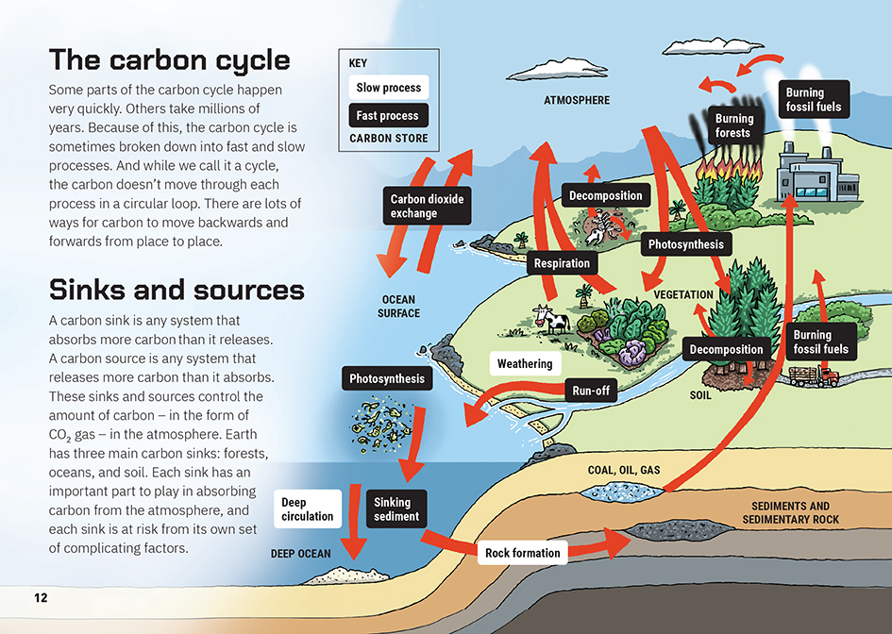
We can use what we know about the way carbon moves through these systems to take actions that reduce the amount of carbon dioxide moving into the atmosphere, where it contributes to global warming and consequent climate change. | 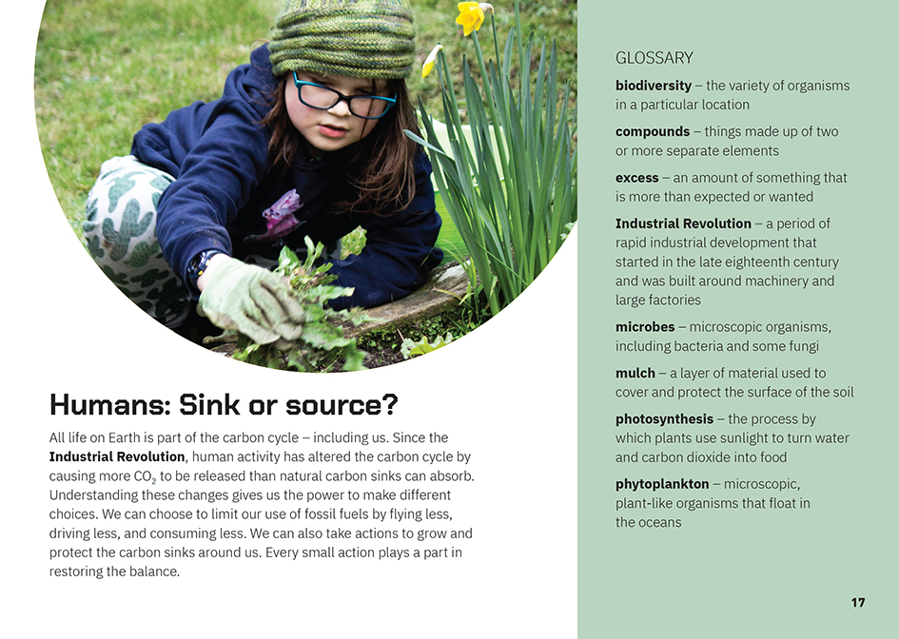

Learning activities – Exploring the science

Activity 1 – My place in the carbon cycle  Support the students to connect what they have read in the article to their place in the world. Move from the big ideas about the carbon cycle and sinks and sources to an exploration of the local ecosystem and their daily activities and actions. Work towards the creation of a diagram that will explain how carbon moves around the local environment and how this is changing.  Revisit the text on page 11 and the concepts about elements and atoms. Select from the following activities to extend and reinforce the learning.  - Use the video from the Cosmic Eye Project to demonstrate just how tiny an atom is and that they make up everything that exists.  - Use the Science Learning Hub carbon cycle interactive diagram to deepen the students’ understandings about carbon and the carbon cycle.  - Use the Carbon Cycle Role Play to reinforce the students’ understandings that there is a finite amount of carbon on Earth, that it moves around the environment, and that humans have an impact on it.  - Use the School Journal article “Feedback” to help the students understand how processes that form part of the carbon cycle can have a negative or positive effect on climate change.  There are many representations of the carbon cycle, including the one on the Science Learning Hub. Have the students locate and critique other examples to create a set of criteria for an effective way of representing it to people in the local community.  Have the students look at maps, photos, film clips, or sketches of your local area over time.  What changes can you see in our local environment?  Do you think that the carbon sink in our area has increased or decreased?  How big do you think the change is?  What can people who have lived in our area for a long time remember?  Discuss how the students can find out more about these historical changes. Then have them use their criteria to support the creation of diagrams that describe the carbon cycle in the local area. Have them create two versions that show what would have been observed before the arrival of Europeans and what the picture is today.  Extension  The students could use their diagrams to provide an evidence base for an environmental initiative. | The following activities and suggestions are designed as a guide for supporting students to explore and extend their content knowledge across the learning areas. Adapt these activities to support your students’ interests and learning needs.  Activity 2 – Sink or source?  Challenge the students to consider their own role in the environment as a sink or source by downloading and using the Ekos Carbon Footprint School Calculator. Explore how the school and community could work together to reduce carbon dioxide emissions and work towards becoming carbon neutral.  Some options include:  - measuring the amount of waste produced in the school; identifying ways to reduce, reuse, and recycle; and monitoring change over time  - researching the role of trees in off-setting climate change; identifying suitable trees for planting in the school and community; and persuading others to contribute to reforestation  - examining the impact of farming on the local environment from a range of perspectives and learning about and raising awareness of the efforts being made by farmers to mitigate its effects  - investigating the impact of the COVID-19 lockdown on carbon emissions and identifying and sharing lessons that can be learned about how we can help restore balance  - exploring the carbon footprint of different foods, surveying students’ current dietary habits, finding foods that are locally available, and identifying what a low carbon (but tasty and nutritious) diet would look like. (This will need to be done with sensitivity.)  Have the students conclude by writing and illustrating explanations of what they have learned and why it is important. They should use the language of cause and effect and the scientific information and language they learned from the article.

RESOURCE LINKS

Connected and School Journal  “Captured in Ice”, Connected 2017, Level 3, Mahi Tahi  “Feedback”, School Journal, Level 4, May 2020  Science Learning Hub  Elements – weird and wonderful: https://www.sciencelearn.org.nz/resources/2760-elements-weird-and-wonderful  Carbon cycle: https://www.sciencelearn.org.nz/resources/1569-carbon-cycle  Carbon cycle quiz (interactive): https://www.sciencelearn.org.nz/resources/2587-carbon-cycle-quiz  The carbon cycle interactive diagram: https://www.sciencelearn.org.nz/image_maps/3-carbon-cycle  The ocean and the carbon cycle: https://www.sciencelearn.org.nz/resources/689-the-ocean-and-the-carbon-cycle  Southern Ocean carbon sink (video): https://www.sciencelearn.org.nz/videos/348-southern-ocean-carbon-sink  Ocean acidification (video): https://www.sciencelearn.org.nz/videos/1504-ocean-acidification  Greenhouse effect: https://www.sciencelearn.org.nz/resources/1004-greenhouse-effect  What is in soil?: https://www.sciencelearn.org.nz/resources/890-what-is-in-soil  Te Ara  Coal in the twentieth century: https://teara.govt.nz/en/coal-and-coal-mining/page-4  Soils: https://teara.govt.nz/en/soils/page-1  Youtube  Crash course: Industrial revolution: https://www.youtube.com/watch?v=zhL5DCizj5c  Crash course: The global carbon cycle: https://www.youtube.com/watch?v=aLuSi_6Ol8M  Carbon: The element of life: https://www.youtube.com/watch?v=ULiLt2rtpAg  NIWA  Ocean acidification (video): https://niwa.co.nz/research-subject/ocean-acidification  Carbon cycle diagram: https://niwa.co.nz/gallery/carbon-cycle-diagram | Ministry for the Environment  Measuring forest carbon: https://www.mfe.govt.nz/climate-change/state-of-our-atmosphere-and-climate/measuring-greenhouse-gas-emissions/measuring  New Zealand’s greenhouse gas inventory: https://www.mfe.govt.nz/climate-change/state-of-our-atmosphere-and-climate/new-zealands-greenhouse-gas-inventory  Other  California Academy of Sciences: Carbon cycle role play: https://www.calacademy.org/educators/lesson-plans/carbon-cycle-role-play  NZ Wood: The carbon cycle – forestry: http://www.nzwood.co.nz/forestry-2/the-carbon-cycle/  NZ Agriculture: How do livestock affect the carbon cycle?: https://www.nzagrc.org.nz/faq-1,listing,464,how-do-livestock-affect-the-carbon-cycle.html  DOC: Forest habitats: https://www.doc.govt.nz/nature/habitats/forests/  Royal Society: How we use elements in our everyday lives (videos): https://www.royalsociety.org.nz/whats-happening/opportunities/periodic-table-turns-150/  Forest and Bird: Ocean acidification: http://blog.forestandbird.org.nz/ocean-acidification-how-climate-change-is-affecting-our-oceans/?gclid=EAIaIQobChMIo4-OlLn96gIVyhErCh3SMwWDEAAYASAAEgK1oPD_BwE  Waikato Regional Council: Ocean acidification: https://www.waikatoregion.govt.nz/assets/PageFiles/41458-coastal-fact-sheets/Ocean-acidification-WRC.pdf  University of Otago: What is ocean acidification?: https://www.otago.ac.nz/oceanacidification/whatisoa/index.html  New Zealand ocean acidification community: http://nzoac.nz/#new-zealand-ocean-acidification-community  New Zealand Geographic: Acid seas: https://www.nzgeo.com/stories/acid-seas/  Ekos: What is the carbon footprint of your school? Register for the carbon footprint school calculator: https://ekos.co.nz/school-calculator  Gen less: Low carbon eating: https://genless.govt.nz/individuals/living-gen-less/low-carbon-eating/  National Library Photographic Archive: https://natlib.govt.nz/collections/a-z/photographic-archive#

