Connected
Level 3
2020

Te Tapa Ingoa
by Priscilla Wehi and Hēmi Whaanga
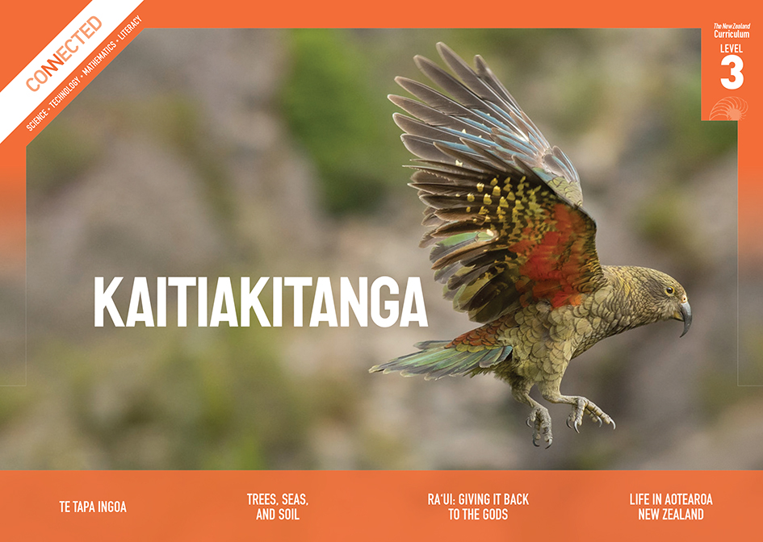
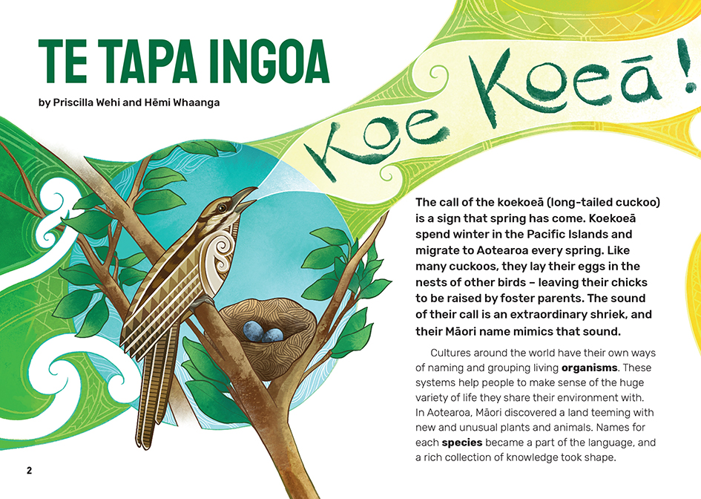

The Literacy Learning Progressions: Meeting the Reading and Writing Demands of the Curriculum describe the literacy-related knowledge, skills, and attitudes that students need to draw on to meet the demands of the curriculum.
The Learning Progression Frameworks (LPF) describe significant signposts in reading and writing as students develop and apply their literacy knowledge and skills with increasing expertise from school entry to the end of year 10.

Overview
This article explores how early Māori went about naming and grouping the plants and animals they found around them. It explains what this process reveals about Māori ways of viewing the world and the framework provided by whakapapa. It prompts comparisons with the Linnaean system for naming and grouping organisms and describes an example of Māori and Pākehā working together and drawing on knowledge from both systems.
A Google Slides version of this article is available at www.connected.tki.org.nz
Curriculum contexts

SCIENCE: Nature of Science: Understanding about science  Level 3 – Students will appreciate that science is a way of explaining the world and that science knowledge changes over time; students will identify ways in which scientists work together and provide evidence to support their ideas. | Key Nature of Science ideas  Scientists:  - work out systems and ways of grouping things together and classifying them to help make sense of the world  - may review their ideas and ways of classifying things as new evidence emerges  - benefit from working with tangata whenua to understand the unique ecosystems of Aotearoa New Zealand.
SCIENCE: Living World: Evolution  Level 3 – Students will begin to group plants, animals, and other living things into science-based classifications; explore how the groups of living things we have in the world have changed over long periods of time and appreciate that some living things in New Zealand are quite different from living things in other areas of the world. | Key science ideas  - Living organisms can be grouped in many different ways – this could be functional, for example, based on what they eat, as in herbivores, or could be based on similarities in structural features, for example, quadrupeds, which all have four feet.  - One way of grouping living organisms and working out how they are related to each other is by examining the sets of features that they have in common.  - Another way of grouping and establishing evolutionary relationships between species is by examining similarities in DNA.  - Scientific names are given to groups of organisms to reduce confusion.

ENGLISH: Reading
Level 3 – Ideas: Students will show a developing understanding of ideas within, across, and beyond texts.
Level 3 – Language features: Students will show a developing understanding of how language features are used for effect within and across texts.

The New Zealand Curriculum

Meeting the literacy challenges

The main challenge arising from this text is for students to interpret and understand the concept of whakapapa as a way of framing the world, while also understanding that there are regional differences. They then need to connect with their prior knowledge to note the similarities between the Māori and Western systems of naming and classifying plants and animals and the value of learning from both traditions.  The article includes several big ideas, but these are clearly explained, and key words are repeated in the topic sentences. The explanations are supported with examples, stories, and visual images. Apart from the title, the topic-specific vocabulary in te reo Māori and English is explained in the text and the glossary.  The warm and inclusive tone is engaging for readers, reinforcing the underlying messages about identity and respect. | The instructional strategies below support students to meet the literacy challenges of this text. For each strategy, there are links to the relevant aspect of The Learning Progression Frameworks (Reading). The signposts on each of these aspects provide detailed illustrations on what to notice as your students develop their literacy knowledge and skills for different purposes in different curriculum areas.  The following strategies will support students to understand, respond to, and think critically about the information and ideas in the text.  You may wish to use shared or guided reading, or a mixture of both approaches, depending on the reading expertise of your students and the background knowledge they bring to the text.  After reading the text, support students to explore the activities outlined in the following pages.

INSTRUCTIONAL STRATEGIES

Building understanding  [LPF Reading: Acquiring and using information and ideas in informational texts]  ASK the students what they think the title means. Some will know; others will need to scan the text to make inferences. DISCUSS what the students find. If necessary, they can then check their inferences in the Māori Dictionary.  TELL the students to read the first page. PROMPT them to make connections with their prior knowledge and with the big ideas in this article. Make sure they notice that both the English and te reo Māori versions of the koekoeā’s name tell us something about the bird.  What did you find out about the koekoeā? Where did you find that information?  What plants and animals might early Māori have found strange?  With what you have read and seen so far, what do you think this article is about?  Give the students an opportunity to try making the bird’s call and to pronounce its name in te reo Māori. PLAY the audio of the bird’s call on the Project Island Song website and the audio of the name being said on the Māori Dictionary so the students can check their predictions and, if necessary, correct their pronunciation.  PROMPT the students to recall the features of an explanation.  What features of an explanation can you find in this text?  Why do you think it was written? Which words in the introduction tell you that?  Have the students read the first section to find further evidence for their predictions. | CLARIFY that this is an explanation of how and why people in different cultures name and group plants and animals, and that it focuses on Māori. The explanation is organised into a series of sections, each focused on a main idea and supported by details.  Identifying main ideas and supporting information  [LPF Reading: Reading to organise ideas and information for learning]  Have the students work in pairs to complete a graphic organiser in which they identify the main ideas in each section, identify two or three supporting details, and write a summary of the writers’ message. Have the pairs share their summary statements, crafting a final statement that gives a consensus about the writers’ main message.  “Te Tapa Ingoa”  Heading Main idea Supporting details  Similar species  Naming the new  Regional differences  Whakapapa: We are all related  The whakapapa of the kūmara  Linnaean taxonomy  What’s in a name?  Summary:

Meeting the literacy challenges

REVIEW the concept of a signal word – a word that lets us know, or signals, what is going to come next in the text.  Remember that writers use signal words to tell us what is coming up. In an explanation, we often find signal words that tell us we are being given additional information – words like “for example” and “such as”. However, writers also use signal words for other reasons, such as for comparison, to make a contrast, to provide examples, to tell us about time and sequence, and to tell us that the writer is going to summarise the explanation. Can you think of some examples of signal words?  It may be useful to review the text with the students to identify different types of signal words and their purpose. Students could then work in pairs, with each pair having one or two photocopied pages from the text to find examples of the following signal words. When finished, they could share their findings with the whole group.  Signal words Examples in “Te Tapa Ingoa”  Examples  Additional information  Comparison  Contrast  Time  Sequence  Summary  Use this activity to support the students to notice how the signal words in this example help shift from an explanation of how plants and animals are named and grouped in te ao Māori to an explanation of the Linnaean system brought by Pākehā.  Why do you think there are two different explanations? What do the writers want us to do?  Are there signal words that provide a clue for this? What other words signal this shift?  Let’s think back to what we said about the writers’ purpose for writing this article. What do we think now? | [LPF Reading: Making sense of text: reading critically]  Have the students share their summary statements and any questions that have arisen as they read the article. PROMPT them to reflect critically on their response to the ideas and messages in the article.  How accurate were your original predictions about the writers’ message? What did the writers want to say to us? How did they convey their message? Why did they think that was important?  X’s group say that the main messages were … Do you agree? What do you think the main messages were?  Have you thought of any questions from reading this article? What does it make you wonder about?  What do you think an “origin story” is? How does that connect to the idea of whakapapa?  The writers state that “names have power”. Do you agree? What examples justify your opinion?  How did the explanation of whakapapa help you to understand more about this important idea?

The Learning Progression Frameworks
The Literacy Learning Progressions
Effective Literacy Practice: Years 5–8

Illustrating the key ideas
One way of grouping living organisms is by examining the sets features they have in common.
Living organisms can be grouped in many different ways.  Scientists benefit from working with tangata whenua to understand the unique ecosystems of Aotearoa New Zealand. | 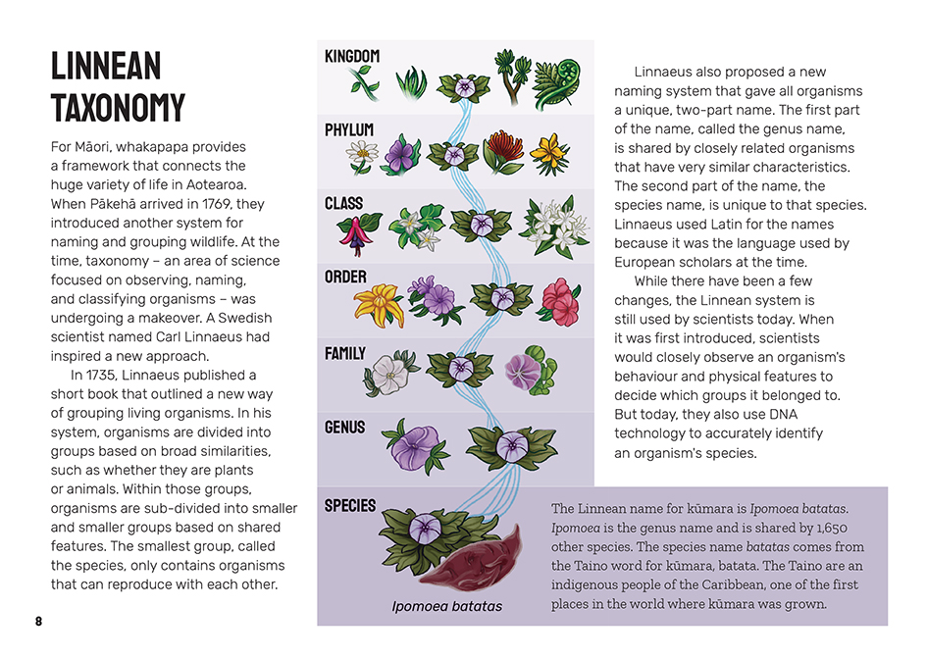  Scientists work out systems and ways of grouping things together and classifying them to help make sense of the world.  Another way of grouping and establishing evolutionary relationships between species is by examining similarities in DNA.

Learning activities – Exploring the science

Activity 1 – The power of a name  Have the students list the names in te reo Māori of all the plants and animals discussed in the article, then work in pairs to find out their names under the Linnaean system and the story of that name (that is, the characteristics that are linked with its genus and species name). They could use a graphic organiser like the one below. Get them started by using the example of the kūmara, then have them work in pairs to research the rest.  Have the students note that the genus and species name are always written in italics, the genus name starting with an upper-case letter. This is an important scientific convention that connects with students’ ability to communicate in science.  Name in te reo Māori Name in English Linnaean name  Genus name Species name Reason for the names  Use this activity to prompt further discussion about the similarities and differences between the Linnaean system and the whakapapa framework from te ao Māori for understanding life in Aotearoa.  What are the similarities and differences between the two ways of naming and classifying plants and animals? Why do you think there are these similarities and differences?  The writers say that Māori typically named birds after their appearance, behaviour, or call. How does that compare with what happens in the Linnaean system?  What does this say to you about the different ways Māori and Pākehā interact with their environment?  Have the students think, pair, and share any other stories they know about how plants and animals got their names, either from te ao Māori, te ao Pākehā, or from other cultures around the world. Some students may be more interested in exploring regional differences in iwi stories. Others may want to share stories from their own cultures or others they know.  What are the messages in the stories?  What do the stories tell us about the relationships humans have with the plants and animals around them?  How do people in non-Māori cultures relate to other living things and how is this reflected in the way they name them?  How do our stories add to our understanding about the power of names?  How might knowing these stories help us to grow our knowledge of the world?  How important is it for children to know and understand these stories? | The following activities and suggestions are designed as a guide for supporting students to explore and extend their content knowledge across the learning areas. Adapt these activities to support your students’ interests and learning needs.  Extension  Have the students research, retell, and illustrate a story of their choice about how a plant or animal was named. Encourage them to draw from the knowledge of whānau and others in their community, as well as from print and online reference materials. The stories could be compiled into a book that the students gift to younger students.  Activity 2 – Learning from mātauranga Māori  While the article is all about mātauranga Māori, the word mātauranga is not used in the article. Have the students read “Listening to the Land”, a Connected article about how scientists are using digital technologies to preserve knowledge from mātauranga Māori to help understand and combat climate change. Have them use both this article and “Te Tapa Ingoa” to develop a concept map for mātauranga Māori. This could be in the form of a Frayer model like the one below.  Definition  Characteristics  WORD  Non-examples  Examples  Focus on the concept of whakapapa and its place in mātauranga Māori. Have the students reread the sections in “Te Tapa Ingoa” on whakapapa and then read the Learnz item on Māori and kōkako and the Te Ara item on Māori genealogy.  What does this article add to what we learned about mātauranga?  What might we add to our concept map?  Explain that there is a debate on the value of using te reo Māori in taxonomy. Have the students read the Newsroom item on this issue and identify the different perspectives people may have. Then encourage them to take and justify their own stance on why it is time to include te reo Māori in the way New Zealand scientists classify and name the species that live here.

Extension  The students could read “Whakaotirangi and Her Kete of Kūmara” (Connected 2020, Level 2, Digging Deeper) to further explore the important role of kūmara in te ao Māori. They will have seen that the species name for kūmara comes from the Caribbean as that is where the kūmara was first grown. This could prompt exploration of the whakapapa of the kūmara beyond Aotearoa, the stories told in other cultures, and what these say about the place of kūmara in these cultures. | Activity 3 – Helping in the war on weeds  Have the students read “The War on Weeds”, a Connected article about students who use digital technology to identify and classify weeds and upload the information to a national database. By doing this, they are helping scientists to combat the spread of weeds. The teacher support materials include a plant classification activity that your students can use to take similar action. The Resource links below suggest others that could also be used.

RESOURCE LINKS

Connected  “Whakaotirangi and Her Kete of Kūmara”, Connected 2020, Level 2, Digging Deeper  “The War on Weeds”, Connected 2018, Level 2, Step By Step  “Listening to the Land”, Connected 2018, Level 3, Cracking the Code  Building Science Concepts  Book 7: The Bush: Classifying Forest Plants  Book 35: Is This a Plant?: Introducing the Plant Kingdom  Book 39: Is This an Animal?: Introducing the Animal Kingdom  Book 55: Mammals: Investigating a Group of Animals  Science Learning Hub  Classification system: https://www.sciencelearn.org.nz/resources/1438-classification-system  Develop a classification system (activity): https://www.sciencelearn.org.nz/resources/158-develop-a-classification-system  Native plant leaves – DIY classification system (activity): https://www.sciencelearn.org.nz/resources/2604-native-plant-leaves-diy-classification-system  Identifying native plants: https://www.sciencelearn.org.nz/resources/2634-identifying-native-plants  Mātauranga Māori and science: https://www.sciencelearn.org.nz/resources/2545-matauranga-maori-and-science  Fred the thread: https://www.sciencelearn.org.nz/resources/1434-fred-the-thread  Science and literacy – using Fred the thread: https://www.sciencelearn.org.nz/resources/2683-science-and-literacy-using-fred-the-thread  Discovering new species: https://www.sciencelearn.org.nz/collections/shared/c093357e294bca58330251b1fd7a6c6c  Te Ara  Classification of humans using Linnaean classification: https://teara.govt.nz/en/table/12130/classification-of-humans | The first naturalists: European discovery of plants and animals: https://teara.govt.nz/en/european-discovery-of-plants-and-animals/page-1  Māori genealogy: European discovery of plants and animals: https://teara.govt.nz/en/whakapapa/10934/maori-genealogy  LEARNZ  Identifying living things: http://learnz.org.nz/bioblitz191/bg-easy-f/identifying-living-things  Māori and Kōkako: http://www.learnz.org.nz/kokako182/m%C4%81ori-and-k%C5%8Dkako  Other  Department of Conservation: Native plants: https://www.doc.govt.nz/nature/native-plants/  Bushman’s friend: Naming native plants – how native plants have been given their names: https://www.bushmansfriend.co.nz/nznative-plants/naming-native-plants  Manaaki Whenua Landcare Research: Identification tools: https://www.landcareresearch.co.nz/tools-and-resources/identification/  Newsroom: Te reo in taxonomy: https://www.newsroom.co.nz/te-reo-in-taxonomy  University of Otago: Pre-Linnaean classification: https://www.otago.ac.nz/library/exhibitions/linnaeus/cabinet3/index.html  ScienceDirect: Journal of Marine and Island Cultures: The use of the Māori language in species nomenclature: https://www.sciencedirect.com/science/article/pii/S2212682113000383  New Zealand Geographic: Carl Linnaeus: https://www.nzgeo.com/stories/carl-linnaeus/  New Zealand Birds Online: The digital encyclopaedia of New Zealand birds: http://www.nzbirdsonline.org.nz/  Project Island Song: Koekoeā: picture and sound: https://www.projectislandsong.co.nz/index.php/education/endemic/108-long-tailed-cuckoo-picture-sound.html  Māori dictionary: https://maoridictionary.co.nz/  Māori dictionary: Koekoeā: https://maoridictionary.co.nz/word/2767

