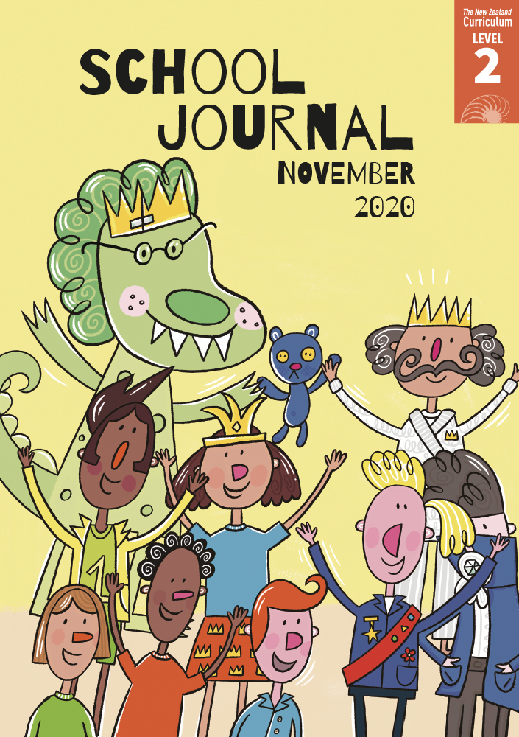

School Journal

Level 2, November 2020

**Year 4**

# Don’t Forget to Vote

by Simon Cooke

The[Learning Progression Frameworks](https://curriculumprogresstools.education.govt.nz/lpf-tool/) describe significant signposts in reading and writing   
as students develop and apply their literacy knowledge and skills with increasing expertise from school entry to the end of year 10.

## Overview

This is a humorous play featuring the characters from “Let’s Vote on It” (SJ L2 May 2020). It’s based around the importance of voting so that you can have your say. The citizens want to replace the king – a vote is held, but the king forgets to vote and loses the election as a result. Plays provide opportunities for students to develop their oral language and performance skills. They will also be able to use the characters’ actions and dialogue to make inferences and interpret the play’s main message.

A PDF of the text is available at [www.schooljournal.tki.org.nz](http://www.schooljournal.tki.org.nz)

## Themes

|  |  |  |  |
| --- | --- | --- | --- |
| * Democracy | * Humour |  |  |

## Related texts

**“****Let’s Vote on It!”** SJ L2 May 2020 | **“The Best Team Ever”** SJ L3 Aug 2017 | **“The Race”** SJ L3 May 2017 |   
**“A Work of Art”** SJ L2 Oct 2015 | **“I Want to Be Zippy”** SJ L2 Sept 2014

## Strengthening reading behaviours (what to notice)

|  |  |
| --- | --- |
| Text structure and features | Requiring students to: |
| * Humour ***PRINCESS BIFFELDA.*** *This is your fault, Daddy. You make people vote on too many things.* ***SIR SPEEDY.*** *Like whether to have scrambled or poached eggs for breakfast.* | * use what they know about plays, humour, and playful language to understand that the ridiculous comments the characters make are intended to be funny and to entertain. |

|  |  |
| --- | --- |
| Vocabulary | |
| Unusual character names | Sir Hides-a-lot, Sir Speedy, Princess Biffelda, Royal Advisor, King Snooze, Mr Teddykins |
| Words connected with politics/voting  Other possibly challenging words | citizens, election, vote, raise taxes, elect, draw, electoral roll, polls have closed, declare   royal, throne, short-sighted, statues, sire, kingly work, traitor, sewers, goblin, invade, knights, town square, announcement, hurrah, crown, co-king, banquet |

|  |
| --- |
| Helpful prior knowledge (pre-reading and introducing the text) |
| * Plays have certain structures and features. * Fairy tales have conventions, and authors can play with these conventions for humorous effect. * Decisions can be made by voting. In a democracy, the person who gets the most votes usually wins. * This play is a sequel to “Let’s Vote on It!” (SJ L2 May 2020) and has the same characters and setting. |

## Possible reading and writing purposes

* Read and enjoy a story about what happens to King Snooze on voting day
* Identify how the author created humour in his play
* Find information about how voting works
* Identify and evaluate the features of the play.

See *Effective Literacy Practice in Years 1–4* for suggestions on using this text with your students ([Approaches to teaching reading](http://literacyonline.tki.org.nz/Literacy-Online/Planning-for-my-students-needs/Effective-Literacy-Practice-Years-1-4/Approaches-to-teaching-reading)) and for information about teaching comprehension strategies ([Building comprehension](http://literacyonline.tki.org.nz/Literacy-Online/Planning-for-my-students-needs/Effective-Literacy-Practice-Years-1-4/Building-comprehension) and [Text processing strategies](http://literacyonline.tki.org.nz/Literacy-Online/Planning-for-my-students-needs/Effective-Literacy-Practice-Years-1-4/Text-processing-strategies)).

## Possible curriculum contexts

This text has links to level 2 of *The New Zealand Curriculum* in: [**ENGLISH**](http://nzcurriculum.tki.org.nz/The-New-Zealand-Curriculum/English) [**SOCIAL SCIENCES**](https://nzcurriculum.tki.org.nz/The-New-Zealand-Curriculum/Social-sciences)[**THE ARTS: DRAMA**](https://nzcurriculum.tki.org.nz/The-New-Zealand-Curriculum/The-arts)

## Understanding progress

The following aspects of progress are taken from the [Learning Progression Framework](https://curriculumprogresstools.education.govt.nz/lpf-tool/)s and relate to the specific learning tasks below. See the LPFs for more about how students develop expertise and make progress in these aspects:

* Reading for literary experience
* Making sense of text: using a processing system; using knowedge of text structure and features; vocabulary knowledge
* Using writing to think and organise for learning
* Creating texts for literary purposes.

## Strengthening understanding through reading and writing

**Select from the following suggestions and adapt them** according to your students’ strengths, needs, and experiences.   
Note: Most of these activities lend themselves to students working in pairs or small groups.

* Ask the students to share with a partner one thing from this play they found funny, one thing they thought fair, one thing that was not fair, and their favourite character. Alternatively, go quickly around the group and have them state their opinion. Before doing this, write discussion prompts to support the students to prepare what they will say. Allow thinking time before they share out loud.
* Use the **Voting terms** template at the end of this TSM to explore the vocabulary connected with voting. They could work in pairs to find information about all the words or explore one word and then come together as a group and collate the information from all the pairs. Discuss how all the terms work together to help explain how voting works.  The students could reuse topic vocabulary by creating an interactive online poster about voting and the election process using a digital tool such as [Glogster](https://edu.glogster.com/).
* Have the studentssummarise what happens in this play. You could give them a template to map the main events from one character’s view (see the template in [“Kupe and Te Wheke” TSM](https://instructionalseries.tki.org.nz/Instructional-Series/School-Journal/School-Journal-Level-2-May-2020/Kupe-and-the-Giant-Wheke), SJ L2 May 2020).
* Have the students make connections to what they know about voting: *How does it work? Have you used voting in class? How is voting used in the wider school community? Is voting fair? What could make it not fair? How does voting work in New Zealand? What other systems of voting are there?* Invite parents or students from other countries to share about the voting process in their home country. *What things are similar and what things are different from the way we vote in New Zealand?*
* Ask the students to think critically about the characters’ names and how they relate to their personalities. Working in groups, the students could choose one character and note down examples from the text under the following headings: Facts about the character, What the character says, What the character does, What the character thinks or feels. Then have the students summarise what they infer about the character from the evidence, and have the groups share their findings.
* To further explore the humour, have the students use a table like the one below to note down things they think make the play funny.

|  |  |  |
| --- | --- | --- |
| **Funny words and phrases** | **Funny actions** | **Why I think this is funny** |
|  | Holding teddykins |  |

* Use the play to generate writing ideas, for example:
  + Write a diary from the point of view of the King, a citizen, or the monster. *How are you feeling? What did you do and why?*
  + Write about being king for a day (or the principal or teacher for a day). *What would you do? What things would you change?*
  + Write a different ending or a sequel to the play. The students could choose their preferred text type (story, poem, play, or report).

|  |
| --- |
| “Don’t Forget to Vote” Voting terms |

Write one of the following words in the centre of each diagram and fill in the information around them:   
**vote, citizen, election, taxes, electoral roll, poll**

|  |  |  |  |
| --- | --- | --- | --- |
| **Definition  (in your own words)**  When you choose the one you want to win from a list of things or people | | **Facts about the word**  Sometimes people have a secret vote.  Everyone has the right to vote. | |
|  | **Word:** vote | |  |
| **Examples** | **Antonyms (opposites)** |
| We voted for the best artwork in our class display.  Adults vote for a new government every three years. | | No choice  When you are told what you have to do | |

|  |  |  |  |
| --- | --- | --- | --- |
| **Definition  (in your own words)** | | **Facts about the word** | |
|  | **Word:** | |  |
| **Examples** | **Antonyms (opposites)** |
|  | |  | |

|  |  |  |  |
| --- | --- | --- | --- |
| **Definition  (in your own words)** | | **Facts about the word** | |
|  | **Word:** | |  |
| **Examples** | **Antonyms (opposites)** |
|  | |  | |

|  |  |  |  |
| --- | --- | --- | --- |
| **Definition  (in your own words)** | | **Facts about the word** | |
|  | **Word:** | |  |
| **Examples** | **Antonyms (opposites)** |
|  | |  | |

|  |  |  |  |
| --- | --- | --- | --- |
| **Definition  (in your own words)** | | **Facts about the word** | |
|  | **Word:** | |  |
| **Examples** | **Antonyms (opposites)** |
|  | |  | |

|  |  |  |  |
| --- | --- | --- | --- |
| **Definition  (in your own words)** | | **Facts about the word** | |
|  | **Word:** | |  |
| **Examples** | **Antonyms (opposites)** |
|  | |  | |

