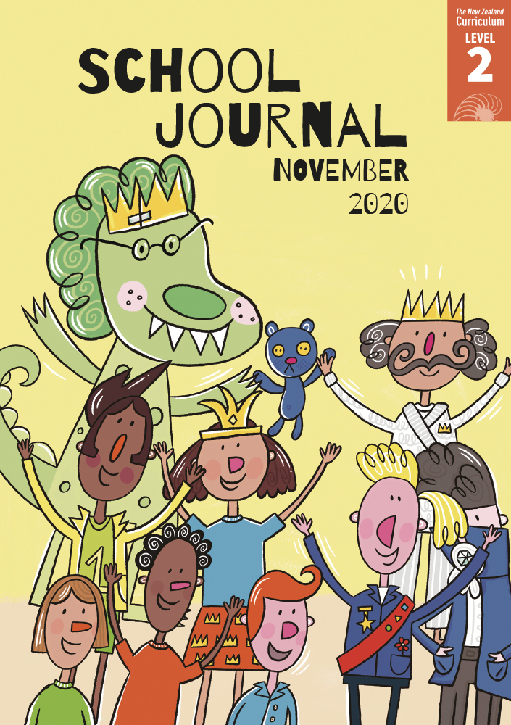

# He Toi Whakairo

by Kelly Joseph

School Journal

Level 2, November 2020

**Year 4**

The[Learning Progression Frameworks](https://curriculumprogresstools.education.govt.nz/lpf-tool/) describe significant signposts in reading and writing   
as students develop and apply their literacy knowledge and skills with increasing expertise from school entry to the end of year 10.

## Overview

This poem is about the art of whakairo, linking to the article about the Kaipara School carved waka in this Journal. It shows that a theme can be explored in various ways using different text forms. It also provides a model for poetic writing on a topic. Students will be able to think critically about the art of whakairo by making inferences and finding specific information. They will also be able to identify and evaluate the language features and structures the author has chosen for her particular purpose. It includes a glossary of te reo Māori terms used in the poem and a pictorial glossary showing four whakairo patterns.

A PDF of the text and an audio version as an MP3 file are available at [www.schooljournal.tki.org.nz](http://www.schooljournal.tki.org.nz)

## Themes

|  |  |  |  |
| --- | --- | --- | --- |
| * Whakairo/carving | * Culture and tradition | * Nature |  |

## Related texts

**“Carving”** SJ L2 Aug 2013 | **“Painted Hoe”** SJ L2 June 2018 | **“A Hoe!”** SJ L2 June 2018 | **“Sixth Sense”** SJ L2 Aug 2018 |   
**“The Kōrero of the Waka”** SJ L2 Nov 2020 | **“Kākahu Pekepeke”** JJ 61

## Strengthening reading behaviours (what to notice)

|  |  |
| --- | --- |
| Text structure and features | Requiring students to: |
| * Connections across the text The four stanzas describe the process of carving and the underlying significance of it: 1. What is happening; 2. The patterns that  are appearing; 3. What the patterns mean;  4. What the carving is for | * look for clues in the first sentence of each of the first three stanzas to understand the part of the process being described in that stanza and then use their knowledge of paragraph/stanza structure to see that the first three lines of the last stanza build up to the last line, which explains the purpose of the carving |
| * Repetition of words and phrases, alliteration, and onomatopoeia *pātōtō – pātōtō – pātōtō – pātōtō* | * connect the repeated words to the idea of work carrying on, time passing, and the repeated sound of the carving tool. |

|  |  |
| --- | --- |
| Vocabulary | |
| Topic-related words  Te reo Māori | mallet, strikes, chisel, grain, ridges, notches, wood chips, triangles, diamonds, zigzags, spirals  He Toi Whakairo, pātōtō, Rauru, ata, ātārangi, tohunga, tiki, manaia, waka, pūngāwerewere, unaunahi, pātiki, koru |
| Other possibly challenging words  and phrases | inspire, scales, flounder, unfurling fern fronds, decorate, prow, stylised, master carver |

|  |
| --- |
| Helpful prior knowledge (pre-reading and introducing the text) |
| * Whakairo is a fundamental part of Māori culture, telling stories about identity and whakapapa. * Some whakairo patterns are related to particular iwi. * Knowledge of the art is handed down through the generations. * In whakairo, patterns and figures are created by carving away material from the original piece of wood. * Whakairo has many traditional patterns with symbolic meaning, many of which take their design from nature. |

## Possible reading and writing purposes

* Read and enjoy a poem about carving a special item
* Explore the cultural significance of the art of whakairo
* Find specific information about the art of whakairo
* Identify the structure and specific language features used by the poet.

See *Effective Literacy Practice in Years 1–4* for suggestions on using this text with your students ([Approaches to teaching reading](http://literacyonline.tki.org.nz/Literacy-Online/Planning-for-my-students-needs/Effective-Literacy-Practice-Years-1-4/Approaches-to-teaching-reading))   
and for information about teaching comprehension strategies ([Building comprehension](http://literacyonline.tki.org.nz/Literacy-Online/Planning-for-my-students-needs/Effective-Literacy-Practice-Years-1-4/Building-comprehension) and [Text processing strategies](http://literacyonline.tki.org.nz/Literacy-Online/Planning-for-my-students-needs/Effective-Literacy-Practice-Years-1-4/Text-processing-strategies)).

## Possible curriculum contexts

This text has links to level 2 of *The New Zealand Curriculum* in: [**ENGLISH**](http://nzcurriculum.tki.org.nz/The-New-Zealand-Curriculum/English) [**THE ARTS: VISUAL ARTS**](https://nzcurriculum.tki.org.nz/The-New-Zealand-Curriculum/The-arts)

## Understanding progress

The following aspects of progress are taken from the [Learning Progression Framework](https://curriculumprogresstools.education.govt.nz/lpf-tool/)s and relate to the specific learning tasks below. See the LPFs for more about how students develop expertise and make progress in these aspects:

* Reading for literary experience
* Making sense of text: using a processing system; using knowledge of text structure and features; vocabulary knowledge
* Creating texts for literary purposes.

## Strengthening understanding through reading and writing

**Select from the following suggestions and adapt them** according to your students’ strengths, needs, and experiences.   
Note: Most of these activities lend themselves to students working in pairs or small groups.

* After the students have read the poem to themselves, play the [audio](https://instructionalseries.tki.org.nz/Instructional-Series/School-Journal) or read the poem aloud (if you are confident of your te reo Māori pronunciation) so that they hear a fluent, expressive reading. Ask them to close their eyes and visualise what is being described – what they can see, hear, smell, touch, or taste.
* The students could also chorus read it together to enjoy the language and rhythm and become more familiar with the poem. They could suggest ideas for voice sounds or actions to accompany the reading, for example, for the repeated “pātōtō” line.
* Draw attention to the first lines in each stanza. *How do these lines help us understand carving?*   
  (Verse 1 describes what is happening, verse 2 describes the patterns that are appearing, verse 3 explains what the patterns mean, and verse4 tells us what the carving is for.)
* Read all the first lines. Use the subsequent lines to unpack each stanza, drawing on any prior knowledge about carving (and referring to the Related texts, if necessary). *How does this stanza help us understand the process of whakairo? How does it help to explain the importance of whakairo? Is the glossary necessary to understand the poem? How do the four whakairo patterns help?*
* Use the first **Process poem** template at the end of this TSM to analyse “He Toi Whakairo” as a group. Prompt the students to notice the alliteration (“**f**ish”, “**f**lounder / un**f**urling **f**ern **f**ronds”), if necessary explaining that two words together can be coincidence but more indicates a deliberate choice of language by the writer. Draw attention to the poet’s use of noun phrases (“sharp metal chisel”), opposites (“ata and ātārangi”, “outwards and inwards”) and how the glossary and inset illustrations provide support.
* To help the students become familiar with any new vocabulary, ask them to select some examples from the poem (or give them some from the vocabulary list on page 1 of this TSM) and have them write each word in a bubble. In four boxes around the word, have them write a definition of the word in their own words, use the word in a sentence, list other words that have a similar meaning, and draw the word. They could do this individually or together as a group. English language learners could also add a translation in their first language.
* The students could then use the second **Process poem** template to plan their own poem about the process of making or doing something (for example, making muffins, building a fort, making a model plane, writing a story, playing an instrument, riding a bike). *What do you use? What do you see, smell, and hear? Where does the idea come from? What will you use the thing for and why?*   
  Encourage them to use the four-stanza model with a recurring word or phrase and to include any text features that you drew out, for example, alliteration, words from other languages, noun phrases, adjectives, and so on.

|  |
| --- |
| “He Toi Whakairo” Process poem |

|  |  |  |
| --- | --- | --- |
| The process: “He Toi Whakairo” | Lead sentence | Words or phrases to help explain (alliteration, other languages, adjectives, expressive verbs, noun phrases) |
| 1. What is happening (and what is being used) |  |  |
| 2. What we see (the patterns that are appearing) |  |  |
| 3. Where the ideas come from (what the patterns mean) |  |  |
| 4. What the carving is used for (purpose) |  |  |
| 5. Repeated words or phrases |  |  |

|  |  |  |
| --- | --- | --- |
| The process: _________________ | Lead sentence | Words or phrases to help explain (alliteration, other languages, adjectives, expressive verbs, noun phrases) |
| 1. What is happening (and what is being used) |  |  |
| 2. What we see |  |  |
| 3. Where the ideas come from |  |  |
| 4. What the product is used for (purpose) |  |  |
| 5. Repeated words or phrases |  |  |

