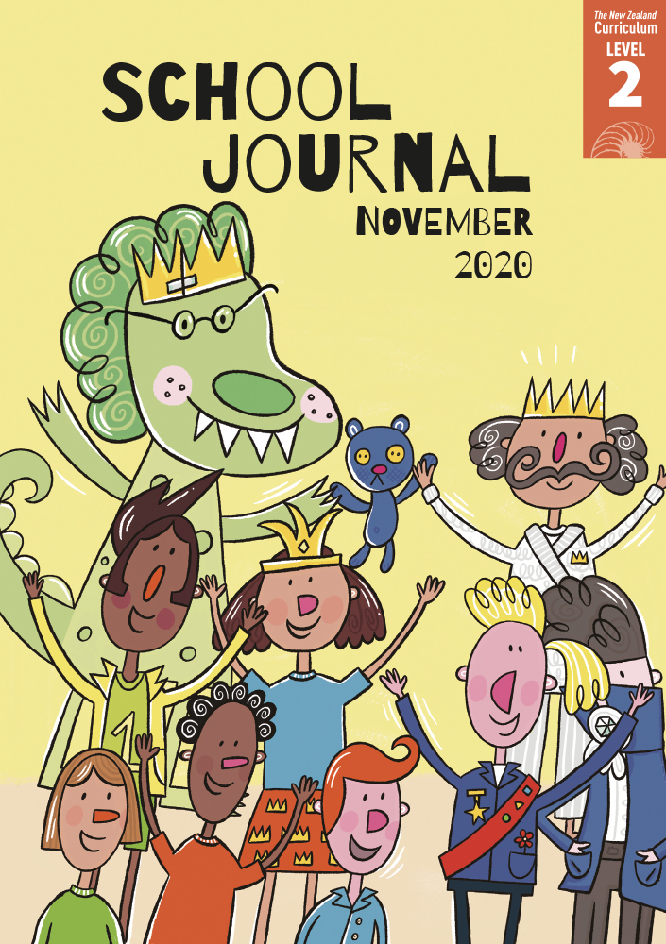

School Journal

Level 2, November 2020

**Year 4**

# Orca – The World’s Largest Dolphin

by Ingrid N. Visser

The[Learning Progression Frameworks](https://curriculumprogresstools.education.govt.nz/lpf-tool/) describe significant signposts in reading and writing as students develop and apply their literacy knowledge and skills with increasing expertise from school entry to the end of year 10.

## Overview

This article shares information about orca and the research conducted by the author (Ingrid Visser runs the Orca Research Trust).   
It looks at how and why she carries out research and what is known about orca. It also covers some of the threats to their habitat and what we need to do to protect them. The article includes a text box about the various names given to orca and another with advice on how to act around orca should you encounter them.

A PDF of the text is available at [www.schooljournal.tki.org.nz](http://www.schooljournal.tki.org.nz)

## Themes

|  |  |  |  |
| --- | --- | --- | --- |
| * Environment | * Endangered creatures | * Sustainability |  |

## Related texts

**“Seals”** SJ L2 Oct 2016 | **“Sharks”** SJ L3 June 2018 | **“Fantastic Penguins”** SJ L3 Nov 2019 | **“Hoiho”** JJ 43 |   
**“Bird of the Year”** JJ 59 | **“And the Winner Is …”** JJ 59

## Strengthening reading behaviours (what to notice)

|  |  |
| --- | --- |
| Text structure and features | Requiring students to: |
| * Abstract ideas *Each group [of orca] has its own* ***culture****. This includes the way its members hunt, what they feed on, where they travel, their* ***dialect****, and the way they live together.* | * use word knowledge and/or the glossary with their prior knowledge and the context to understand the meaning of unfamiliar words and concepts |
| * Technical information *Some people call them killer whales – but not because they think orca are whales. It’s because orca are the “killer of whales”.* | * find the main idea in each sentence and use the linking words to build the information as they read each new idea (for example, use “Some people”, “but not because”, “It’s because” to understand why orcas are called killer whales). |

|  |  |
| --- | --- |
| Vocabulary | |
| Topic-related terms | orca, bottlenose, dolphin, oceans, *Orcinus orca,* researching, **catalogue,** record, monitor, **habitat, prey,** Antarctic, penguins, species, ray |
| Te reo Māori  Other possibly challenging words | maki, kākahi  **culture**, **dialect**, coastline, harbours, survive, responsibly, stun, shore, stranded |

|  |
| --- |
| Helpful prior knowledge (pre-reading and introducing the text) |
| * Dolphins, orca, and whales are sea creatures that have similarities but also differences. * Orca are often seen in New Zealand waters and are sometimes stranded. * Orca communicate with each other. * Some jobs involve monitoring and researching sea animals to understand more about them. * Some orca are endangered. * Some iwi in Aotearoa consider orca to be kaitiaki (guardians or protectors). |

## Possible reading and writing purposes

* Discover some interesting information about orca
* Explain how people can make sure orca are kept safe
* Understand what people do when working with marine animals.

See *Effective Literacy Practice in Years 1–4* for suggestions on using this text with your students ([Approaches to teaching reading](http://literacyonline.tki.org.nz/Literacy-Online/Planning-for-my-students-needs/Effective-Literacy-Practice-Years-1-4/Approaches-to-teaching-reading)) and for information about teaching comprehension strategies ([Building comprehension](http://literacyonline.tki.org.nz/Literacy-Online/Planning-for-my-students-needs/Effective-Literacy-Practice-Years-1-4/Building-comprehension) and [Text processing strategies](http://literacyonline.tki.org.nz/Literacy-Online/Planning-for-my-students-needs/Effective-Literacy-Practice-Years-1-4/Text-processing-strategies)).

## Possible curriculum contexts

This text has links to level 2 of *The New Zealand Curriculum* in: [**ENGLISH**](http://nzcurriculum.tki.org.nz/The-New-Zealand-Curriculum/English) [**SCIENCE**](https://nzcurriculum.tki.org.nz/The-New-Zealand-Curriculum/Science)

## Understanding progress

The following aspects of progress are taken from the [Learning Progression Framework](https://curriculumprogresstools.education.govt.nz/lpf-tool/)s and relate to the specific learning tasks below. See the LPFs for more about how students develop expertise and make progress in these aspects:

* Acquiring and using information and ideas in informational texts
* Making sense of text: using a processing system; using knowedge of text structure and features; vocabulary knowledge
* Creating texts to communicate current knowledge and understanding.

## Strengthening understanding through reading and writing

**Select from the following suggestions and adapt** them according to your students’ strengths, needs, and experiences.   
Note: Most of these activities lend themselves to students working in pairs or small groups.

* Before reading the text, have the students start a KWL chart (What I **k**now and What I **w**ant to find out) and then complete it when they finish reading (What I **l**earnt). Alternatively, when they finish reading the text, ask the students open-ended questions to encourage an initial response. *What did you already know about orca? What did you learn about them? What was something interesting? What surprised you?*
* To support the students to summarise the main ideas, draw attention to the bolded glossary words on each page. Working in pairs or small groups, have them discuss these words in context and then summarise in their own words what they tell us about orca. You could model one of the examples, such as “culture” or “dialect”. Encourage the students to share their findings. They could discuss what is meant by “culture” and “dialect” and where else we find these words.
* Have the students complete the **Fact collection** templateon page 3 of this TSM. Tell them to find and record a minimum of four facts from the article that are new to them or that they find interesting. If they want to record more, they can add more sections. Then ask them to share their work. If the students include information that was not new to them, ask them to justify why they chose those particular facts.
* Focus on the topic-related words, such as “researching”, “dolphin”, and “habitat”. For each word, have the students identify and group related words in the text. Then have them share their findings and discuss any words that appear in more than one grouping.  The students could do this activity using a [Word Cloud](https://www.wordclouds.com/).
* Explore how the new idea in each paragraph is stated and then explained in subsequent sentences. Have the students identify   
  the topic sentence in each paragraph and then highlight the supporting details and information. (For example, topic sentence:   
  “They live in extended family groups, and each group has its own **culture**.” Supporting details and information: “This includes the way its members hunt, what they feed on, where they travel, their **dialect**, and the way they live together.”)
* To support English language learners, you could take out the topic sentences from each paragraph and have the students match the sentences to the correct paragraphs.
* English language learners could look at noun phrases in the text, exploring how these are built by adding adjectives to the head noun, for example, “extended family groups”. They could practise building their own noun phrases and using them in their writing.
* The students could create a poster or flyer targeting boaties or beach users explaining how to respond if they see an orca, highlighting critical informatiion from page 5 and the text box on page 7.  They could use [Google Slides](https://www.google.com/slides/about/) for this activity.
* The students could research an animal of their own choice and present their findings using the text as a model.
* Using what they have learnt from the text, the students could write a diary of a week in the life of Ingrid Visser, or write a job description for someone to do a similar job.

|  |
| --- |
| “Orca” Fact collection |

In your own words, write one fact about orca in each section of the circle. You can divide the circle into more sections if you want   
to add more facts.

