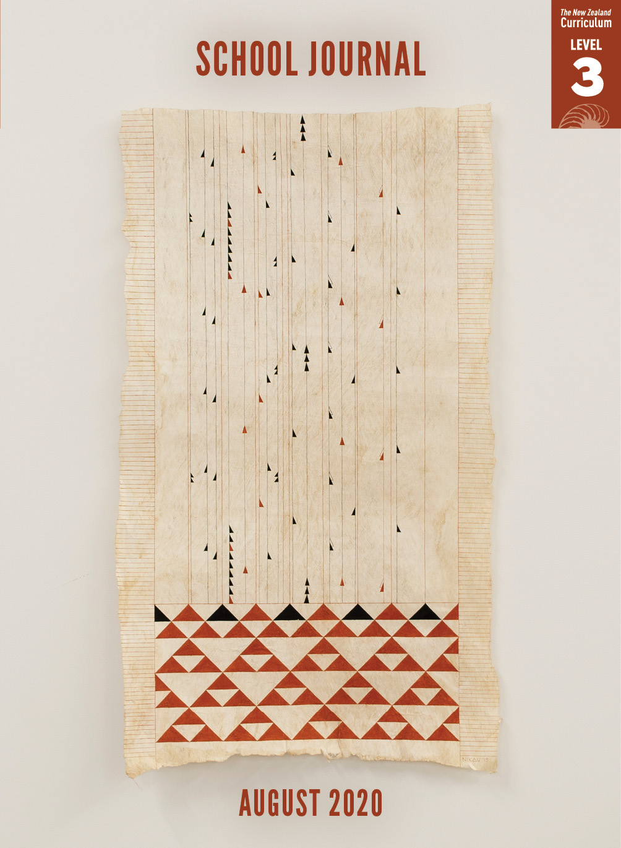

School Journal

Level 3, August 2020

**Year 5**

# Star-gazing

by Maria Samuela

The[Learning Progression Framework](https://curriculumprogresstools.education.govt.nz/lpf-tool/)s describe significant signposts in reading and writing as students develop and apply their literacy knowledge and skills with increasing expertise from school entry to the end of year 10.

## Overview

“Star-gazing” is a fantasy while also being based, in part, on a traditional story from Mangaia, the second largest island in the Cook Islands. The “no place like home” lesson is spiced up with sassy dialogue and combative personalities, deepening its contemporary feel and appeal.

A PDF of the text is available at [www.schooljournal.tki.org.nz](http://www.schooljournal.tki.org.nz).

## Themes

|  |  |  |  |
| --- | --- | --- | --- |
| * Family | * Fantasy | * Traditions |  |

## Related texts

**“Origin Story (with fairy)”** SJ L4 May 2017 | **“Atutahi’s Unicorn”** SJ L3 Nov 2016 |   
**“The World Will End Said the Cat”** SJ L4 Nov 2016 | **“Cancel the Invasion”** SJ L3 Nov 2016

## Strengthening reading behaviours (what to notice)

|  |  |
| --- | --- |
| Text structure and features | Requiring students to: |
| * Factual information about the planets in our solar system included in a fictional story  *That place turned out to be Mercury. It was smaller, and its surface was pitted with craters.* | * use prior knowledge of the solar system and basic information about the planets to track Stella’s journey and infer why no planet could become her new home |
| * Dialogue, which readers have to navigate *“This planet is hotter than the sun,” Stella exclaimed. “Not true,” said Mere. Stella didn’t like her tone. “Whatever,” she said, using a tone of her own. “But I can’t stay here.”* * Some use of colloquial language  *Kai time at Stella’s house drove her nuts; Yo; Yup, it’s me; Go figure; Literally no one is stopping you;* | * pay close attention to the sequence of events and information provided about the journey to keep up with the pace of the story * use prior knowledge of what is meant by “tone” to understand the manner in which Mere and Stella are talking to each other * use their knowledge of colloquial language to understand the meaning behind the characters’ words. |

|  |  |
| --- | --- |
| Vocabulary | |
| A small amount of Cook Islands Māori | kai (food), pēpe (baby), Mere, Auē (Oh dear; heck), ‘Āe (yes) |
| Technical terms  Other unfamiliar words | Matariki, cluster, asteroids, fragments, shard  ancestors, tranquil-looking, twinkling, dazzlingly, unbearably, exclaimed, literally, incredulous, cackled, vortex |

|  |
| --- |
| Helpful prior knowledge (pre-reading and introducing the text) |
| * Knowledge of the planets in our solar system * Knowledge of Matariki * Experience of family life * Exposure to fantasy stories |

## Possible reading and writing purposes

* Find out what happens when Stella tries to escape her family
* Describe how Stella’s love of the stars turns into a nightmare
* Identify and discuss the author’s purpose
* Describe and evaluate the language features and structure the writer uses

See *Effective Literacy Practice in Years 5–8* for information about teaching comprehension strategies ([Teaching comprehension](http://literacyonline.tki.org.nz/Literacy-Online/Planning-for-my-students-needs/Effective-Literacy-Practice-Years-5-8/Teaching-comprehension)) and for suggestions on using this text with your students ([Approaches to teaching reading](http://literacyonline.tki.org.nz/Literacy-Online/Planning-for-my-students-needs/Effective-Literacy-Practice-Years-5-8/Approaches-to-teaching-reading)).

## Possible curriculum contexts

This text has links to level 3 of *The New Zealand Curriculum* in: [**ENGLISH**](http://nzcurriculum.tki.org.nz/The-New-Zealand-Curriculum/English) [**SOCIAL SCIENCES**](http://nzcurriculum.tki.org.nz/The-New-Zealand-Curriculum/Social-sciences)

## Understanding progress

The following aspects of progress are taken from the [Learning Progression Framework](https://curriculumprogresstools.education.govt.nz/lpf-tool/)s and relate to the specific learning tasks below. See the LPFs for more about how students develop expertise and make progress in these aspects:

* Reading for literary experience
* Making sense of text: reading critically
* Making sense of text: knowledge of text structure and features
* Using writing to think and organise for learning.

## Strengthening understanding through reading and writing

The *School Journal* provides rich texts that can be returned to many times. The following suggestions are based on the premise that rereading the text is a fundamental part of developing students’ understanding and reading skills. **Select from and adapt** them according to your students’ strengths, needs, and experiences.   
Note: Most of these activities lend themselves to students working in pairs or small groups.

* Re-enact the story’s opening scene through role play. Encourage the students to make up their own lines based on what they would say at a big dinner with family/whānau or friends. You might want to brainstorm typical things that happen at a busy dinner table first so the students can think about what they might say. Freeze the students in the middle of the scene and ask them to share their feelings about it – are they enjoying it or do they, like Stella, want to get away?
* Check English language learners understand the colloquial language and can follow the dialogue. As necessary, provide explicit explanations and give them opportunities to practise the new language in other situations. For example, the students could play a matching game with the new words or phrases on one set of cards and the meanings on another set.
* Discuss the story’s use of “said” as a dialogue tag. You could make a vocabulary ladder to brainstorm other words that could be used to emphasise the speaker’s positive or negative intent, using examples from the text. (For an example of a vocabulary ladder, see the TSM for “The Story of Taranaki”, SJ L2 August 2020.) Compare the benefits of using “said” (for example, to avoid overwriting and to focus the reader’s attention on the actual dialogue) with the benefits of using more descriptive tags (for example, to indicate a specific tone).
* Have the students make character maps of the main characters, looking for evidence in the text (particularly in the dialogue) that reveals the characters’ personalities and motives.  You could create a template in [Google Slides](https://www.google.com/slides/about/) for the students to use.
* Ask the students to track the plot by identifying the important events. Then have them summarise the story in twenty-five words or less. Alternatively, they could draw important moments in the story and then use the drawings to summarise the plot.
* Have the students reread page 37 where Nan recounts the traditional Cook Islands story about Mere and Matariki. Then, working in pairs, ask the students to draw up two columns and in the left-hand column note places in “Star-gazing” where the text links to the traditional story. In the right-hand column, have them explain how the text links, for example, on page 39, Mere says Venus will be Stella’s “new home”. On page 37, Nan says that the ancestors were following the stars to find a “new home”. When they’ve finished, the students could compare their ideas with those of other students.
* Ask the students to record the things that Stella learns in the story using the **Character development** template at the end of this TSM. They could then identify which lesson they think is the most important.  You could create the template in Google Docs for the students to use.
* Review the features of written dialogue. Have the students use these conventions to write dialogue for their own family/whānau dinner scene. Alternatively, you could have the students change the dialogue from the first page of the text into prose.
* In groups, have the students make a chart listing the planets in the story and how they are described. In another column, write facts that the group know or find out about the planets and compare the two.

|  |
| --- |
| “Star-gazing” Character development |

Focus character: Stella

|  |  |  |
| --- | --- | --- |
| Events | Stella’s reactions (Her feelings, thoughts, and actions) | What Stella learns – evidence from the text |
| Kai time at Stella’s | Her family drove her nuts. She couldn’t take it anymore. She went outside. | She loves her family. “It took every ounce of self-control to resist running through the house, kissing everything in sight.” |
|  |  |  |
|  |  |  |

Summary sentence (the most important thing Stella learns):