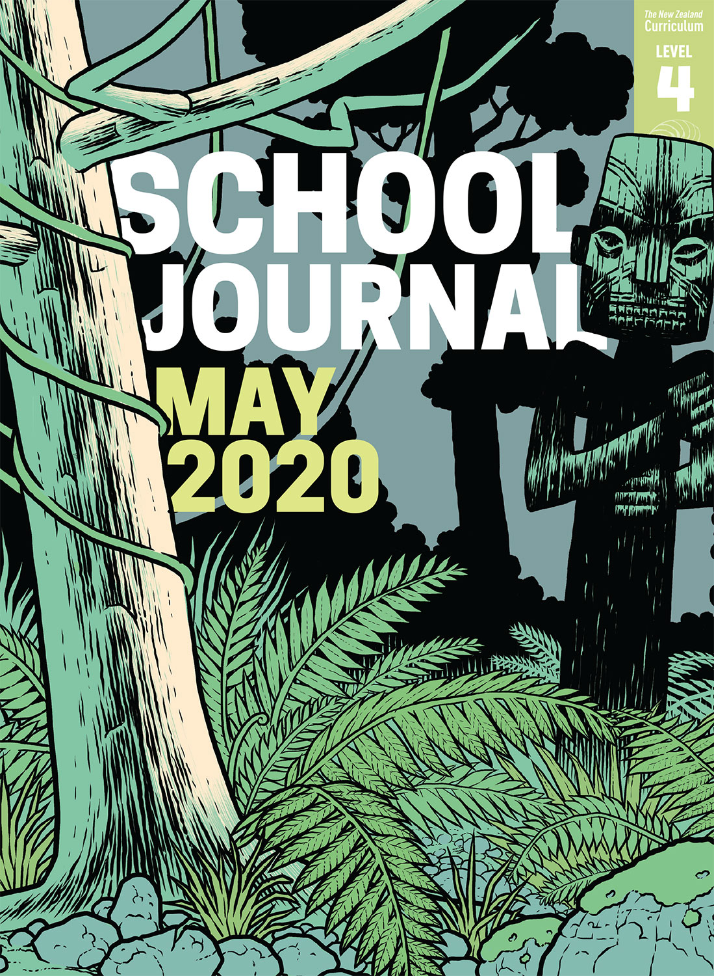

School Journal

Level 4, May 2020

**Year 7**

# The Winning Side

by Sarah Johnson

The[Learning Progression Framework](https://curriculumprogresstools.education.govt.nz/lpf-tool/)s describe significant signposts in reading and writing as students develop and apply their literacy knowledge and skills with increasing expertise from school entry to the end of year 10.

## Overview

This story references general elections, in the context of an election to a school council. “The Winning Side” introduces a few big ideas: the need for a platform, the importance of giving everyone a voice, and why we vote.

A PDF of the text is available at [www.schooljournal.tki.org.nz](http://www.schooljournal.tki.org.nz)

## Themes

* Courage (speaking up)
* Democracy
* Values

## Related text

“**The Mohawk**” SJ L3 Aug 2019

## Strengthening reading behaviours (what to notice)

|  |  |
| --- | --- |
| Text structure and features | Requiring students to: |
| * Implied information or ideas, particularly about the students who are popular and have some power * Metaphor and other figurative or connotative language * Topic-specific language | * infer why Nia decided to speak out and make her stand * draw on their prior knowledge of figurative language and language features in order to interpret the intended meaning * use prior knowledge and context clues to understand the intended meaning of the language. |

|  |  |
| --- | --- |
| Vocabulary | |
| Possibly unfamiliar words and phrases, much of it related to politics and elections | charisma, general election, democratic, agenda, issue, representative, campaign manager, facilities, politics, priority, plaques, policies, elected, electoral candidate |
| Figurative language | so bright it made people blink, her best Hollywood, had the charisma of a carrot, mouth hanging open like she was watching Mrs Lamb do a tap dance |

|  |
| --- |
| Helpful prior knowledge (pre-reading and introducing the text) |
| * Elections and politics are an essential part of a democracy. * Speaking out or supporting a cause requires courage. |

## Possible reading and writing purposes

* Find out what happens when the school holds an election for the school council
* Explore some of the terms and processes involved in elections
* Identify how Nia’s character develops
* Explore the writer’s message and what she wants the reader to know and think about

See *Effective Literacy Practice in Years 5–8* for information about teaching comprehension strategies ([Teaching comprehension](http://literacyonline.tki.org.nz/Literacy-Online/Planning-for-my-students-needs/Effective-Literacy-Practice-Years-5-8/Teaching-comprehension)) and for suggestions on using this text with your students ([Approaches to teaching reading](http://literacyonline.tki.org.nz/Literacy-Online/Planning-for-my-students-needs/Effective-Literacy-Practice-Years-5-8/Approaches-to-teaching-reading)).

## Possible curriculum contexts

This text has links to level 4 of the New Zealand Curriculum in:[**ENGLISH**](http://nzcurriculum.tki.org.nz/The-New-Zealand-Curriculum/English)[**SOCIAL SCIENCES**](http://nzcurriculum.tki.org.nz/The-New-Zealand-Curriculum/Social-sciences)

## Understanding progress

The following aspects of progress are taken from the [Learning Progression Framework](https://curriculumprogresstools.education.govt.nz/lpf-tool/)s and relate to the specific learning tasks below. See the LPFs for more about how students develop expertise and make progress in these aspects:

* Reading for literary experience
* Making sense of text: reading critically
* Making sense of text: vocabulary knowledge
* Reading to organise ideas and information for learning
* Creating texts to influence others
* Using writing to think and organise for learning.

## Strengthening understanding through reading and writing

The *School Journal* provides rich texts that can be returned to many times. The following suggestions are based on the premise that rereading the text is a fundamental part of developing students’ understanding and reading skills. **Select from and adapt** them, according to your students’ strengths, needs, and experiences.   
Note: Most of these activities lend themselves to students working in pairs or small groups.

* Create a KWL chart for elections. This might be started before reading the story. Have the students read the text, then work with a partner to try to answer their questions in the “Want to find out” section.
* Track Nia’s character development. Nia is a “dynamic character” who changes significantly throughout the story. The students might use a template (such as the Tracking Change one provided in the TSM for “Kia Māia” SJ L3 May 2020) to identify the points where she changes. Ask them to find words and phrases that show her character.
* Unpack what “charisma” looks, sounds, and feels like using the text and adding the students’ own thoughts and discoveries. Consider how the author expresses her view of charisma. The students could write their opinion about its importance in winning an election.
* Highlight the words and phrases related to elections. The students could record them on the **Words and definitions match** template provided. They could then use another source (dictionary, thesaurus, online tool) to record the definition and then write it in their own words. These can be cut out and mixed up for a partner to match.  The students could complete the template using Google Slides or Google Docs.
* Have the students find examples of when they’ve seen election words used in the real world.
* Revise the elements of persuasive writing, then have students:
* prepare a speech for their school election outlining what their platform is and what they stand for
* write a letter to the school council outlining their ideas for how the school could be improved
* write a letter to their local MP outlining a problem that needs fixing in their community.
* For more ideas and strategies to support English language learners, see [ESOL Online](https://esolonline.tki.org.nz/).

“The Winning Side” Words and definitions match

|  |  |  |
| --- | --- | --- |
| **Word or phrase** | **Definition from another source** | **Definition in own words** |
|  |  |  |
|  |  |  |
|  |  |  |
|  |  |  |
|  |  |  |
|  |  |  |
|  |  |  |
|  |  |  |