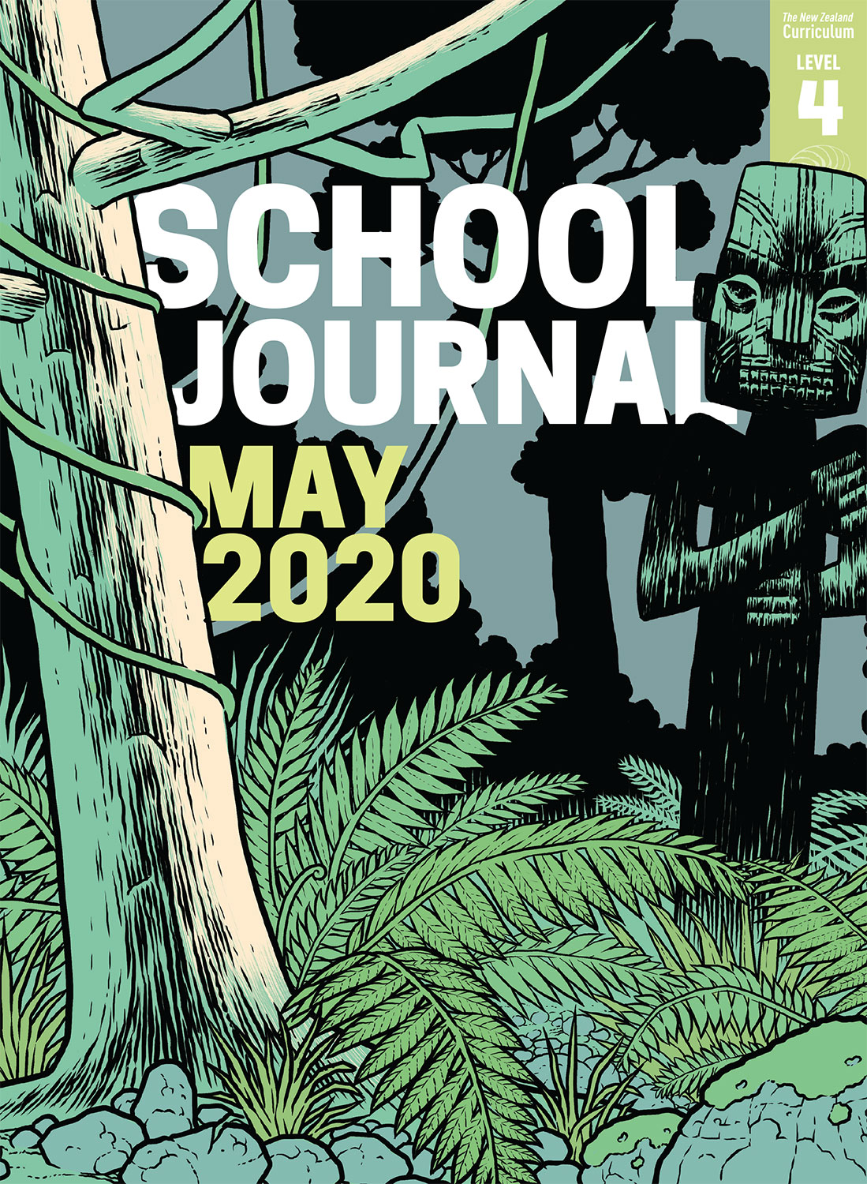

School Journal

Level 4, May 2020

**Year 8**

# Game Changers

by Clare Bardsley

The[Learning Progression Framework](https://curriculumprogresstools.education.govt.nz/lpf-tool/)s describe significant signposts in reading and writing as students develop and apply their literacy knowledge and skills with increasing expertise from school entry to the end of year 10.

## Overview

The students at Newlands Intermediate have learnt that creating successful digital technologies requires a realistic, think-small approach – and that it’s OK to make mistakes. As well as attempting to build their own game, they were also part of a real-world software development team that developed and tested Mixiply, a platform for making games and apps that use augmented and virtual reality.

A PDF of the text is available at [www.schooljournal.tki.org.nz](http://www.schooljournal.tki.org.nz)

## Themes

* Growth mindsets
* Collaboration and co-operation

## Related texts

“**Talking to the River**” SJ L3 June 2018 | *Digital Space* Connected L4 2018 | *Cracking the Code* Connected L3 2018

## Strengthening reading behaviours (what to notice)

|  |  |
| --- | --- |
| Text structure and features | Requiring students to: |
| * Technical information (historical and scientific) * Abstract ideas * Some long and challenging compound and complex sentences | * draw on previous learning and experience with augmented and virtual reality, for example, in gaming, to gain an understanding of these and the possibilities they hold * draw on and integrate their prior knowledge about technological language and idioms in English to make inferences about the meaning behind the phrases * use their knowledge of sentence structure (in particular, the organisation of the clause containing the main idea and supporting clauses providing the detail) and how punctuation supports meaning and understanding (commas to separate clauses and brackets to add description or explanation) to gain understanding. |

|  |  |
| --- | --- |
| Vocabulary | |
| Idiomatic phrases | They’re not computer whizzes, the next generation of users, always on the lookout, a short time frame, push the platform to its limits, He didn’t need to ask twice, first-hand input, The students also reported on bugs |
| Content-area terms | digital technologies, software, platform, apps, augmented reality, virtual reality, technologies architect, creative process, digital special effects, digital environment, coding, pivoting, production, mechanics, 3D-modelling, story arc, deadline, production schedule, programmer, beta phase, prototype, sector |
| Other possibly unfamiliar words and phrases | authentic, collaboration, replicate, negotiate, compromise, momentum, hordes, refined, concept, assets, rescope, isolation, evolve, blueprints, procedures, efficiently, eliminating, troubleshooting |

|  |
| --- |
| Helpful prior knowledge (pre-reading and introducing the text) |
| * Augmented and virtual reality are similar but different and have extensive possibilities. * Development processes, including trialling initial ideas and making improvements, are essential in developing technology. |

## Possible reading and writing purposes

* Find out about the challenges faced by a group of students as they learn about building their own game
* Identify the process of developing gaming software
* Evaluate the process and identify how it might be improved
* Generate questions and look for answers

See *Effective Literacy Practice in Years 5–8* for information about teaching comprehension strategies ([Teaching comprehension](http://literacyonline.tki.org.nz/Literacy-Online/Planning-for-my-students-needs/Effective-Literacy-Practice-Years-5-8/Teaching-comprehension)) and for suggestions on using this text with your students ([Approaches to teaching reading](http://literacyonline.tki.org.nz/Literacy-Online/Planning-for-my-students-needs/Effective-Literacy-Practice-Years-5-8/Approaches-to-teaching-reading)).

## Possible curriculum contexts

This text has links to level 4 of the New Zealand Curriculum in:[**ENGLISH**](http://nzcurriculum.tki.org.nz/The-New-Zealand-Curriculum/English)[**DIGITAL TECHNOLOGIES**](http://nzcurriculum.tki.org.nz/The-New-Zealand-Curriculum/Technology/Achievement-objectives)

## Understanding progress

The following aspects of progress are taken from the [Learning Progression Framework](https://curriculumprogresstools.education.govt.nz/lpf-tool/)s and relate to the specific learning tasks below. See the LPFs for more about how students develop expertise and make progress in these aspects:

* Acquiring and using information and ideas in informational texts
* Making sense of text: using knowledge of text structure and features
* Reading to organise ideas and information for learning
* Using writing to think and organise for learning.

## Strengthening understanding through reading and writing

The *School Journal* provides rich texts that can be returned to many times. The following suggestions are based on the premise that rereading the text is a fundamental part of developing students’ understanding and reading skills. **Select from and adapt** them, according to your students’ strengths, needs, and experiences.   
Note: Most of these activities lend themselves to students working in pairs or small groups.

* Identify and discuss what the teacher, the technologies architect, the students, and the author think are important. The students could use different coloured highlighter pens and an organiser to sort the similarities and differences in opinions. They could then ask the opinions of classmates about what they think is most important, and include their own opinions as well.
* In pairs, ask the students to focus on their opinions of team work, using the **Key elements** template provided to identify nine elements of what matters most when working as a team. They may need to justify why a particular element is included or not. Pairs could then compare their ideas and again decide on the nine most important elements. The whole group may then agree on the elements and rank them in importance. As a ranking suggestion, you may turn the Key Elements template so it forms a diamond shape or you could cut out and sort the elements.
* Have the students list the challenges faced by the MiniDevs and suggest possible solutions for each challenge.
* Ask students to write questions about the text that remain unanswered. They could choose one question to explore further.
* Have the students write an explanation of an experimental digital technology inquiry you or your class have undertaken.
* Ask the students to create a diagram or flowchart to explain the process of developing and testing a new technology product.  The students could use Google Slides to create their diagram or flowchart.
* Have the students write a job description or CV for one of the roles in the article.  The students could use a [Google Docs Resume](https://docs.google.com/document/u/0/?ftv=1&tgif=c) template for this.
* Create a glossary including the technical terms from the text.
* To support English language learners, you could select some content-area words for further study. Draw up a page with four columns headed Word, Definition, Picture/symbol, and Hint. For each word, the students write their own definition, draw a picture of what the words means, and add a hint for remembering the meaning.
* For more ideas and strategies to support English language learners, see [ESOL Online](https://esolonline.tki.org.nz/).

“Game Changers” Key elements

|  |  |  |  |  |
| --- | --- | --- | --- | --- |
|  |  |  |  |  |
|  |  |  |  |  |
|  |  |  |  |  |
|  |  |  |  |  |
|  |  |  |  |  |