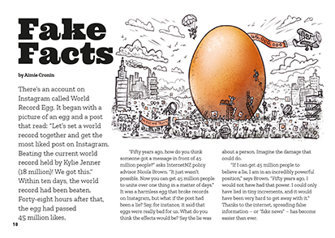

The Literacy Learning Progressions: Meeting the Reading and Writing Demands of the Curriculum describe the literacy-related knowledge, skills, and attitudes that students need to draw on to meet the demands of the curriculum.

Fake Facts
by Aimie Cronin
Connected
Level 4
2019
The Learning Progression Frameworks (LPF) describe significant signposts in reading and writing as students develop and apply their literacy knowledge and skills with increasing expertise from school entry to the end of year 10.

Overview
This article addresses the topical issue of fake news. Digital technology creates huge opportunities for us to create and share information but also exposes us to information that can be false or can do harm. The article encourages students to take a critical gaze on information and suggests strategies for evaluating what information is based on facts and worth sharing.
A Google Slides version of this article is available at www.connected.tki.org.nz
Curriculum contexts

TECHNOLOGY: Nature of Technology: Characteristics of technological outcomes  Level 4 – Students will understand that technological outcomes can be interpreted in terms of how they might be used and by whom and that each has a proper function as well as possible alternative functions.  Designing and developing digital outcomes  Progress outcome 2  In authentic contexts and taking account of end-users, students make decisions about creating, manipulating, storing, retrieving, sharing, and testing digital content for a specific purpose, given particular parameters, tools, and techniques. They understand that digital devices impact on humans and society and that both the devices and their impact change over time … | Key technology ideas  - Societal and environmental issues can influence technological outcomes.  - There is a need for ethical sharing and receiving of data and information.
SOCIAL SCIENCES: Social Studies  Level 4 – Students will understand how producers and consumers exercise their rights and meet their responsibilities. | Key social studies ideas  - Reliable information is sourced through a process of peer review and critique.  - Peer review and being critical makes information more trustworthy.
ENGLISH: Reading  Level 4 – Ideas: Students will show an increasing understanding of ideas within, across, and beyond texts. | Indicators:  - makes meaning of increasingly complex texts by identifying and understanding main and subsidiary ideas and the links between them  - makes connections by thinking about underlying ideas within and between texts from a range of contexts  - recognises that there may be more than one reading available within a text  - makes and supports inferences from texts with increasing independence.

The New Zealand Curriculum

Meeting the literacy challenges

The main literacy demands of this text require students to make connections as it moves through information from multiple sources. The text touches on elements of psychology, such as how we process and interpret information and how this influences our responses. It includes examples that will help students connect to their prior knowledge. It has an engaging style of writing that reinforces the message that you need to consider your sources and be critical of the information you receive. Humorous cartoons also help to connect the reader to key messages.  The quotations create sentences that are conversational, starting with conjunctions or broken up with en dashes. Extended metaphors, such as “driving the internet” are extended to the pictures. Most of the topic-specific vocabulary will be familiar to students, but it offers room to explore changes in language, along with changes in communication methods. Some items are explained in a glossary. | The instructional strategies below support students to meet the literacy challenges of this text. For each strategy, there are links to the relevant aspect of The Learning Progression Frameworks (Reading). The signposts on each of these aspects provide detailed illustrations on what to notice as your students develop their literacy knowledge and skills for different purposes in different curriculum areas.  The following strategies will support students to understand, respond to, and think critically about the information and ideas in the text.  You may wish to use shared or guided reading, or a mixture of both approaches, depending on the reading expertise of your students and the background knowledge they bring to the text.  After reading the text, support students to explore the activities outlined in the following pages.

INSTRUCTIONAL STRATEGIES

Establishing prior knowledge  [LPF Reading: Making sense of text: using a processing system]  TELL the students the title. Prompt them to think, pair, and share what they know about fake facts. Create a mind map to record their ideas, words, and concepts. This could be done using a digital tool, such as MindMup. PROMPT the students to add to their mind map as they read.  Earlier you said … What do you think about this now?  Responding critically to the text  [LPF Reading: Making sense of text: reading critically]  DISCUSS the advice from Elle Hunt on page 16 that we only post or share stories we know to be true from sources we know to be responsible. PROMPT the students to make connections across the text that justify this advice.  What have we learned from the text to justify the idea that we need to think critically about sources of information?  Have the students SUMMARISE the main information on an ISP chart – a chart that is used to identify where information has been sourced. (You can find digital versions on Edraw.)  Information Source Page  DISCUSS the credibility of the writer’s message.  Let’s scan through the article. How much of what the writer said was fact? How much was opinion? How can you tell?  Looking at our ISP chart, we can see that she used a lot of sources. How credible do you find them? | Using visual features for deeper understanding  [LPF Reading: Making sense of text: using knowledge of text structure and features]  PROMPT the students to look closely at the pictures.  What concepts do the pictures help us to understand?  This text uses metaphors in the writing and the pictures. What are they? Are they effective? (You may need to explain the visual allusion to the many-headed Hydra of Greek mythology on page 12.)  Do the illustrations in this article add to its appeal? Justify your answer with examples from the text.  Dealing with unfamiliar vocabulary  [LPF Reading: Making sense of text: vocabulary knowledge]  Explore the series of pictures on page 11 to clarify the distinction between “misinformation”, “malinformation”, and “disinformation”. DISCUSS how the prefix changes the meaning. TELL the students that some people now use the term “hyperinformation”. Have them guess what this might mean, then look it up to check. Challenge them to create a fourth picture to explain this term. DISCUSS whether it could also be connected to the key below the images. (No, because hyperinformation refers to the sense that we have too much information to deal with rather than whether it’s true or harmful.)  Reference Nicola Brown’s comment that fifty years ago, you couldn’t have got a message in front of 45 million people. Point out that those 45 million people wouldn’t have any idea what some of the terms in this article mean.

Meeting the literacy challenges

Have the students REVIEW the text to identify words and expressions that are new or that are used in special ways when we are talking about digital technology. Have them create definitions that could help older people understand terms like “clickbait” or “influencer” and what “social media” is and how it is different from traditional media.  Extending the learning  The students could investigate how and why old words can change their meaning and new words can be created and popularised.  Language has always changed, but has language changed more in the digital age?  What trends do you see? What do you think our language will be like in fifty years? | The students could also have fun playing with language, extending their awareness of the meanings of prefixes as they do so.  What are some other prefixes we could add to “information” to make up a new word?  What would the definition of our new word be? How could we have used it in a sentence?

The Learning Progression Frameworks
The Literacy Learning Progressions
Effective Literacy Practice: Years 5–8

Illustrating the key ideas
There is a need for ethical sharing and receiving of data and information.

Societal and environmental issues can influence technological outcomes. | 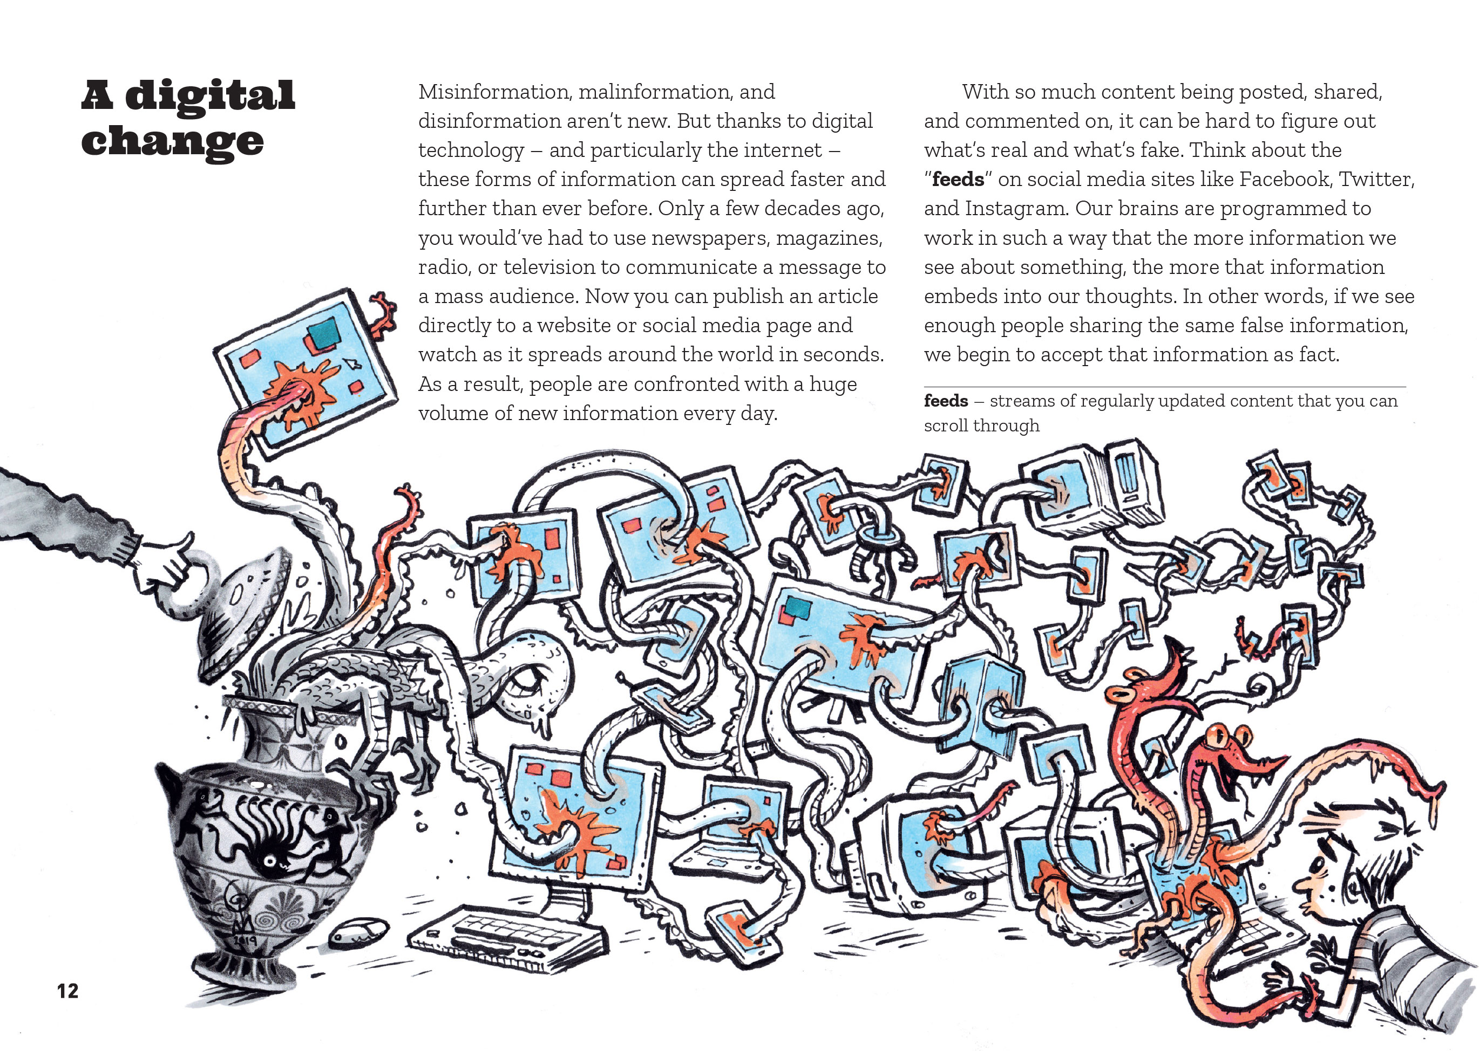  Reliable information is sourced through a process of peer review and critique.

Learning activities – Exploring technology,
science, and social sciences

Activity 1 – Positive digital citizens  Discuss what the students learned about how the internet exposes us to the risk of fake news and how we can defend ourselves from this risk. Introduce or review the concept of “digital citizenship”. The National Library describes it like this:  Digital citizenship is about the way people use the internet and interact with social media. It includes thinking critically about the things you find online, being safe online by keeping yourself and your personal information safe, and treating others with respect.  Connect the discussion of digital citizenship to the values operating in your classroom, school, and the wider community. See Building Conceptual Understandings in the Social Sciences: “Belonging and Participating in Society” for thoughts about the concept of citizenship.  What do we mean by “citizen”?  What does it mean to be a good citizen?  These are the values we say we value in our community. How do you think they apply to the concept of a digital citizen?  Have the students create their own charts that show how the qualities of a good citizen are reflected in the practices of a good digital citizen. The charts might look like this:  Our definition of a good citizen  A good citizen is someone who: A good digital citizen is someone who:  is honest does not spread fake news  Use the explanation on the Netsafe site to introduce the term “digital literacy”. Develop a definition of digital literacy and relate this to the concept of being a good digital citizen. Check that the students understand that it’s not enough to want to be a good digital citizen and that we need to be digitally literate if we are to avoid being taken in by fake news and even contributing to its spread.  Have the students investigate further and develop a set of guidelines for evaluating online information. Discuss who needs to use these guidelines and how they could be shared. Support the students to design an approach for communicating their guidelines to others and for explaining why they are important. Consider posters, a blog, or a YouTube video – bearing in mind the need to stay safe!  Extending the learning  Explore the other risks and opportunities offered by the internet and extend the guidelines to considerations of how to stay safe. | The following activities and suggestions are designed as a guide for supporting students to explore and extend their content knowledge across the learning areas. Adapt these activities to support your students’ interests and learning needs.  Activity 2 – The bigger picture  The article concludes by asking important questions about “the bigger picture”.  Do you think we need to change some of our laws around social media?  Do our current media outlets and political systems support or suppress misinformation?  What should we demand of them?  Have the students use an online surveying tool to find out how people in their school, whānau, and community feel about these issues. Ensure that they design their survey so that they can separate the responses of different groups according to factors such as age and gender. Have them analyse and discuss the responses, thinking critically about their own opinions as they do so.  Have the students write reports in which they state their personal responses to these questions, justifying them with evidence. Have them debate their opinions and consider social action if they feel strongly about a need for change.  Activity 3 – The myth of scientific objectivity  A page on the Science Learning Hub addresses common myths about science. One is that scientists are objective. The reality is that, like anyone else, scientists bring their own preconceptions and biases to their observations and the interpretations they make.  Have the students read “Pseudoscience” in Connected 2015 to compare the skills of a digitally literate citizen with a scientifically literate one. They could create a Venn diagram to do this.  The TSM for “Pseudoscience” includes activities to support students to defend themselves against bad science. Alternatively, students could use the News Bug process to critically review scientific articles. This is described in the appendix of this article. It involves creating a three-dimensional model of a bug and using it to analyse a text and determine whether it stands up to scrutiny.

RESOURCE LINKS

Connected and School Journal  “Pseudoscience”, Connected 2015, Level 3, Fact or Fiction?  Google  Be internet awesome: Digital safety resources: https://beinternetawesome.withgoogle.com/en_us/educators  InternetNZ  Resources: https://internetnz.nz/resources  The end of fake news (infographic): https://internetnz.nz/end-fake-news  Other sources  TKI: Digital citizenship: http://elearning.tki.org.nz/Teaching/Digital-citizenship  Science Learning Hub: Myths of the nature of science: https://www.sciencelearn.org.nz/resources/415-myths-of-the-nature-of-science  Building Conceptual Understandings in the Social Sciences: “Belonging and Participating in Society”: http://ssol.tki.org.nz/Social-studies-years-1-10/Teaching-and-learning/effective_teaching_in_social_studies/Building-conceptual-understandings/belonging_and_participating_in_society  Compound interest: A rough guide to spotting bad science: https://www.compoundchem.com/wp-content/uploads/2014/04/A-Rough-Guide-to-Spotting-Bad-Science-20151.pdf  The Guardian: What is fake news? How to spot it and what you can do to stop it: https://www.theguardian.com/media/2016/dec/18/what-is-fake-news-pizzagate | Ask for evidence: Working out what’s reliable evidence: https://askforevidence.org/help/evidence  Time: How your brain tricks you into believing fake news: http://time.com/5362183/the-real-fake-news-crisis/  New Zealand Geographic: False notes – The price of sound science is eternal vigilance: https://www.nzgeo.com/stories/false-notes/  Guinness World Records: Egg photo breaks Kylie Jenner's record for most liked image on Instagram: http://www.guinnessworldrecords.com/news/2019/1/egg-photo-breaks-kylie-jenners-record-for-most-liked-image-on-instagram-554801  Learn.org: What is digital media? https://learn.org/articles/What_is_Digital_Media.html  Any Questions: Digital citizenship: https://anyquestions.govt.nz/many_answers/digital-citizenship  Committing curriculum time to science literacy: The benefits from science based media resources (News Bug): https://pureadmin.qub.ac.uk/ws/portalfiles/portal/128694344/1finaljes_12_feb_2017_web_v3_1_.pdf  Creating a positive digital footprint: http://thoughtfullearning.com/inquireHSbook/pg281  Digital citizenship vs digital literacy – Is there a difference? https://educationtechnologysolutions.com/2018/02/digital-citizenship-vs-digital-literacy-difference/  Mindmup: Free online mind mapping: https://www.mindmup.com/  Edraw: https://www.edrawsoft.com/ispchart.php  Netsafe: Online safety for New Zealand: https://www.netsafe.org.nz/

