The House that Dan Built
by Johanna Knox
Connected
Level 2
2019
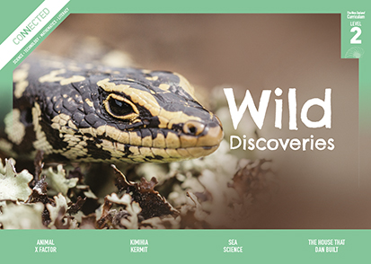
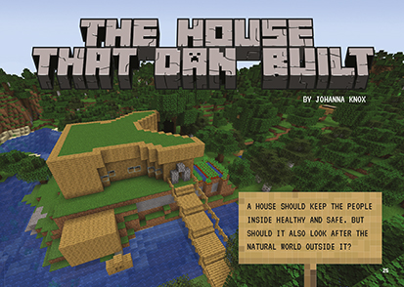

The Literacy Learning Progressions: Meeting the Reading and Writing Demands of the Curriculum describe the literacy-related knowledge, skills, and attitudes that students need to draw on to meet the demands of the curriculum.
The Learning Progression Frameworks (LPF) describe significant signposts in reading and writing as students develop and apply their literacy knowledge and skills with increasing expertise from school entry to the end of year 10.

Overview
In 2018, Daniel Turinsky, a student at Nelson Central School, entered a competition to design an eco-house using the computer game Minecraft. This article describes the thought processes Daniel went through as he weighed up different options to create his winning design. It offers an authentic example of a student drawing on scientific and technological information to design and develop a digital outcome.
A Google Slides version of this article is available at www.connected.tki.org.nz
Curriculum contexts

TECHNOLOGY: Technological Practice: Planning for practice  Level 2 – Students will develop a plan that identifies the key stages and the resources required to complete an outcome.  TECHNOLOGY: Technological Knowledge: Technological products  Level 2 – Students will understand that there is a relationship between a material used and its performance properties in a technological product.  TECHNOLOGY: Nature of Technology: Characteristics of technology  Level 2 – Students will understand that technology both reflects and changes society and the environment and increases people’s capability.  Designing and developing digital outcomes: Progress outcome 1  In authentic contexts and taking account of end-users, students participate in teacher-led activities to develop, manipulate, store, retrieve, and share digital content in order to meet technological challenges. In doing so, they identify digital devices and their purposes and understand that humans make them. They know how to use some applications, they can identify the inputs and outputs of a system, and they understand that digital devices store content, which can be retrieved later. | Key technology ideas  - Technological outcomes are fit for purpose.  - Environmental issues can influence what technological outcomes are made.  - Software can be used to create a sustainable digital environment and to simulate an eco-house.
SCIENCE: Planet Earth and Beyond: Interacting systems  Level 2 – Students will describe how natural features are changed and resources affected by natural events and human actions. | Key science ideas  - Design features such as the shape of buildings can be used to slow heat loss.  - The energy of moving water or air can be used to make turbines move.  - Renewable resources can be easily replaced; non-renewable resources cannot be replaced.
ENGLISH: Reading  Level 2 – Ideas: Students will show some understanding of ideas within, across, and beyond texts. | Indicators:  - uses their personal experience and world and literacy knowledge to make meaning from texts  - makes meaning of increasingly complex texts by identifying main ideas  - makes and supports inferences from texts with some independence.

The New Zealand Curriculum

Meeting the literacy challenges

The main literacy demands of this text lie in the abstract concept of being “eco-friendly” and the need to make inferences and connections between ideas to understand that what people take from the environment has an impact on it. There is also a lot of technical information, which students need to use to weigh up the pros and cons of different technological solutions.  The first part of the article introduces the criteria for being eco-friendly. Each subsequent section explains how different elements of the house fulfil that criteria. New ideas are also introduced and developed, with connections to familiar, concrete examples.  Charts and diagrams help the reader unpack the technical information, as well as interpret the challenging vocabulary. Sentence-level support and the glossary will help students with technical and topic-specific language. | The instructional strategies below support students to meet the literacy challenges of this text. For each strategy, there are links to the relevant aspect of The Learning Progression Frameworks (Reading). The signposts on each of these aspects provide detailed illustrations on what to notice as your students develop their literacy knowledge and skills for different purposes in different curriculum areas.  The following strategies will support students to understand, respond to, and think critically about the information and ideas in the text.  You may wish to use shared or guided reading, or a mixture of both approaches, depending on the reading expertise of your students and the background knowledge they bring to the text.  After reading the text, support students to explore the activities outlined in the following pages.

INSTRUCTIONAL STRATEGIES

Finding the main ideas  [LPF Reading: Acquiring and using information and ideas in informational text]  Have the students read pages 25–26 to orient themselves to the text. ASK QUESTIONS to help them make connections to their experiences with Minecraft and to what they know about “the natural world”, “eco-houses”, and “resources”.  What does the writer mean by the natural world? What do you recall from other articles we’ve read or discussions we’ve had?  Have you heard of eco-houses? What can you tell us about them?  What do you suppose the prefix “eco” means? (relating to the environment). Can you think of other words that use “eco”?  Who has played Minecraft? How do you move the blocks around to create an imaginary world?  What is a resource? What can we see in the photographs? What sorts of resources might Daniel have used to build his bedroom?  EXPLAIN that any design process involves evaluating options to design a technological outcome that meets the brief. In this case, the brief is to construct an eco-house. Use the diagram on page 27 to CLARIFY the two things Daniel will need to think about to design an eco-friendly house. Make sure that the students understand that the left-hand side lists potential resources and the right-hand side lists potential pollutants.  Share an experience of your own where you built something new, explaining what went into it and what came out of it. PROMPT the students to share their experiences from home or at school. If a building project is in process nearby, they could observe what they see of materials going in and waste materials and other pollutants going out. | PREVIEW the rest of the text with the students. EXPLAIN that the article takes us through the decisions Daniel had to make when deciding how he could design a house that was as eco-friendly as possible. Give the students a graphic organiser, such as the one below, to track the design decisions Daniel had to make, the problems he had, and the solutions.  Design decision Problem Solution  Choosing the right materials  Saving energy  Choosing an eco-friendly source  PROMPT the students to respond to the rhetorical question “Which energy source would you use?” on page 31, referring back to the criteria for eco-friendliness.  Have another quick look at the diagram on page 27. Keeping a house eco-friendly means thinking about what your house takes from the world and what it puts into the world. It can be a balancing act. You have to weigh one thing against the other.  PROMPT the students to think, pair, and share their initial responses to the question at the end of the article.  Using visual features for deeper understanding  [LPF Reading: Making sense of text: using knowledge of text structure and features]  PROMPT the students to look closely at the diagram Turbine Power on page 30. MODEL by thinking aloud how the diagram supports the text so that, together, they describe how energy is converted into electricity and sent to our homes.

Meeting the literacy challenges

The title of the diagram, “Turbine Power”, gives me a clue that turbines help provide our power. The text says: “This electricity is generated at power stations, where an energy sources spins huge turbines.”  The first column in the diagram is labelled “Energy source”. Below it, I can see examples of energy sources: wind, coal and gas, and water. The next column is labelled “Power station” and explains that this is where the turbines are spun. The power stations all look different, but I know from the text and the label that they all have turbines. That is where the energy source is transformed, or turned, into electricity.  Have students work in pairs to explain why the three kinds of power all end at the same place. Work with the students to write a summary of the diagram.  PROMPT the students to look closely at the table on page 31, thinking about its purpose, layout, and the questions it provokes. EXPLAIN how it links to the diagram on the previous page.  What does this diagram show you? Why has the information been organised in a table?  Remember we talked about balancing acts? What are some examples of tricky decisions that involve weighing up the good things about an energy source against the things that are bad?  We have lots of wind! I wonder why we only get a tiny bit of our electricity from wind. | Dealing with scientific and technical vocabulary  [LPF Reading: Making sense of text: vocabulary knowledge]  As the students read, have them IDENTIFY and LIST the vocabulary that is new to them. Following the reading, DISCUSS the strategies they used to work out their meanings and RECORD them. Then have the students sort the vocabulary according to the strategies they used. These may include:  - I know this word from another context.  - I found the definition in the text.  - I found a clue in the text.  - I predicted the meaning from reading the text.  - I used my knowledge of prefixes.  - I used my knowledge of compound words.  - I noticed word families.  - I checked the glossary.  - I found the meaning from a picture or diagram.  - I found the word in a dictionary or thesaurus or on the internet.  DISCUSS this activity with the students, then work with them to construct concept circles for key terms, such as “eco-house” and “renewable energy”. Revisit this activity as you continue exploring these concepts, building their confidence to use these terms independently.

The Learning Progression Frameworks
The Literacy Learning Progressions
Effective Literacy Practice: Years 1–4

Illustrating the key ideas

Environmental issues can influence what technological outcomes are made.  Renewable resources can be easily replaced; non-renewable resources cannot be replaced.  The energy of moving water or air can be used to make turbines move. | 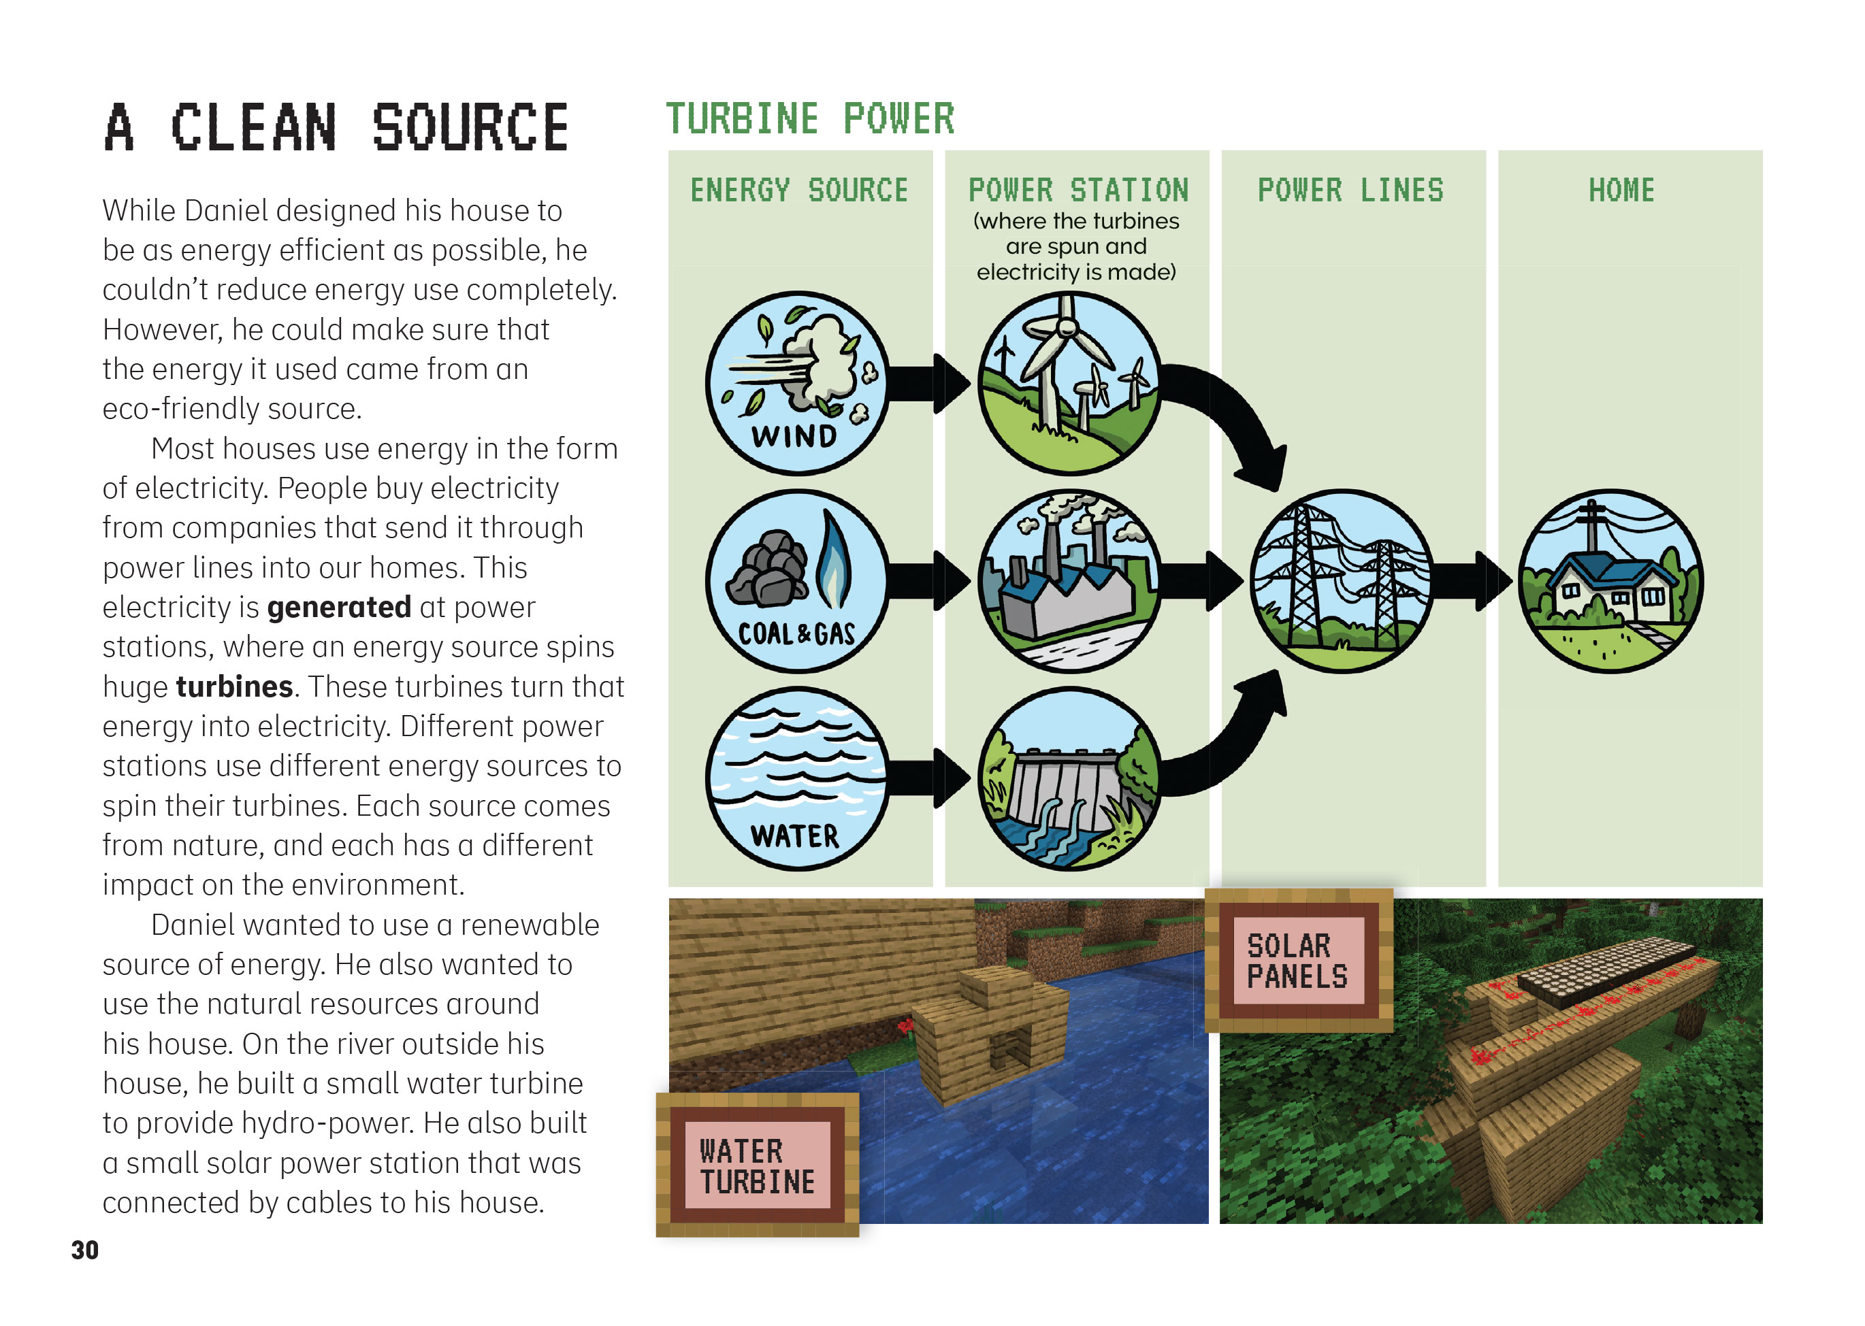
 | Technological outcomes are fit for purpose.

Learning activities – Exploring the science
and technology

Activity 1 – Energy exploration  Delve further into the technological information about generating and conserving energy. To prepare for this activity and the next, engage students in design tasks, or ask them to compare different technological solutions to a problem.  Use activities from Building Science Concepts Book 47 to investigate insulation. The students could then gather energy-related data about their classroom. For example, have them measure and record temperatures at different times of the day over some weeks to show heat gain and loss and compare this with the hours of sunlight. They could use the data to design a more energy-efficient classroom.  Use activities from Building Science Concepts Book 45 to investigate the energy of flowing fluids, such as water and air, and design windmills or waterwheels. Have students gather data about water flow or wind strength and frequency. Support students to use this information to identify local sources of energy, such as streams or appropriate sites for windmills.  Use activities from Building Science Concepts Book 29 to explore what solar energy is, how it is used, and the technologies involved in “harnessing” and transforming energy from the sun. Read the Connected 2015 article “Lighting the Way with Solar Energy” to learn how Tokelau switched from fossil fuels to solar energy, becoming the first nation in the world to use 100 percent renewable energy. Students could monitor hours of sunlight to identify renewable local sources of energy for their school. | The following activities and suggestions are designed as a guide for supporting students to explore and extend their content knowledge across the learning areas. Adapt these activities to support your students’ interests and learning needs.  Activity 2 – Design challenge  Challenge the students to create their own eco-house. They could do this using Minecraft or with physical materials to explore what they could use to build their eco-house, such as cardboard, earth, or straw. Before beginning, develop a plan that identifies the key stages and the resources required to design and develop a technological outcome. Whichever challenge they undertake, the design process will be similar:  - Identify the problem or opportunity  - Explore ideas  - Develop a brief and create a plan  - Create a model  - Test, evaluate, and modify the model  - Present the solution for feedback.  See “The Cardboard Cathedral” (Connected 2014) for prompts, questions, and activities you could adapt to support your students through the design process. Like the other Connected items listed below, it offers information and links to additional resources about the role of technological products and materials in construction. Building Science Concepts Book 51 provides opportunities for students to focus on the relationship between structure and function in plants and to relate this to the way people choose materials and design frameworks when they construct buildings.  Many students will want to use Minecraft to design their houses. The resource links below offer lesson plans and ideas you could use to scaffold students through this process.  EcoBob has lots of examples of sustainable houses. An introductory activity could include the class exploring the site to identify different “eco-features” they see in these houses and considering their applicability to their own designs in the context of their location.

RESOURCE LINKS

Connected and School Journal  “Building a Wharenui”, Connected 2011, Level 2, Structure  “More Than a Box”, Connected 2011, Level 2, Structure  “The Cardboard Cathedral”, Connected 2014, Level 2, How Do You Know?  “Rebuilding Christchurch with Amazing Ideas”, Connected 2014, Level 3, Why is That?  “Building for the Future”, Connected 2017, Level 3, Mahi Tahi  “Lighting the Way with Solar Energy”, Connected 2015, Level 4, Is That So?  Science Learning Hub  Renewable energy sources: https://www.sciencelearn.org.nz/resources/1571-renewable-energy-sources  Exploring solar power (activity): https://www.sciencelearn.org.nz/resources/1753-exploring-solar-power  Futures thinking toolkit: https://www.sciencelearn.org.nz/resources/2439-futures-thinking-toolkit  Building Better Homes, Towns, and Cities National Science Challenge: https://www.sciencelearn.org.nz/resources/2777-building-better-homes-towns-and-cities-national-science-challenge  Building Science Concepts  Book 29: Solar Energy: Sun Power on Earth  Book 47: Insulation: Keeping Heat Energy In  Book 51: Standing Up: Skeletons and Frameworks  Book 54: Windmills and Waterwheels: Harnessing the Energy of Wind and Water  TKI  enabling e-Learning ǀ teaching: Using Minecraft as a tool for learning: http://elearning.tki.org.nz/Teaching/Future-focused-learning/Minecraft  Technology Online: Solar energy: http://technology.tki.org.nz/Technology-in-the-news/(tag)/solar  Technology Online: Sustainability: https://technology.tki.org.nz/Videos/Sustainability | Minecraft education  Lessons by Minecraft: https://education.minecraft.net/user/MEEAdmin  Building sustainable homes: https://education.minecraft.net/lessons/climate-change/  ECOBOB  What is an eco home? https://www.ecobob.co.nz/what-is-an-eco-home/  What is a sustainable house? https://www.ecobob.co.nz/info-and-news/category/what-is-a-sustainable-house-1427/  Net-zero energy homes: https://www.ecobob.co.nz/info-and-news/building-design-construction-and-renovations/net-zero-energy-homes/  Other sources  AHS Makerspace: Designing an eco-friendly house with Minecraft: https://ahsmakerspace.wordpress.com/2015/12/12/designing-a-sustainable-house-with-minecraft/  Genesis School-gen: Design an energy efficient house (L3–4 teaching resource): http://www.schoolgen.co.nz/teach-and-learn/resource/  Education for sustainability: https://nzcurriculum.tki.org.nz/Curriculum-resources/Education-for-sustainability  Energy Efficiency and Conservation Authority: https://www.eeca.govt.nz/about-eeca/  Sustainable Energy Association New Zealand: https://www.seanz.org.nz/  Note that the electricity companies have information about power generation on their websites.

