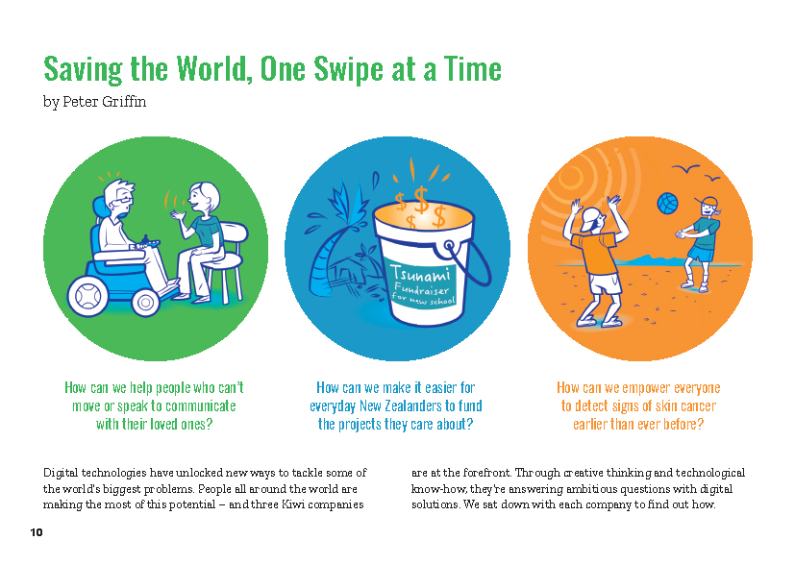
Connected
Level 4
2018

Saving the World, One Swipe at a Time
by Peter Griffin

Overview
This article describes how three Kiwi companies have used digital technology to help solve health or social problems. It demonstrates how digital technologists think through a problem and how a seemingly abstract issue can be turned into a series of tasks that digital technologies can solve. Each of the examples also demonstrates the principle of user-centred design.
A Google Slides version of this article is available at www.connected.tki.org.nz
Curriculum contexts

TECHNOLOGY: Technological Practice: Brief development  Level 4 – Students will justify the nature of an intended outcome in relation to the need or opportunity; describe the key attributes identified in stakeholder feedback, which will inform the development of an outcome and its evaluation. | Key technology idea  - Digital technologies are helping to find solutions to social and medical problems.
ENGLISH: Reading  Level 4 – Ideas: Students will show an increasing understanding of ideas within, across, and beyond texts. | Indicators:  - makes meaning of increasingly complex texts by identifying and understanding main and subsidiary ideas and the links between them  - makes connections by thinking about underlying ideas within and between texts from a range of contexts  - recognises that there may be more than one reading available within a text  - makes and supports inferences from texts with increasing independence.
MATHEMATICS and STATISTICS: Statistics: Statistical investigation  Level 4 – Students will plan and conduct investigations using statistical enquiry cycle:  - determining appropriate variables and data collection methods;  - gathering, sorting, and displaying multivariate category, measurement, and time-series data to detect patterns, variations, relationships, and trends;  - comparing distributions visually;  - communicating findings, using appropriate displays.  MATHEMATICS and STATISTICS: Geometry and Measurement: Measurement  Level 4 – Students will use appropriate scales, devices, and metric units for length, area, volume and capacity, weight (mass), temperature, angle, and time. | Key mathematics ideas  - Engineers use measurement data and mathematical thinking to solve problems (for example, debugging).

The New Zealand Curriculum

Meeting the literacy challenges

The main literacy demands of this text arise from the need to make sense of information about three different technological outcomes. Students may need support to recognise that the article is organised into three parts, with an introduction and conclusion, and that each part follows the same structure. Understanding this will help them to integrate the main ideas.  The article includes topic-specific vocabulary that will be challenging for some readers. Significant terms, such as “encryption”, “algorithm”, and “user-centred design”, are explained in the text, in the glossary, or in breakout text.  There are some complex sentences, often to link the multiple steps in a single process. Students will need to use their knowledge of connectives and punctuation to track the connections between the ideas. | The following strategies will support students to understand, respond to, and think critically about the information and ideas in the text. It may be appropriate to use all or only one or two of these strategies, depending on your students’ literacy knowledge and skills. You are encouraged to reword the suggested questions that will best suit your learners’ strengths and needs.  You may wish to use shared or guided reading, or a mixture of both, depending on the reading expertise of your students and the background knowledge they bring to the text.  After reading the text, support students to explore the activities outlined in the following pages.

INSTRUCTIONAL STRATEGIES

Consider spreading this reading over two or three days, focusing first on the overall structure and part one, then on the rest of the article, and finally on bringing the ideas together.  Finding the main ideas  Tell the students that this text gives us three different examples about how digital technologies are being used to solve three very different problems. EXPLAIN that there is a lot of information in this text but that the writer has organised it in a way that will help us make sense of it. Have the students SCAN the subheadings to identify the overall structure.  How has the information been organised?  What connections are there between the three pictures and images on page 10 and the rest of the article?  What can you figure out from the paragraph at the bottom of the page?  What additional information can you get from the three questions and the illustrations?  How could we check our theory that the three questions and illustrations match up with the three parts? [Scan the text again, looking at the visual images, as well as the subheadings.]  PROMPT the students to make inferences about how the article was written and why.  How do you think the writer got the information he needed to write this article? How do you know? Where can you find a clue?  There’s only one writer, but he says “We sat down with each company to find out how”. What does the “we” imply? [That he is writing on behalf of the Connected series.]  What is the writer’s attitude to his subjects? What words give you clues about how he feels about these three companies? What does he think they have in common?  What do words like “creative thinking”, “technological know-how”, and “ambitious questions” actually mean? How do they make you feel about the prospect of reading this article? | EXPLAIN, or have the students explain, the key attributes of a technological outcome. Write the following key words on the board as you or they speak: “need or opportunity”, “purpose”, “attributes”, “user feedback”, “development”. There is a suggested script below, which you could adapt for your students.  In some ways, a digital technological outcome is just like any other technological outcome. Just as a hammer is designed to meet a particular need or to respond to an opportunity – something needs to be fixed or there’s an opportunity to build something – so too is digital technology. What is the purpose of a smartphone? What was the need or opportunity it helps us to address?  A hammer has certain attributes that mean it can do what it’s meant to do. What are some of the attributes of a smartphone?  Digital technologies are developed in response to feedback from users. The original hammers were just stones – now there are lots of different sorts of hammers, from tiny ones for delicate tasks to huge pile drivers. How have smartphones evolved in response to user feedback? What attributes have been added or changed to meet customer demand?  Have the students read the hook on page 11 and SKIM the rest of part one to identify the need for this technology, its purpose, its key attributes, and the role user-feedback played in its development.  How does this compare with what we do when writing for an audience? [A good writer thinks about the audience while writing and gets other people to provide feedback. They check that the writing meets its purpose and that the audience finds it enjoyable and easy to read.]  EXPLAIN that the writer has also structured each part of the text in a way that helps us make sense of the information. Have them SCAN parts two and three to find features that are repeated from part one.

Meeting the literacy challenges

With this information in mind, create a graphic organiser that the students can use to summarise each part. Encourage them to work in pairs, supporting each other to keep their summaries as succinct as possible. Remind them that one way of doing this is to capture some of the concepts with sketches. (You could MODEL this by sketching a simple flow diagram to show how the nous headband measures electrical impulses in the brain and then turns these impulses into instructions for a computer.) When they have finished, have each pair partner up with another pair to compare their summaries and evaluate them against the criteria for brevity and completeness.  Name of technology  Developer  Need or opportunity  Purpose  Key attributes  User-centred design  Note that the term “user-centred design” is not repeated in parts two and three, so the students will have to use inference to make an informed guess as to whether the other companies also took a “user-centred” approach.  Continuing in small groups, have the students create Venn diagrams to capture what the three different technologies have in common and what is unique. DISCUSS what this tells them about features they can expect to find when engaging with digital technologies in their day-to-day lives. | Dealing with unfamiliar vocabulary  DISCUSS how new technology has led to changes in language, with new words being created and other words changing in meaning.  The word “swipe” used to refer to a swinging blow or to the act of stealing something. You might “swipe” at a ball or “swipe” someone’s lollies. But in this article, “swipe” means moving your finger across a touchscreen.  Show the students how the word “swipe” has escalated in use with the introduction and spread of digital technologies. (See Google: Use over time for: swipe.)  REVIEW the text with the students to identify other terms that have been added to the English language or changed in meaning over the last fifty years or so. Using the example in the table below, MODEL how to find out the original meanings of these words and to write a definition that matches the way it is used in the article. They should then use the term in a sentence of their own. This information could be collated in a Google doc that could grow over time.  Digital technologies term Original meaning/s Meaning in the context of this article Example of the term in use  mouse A small rodent / mammal A hand-held pointing device used to move a cursor around a computer screen. Items can be selected by pressing (clicking) the mouse buttons. ‘an easy to use computer program that translates a person’s thoughts or blinks into the click of a mouse.’

Meeting the literacy challenges

TEACHER RESOURCES

Want to know more about instructional strategies? Go to:  - http://literacyonline.tki.org.nz/Literacy-Online/Planning-for-my-students-needs/Effective-literacy-practice-years-5-8  - “Engaging Learners with Texts” (Chapter 5) from Effective Literacy Practice in Years 5 to 8 (Ministry of Education, 2006).  Want to know more about what literacy skills and knowledge your students need? Go to:  - http://nzcurriculum.tki.org.nz/Assessment/Reading-and-writing-standards  - http://www.literacyprogressions.tki.org.nz/ | We have retained the links to the National Standards while a new assessment and reporting system is being developed. For more information on assessing and reporting in the post-National Standards era, see:  - http://assessment.tki.org.nz/Assessment-and-reporting-guide

Reading standard: by the end of year 8
The Literacy Learning Progressions
Effective Literacy Practice: years 5–8

Illustrating the key ideas

TEACHER SUPPORT
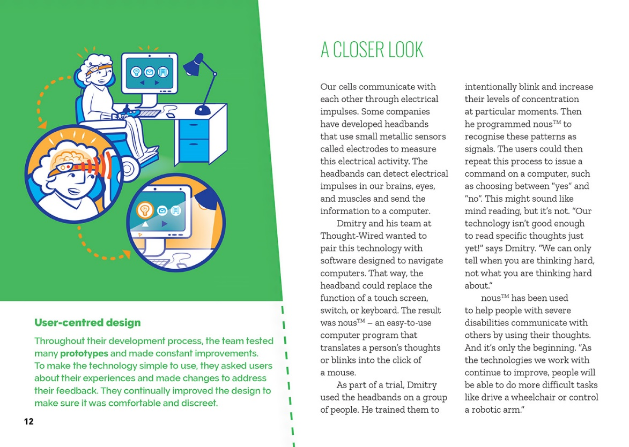

Digital technologies are helping to find solutions to social and medical problems.

Technological outcomes are developed to meet a need or opportunity.

Feedback from users informs the development of an outcome.

Learning activities – Exploring the technology
and mathematics and statistics
The following activities and suggestions are designed as a guide for supporting students to explore and extend student content knowledge across the learning areas. Adapt these activities to support your students’ learning needs.

Activity 1 – Evaluating the technologies  When the students have completed the reading, have them work in small groups to create PMI charts like the one below to evaluate the three different technologies. Prompt critical thinking, encouraging them to go beyond the text to consider benefits, risks, and possible future developments. This activity may prompt some online research.  How does society benefit from each of these technologies?  What could go wrong?  What are some other interesting possibilities for these technologies?  People often talk about new digital technologies as being innovative. What does innovative mean? Do you agree that these technologies are innovative? Why or why not?  When people innovate, they often bounce off other people’s ideas. What are some examples of technologies that these companies have adapted or improved?  Plus Minus Interesting  Thought-Wired  PledgeMe  Firstcheck  With all this in mind, have the students rank the three examples in terms of different criteria. Conduct a version of the four corners activity in which the students move to a different part of the room according to how they ranked the digital technologies in relationship to the criteria. They can discuss their evidence and reasoning in groups and then test and challenge their reasoning in discussion between the groups. Students can shift to a different group if they change their minds. The criteria could include:  - most innovative  - most beneficial to society  - most risks for society.  Activity 2 – Digital technologies and healthcare  Have the students research digital technologies that are being used to address medical issues, such as artificial limbs, digital devices to help monitor insulin levels or blood pressure, or digital hearing aids. Brainstorm examples, then have the students summarise what they have learnt using graphic organisers like the ones they created when reading the article. Prompt them to focus on the concept of user experience – where the developers of the technologies incorporate the lived experiences of their users into the design of their products. | Name of technology  Developer  Need or opportunity  Purpose  Key attributes  User-centred design  The students could extend their summaries with images or diagrams, interviews with designers or users, and actual examples of the technologies in use. They could put these together into a health expo that shows other people in the school the possibilities for using digital technology to promote health and well-being across our communities.  Following the expo, return to the concept of user-centred design. Have the students brainstorm what they believe are the key principles of user-centred design, then narrow them down to a short list of principles that they can apply whenever they are designing new technologies.  Extension  The students could design a simple website that reflects the principles of user-centred design. They will need to decide on the purpose of the website and its audience. For example, the audience might be people who are concerned about potential health issues as they age and want to know about digital technologies that could help them.  Activity 3 – Can we help?  Reiterate the point that the companies we read about are all using digital technologies to answer “ambitious questions” and “tackle some of the world’s biggest problems”. Invite the students to identify issues in their own homes, school, and community and develop ideas for technologies that could make a positive difference. Prompt their thinking by mentioning common problems, such as forgetting sports shoes or running late for school.  - How could digital technologies enhance life at our school? What about at home or in our neighbourhood?  - What are some problems or issues that bug you?  - Have you seen digital technologies in action that you think could be repurposed to make life better for people in our community?  - The school jubilee is coming up. Is there an app we could create to help with that? Maybe to collect people’s memories? Or help with the scheduling?  Have the students move into groups to develop their ideas. They could work through the same process of developing their aims and designing key features as the developers in the article. It may or may not be feasible to take their ideas to fruition, but the students could still:

Learning activities – Exploring the technology and mathematics and statistics

Activity 3 – Can we help? (continued from page 6)  - specify their brief – the need or opportunity they are responding to and what they want their technology to do  - sketch their designs, identifying key attributes  - create diagrams to show the principles the design is built on  - take their ideas out to potential users for feedback  - investigate local funding options | - pitch their ideas to potential funders in a “Dragons’ Den” scenario or to a company that might be interested in taking it further  - find out how to patent their ideas.  Extension  The students could use Minecraft to design a healthy community of the future.

RESOURCE LINKS

Science Learning Hub  Innovation: www.sciencelearn.org.nz/resources/1699-introducing-innovation  You, me and UV: www.sciencelearn.org.nz/resources/217-you-me-and-uv-introduction  Understanding skin cancer timeline: www.sciencelearn.org.nz/resources/1737-understanding-uv-and-skin-cancer-timeline  Thought-Wired  Thought-Wired: www.thought-wired.com/  Stuff business – Thought-Wired crowdfunding to launch brain-controlled technology: www.stuff.co.nz/business/industries/83420837/thoughtwired-crowdfunding-to-launch-braincontrolled-technology  PledgeMe – Thought-Wired: www.pledgeme.co.nz/investments/237-thought-wired  PledgeMe  About PledgeMe: www.pledgeme.co.nz/about  Firstcheck  Firstcheck: https://firstcheck.me/  Stuff technology – Firstcheck app detects skin cancer early: www.stuff.co.nz/technology/apps/86324638/Firstcheck-app-detects-skin-cancer-early  Other sources  Diginomica – Technology for Social Good – myAgro seeds a mobile future: https://diginomica.com/2017/10/19/technology-social-good-myagro-seeds-mobile-future/  Diginomica/government – Technology for Social Good – UNICEF skills up refugee kids for a tech future: https://government.diginomica.com/2017/09/25/technology-social-good-unicef-skills-refugee-kids-tech-future/  Reuters – The robot helping ill kids to beat loneliness and keep learning: www.reuters.com/article/us-europe-education-healthcare/the-robot-helping-ill-kids-to-beat-loneliness-and-keep-learning-idUSKCN1GD56T  The Guardian – 3D-printed prosthetic limbs: the next revolution in medicine: www.theguardian.com/technology/2017/feb/19/3d-printed-prosthetic-limbs-revolution-in-medicine | Digital Trends – Here’s 7 prosthetic limbs that’re so amazing that they’re almost better than the real thing: www.digitaltrends.com/cool-tech/best-prosthetic-limbs/  Smithsonian.com – This digital prosthesis could help amputees control computers: www.smithsonianmag.com/innovation/digital-prosthetic-could-help-amputees-control-computers-180961397/  Prosthetic arms can provide controlled sensory feedback (study – YouTube video): www.youtube.com/watch?v=E90_4RY-K8w  MoleMan: http://moleman.co.nz/  Wellington student’s project lets amputees design their own artificial limb covers: www.stuff.co.nz/national/health/100069723/wellington-students-project-lets-amputees-design-their-own-artificial-limb-covers  3D printing a new way of life for amputees: www.mbie.govt.nz/ info-services/science-innovation/news-success-stories/success-stories/3d-printing-new-way-of-life-for-amputees  Paralympics: Techno-athletes Rio-bound: www.stuff.co.nz/sport/ other-sports/83529854/technoathletes-riobound  The bionic man – Liam Malone and his quest to be the fastest man in the world: https://idealog.co.nz/casestudies/bionic-man-liam-malone-and-his-quest-be-fastest-man-world  NZ Digital Health Strategy: www.digital.health.nz/content/digital-health/en/home.html  Givealittle: https://givealittle.co.nz/  GoFundMe: www.gofundme.com/  How Encryption Works: https://computer.howstuffworks.com/encryption.htm  Caesar cipher decryption tool: www.xarg.org/tools/caesar-cipher/  Wikipedia – Classical ciphers: https://en.wikipedia.org/wiki/Category:Classical_ciphers  Minecraft: https://minecraft.net/en-us/what-is-minecraft/

