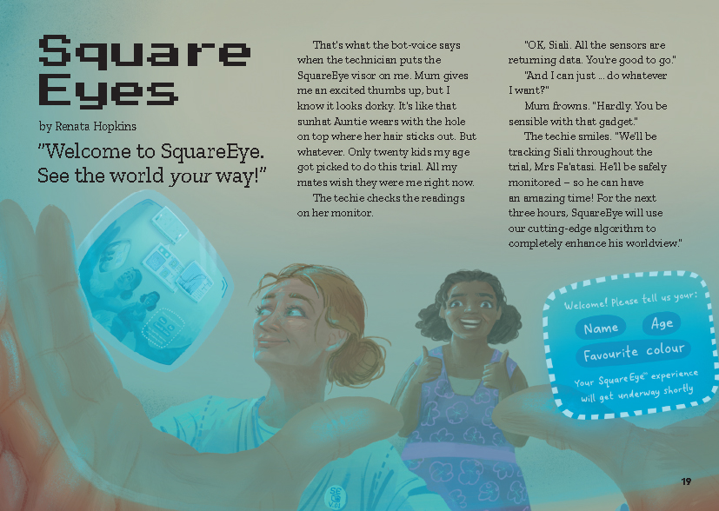
Connected
Level 3
2018

Square Eyes
by Renata Hopkins

Overview
This story is a kind of morality tale about how some digital technologies alter our experiences without us knowing. Told by the main character and set in the near future, it reveals what can happen if we place too much trust in digital technologies that collect personal data and track what we do.
A Google Slides version of this article is available at www.connected.tki.org.nz

Curriculum contexts

TECHNOLOGY: Technological Knowledge: Technological modelling  Level 3 – Students will understand that different forms of functional modelling are used to inform decision making in the development of technological possibilities and that prototypes can be used to evaluate the fitness of technological outcomes for further development. | Key technology ideas  - Societal and environmental issues can influence what technological products are made.  - Algorithms are often not neutral. They can be used to influence people and to encourage them to do one thing over another.  - Augmented reality is when computer-generated information is superimposed on a user’s view of the real world.  - New technologies have upsides and downsides.
ENGLISH: Reading  Level 3 – Ideas: Students will show a developing understanding of ideas within, across, and beyond texts. | Indicators:  - uses their personal experience and world and literacy knowledge confidently to make meaning from texts  - makes meaning of increasingly complex texts by identifying main and subsidiary ideas in them  - starts to make connections by thinking about underlying ideas in and between texts  - makes and supports inferences from texts with increasing independence.
MATHEMATICS and STATISTICS: Statistics: Statistical investigation  Level 3 – Students will conduct investigations using the statistical enquiry cycle:  - gathering, sorting, and displaying multivariate category and whole-number data and simple time-series data to answer questions;  - identifying patterns and trends in context, within and between data sets;  - communicating findings, using data displays. | Key mathematics ideas  - Algorithms are used to collect and make sense of data.  - Statistical investigations explore and find patterns, trends, and relationships.

The New Zealand Curriculum

Meeting the literacy challenges

The main literacy demands of this text lie in the abstract ideas about how algorithms can change our individual experiences and how this can interfere with our critical thinking and harden our prejudices. While the story is set in the future, it is not far in the future, and the technologies are recognisable, operating on the same principles as technologies that students are likely to be familiar with.  The narrator is unreliable, as his perceptions are distorted by his visor. Students will need to infer information from the text and the illustrations to recognise that his “enhanced” worldview is actually blinkered. Given that this is the point of the story, it is not necessary that students realise this until the end of the first reading. For this reason, it would be preferable to let the students read without too much discussion. | The following strategies will support students to understand, respond to, and think critically about the information and ideas in the text. It may be appropriate to use all or only one or two of these strategies, depending on your students’ literacy knowledge and skills. You are encouraged to reword the suggested questions that will best suit your learners’ strengths and needs.  You may wish to use shared or guided reading, or a mixture of both, depending on the reading expertise of your students and the background knowledge they bring to the text.  After reading the text, support students to explore the activities outlined in the following pages.

INSTRUCTIONAL STRATEGIES

Establishing the context  EXPLAIN that this is not an article but a story, one that features digital technology. Have the students read the title and the hook and look closely at the picture on page 19. ASK QUESTIONS to PROMPT them to infer information from these features.  Whose perspective are we looking from?  Who are we looking at? What else can this person see?  It says “Square Eyes” in the title and “SquareEye” in the hook. I wonder why there is this difference.  What do the words “Square Eyes” make you think of? What do you think SquareEye is? What can it do?  What do you notice about the colour in the illustration? What might that signal? [It distinguishes the real world from the augmented world]  What do you take from the slogan “See the world your way!”? Why do you think the word “your” is italicised? Who is saying these words? What does the exclamation mark signal?  What feeling does the image convey? How do you think the narrator feels about this experience?  Have the students read page 19 to check their inferences and find more information.  When do you think this story might be taking place? What are the clues for this?  How do each of the people in the story feel about the trial? How can you tell?  What do you make of the word “algorithm”? How might a “cutting-edge algorithm” enhance Siali’s worldview?  What is the main message the narrator is getting from his mother, the technician, and SquareEye? What does he think will happen? What do you think will happen? Let’s read on to find out if we’re right.  Unless the students require further support, have them read the story independently. If they do need additional support, help them make connections to their prior knowledge. However, try not to give away too much – let them work out what might be happening as they read. | Making connections and finding the main ideas  Following the reading, focus the students’ attention on the digital technology in this story. Have them work in pairs to discuss:  - the difference between an input device and an output device [An input device, like a keyboard, sends information to a computer for processing, and an output device, like a monitor, reproduces or displays the results of this processing.]  - the types of input and outputs the SquareEye could be using [Possible inputs include a camera, a microphone, light sensors, or a brain sensor. Possible outputs include a screen in the visor or a speaker in the ear.]  - other technologies that resemble SquareEye at the moment. [Possible answers include augmented reality, brain–computer interfaces, Google Glass, virtual reality headsets like Oculus Rift, and websites like YouTube and Google that collect your data and personalise your experience.]  Working in pairs, have the students discuss:  - whether or not they were surprised about how the story ended  - the authors purpose and the effectiveness of the story in conveying this purpose  - the credibility of the story – could it happen? Why? Why not?  Encourage students to use evidence from the text to support their reasoning.  Responding to the story  Working in groups, have the students draw up a PMI chart to RECORD their thoughts about the positives and negatives of using a digital tool like SquareEye to “enhance” their worldview.  SquareEye  Positives Negatives Interesting  DISCUSS the features of a report and then have the students write a brief report in the role of the technician. Use the “pass it on” technique, which has each student writing a sentence and then passing it on to the next person. When they finish their reports, each group selects their favourite version to share with the class.

Meeting the literacy challenges

TEACHER RESOURCES

Want to know more about instructional strategies? Go to:  - http://literacyonline.tki.org.nz/Literacy-Online/Planning-for-my-students-needs/Effective-literacy-practice-years-5-8  - “Engaging Learners with Texts” (Chapter 5) from Effective Literacy Practice in Years 5 to 8 (Ministry of Education, 2006).  Want to know more about what literacy skills and knowledge your students need? Go to:  - http://nzcurriculum.tki.org.nz/Assessment/Reading-and-writing-standards  - http://www.literacyprogressions.tki.org.nz/ | We have retained the links to the National Standards while a new assessment and reporting system is being developed. For more information on assessing and reporting in the post-National Standards era, see:  - http://assessment.tki.org.nz/Assessment-and-reporting-guide

Reading standard: by the end of year 6
The Literacy Learning Progressions
Effective Literacy Practice: years 5–8

Illustrating the key ideas

TEACHER SUPPORT
Algorithms are often not neutral. They can be used to influence people and to encourage them to do one thing over another.
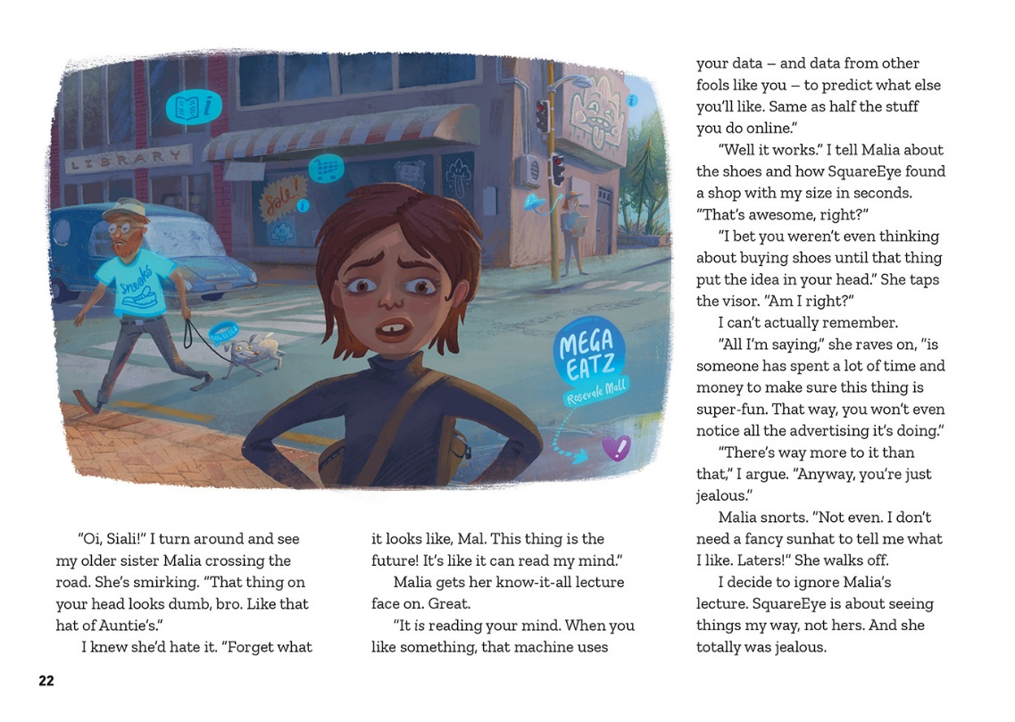

Augmented reality is when computer-generated information is superimposed on a user’s view of the real world.

Societal and environmental issues can influence what technological products are made.

New technologies are not always positive for society.

Learning activities – Exploring the technology
and mathematics and statistics
The following activities and suggestions are designed as a guide for supporting students to explore and extend student content knowledge across the learning areas. Adapt these activities to support your students’ learning needs.

Activity 1 – Digital devices with tracking tools or brain-computer interfaces – what’s out there now?  Have the students share examples of digital tools that collect personal data or use tracking technology (for example, Siri, Alexa, Fitbit, Google Locate, Find my iPhone, Net Nanny, Life 360 Family Locator, the National Dog Register, parcel tracking).  Complete a jigsaw activity in which the students work in small groups to investigate a digital tool that collects personal data and incorporates tracking technology and/or a brain–computer interface. Their questions for investigation might include:  - Who is it for?  - What it is used for?  - How do you use it?  - Who makes it?  - How does the technology work?  - What might the future hold for this sort of tool?  - What are the potential advantages?  - What are the potential negatives?  Set up a shared space like a Google doc where the students can record their answers to each of these questions.  When the students have completed their investigations, have them read through all the entries so they can learn from each other. Encourage them to think critically and note any questions or thoughts in the relevant parts of the Google doc. This may be better done within their groups so they can support each other to continue any conversations about the implications of the new technologies. Then break the students into new groups. They are to discuss the questions and comments, recording the main points that emerge from their discussions and share them with the rest of the class.  If the students have difficulty thinking of questions, you could ask them to organise the list of digital tools according to certain criteria, for example:  - how helpful they think it could be  - how risky they think it could be  - how accessible it could be for ordinary people  - how exciting they find it.  They will need to debate their decisions and try to come to a consensus. Have the groups compare their rankings with other groups and discuss the differences.  Support the students to identify any big questions that emerge from these activities and to research them further (for example, about privacy or accessibility). Potentially, this could lead to social action (for example, campaigning for or against the use of apps to monitor young people’s movements or their use of the internet).  Extension  Have the students design their own brain-computer interfaces and expand on how it could enhance their lives, covering the positives and the negatives. They could then debate the proposition: “It’s too dangerous. Our thoughts are our own  – we shouldn’t automatically share them with technology. | Activity 2 – Are we being brainwashed?  Check that the students know what an algorithm is and what an algorithm can do. You could use the TechTarget video, How Stuff Works, or the BBC Bitesize item (all in the resource links) to support this.  Use the following exercise, borrowed from Quartz, to introduce the concept of a filter bubble and how algorithms in computer systems reinforce bias. Open Google in two tabs and search “Are reptiles good pets?” in one and “Are reptiles bad pets?” in the other. Quartz explains that in both instances, Google will faithfully attempt to offer you advice, but the answers will be different. In the first instance, it will reflect what it perceives to be your enthusiasm for reptilian pets by suggesting sites that explain why reptiles make great pets. In the second, it reflects your perceived hesitation by suggesting sites that explain the negatives. The search engine reinforces your biases as a side effect of the way its algorithm deals with your question.  The students could examine other forms of digital technology that have the potential to subconsciously influence their thoughts and actions (for example, Facebook feeds and product suggestions from sites such as Amazon or Trademe).  Ask questions to prompt the students to ask ethical questions about this kind of influence.  - How do you feel about the idea that when you search for answers to a question, the answers may be specifically tailored to you? What are the implications of this for your inquiry? Is it helpful or harmful, or both?  - Are you aware of being influenced to buy something on the basis of this sort of advertising?  - Have you heard about claims of Facebook being used to influence people during the 2016 United States presidential election? Could something like that happen here?  - Which people are most likely to use digital technology in this way? Which people are most likely to be the targets of this sort of subtle pressure?  - What can we do to safeguard against this kind of influence?  Have the students design an investigation into the ways that algorithms are used in marketing or in political campaigns. The investigations could include a survey to find out whether people in their whānau, school, and wider community are aware of this influence. They could include some form of action, such as publishing a pamphlet that teaches people how to manage the influence of algorithms.  Extension  Activity 1 in the teacher support materials for “Sensing Data” (Connected 2017, Level 4) suggests approaches for students to explore the implications of collecting and using big data.

Learning activities – Exploring the technology and mathematics and statistics

RESOURCE LINKS

Connected and School Journal  “Driving Us into the Future”, Connected 2016, Level 4, Getting the Message  “Sensing Data”, Connected 2017, Level 4, Where to Next?  “Boost”, School Journal Level 3, August 2015  “Thirst”, School Journal Level 3, August 2015  “The World Will End, Said the Cat”, School Journal Level 4, November 2016  Science Learning Hub  A guide to developing students’ “futures thinking” skills: www.sciencelearn.org.nz/resources/2438-teaching-futures-thinking  Frameworks for ethical decision making: www.sciencelearn.org.nz/resources/2146-frameworks-for-ethical-analysis  Other sources  TechTarget: WhatIs.com – algorithm: http://whatis.techtarget.com/definition/algorithm  How Stuff Works: What is a computer algorithm?: https://computer.howstuffworks.com/question717.htm  BBC Bitesize: What is an algorithm?: www.bbc.co.uk/guides/z3whpv4  How Stuff Works: How Brain-computer interfaces work: https://computer.howstuffworks.com/brain-computer-interface.htm  Bloomberg: Brain-computer interfaces are already here: www.bloomberg.com/news/features/2017-09-07/brain-computer-interfaces-are-already-here  CNN: How close are we to Elon Musk’s brain-computer interface?: https://edition.cnn.com/2017/04/12/health/brain-computer-interface-partner/index.html | RNZ: Explainer: Why you should care about Cambridge Analytica: www.radionz.co.nz/news/national/353023/explainer-why-you-should-care-about-cambridge-analytica  Pass it on writing: http://esolonline.tki.org.nz/ESOL-Online/Planning-for-my-students-needs/Resources-for-planning/ESOL-teaching-strategies/Writing/Pass-it-on-writing  Quartz: Google is finally admitting it has a filter-bubble problem: https://qz.com/1194566/google-is-finally-admitting-it-has-a-filter-bubble-problem/  Stuff: Daycare centres use GPS to track children: www.stuff.co.nz/technology/digital-living/5669941/Daycare-centres-use-GPS-to-track-children  Tech Trends 2017 Mixed Reality: AR, VR, and IoT collide: www.youtube.com/watch?v=Y9AWCndW_n4  Noted: How much will Facebook influence this year's election?: www.noted.co.nz/currently/politics/how-much-will-facebook-influence-this-years-election/  Political Roundup: NZ’s “like me” social media election campaign: www.nzherald.co.nz/nz/news/article.cfm?c_id=1&objectid=11888838  The Star Online: Is digital fitness tracking actually improving our health?: www.thestar.com.my/tech/tech-news/2018/06/25/is-digital-fitness-tracking-actually-improving-our-health/  Understanding digital tracking: www.youtube.com/watch?v=6EHSlhnE6Ck  Immersive Learning Resources: Augmented reality: www.dlt.auckland.ac.nz/2018/03/08/immersive-learning-resources-augmented-reality/

