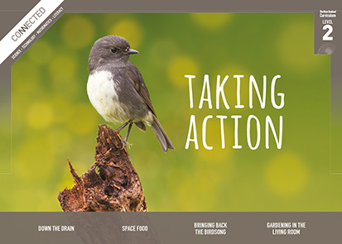
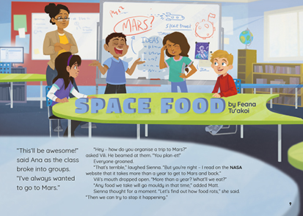
Connected
Level 2
2017

Space Food
by Feana Tu’akoi

Overview
This article recounts a lively classroom discussion about how to prevent food rotting on a journey to Mars. It demonstrates how scientists build knowledge by sharing what they know, asking critical questions, seeking evidence, and checking for logical connections.
A Google Slides version of this article is available at www.connected.tki.org.nz.

Curriculum contexts

SCIENCE: Nature of Science: Participating and contributing  Level 2 – Students will explore and act on issues and questions that link their science learning to their daily living. | Key Nature of Science ideas  When we engage scientifically with an issue, we:  - Look for a range of scientific information that relates to the issue  - Check that information we use is from a trustworthy source  - Consider the reliability and validity of the evidence  - Decide if and how to respond to the issue, justifying our decisions based on evidence and/or reliable scientific information  - Monitor the effects of any actions we take.
SCIENCE: Material World: Properties and changes of matter  Level 2 – Students will observe, describe, and compare physical and chemical properties of common materials and changes that occur when materials are mixed, heated, or cooled. | Key science ideas  - Food changes as it loses its freshness.  - The types of changes that food can undergo are related to their chemical composition and the conditions in which they are kept.  - People have developed technologies that slow down or alter the natural processes of decomposition in food.  - Preserving stops or slows fungi and bacteria from spoiling food.
ENGLISH: Reading  Level 2 – Ideas: Students will show some understanding of ideas within, across, and beyond texts. | Indicators  - Uses their personal experience and world and literacy knowledge to make meaning from texts.  - Makes meaning of increasingly complex texts by identifying main ideas.  - Makes and supports inferences from texts with some independence.
TECHNOLOGY: Technological Knowledge: Technological products  Level 2 – Students will understand that there is a relationship between a material used and its performance properties in a technological product. | Key technology ideas  - People use food materials (ingredients) for different purposes.  - Food can be changed in many ways to make different products.

The New Zealand Curriculum

Science capability: engage with science

Capability overview
This capability requires students to use the other capabilities to engage with science in real-life contexts. It requires students to take an interest in science issues, participate in discussions about science, and at times, take action.  The dimensions of this capability can be demonstrated when students engage in discussions about science issues, including those in the media. If these discussions build on the ideas of others, emphasise logical connections, and draw reasonable conclusions, and if the speakers make the evidence behind their claims explicit, then students have the opportunity to practise playing the “game of science” (Resnick, Michaels, & O’Connor, 2010). | This allows them to deepen their understanding of what science is.  Students also need opportunities to be actively engaged in exploring real-life science issues that are relevant to them and their communities. This could involve building new knowledge with others and taking action to address local or global concerns.

More about the capability

The capability in action
Real-life science issues:  - may involve a mix of scientific issues and forms of social-science inquiry, including values and ethics  - provide opportunities to build awareness of which questions can be investigated and which questions science does not answer  - provide opportunities to see science as tentative, that is, developing over time as evidence is gathered or reinterpreted  - provide experiences of uncertainty where there is no clear explanation or solution  - allow students to gather and interpret data about a local situation or to critique a range of evidence and claims  - may generate a range of student views, responses, and possible actions.  Students  Students should have opportunities to:  - take an interest in a range of scientific issues  - participate in discussions about scientific issues  - use their developing capabilities of gathering and interpreting data, using and critiquing evidence, and interpreting representations to create a viewpoint, response, or action on scientific issues.  Teachers  Teachers can:  - establish a science classroom culture by:  - taking a personal interest in scientific issues, modelling questions, explicitly critiquing evidence, and seeking further evidence  - maximising everyday opportunities to introduce learning conversations that engage students with science and scientific issues | - helping their students to notice and investigate science in their everyday surroundings, such as ice on a puddle, the health of a local stream or river, or what happens as materials are mixed or heated  - listening to and discussing socio-scientific items in the news  - exploring locally relevant and contentious scientific issues, such as irrigation, intensive farming, or the effects of climate change  - support students to identify scientific aspects of an issue  - provide a range of resources and investigation opportunities pertaining to scientific issues that require students to use a range of science capabilities  - encourage students to seek and critically evaluate a range of scientific evidence, opinions, and actions from a variety of sources about an issue  - manage with sensitivity situations where students and their whānau may hold differing and strongly held opinions about a science-related issue, such as irrigation  - support students to identify and take appropriate actions in response to science-related issues.  It is important that students are empowered to be hopeful and see opportunities for positive action and change when considering local and global issues.

More activities to develop the capability

Meeting the literacy challenges

The main literacy demands of this text require students to follow a recount of an investigative and problem-solving process to find the best way of preserving food for a trip to Mars. Dialogue is used to convey how questions guide the investigative process, and the main ideas and details are often provided in these conversations. Students will use their prior knowledge of how web pages work, including knowing about pop ups and hyperlinks. Diagrams are also used to explain bacteria and the difference between “use-by dates” and “best-before dates”. Unfamiliar vocabulary is supported in the text or explained in a glossary. | The following instructional strategies will support students to understand, respond to, and think critically about the information and ideas.  You may wish to use shared or guided reading, or a mixture of both, depending on your students’ reading expertise and their background knowledge.  After reading the text, support students to explore the activities outlined in the following pages.

INSTRUCTIONAL STRATEGIES

Finding the main ideas  Have the students read the title and introduction, then SCAN the rest of the article. ASK QUESTIONS to help them notice how the author uses dialogue to engage the reader. Help them connect this to the way scientists use dialogue to debate and develop scientific ideas.  How does the author introduce the problem in the introduction? Why has the author used this technique? How effective do you think it is?  How does the author use dialogue in the rest of the story? Why do you think the writer uses dialogue to tell this story?  The author found another way to engage the reader in the introduction. Can you see what it is? What is this kind of word play called? [a pun] Look out for another example later in the story.  Make a chart about the ideas in the story and what they thought of each idea (see example below). Use the text on page 12 about Sienna’s vacuum sealing idea to MODEL how the students can use the chart to record this information. Have the students complete the rest of the chart in small groups.  Problem: How can we stop food from rotting?  Idea The students’ evaluation of the idea  Vacuum sealing Takes out the air to stop organisms growing Seals the bag so new organisms can’t get in Doesn’t take out the water so the food will still rot  The dialogue in the story is used to model a scientific discussion. PROMPT your students to notice how questions are used to explore scientific concepts and prompt the search for further evidence. | Notice how Miss Choudhary helped the students by asking specific questions. Look back through the article.  How did these questions help the students to think like scientists?  Where did the students get their ideas from? Where did they find evidence to support or disprove their ideas? (Note that the evidence in the article includes students’ prior knowledge, the cultural knowledge gained from relatives, research online, and books.)  There were problems with all of the students’ ideas. How did the ideas all come together in the end? Can you sketch this?  Extending the learning  Have the students use dialogue to describe an investigation they have done. They need to show the problem and the kinds of questions that arose as they set up their investigation and gathered and analysed their data.  Using design features for deeper understanding  There is a great deal of additional information in the images. This is particularly true of the image of the computer screen on page 10. Have the students IDENTIFY and LIST the features of this page (for example, the heading, introductory text, and symbols).  Have the students COMPARE how information about micro-organisms is conveyed on the screen with how information about freeze-drying is conveyed in the book (page 15).  How is information shown in the page on freeze-drying? What are some other ways scientific information is conveyed in books? We’re reading a book right now. What are some of the design features of this book that help you learn about science?  Which do you prefer to use when you are researching scientific information – books or the Internet? What are the advantages and disadvantages of each?

Reading standard: by the end of year 4
The Literacy Learning Progressions
Effective Literacy Practice: years 1–4

Meeting the literacy challenges

TEACHER SUPPORT
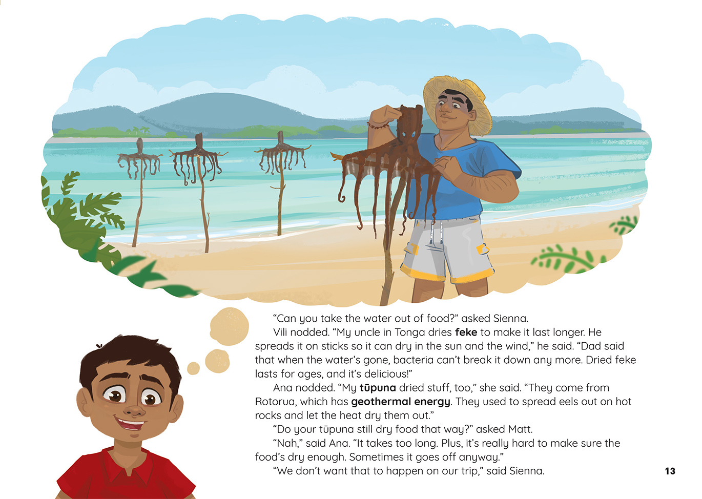 |  | Students take an interest in a scientific issue.  People have developed technologies that slow down or alter the natural processes of decomposition of food.  Preserving stops or slows fungi and bacteria from spoiling food.
Students describe changes that occur when materials are heated. | [Grab your reader’s attention with a great quote from the document or use this space to emphasize a key point. To place this text box anywhere on the page, just drag it.]

Learning activities – Exploring the science
The following activities and suggestions are designed as a guide for supporting students to explore and develop understandings about the science capability “engage with science”. Some activities focus directly on the science capability. Other activities extend student content knowledge across the learning areas. Adapt these activities to support your students’ learning needs.

Activity 1 – What makes food rot … and how can we stop it?
Have the students reread pages 10 and 11 of the article and then check their understanding through some hands-on activities from Building Science Concepts Book 23, Fresh Food: How Food Keeps and Loses Its Freshness and Book 24, Preserving Food: Processes in Food Storage. As the students do these activities, model your use of the subject-specific vocabulary (for example, micro-organisms, bacteria, fungus, energy, and temperature).
- BSC 23: Use the activities in Section Two to support the students to investigate the properties of various foods and how they affect how long the food stays fresh.
- BSC 24: Section One, Activity 2: Have the students observe, record, and analyse the packaging information on food. Add two columns to the table for “use-by dates” and “best-before dates”. When the students analyse their data, ask them to look for any pattern between use-by date and best-before date. (Best-before dates are more common on food that is less perishable. See this Consumer article.)
- BSC 24: Section Two, Activity 2: The students experiment with drying and freezing different kinds of food. They observe how these preservation techniques affect the properties of the food.
- BSC 24: Section Three, Activity 1: The students use their prior knowledge about the role of water, air, and warmth in growing micro-organisms to generate a table recording the best methods for preserving different kinds of food.
- BSC 24: Section Three, Activity 2: Remind the students of Vili and Ana’s descriptions of traditional techniques for preserving food. Have them research and report on other techniques that people used in the past. Examples might include pickling vegetables, preserving fruit in syrup, storing kai in pātaka (storage houses) or kumara pits, or wrapping birds in seaweed and packing them into calabashes. Explain that in their reports they need to identify the source of their information and explain exactly how the technique reduces the effects of warmth, air, or water.
Have the students use what they have learned to experiment with food preservation methods for different:
- types of food
- amounts of food
- lengths of time
- settings and purposes (for example, home, school, travel).

Extending the learning
Bacteria aren’t always bad; in fact, they can be very good for us. Many cultures understand the health benefits of fermented food. To reinforce this concept, the students could experiment with making yoghurt (See Making Better Sense of the Material World, page 53), or sauerkraut.

Activity 2 – Mission to Mars
The students in the article were researching what they would need for a trip to Mars. They began by wondering about the food they would need, and then they investigated how they could ensure their food didn’t rot.
Working in groups, have the students generate questions about “space food”. Each group can select one question. Questions might include:
How would you cook the food?
How would you eat it without making a mess?
How would you drink?
How is the food stored?
They record their ideas, using a similar chart to the one they used when reading the article (see example below). The students can use the resource links listed below, but they can also draw on any prior knowledge, just like the students in the article. Each group should come to a conclusion that they can justify with evidence.
Problem
Idea | Our evaluation
Our conclusion
Sources
When they have completed their investigations, the students can use their charts to report their findings to the rest of the class. Encourage them to listen critically, prompting each other to explain the evidence and justify their conclusions.
How do we know we can trust your evidence?
Tell the students that they have been asked to develop advertising material for a company that wants to take people to Mars.
A trip to Mars is no easy thing! The space travel company needs you to think about the questions people will ask before going on a trip like this. The marketing material will need to address those questions in a way that is convincing.

Learning activities – Exploring the science

Help the students generate questions by having them read Becoming a Martian by Clare Knighton. Questions might include:  How is toileting handled?  How would you get enough exercise?  How would you deal with no gravity?  How long is it likely to take? | Have the students decide the most important questions. Conduct a jigsaw activity:  Have groups of students take responsibility for investigating one of the questions, following the process they used for their focus on food.  Have them share what they have learned and use it to create their promotional material.  The students can decide how they will promote the mission to Mars (for example, posters, pamphlets, or a video presentation). They could present their campaigns to students in another class who could be asked to vote on the most convincing presentation.

RESOURCE LINKS

Building Science Concepts  Book 23 – Fresh Food: How Food Keeps and Loses Its Freshness  Book 24 – Preserving Food: Processes in Food Storage  Making Better Sense of the Material World  Making yogurt activity: Making Better Sense of the Material World, page 53  School Journal  “Becoming a Martian”, School Journal May 2017, level 3. http://instructionalseries.tki.org.nz/Instructional-Series/School-Journal  NASA  Mars facts: https://mars.nasa.gov/allaboutmars/facts/#?c=inspace&s=distance  All about Mars: https://mars.nasa.gov/allaboutmars/  Food for space flight: www.nasa.gov/audience/forstudents/postsecondary/features/F_Food_for_Space_Flight.html  How Stuff Works  How space food works: http://science.howstuffworks.com/space-food.htm  How freeze-drying works: http://science.howstuffworks.com/innovation/edible-innovations/freeze-drying.htm  How food preservation works: http://science.howstuffworks.com/innovation/edible-innovations/food-preservation.htm  An experiment in freeze-drying (scroll down): http://science.howstuffworks.com/innovation/edible-innovations/food-preservation4.htm | ESA kids – Living in space  Eating in space: www.esa.int/esaKIDSen/SEMBQO6TLPG_LifeinSpace_0.html  Meals for Martians: www.esa.int/esaKIDSen/SEMQ8F1DU8E_LifeinSpace_0.html  Other sources  Use-by and best-before dates: www.consumer.org.nz/articles/use-by-dates-on-food  Traditional cooking and preserving: www.teara.govt.nz/en/maori-foods-kai-maori/page-2  Love Food hate waste New Zealand – Everything you need to know about expiry dates: https://lovefoodhatewaste.co.nz/reduce-your-waste/reduce-your-wasteunderstand-use-by-and-best-before-dates/  Smithsonian National Air and Space Museum – Food in Space: https://airandspace.si.edu/exhibitions/apollo-to-the-moon/online/astronaut-life/food-in-space.cfm  Spacekids – a children’s guide to astronaut food: www.spacekids.co.uk/spacefood/  Wonderopolis: Why Does Food Rot? http://wonderopolis.org/wonder/why-does-food-rot

Learning activities – Exploring the technology

Activity 1 – All dried up  In the past, many people knew how to preserve food. Now we can get a lot of our food fresh all year round. Discuss why it is still useful to preserve food. Examples could include dealing with a natural disaster or going for a tramp.  Have the students draw a flowchart to describe the basic process for dehydrating food. Then have them experiment with different methods. For example, they could:  - dehydrate grapes to make raisins, following the process described in the attached activity “Making raisins”  - dehydrate milk, as described in Making Better Sense of the Material World, page 48  - use an oven or microwave to dehydrate other foods, such as apples or tomatoes  - use a freezer to freeze-dry the food  - use a commercial dehydrator.  Have the students draw up a chart to list the pros and cons of each method. | Activity 2 – Putting it to the test  Tell the class that they will be going on a tramp and they will have to take their own food. Invite a tramping expert to talk about the pros and cons of different types of preserved foods.  The students can then plan and prepare a dehydrated meal to take on their tramp. (The meals could be planned at school and prepared at home.) Before the tramp, they can develop a set of criteria to evaluate their meals. Remind them to think about what their visitor told them. The evaluation can take place over lunch, when they evaluate how tasty their meals are, and near the end of the day, when they think about how well they have been sustained.  The students could use what they have learned to create a book of advice that other students could use if they are planning a tramp. If the meal did not go well, the advice could include what not to do. Remind the students that scientists and engineers learn from their mistakes as much as their successes!

RESOURCE LINKS

Building Science Concepts  Book 23: Fresh Food: How Food Keeps and Loses Its Freshness  Book 24: Preserving Food: Processes in Food Storage  Making Better Sense of the Material World  Dehydrating milk article: Making Better Sense of the Material World, page 48  Other sources  Tramping New Zealand – Food, glorious food, maybe: www.tramping.net.nz/planning/food  Using the dehydrator: www.westaucklandtrampingclub.co.nz/gear/using-the-dehydrator/  The Wellington Tramping and Mountaineering Club Cookbook: www.wtmc.org.nz/sites/default/files/WTMC-cookbook-version2-2013_1.pdf  How to dehydrate food in the oven: http://urbansurvivalsite.com/how-to-dehydrate-food/  How to dehydrate food in the microwave: www.leaf.tv/articles/how-to-dehydrate-food-in-a-microwave/ | How Stuff Works  How freeze-drying works: http://science.howstuffworks.com/innovation/edible-innovations/freeze-drying.htm  An experiment in freeze-drying (scroll down): http://science.howstuffworks.com/innovation/edible-innovations/food-preservation4.htm

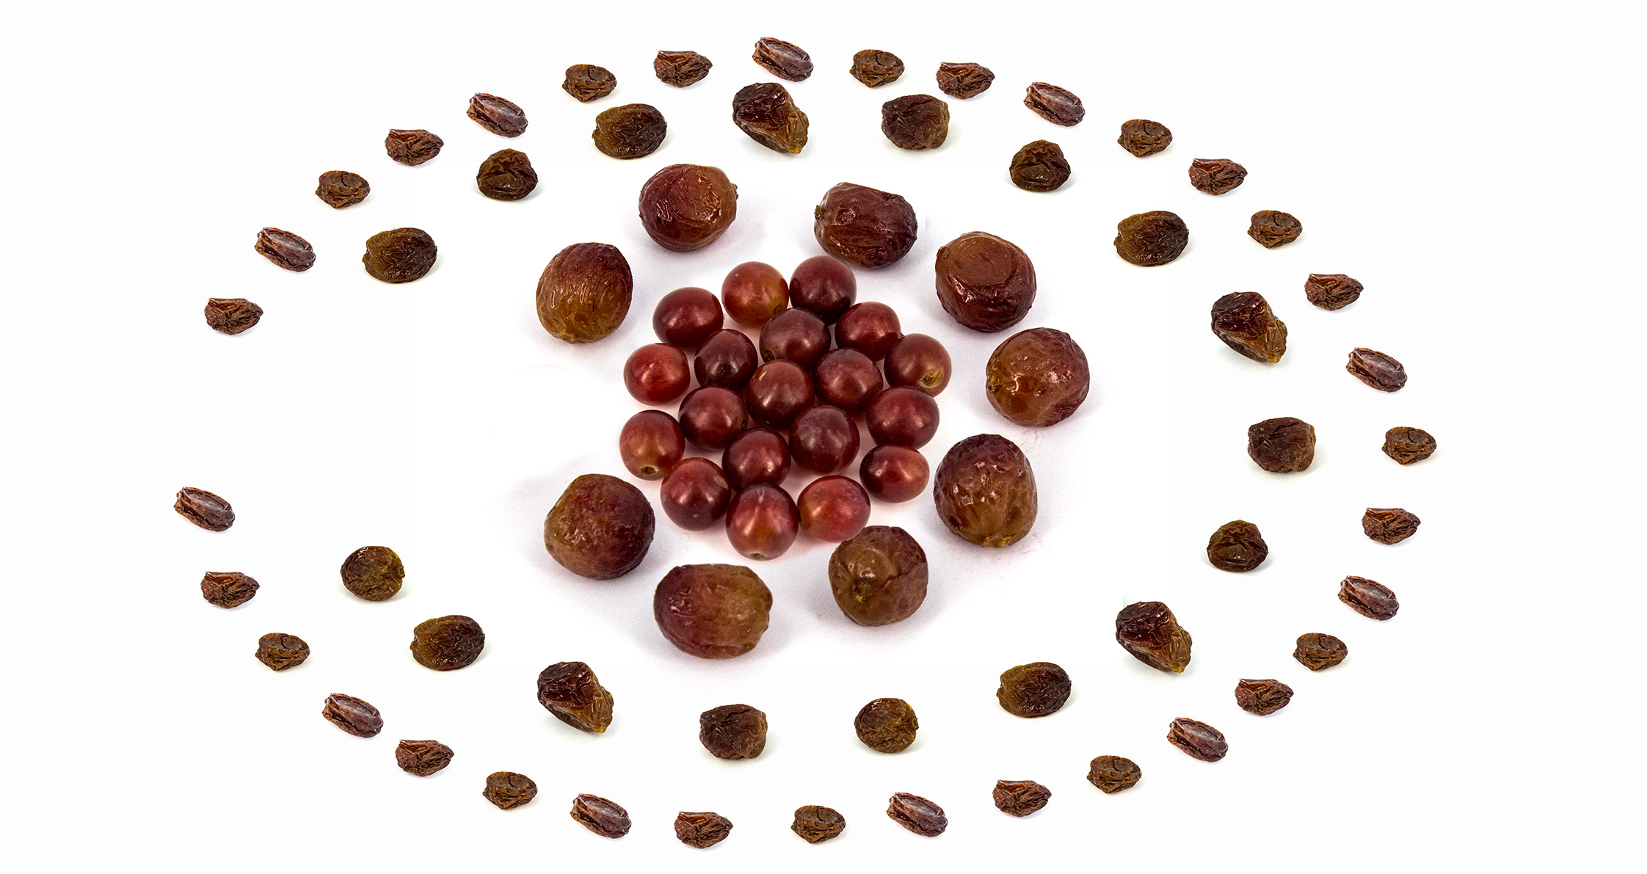

Making Raisins

Did you know that raisins used to be grapes?
Raisins are grapes that have been dried out, or dehydrated. Dehydration is the process of removing water from food. This slows down the growth of micro-organisms that break food down. While grapes normally go rotten in three to five days, raisins can last for over a year.

You will need:  - Fresh seedless grapes (red for raisins, green for sultanas)  - One perforated tray (a tray with holes in it, like a pizza tray)  - Tea towel or pillow case  - Sunshine*  * This activity needs at least five days of warm sun – so make sure to check the weather forecast first. For best results, try the activity in summer. |  | Method:  1. Carefully wash and dry the grapes.  2. Spread the grapes over the perforated tray.  3. Cover the grapes with the tea towel or pillow case – this will stop bugs from eating them. Make sure the tea towel or pillow case can’t blow away.  4. Leave the grapes outside in direct sun for at least five days. The grapes need lots of sun to dry out, so you might need to leave them out longer depending on the weather. If it gets damp or cold at night, take them inside in the evening and put them out again the next morning.  Follow-up activity  If dried-out raisins aren’t for you, try rehydrating them. Rehydrating raisins puts the water back into them. Put ten raisins in a cup of water and leave them to soak overnight. When you check them the next day, the raisins will be plump and round.

