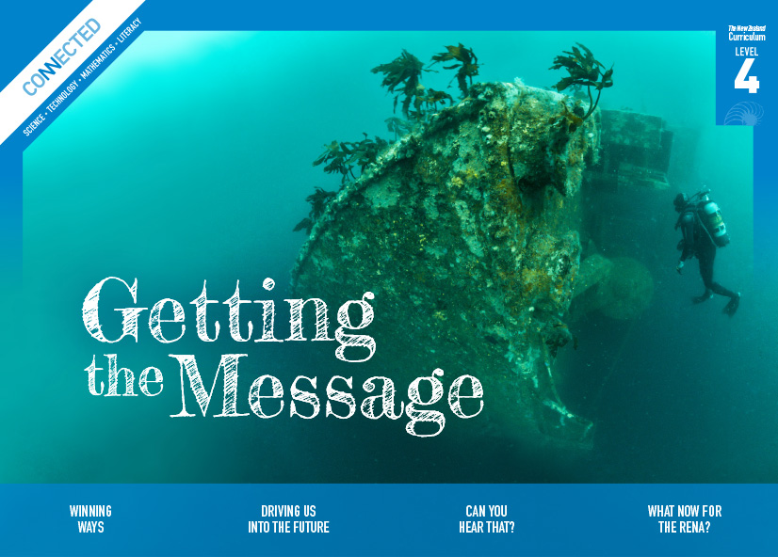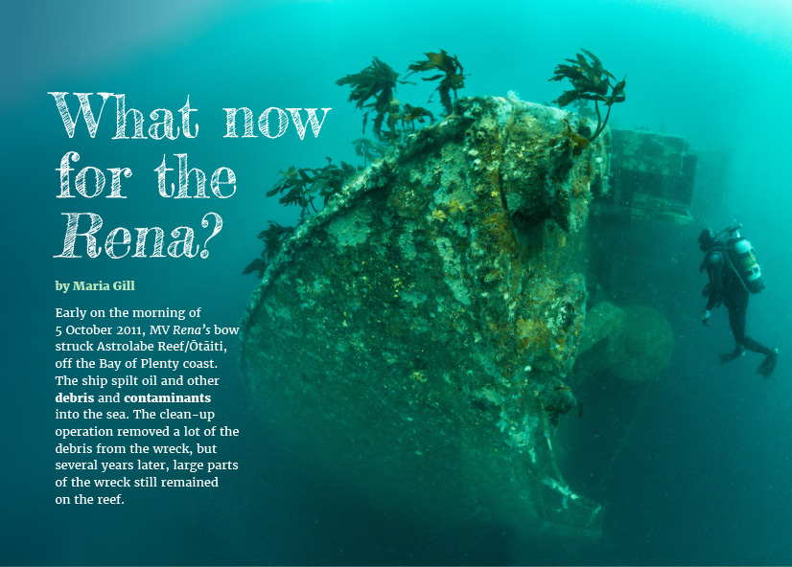
Connected
Level 4
2016

What Now for the Rena?
by Maria Gill

Overview
This article canvasses the differing points of view on whether the wreck of the Rena should be salvaged or left on the Astrolabe Reef/Ōtāiti. It reveals the complexity of the advice and views that the Bay of Plenty Regional Council had to take into consideration before making its decision.
A Google Slides version of this article is available at www.connected.tki.org.nz. This text also has additional digital content, which is available online at www.connected.tki.org.nz.

Curriculum contexts

SCIENCE: Nature of Science: Communicating in science  Level 4 – Engage with a range of science texts and begin to question the purposes for which these texts are constructed. | Key Nature of Science ideas  Scientists:  - record their data carefully in a variety of ways  - sometimes use models to understand a situation better  - draw conclusions from a range of evidence  - understand that scientific knowledge can change as new evidence comes to light.
SCIENCE: Living World: Ecology  Level 4 – Explain how living things are suited to their particular habitat and how they respond to environmental changes, both natural and human-induced.  SOCIAL SCIENCES: Social Studies  Level 4 – Students will gain knowledge, skills, and experience to:  - Understand that events have causes and effects.  - Understand how formal and informal groups make decisions that impact on communities.  - Understand how people participate individually and collectively in response to community challenges. | Key science ideas  - Habitats can be affected by natural phenomena and humans.  - Toxins can accumulate in higher amounts in animals nearer the top of the food chain.  - Materials do not just go away or disappear – they either react with other substances around them to change and rearrange into different substances or they remain in the environment somewhere.
ENGLISH: Reading  Level 4: Ideas: Students will show an increasing understanding of ideas within, across, and beyond texts. | Indicators  - Makes meaning of increasingly complex texts by identifying and understanding main and subsidiary ideas and the links between them.  - Makes connections by thinking about underlying ideas within and between texts from a range of contexts.  - Recognises that there may be more than one reading available within a text.  - Makes and supports inferences from texts with increasing independence.

The New Zealand Curriculum

Science capability: interpret representations

Capability overview
Scientists represent their ideas in a variety of ways. They might use models, graphs, charts, diagrams, photographs, and written text. A model is a representation of an idea, an object, a process, or a system. Scientists often use models when something is not directly observable. Models enable scientists to work on their ideas, even though they are often using a limited representation of the “thing” itself. It is important students can identify what is the same and what is different about the model and the thing. | It is important for students to think about how data is presented and ask questions such as:  - What does this representation tell us?  - What is left out?  - How does this representation get the message across?  - Why is it presented in this particular way?  This sort of questioning provides a foundation to critically interact with ideas about science in the media and to participate as critical, informed, and responsible citizens in a society where science plays a significant role.

More about the capability

The capability in action
The science capability “Interpret representations” is about students understanding information that is presented as a description or in visual form and recognising the best way to present information.  Scientific representations include diagrams, models, charts, and graphs, as well as written text  Scientists develop models and diagrams that best represent their theories and explanations.  Scientists  Scientists use:  - representations that can help both the original scientist and others clarify, critique, and evaluate their ideas, research, and theories  - computer and other kinds of modelling to predict what might happen in certain conditions and then test these predictions to see how accurate the model or idea is  - diagrams or models to communicate science ideas  - graphs to present data  - scientific forms of text involving argumentation that use evidence to debate explanations.  Students  Students should have opportunities to:  - learn to interpret a variety of representations, including models, diagrams, graphs, and text  - develop their own representations of scientific ideas, for example, through modelling using concrete materials or using their own bodies in mime and drama  - recognise how the model or representation matches the science idea and how it is different  - consider and critique a range of representations, including scientific texts, newspaper articles about scientific matters, online information about science matters, and scientific representations developed by their peers. | Teachers  Teachers can:  - help students to be more critical consumers of science information by being explicitly critical themselves and modelling useful questions  - support students to evaluate how information is presented, for example, to assess if a graphical representation has been done appropriately or is it misleading  - ask questions such as:  - What do you think this representation tells us?  - What do the (arrows, lines, symbols, etc.) mean? (that is, help your students interpret the features)  - Is anything left out? Do you think anything is missing?  - How does this get the message across?  - Is there anything more you need to know to be able to interpret this representation?  - How does the representation make the science idea clear?  - Which aspects of this representation could mislead the reader?  - Why is it presented in this way?  - Could you suggest a better way to represent it?  - establish a science classroom culture by:  - modelling and encouraging a critical stance  - encouraging students to consider the quality and interpretation of scientific representations  - introducing learning conversations that involve interpreting, critiquing, and developing representations to demonstrate the idea's relevance in everyday life.

More activities to develop the capability

Meeting the literacy challenges

The literacy demands in this text require students to combine information across the text to gain an understanding of the environmental issues caused by the Rena wreck. The article includes various language structures such as cause and effect, descriptions of differing viewpoints, and a table of detailed information about the contaminants.  Headings and subheadings help students to navigate each topic and gather information as they read. They will need to use photos and information in the text to build understanding of the decisions affecting the Rena’s future and effects on the environment. The table presents descriptions of the contaminants and chemicals still on board the wreck, and some of this vocabulary may be unfamiliar for students. | The following strategies will support students to understand, respond to, and think critically about the information and ideas.  You may wish to use shared or guided reading, or a mixture of both, depending on your students’ reading expertise and background knowledge.  After reading the text, support students to explore the activities outlined in the following pages.

INSTRUCTIONAL STRATEGIES

Finding information in the text  PROMPT the students to make connections to their prior knowledge of the Rena and its impact on the Astrolabe Reef/Ōtāiti. In most classes, some students will know this knowledge, but if this is limited in your class, consider first reading the School Journal article “What a Disaster!” or the Connected article “After the Spill”.  - What do you know about this shipwreck?  - What was its impact on the environment?  - How do you think different people in the Bay of Plenty area have felt about it?  - Who might have dealt with the wreck? What might different people have tried to do?  PROMPT the students to read page 28 and IDENTIFY the author’s purpose in writing this article:  - There have already been articles in Connected and the School Journal about the grounding of the Rena. I wonder why the writer thinks we need another one. Is there a clue in the title? Or in the introduction on the first page?  DISCUSS the fact that the introduction takes the time frame forward from the focus in the other articles. The author speaks directly to the reader, “Let’s explore some of the factors the panel considered when making their decision.” Have the students skim the text to get an idea of the factors the panel had to consider in deciding whether to leave the Rena on the reef. Encourage the students to suggest how they could organise the information for or against this decision. Using the subheadings, they could create a graphic organiser similar to the one below. As they work through the text, the students may find it helpful to add further layers to the heading levels, reflecting those in the text. Let this be something they discover for themselves. | Should the Rena be left on the reef?  Reasons for Yes Reasons for No  Environmental factors  Social and economic factors  Māori values and viewpoints  Pause after the students have read each of the main sections to allow them to RECORD the arguments for or against leaving the wreck. Ask for a show of hands (or line up along an imaginary continuum) whether the students think the ship should have been left there, removed, or whether they are unsure. Briefly DISCUSS the reasons for their thinking, taking particular note of students who have changed their minds.  - What is the new piece of information that has changed your thinking? Why did you find it persuasive?

Meeting the literacy challenges

After the reading, have the students reread paragraph 3 on page 28 and then scan the text to IDENTIFY the broad range of groups whose viewpoints are represented in the article (scientists, experts in recreation and tourism, local residents in general, local Māori). Using different-coloured highlighters, have the students go back over the reasons in the table to IDENTIFY the arguments and evidence put forward by the different groups. ASK QUESTIONS to help them explore what this reveals and what they think about it.  - Do you notice any patterns? For example, do different groups seem to have more to say about different factors? What does that say about what is important to them?  - Does everyone in the same group have the same opinion? Why do you think that is?  - Do you personally feel that any of the factors are more or less important than the others? Why is that?  - If you had been on the panel, what would you have decided? Why?  Draw out the concept that this sort of decision making is not just about scientific evidence. It is also about other aspects that are important to people as individuals and groups. Model how scientists consider scientific evidence alongside social needs and requirements.  - As humans, our beliefs and values can be just as important as the scientific facts. Each of us is unique in how we think and feel about things. So it's natural that sometimes, we can look at the same situation, the same factors, and the same evidence, and come to different conclusions. What we must always do is listen respectfully while weighing up the information for ourselves. | PROMPT the students to notice that the trust took account of some of the objections by promising to monitor the environmental impact.  - How did the trust address people’s concerns about the impact of leaving the wreck?  Using the table to interpret information  Have the students examine the table on page 31 before they read the final paragraph on page 28. Ask them to go through the table row by row, deciding whether the information about each contaminant is an argument for continuing the clean-up, is against it, or is neutral. They will get more out of this activity if they do it in pairs or small groups. The groups could then come together to DISCUSS their decisions as a class.  ASK the students if they think this table is an effective way to present the information.  - Why do you think the writer chose to put this information into a table?  - What other way could she have used?  - Do you think she chose the right headings? Do you think they are oriented the right way? Would you have chosen to put the types of chemical along the x-axis or the y-axis?

Reading standard: by the end of year 8
The Literacy Learning Progressions
Effective Literacy Practice: years 5–8

Meeting the literacy challenges

TEACHER SUPPORT
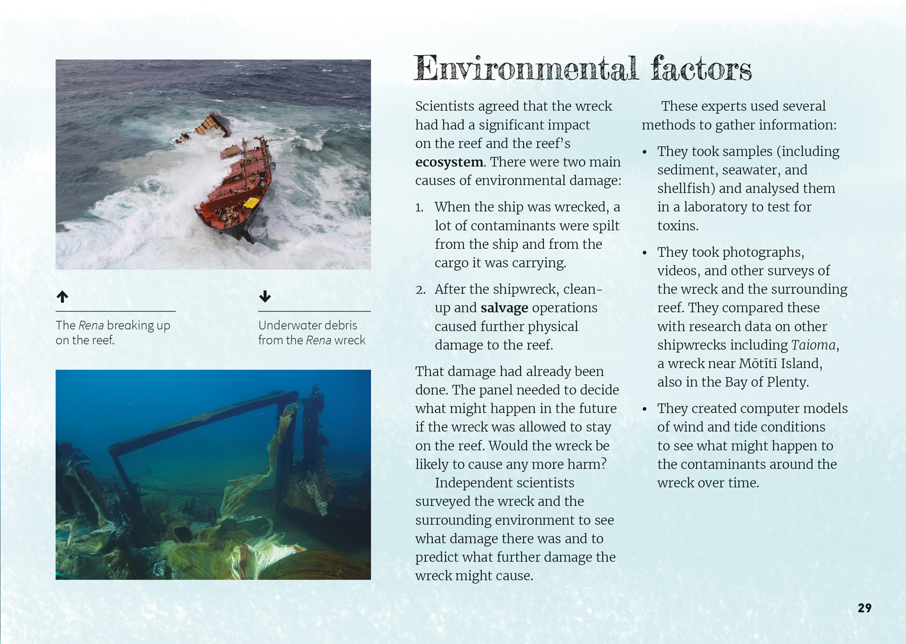  Students will understand how formal and informal groups make decisions that impact on communities.  Scientists draw conclusions from a range of evidence. | Scientists record their data carefully in a variety of ways.  Scientists sometimes use models to understand a situation better.

Learning activities – Exploring the science
The following activities are a guide for supporting students to explore and develop understandings about the science capability “interpret representations”. Some activities focus directly on the science capability. Other activities extend student content knowledge across the learning areas. Adapt these activities to support your students’ learning needs.

Activity 1 – Salvage operations
The article discusses what the salvage effort has achieved and what the environmental and financial costs have been. But what did it actually involve? The resource links include information, particularly about the dive operations. The students could follow this up to find out more about how the salvage was carried out, the costs, and the risks that the divers took.

Activity 2 – Creating a presentation
The students could examine some creative ways to present data and statistics, for example, using those on the “Information Is Beautiful” website. They could then design a creative and informative way to present the information in the table on page 31. Have each student choose just one or two dimensions to focus on (for example, the amount of the chemical, their interpretation of the risk it poses, or both). When completed, have the students critique their representations.
- What do the representations show that the table on page 31 does not?
- What do the representations leave out?
- When would the different representation be more appropriate?

RESOURCE LINKS

Connected  “After the Spill”. Connected 4, 2013 https://docs.google.com/presentation/d/1rfi6LJFwd8eAitdvD5F5Qm8i0bDrc276Vuub7BkL0m4/present?slide=id.p  Science Learning Hub  “The Rena Disaster” (video, 26 mins): http://link.sciencelearn.org.nz/resources/809-restoring-mauri-after-the-rena-disaster  Where land meets sea – the Rena disaster: http://link.sciencelearn.org.nz/resources/1117-where-land-meets-sea-the rena-disaster  Pollution from Rena: http://link.sciencelearn.org.nz/resources/1138-pollution-from-rena  Environmental toxicity: http://link.sciencelearn.org.nz/resources/1122-environmental-toxicity  Cleaning up the oil spill: http://link.sciencelearn.org.nz/resources/1140-cleaning-up-the-oil-spill  Responding to Rena: An activity exploring short and long term consequences: http://link.sciencelearn.org.nz/resources/1176-responding-to-rena  Rena bird recovery: http://link.sciencelearn.org.nz/resources/1135-rena-bird-recovery  Sun Media  Cyclone Pam moves Rena wreck 23 April 2015 – article, images, and video: www.sunlive.co.nz/news/98471-video-cyclone-pam-moves-rena-wreck.html | Stuff  Rena wreck: a rare spectacle five years on (includes links to other articles): www.stuff.co.nz/environment/79737594/Tauranagas-Rena-wreck-a-rare-spectacle-five-years-on  University of Waikato  Rena Environmental Recovery Monitoring Programme  2011–2013: http://sci.waikato.ac.nz/__data/assets/pdf_file/0008/180476/RENA-executive-summary.pdf  Bay of Plenty Regional Council  MV Rena Resource Consent Process: www.renaresourceconsent.org.nz/#whathappensnow  Bay of Plenty Regional Council dive team survey of the Rena, 16 Feb 2015 (video): www.youtube.com/watch?v=37-76kvdmFY  Auckland University Underwater Club  Diving WWI shipwreck Port Kembla (article and video): http://unidive.co.nz/diving-wwi-shipwreck-port-kembla-in-nz/  Dive! Tutukaka  New Zealand wrecks – sinking of Tui and Waikato for recreational diving (video and information): http://diving.co.nz/go-diving/wreck-diving  Creative ways to present statistics  Information Is Beautiful: www.informationisbeautiful.net/browse/interactive  Videos of divers working  www.youtube.com/watch?v=_5-uSKE87Jk  Rena: A day with the Resolve dive team: www.youtube.com/watch?v=4_2G_EqS9EA

Learning activities – Links to social studies
The following activities are a guide for supporting students to explore and develop understandings about perspectives, values, and decision making. Adapt the activities to suit the specific needs of your students.

Activity 1 – Seeking a balance
Discuss the features of scientific writing and the need to be factual and credible. Focus on this article and discuss how successful the author was in achieving this.
Discuss environmental issues in your local area and have the students select one for further exploration. They are to present this information in a factual way, showing a range of points of view and the evidence that underpins each. They are to do this in writing, but they can also consider how they can integrate this with other ways of representing data, for example, using diagrams and photographs. Talk about the need for visual and written information to work together and support what the other is saying.
The students can then debate the pros and cons of the issue. Remind them that they can seek consensus, but it is not necessary for everyone to reach the same conclusion.
- We’re all part of the same class, but that doesn’t mean we all agree. We can use science to help us make decisions, but we also have to take into account all the other things that are important to us.
If the students feel strongly enough, they may like to write a persuasive text to convince others of their point of view. Discuss how this will require a slightly different kind of writing – still credible, but also appealing to people’s values and beliefs.
Allow plenty of time for students to talk about their ideas before either writing activity.

Activity 2 – Weighing it up
Set up a role-play activity in which the students take on roles of people who are making submissions on the resource application. Explain that they are to prepare a three-minute speech to persuade their audience whether the Rena should be removed or left on the reef. If possible, invite some “impartial” people from outside the class to take on the role of panel members.
Assign roles to the students, ensuring it includes scientists, salvage workers, the owner of the company, the insurer, council representatives, iwi groups, local resident groups, divers, surveyors, and environmental activists. Remind the students that it is up to them as individuals to decide their stance. They can prepare for this by using some of the resource links suggested for the science learning activities.
This activity should be connected to the concept of citizenship, a concept that is discussed in the Ministry resource Belonging and Participating in Society, in the Building Conceptual Understandings in the Social Sciences series. The ability to submit on resource consents is one of our rights as citizens of Aotearoa New Zealand. For advice on what is involved, see the “Everyday guide” in the resource links. This includes tips for writing a good submission.
The panel should make its decision on the basis of the speeches they hear and not on the basis of what actually happened. The criteria should be clear and could be based on the tips in the guide. The panel needs to justify their decision based on the arguments it has heard.
After the submissions have been made, compare the science writing in the article with the persuasive nature of the speeches that supported for a particular perspective.

Extending the learning
Conduct a similar activity, but this time focus on a local environmental issue. Have the students conduct research and develop considered viewpoints. Support them to participate in local democracy by making a submission on the issue. This is likely to involve additional investigation to find out who to submit to (for example, the local council or residents’ association) and what the best approach is.

RESOURCE LINKS

Ministry of Education (2008). Belonging and Participating in Society. Building Conceptual Understandings in the Social Sciences series. Wellington: Learning Media.  Ministry for the Environment  An everyday guide to the RMA: Making a submission about a resource consent application: www.mfe.govt.nz/publications/rma/everyday-guide-rma-making-submission-about-resource-consent-application | Bay of Plenty Regional Council  MV Rena resource consent process: www.renaresourceconsent.org.nz/#whathappensnow

