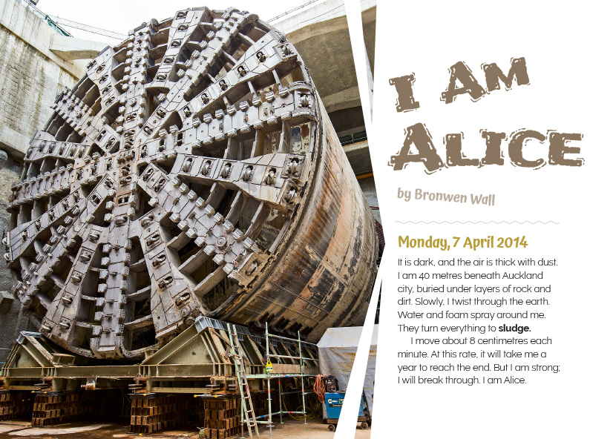
Connected
Level 2
2016

I Am Alice
by Bronwen Wall

Overview
This article is written from the perspective of Alice, the tunnel-boring machine that was brought in to make two tunnels for Auckland’s Western Ring motorway. The article explores the impact of new technology on our land and infrastructures.
A Google Slides version of this article is available at www.connected.tki.org.nz.

Curriculum contexts

TECHNOLOGY: Nature of Technology: Characteristics of technology  Level 2 – Understand that technology both reflects and changes society and the environment and increases people’s capability.  NATURE OF TECHNOLOGY: Characteristics of technological outcomes  Level 2 – Understand that technological outcomes are developed through technological practice and have related physical and functional natures. | Key technology ideas  - We use a wide variety of technologies to change the environment.  - Societal and environmental issues can influence what technological outcomes are made.
ENGLISH: Reading  Level 2 – Ideas: Students will show some understanding of ideas within, across, and beyond texts. | Indicators  - Uses their personal experience and world and literacy knowledge to make meaning from texts.  - Makes meaning of increasingly complex texts by identifying main ideas.  - Makes and supports inferences from texts with some independence.

The New Zealand Curriculum

Meeting the literacy challenges

The text requires the students to follow a first-person narrative to locate specific technical information about how Alice works. The first-person approach personalises the information, making it more accessible for readers, although most of the technical information is shown in a variety of images, including maps, photos, and diagrams that students will need to interpret. These images include:  - A cross-section of the Waterview Connection Tunnels  - A bird’s-eye map of Auckland  - A diagram comparing the Ōtira tunnel with the Waterview tunnels  - A cross-section diagram of Alice’s internal workings. | The following strategies will support students to understand, respond to, and think critically about the information and ideas in the text.  You may wish to use shared or guided reading, or a mixture of both, depending on the reading expertise of your students and the background knowledge they bring to the text.  After reading the text, support students to explore the activities outlined in the following pages.

INSTRUCTIONAL STRATEGIES

Introduce the text, explaining that it is written from the perspective of a narrator who has a very big job to do. Set the purpose for reading, telling the students that they are going to learn about how the narrator does this job and how the technology involved has changed over the last one hundred years. EXPLAIN that there is a lot of information in the text and that one of the best ways of getting that information is to ASK QUESTIONS.  Read aloud the title and first two paragraphs. As you do so, MODEL how to ask questions to make sense of text:  - This article is written by someone who calls herself Alice. Who is Alice?  - The first heading is a date. Is this Alice's diary?  - Wait. I thought Alice was a girl. But what would a girl be doing 40 metres under the city? Why is she twisting through the earth? Do you have any suggestions?  - It says that Alice moves about 8 centimetres a minute and it will take a year to reach the end. I wonder how far she is going. How could I work it out?  REVIEW the questions you just asked, discuss whether you found answers, and explain how you found them. Start a chart that the students can use to RECORD their questions, answers, and strategies. EXPLAIN that sometimes we have to make a guess and need to read on to confirm our ideas. Encourage the students to update the chart as they read and find information to confirm, discount, or modify their answers. | Questions Answers (Place a tick, cross, or question mark, depending on what you think and how sure you are.) How we found the answers  Who is Alice? A girl? No, a machine. But what sort? We used inference – the descriptions of where she is and what she is doing means she must be a machine.  Is it a diary? Yes, but it’s more than that. √ The style of the heading is like that of a diary, and it is written in the first person. When we read on, we found the same sort of heading at the end of the article.  How far is she going? 42,048 metres? But this is 42 kilometres, which can’t be right. x We used our mathematical knowledge to work it out. We multiplied 8 centimetres by the number of minutes in a day, days in a week, and weeks in a year. But we’re not sure whether we know enough to confirm this so will need to read on to check. [You will find that this isn’t correct, so will need to ask more questions about why this is (for example, the assumption that Alice is working constantly may not be correct).]

Meeting the literacy challenges

Ask the students to SKIM and SCAN the text, using the headings, diagrams, and maps to ask questions and to notice where they might find answers. RECORD the questions and LIST the potential sources of information. These might include:  - our knowledge or our friend’s knowledge  - our inferences  - later parts of the text  - the glossary  - the maps  - the diagrams  - the photographs.  Have the students read on, pausing after each section to complete the chart and RECORD any new questions. EXPLAIN that the focus of the first reading will be on understanding the main ideas and generating questions. On a second reading, they will have time to read more closely, looking for answers in the supplementary information (such as the photographs and diagrams), as well as in the narrative.  After this first reading, have the students REVIEW their questions, identifying those that haven’t been answered. Point out that it may not be possible to find all the answers in the text and that one way of finding answers is to ask an expert. PROMPT the students to look at the list of experts on page 32 and identify which of these people could help them with their unanswered questions.  Who would you ask? What question would you ask to get the information you’re looking for? | Using images to gain deeper understanding  The answers to many of the students’ questions are likely to be found in the images, diagrams, maps, and photographs. PROMPT the students to look closely at each image to extract all the information it conveys. Students could work in pairs or groups to explore a particular image. Each pair or group could be provided with a selection of questions to help them interpret and understand the image. For example:  - Look at the cross-section of the tunnels. Why do you think it is called a cross-section? What are we looking at? What do the different colours mean? What can you tell about the shape of the land above the tunnel? Where does the tunnel go? Can you match the cross-section of the tunnel to the map? Does any of this information give you clues about why the tunnel was a good idea?  - There are several maps in the article. Why do you think the author included them? How did they help you understand the text? Have you been through these tunnels? How might these tunnels be useful for people?  - How do you think Alice cuts and grinds through the rock? Can we work it out by looking closely at the diagram on page 30? How could you summarise this information so you could explain it to another person? Could you draw your own diagram to show the process?  - Take a look at the photographs of Alice at work and the photographs of men digging tunnels in the nineteenth century. How has the technology changed? Reading the text and looking at the photographs, what have you learnt about the differences in how tunnels were dug in the past and how they are dug now?  Briefly DISCUSS how the text and images worked together to convey technological information.  - Why do you think the author chose to present the information in this way?  - Do you think diagrams are a good way to convey technological information?

Reading standard: by the end of year 4
The Literacy Learning Progressions
Effective Literacy Practice: years 1–4

Meeting the literacy challenges

TEACHER SUPPORT
We use a wide variety of technologies to change the environment. | Societal and environmental issues can influence what technological outcomes are made.  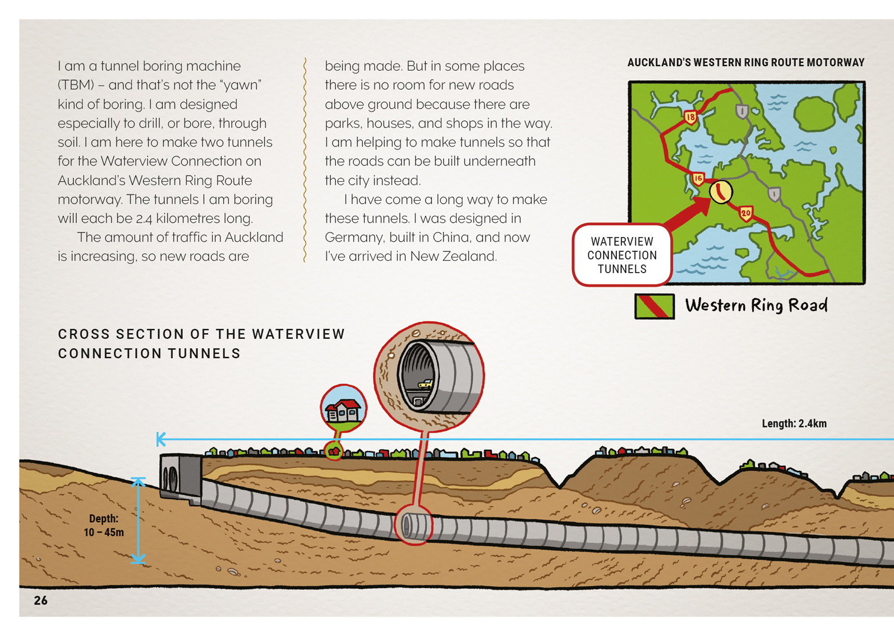  Technologists use diagrams and models to represent ideas.

Learning activities – Exploring the technology
The following activities are a guide for supporting students to explore and develop understandings about the technology content of the article. Adapt these activities to support your students’ learning needs.

Activity 1: Tunnelling through time

Comparing rates of progress
At the start of the article, Alice says that she moves at about 8 centimetres each minute. Give the students a sense of how slow this is by having them work out how long it would take Alice to bore through 8 centimetres of rock, 80 centimetres, 800 centimetres, and 8,000 centimetres. Have them complete a table like this to show Alice’s boring progress.
Time | Progress
1 minute | 8 cm
10 minutes | 80 cm
100 minutes | 800 cm
1,000 minutes | 8,000 cm
Discuss the pattern.
Given this pattern, can you predict how far Alice will go after two hundred minutes? Three hundred minutes? Why does the pattern work like this?
How long it would take Alice to bore through 10,000 centimetres?
Take the students outside with a piece of string 8 centimetres long. Choose a starting spot, set a stopwatch, and have the students mark off 8 centimetres after one minute and 80 centimetres after ten minutes. Take them back outside to mark off as many points as possible during the day. Do this to give the students an impression of how slowly but steadily Alice was working.
Now have the students compare Alice’s progress with that made by the people who built tunnels in the nineteenth century. The resource link to Te Ara provides information about the Lyttelton, Ōtira, Rimutaka, and Kaimai tunnels. Working in groups, have the students estimate the rate of progress for each of these tunnels. They need to be prepared to explain to the class how they worked this out, present their findings on a table similar to the one above, and challenge each other’s conclusions.
Have the students graph the rate of progress for each of the old rail tunnels and that of the Waterview Connection. They can then compare the rates of progress and discuss why there are differences. They might enjoy repeating the outdoor measuring activity to get a real sense of how quickly Alice worked in comparison to what was possible with picks and shovels.

Changing technology
Have the students use the information in the article, and from Te Ara and other online resources (see the resource links), to identify the main features of tunnel-boring technology in the nineteenth century. They can then compare this technology with that used for building the Waterview Connection. It would be helpful to start this activity by viewing video clips on the Waterview Connection YouTube channel.
Tunnel-boring technology in the nineteenth century | Tunnel-boring technology in the twenty-first century
Extending the learning
Tunnels take a very long time to build, they are expensive, and, in the nineteenth century, they cost lives. So why do people build them? There is information about this in this Connected article, on Te Ara, the introductory video to the LEARNZ field trips, and in How Tunnels Work. The students could consider this information and explore the pros and cons of the Waterview Connection project. This could lead to a debate about how much the Waterview Connection will benefit the people of Auckland.

Activity 2: Tunnel through!
Give the students a hands-on activity that lets them experiment with creating models of a tunnel. Explain the concept of a model: that scientists and engineers often use models to represent their ideas about what an object, process, or system might look like and to test their ideas about how it works.
- Models provide the opportunity to test out ideas before trying them out in practice. Consider the length of the Waterview Connection tunnels. If you were an engineer, you would want to know that your tunnel will work before you start to build it.
The hands-on activity, Tunnel Through! from Teach Engineering shows students how to make and test tunnels that pass through clay mountains. It sets out the design brief and a process for testing the tunnels. You may choose to follow this procedure or to adapt it, for example, by simplifying the requirements or substituting clay with wet sand. This activity includes a worksheet for students where they can record their planning and findings. You will need to work through this activity with your students and ensure that they understand subject-specific vocabulary, such as “structure” and “dimensions”.

Extending the learning
A conveyer belt takes away the sludge Alice digs out. The students could experiment with how they could make conveyer belts that can be extended, like Alice’s conveyor belt.

Learning activities – Exploring the technology

RESOURCE LINKS

Waterview Connection  LEARNZ: A series of four virtual field trips that focus on the tunnel development  Waterview Connection 1 (2014): http://rata.learnz.org.nz/summary.php?vft=waterviewconnection143  Waterview Connection 2 (2015): http://rata.learnz.org.nz/summary.php?vft=waterviewconnection153  Waterview Connection 3 (2016): http://rata.learnz.org.nz/summary.php?vft=waterviewconnection163  Waterview Connection introductory video: http://www.learnz.org.nz/waterviewconnection143  Building the tunnels: http://www.learnz.org.nz/waterviewconnection143/bg-easy-f/building-the-tunnels  New Zealand Transport Agency  Virtual tour of the Waterview Connection, with videos and related links: https://education.nzta.govt.nz/field-trips/waterview-connection  Waterview Connection project information, images, and project updates: http://www.nzta.govt.nz/projects/the-western-ring-route/waterview-connection/  Information about Alice and tunnel construction: http://www.nzta.govt.nz/projects/the-western-ring-route/waterview-connection/construction/#tunnels and  https://www.nzta.govt.nz/projects/the-western-ring-route/waterview-connection/construction/#tunnel-construction  Alice poster: https://www.nzta.govt.nz/assets/Uploads/tbm-poster-A1.pdf  Alice turning around poster: http://www.nzta.govt.nz/assets/projects/waterviewconnection/docs/poster-waterview-tbm-turnaround.pdf  Waterview Connection YouTube channel: https://www.youtube.com/user/WCnow | Historical information about tunnels  Te Ara: Bridges and tunnels: http://www.teara.govt.nz/en/bridges-and-tunnels/page-5  IPENZ Ōtira Tunnel, Midland Railway: http://www.ipenz.org.nz/heritage/itemdetail.cfm?itemid=63  Engineering information about tunnels  How tunnels work: http://science.howstuffworks.com/engineering/structural/tunnel2.htm  Tunnelling – Mechanics and Hazards: www.umich.edu/~gs265/tunnel.htm  How Products are Made: Tunnel: www.madehow.com/Volume-6/Tunnel.html  NZ History: Listening Underground with a Geophone: www.nzhistory.net.nz/media/photo/listening-with-a-geophone  Hands-on activity: Tunnel Through! www.teachengineering.org/activities/view/cub_rock_lesson04_activity1

