CONNECTED, LEVEL 3 2015, Fact or Fiction?  The Science of Rongoā  by Phillip Simpson  Overview  According to mātauranga Māori (Māori concepts of knowledge and knowing), kawakawa has medicinal properties. According to modern science, it does not. By keeping an open mind and looking closely at the evidence, Howick College student Chris Ryan discovered that when the method of testing reflected how and why Māori use the leaves, modern science showed kawakawa does indeed have medicinal properties. His approach did more than support the value of kawakawa. It also showed the value of a more holistic approach to scientific investigation that draws together Māori and non-Māori approaches to science.  A Google Slides version of this article is available at www.connected.tki.org.nz. |  |  | 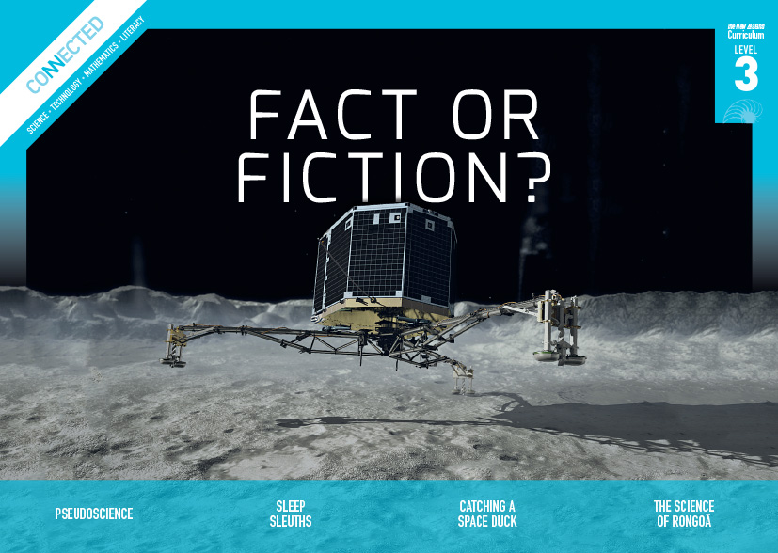  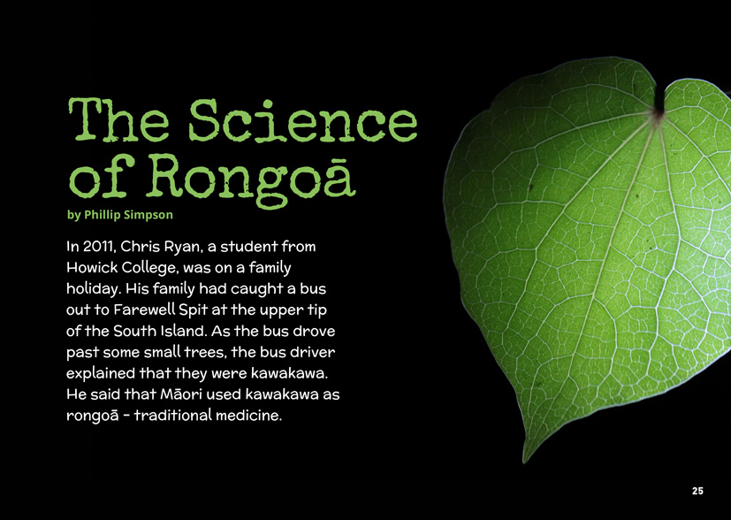
Science capability: Critique evidence |  | Text characteristics

Science knowledge is based on data derived from direct or indirect observations of the natural physical world. An inference is a conclusion drawn from those observations; it is the meaning you make from the observations. Understanding the difference between an observation and an inference is an important step towards being scientifically literate.  Being ready, willing, and able to critique evidence is also an important step towards being scientifically literate. Students must be able to assess the quality and reliability of both the observations (data) and the inferences made from those observations. In order to know what sorts of questions to ask to evaluate the trustworthiness of data, students need both methodological knowledge (how data is generated and collected) and statistical knowledge (how data is collated and analysed).  For more information about the “Critique evidence” science capability, go to http://scienceonline.tki.org.nz/Introducing-five-science-capabilities/Critique-evidence |  | - An informal, conversational voice that speaks directly to the reader and includes rhetorical questions.  - Photographs with captions, subheadings, breakout text, and a glossary to support the text.  - Complex sentences containing explanations.  - Complex ideas and concepts.  - Scientific and technological vocabulary and words in te reo Māori that may be unfamiliar to some students.

Curriculum context

SCIENCE
NATURE OF SCIENCE: Understanding about science  Achievement objective  L3: Students will appreciate that science is a way of explaining the world and that science knowledge changes over time.  Students will identify ways in which scientists work together and provide evidence to support their ideas. |  | MATERIAL WORLD: Chemistry and society  Achievement objective  L3: Students will relate the observed, characteristic chemical and physical properties of a range of different materials to technological uses and natural processes. |  | Key Nature of Science ideas  Scientists:  - evaluate the trustworthiness of data by asking questions about investigations carried out by others  - undertake more than one trial to provide sufficient evidence to support a conclusion  - replicate investigations to critique the evidence or data provided by other scientists  - check that there are enough samples to reliably establish a conclusion  - look carefully at the way data has been collected when they consider investigations done by others.  Key science ideas  - The use of plants for medicinal purposes is related to their properties.  - Many indigenous cultures have traditional knowledge that has been gained over time from observation, investigation, and trial and error.

ENGLISH

READING  Ideas  Students will show a developing understanding of ideas within, across, and beyond texts. |  | INDICATORS  - Uses their personal experience and world and literacy knowledge confidently to make meaning from texts.  - Makes meaning of increasingly complex texts by identifying main and subsidiary ideas in them.  - Starts to make connections by thinking about underlying ideas in and between texts.  - Makes and supports inferences from texts with increasing independence. |  | THE LITERACY LEARNING PROGRESSIONS  The literacy knowledge and skills that students need to draw on by the end of year 6 are described in The Literacy Learning Progressions.

Critiquing evidence

The science capability “Critique evidence” is about students evaluating the quality of the data supporting a scientific claim or idea (http://scienceonline.tki.org.nz/Introducing-five-science-capabilities/Critique-evidence).
Scientists use empirical evidence to develop theories about how the world works.
- Empirical evidence is data gathered from observations, experiments, and investigations.
- Scientific claims are only as dependable as the evidence on which they are based.
- Scientists design their investigations carefully to ensure the data they gather is both reliable and valid. Valid data is data that measures what it is supposed to measure – it answers the research question. Reliable data is dependable and consistent. Replicating the experiment and getting the same results makes us more confident that the data is reliable.
- To gather high-quality evidence that is reliable and valid, scientists measure accurately, keep conditions the same or control variables that might influence measurements or observations, repeat tests or investigations many times, investigate multiple examples, and/or use statistical sampling techniques to make their observations or data as representative and accurate as they can.
Students should be critiquing and evaluating the quality of data gathered from their own investigations by:
- engaging in a range of investigation types, exploring, comparing, classifying, identifying, seeking patterns, using models, making things to test ideas, and investigating systems so that they learn different ways to gather different types of data
- identifying ways to make the data they collect in their own investigations as accurate and reliable as possible
- suggesting and developing ways to control conditions or variables or keep things fair, repeating observations or measurements or tests, and developing appropriate sampling methods
- applying their developing understanding of statistics and probability (sampling, variability, and the exploration of relationships in multivariate data) when making decisions about sample size and repetitions, and when working with their data.
Students should also be encouraged to look for, consider, and critique methods and data underpinning scientific claims made by others. This includes critically examining the appropriateness of methods and the quality of evidence used to develop scientific claims in the media and other sources.
Teachers can:
- help students to be more critical consumers of science information by being explicitly critical themselves
- support students to identify correlations as evidence of a potential relationship, but not necessarily cause and effect
- ask questions such as:
  - Would this always happen?
  - How sure are you of your measurements?
  - How many times should you repeat these tests/measurements?
  - Is this a fair result?
  - What may have influenced the data?
  - Was there a big enough sample?
  - Does the data match the claim?
  - How much variation is there in your results? Why might that be?
- support students to evaluate how data is presented; for example, if data is presented graphically, is this done appropriately or is it misleading? (This draws on another science capability, Interpret representations.)
- support students to apply their understanding of statistics and probability when considering claims, evidence, and data.
- establish a science classroom culture by:
  - modelling and encouraging a critical stance
  - encouraging students to consider the quality and interpretation of data underpinning scientific claims
  - using media headlines to introduce learning conversations and demonstrate the relevance of critiquing evidence to everyday life.
A range of questions and activities designed to get students to critique evidence is available on the Science Online website: http://scienceonline.tki.org.nz/Introducing-five-science-capabilities/Critique-evidence

Meeting the literacy challenges

The text follows a sequential structure. The integration of science ideas and concepts with the holistic approach to healing used by Māori could be challenging for some students.
The following strategies will support students to understand, respond to, and think critically about the information and ideas in the text.
You may wish to use shared or guided reading, or a mixture of both approaches, depending on the reading expertise of your students and the background knowledge they bring to the text.
After reading the text, support students to explore the activities outlined in the following pages.

TEACHER resources

Want to know more about instructional strategies? Go to:
- http://literacyonline.tki.org.nz/Literacy-Online/Teacher-needs/Reviewed-resources/Reading/Comprehension/ELP-years-5-8
- “Engaging Learners with Texts” (chapter 5) from Effective Literacy Practice in Years 5 to 8 (Ministry of Education, 2006).
Want to know more about what literacy skills and knowledge your students need? Go to:
- http://literacyonline.tki.org.nz/Literacy-Online/Student-needs/National-Standards-Reading-and-Writing
- http://www.literacyprogressions.tki.org.nz/
“Working with Comprehension Strategies” (chapter 5) from Teaching Reading Comprehension (Davis, 2007) gives comprehensive guidance for explicit strategy instruction in years 4–8.
Teaching Reading Comprehension Strategies: A Practical Classroom Guide (Cameron, 2009) provides information, resources, and tools for comprehension strategy instruction.

INSTRUCTIONAL STRATEGIES

FINDING THE INFORMATION
Tell the students the title and EXPLAIN that “rongoā” refers to the traditional Māori way of treating illness and disease.
Activate the students’ prior knowledge by asking them to DISCUSS what they know about Māori medicine with their partners. Remind them of articles they may have read, for example: “Plants That Heal” (Connected 2, 2010).
As the students read, ASK QUESTIONS to help them explore the ideas in the text and make connections to their own lives.
- What types of medicines do you use in your whānau? Do you only use medicine prescribed by a doctor, or does your whānau use other types of medicine or treatments? How answers differ between members of our class?
- What does the “Māori view of medicine” mean? How does this compare with other views of medicine?
- How did Chris come up with his hypothesis and how did he test it?
- What sort of questions do you think Chris was thinking about when he critiqued the scientific evidence?
Have the students SUMMARISE the process Chris used, using a graphic organiser like this:
What Chris did | He did this because
Using their graphic organisers, have the students EXPLAIN the steps Chris went through to find his results and then DISCUSS why his results were different to those of other scientists.

DEALING WITH UNFAMILAR VOCABULARY
IDENTIFY the Māori nouns. In this article, many of the nouns have a macron on the “a”. EXPLAIN that a macron indicates a long vowel.
It is likely that the students will have encountered the concept of “hauora” in the context of their learning about health and physical education. Support them to MAKE CONNECTIONS with that knowledge and PROMPT them to think about examples of how the four dimensions of hauora are present in their lives, for example:
- Te taha hinengaro: school, music, hobby, cultural group
- Te taha whānau: family, friends
- Te taha wairua: church, kapa haka, special places, special people, alone time
- Te taha tinana: sport, physical activity, nutrition.
Focus on the use of the prefix “anti” in the words “antibacterial”, “antiviral”, and “anti-inflammatory”. If necessary, remind the students that a prefix is a group of letters placed before the root of a word. ASK them for a definition of “anti” (against, opposite) and then have them research the meanings of the root words “bacterial”, “viral”, and “inflammatory”. Have them use that information to write a definition of the target words and then check their definitions by looking at a dictionary.
 | The root word means: | With the prefix “anti”, I think it means: | After checking a dictionary, I know it means:
antibacterial
antiviral
anti-inflammatory

Key science ideas
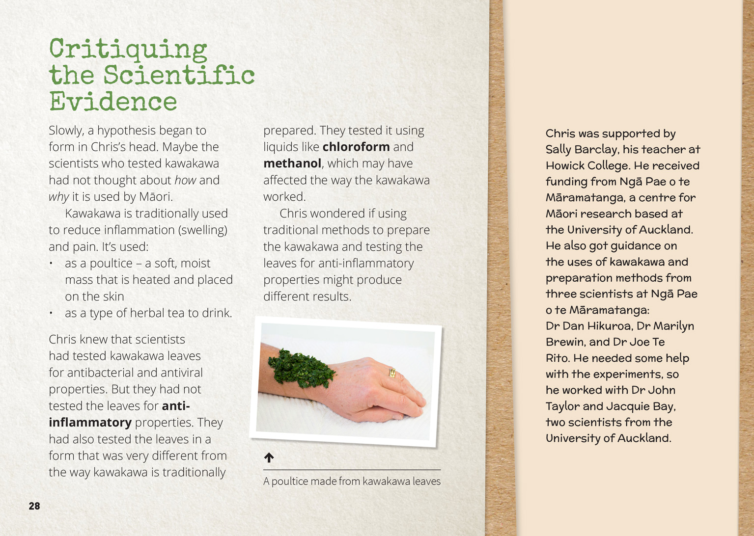 | Scientists replicate an investigation to critique the evidence provided by other scientists.  The chemical and physical properties of kawakawa can be used in different ways.  Scientists evaluate the trustworthiness of data by asking questions about investigations carried out by other scientists.

Learning activities
The following activities and suggestions are designed as a guide for supporting students to explore and develop understandings about the science capability “Critique evidence”. Some activities focus directly on the science capability. Other activities extend student content knowledge across the learning areas. You are encouraged to adapt these activities to support your students’ learning needs.

exploring the science

Activity 1: Rongoā in our rohe
Introduction
Begin this extended activity with a discussion of the concepts in the article.
How did Chris’s investigation compare with the investigations scientists had carried out on kawakawa previously? Did he disprove their findings? (Clarify that that he did not; he just looked for different properties that related more closely to the way kawakawa is used in rongoā.)
How did Chris change the scientific understandings we have about kawakawa?
How do you think Māori found out about the uses of kawakawa and other medicinal plants? How are these methods the same as, and different from, the ways scientists work?
Investigation
Have the students investigate plants traditionally used in rongoā, such as rātā, koromiko, and kūmarahou. They should find out how and why they were used and identify any tikanga that needs to be observed when collecting plants or making rongoā.
Have the students commence their investigations by conducting further background research about rongoā and about how Chris Ryan undertook his research. (See the resource links for some potential sources.) This initial research might include a reading of “Plants That Heal”, a Connected article by Sue Gibbison that describes how students at three Northland schools learned about plants with medicinal properties so that they could make their own ointment. The students could modify the table on page 20 of that book to make one that focuses on the information they want to collect and includes plants that they know grow locally.
Before the students design their investigations, revise how they can ensure that their investigations are conducted safely and respectfully and that they are able to draw reasonable inferences from their observations. Create and display a list that may include the following:
We need to ask questions to develop a hypothesis and to critique our investigation.
We need to get as much data as we can to ensure that our results are reliable.
Our data should include local and cultural knowledge as well as knowledge from science.
If we are testing the properties of plants, then we need to make sure that our tests match the purpose for which the plants were traditionally used.
Plants that can heal people can also make them sick. We need to be very careful and only extract and apply plant extracts with the guidance of experts.
We need to use extraction techniques that do not destroy the properties we want to test.
We need to ensure that all our measurements are accurate.
The students should then interview a local kaumātua or other expert (this could be a member of a student’s whānau or the local community) about the types of rongoā that are used locally. The students should find out (from the school or local hapū/iwi) the most appropriate way to welcome and farewell their guest.
Under the guidance of the local expert, conduct a field trip for the students to identify and collect plant samples, following correct tikanga. Back in the classroom, they should be supported to follow Māori tikanga to extract the plant oil that holds the plant’s active chemicals. Ideally, this will also be done under the supervision of kaumātua. If this is not possible, there are instructions for extraction techniques in the teacher support materials for “Plants That Heal”. These materials also include advice on activities and questions you could ask to probe the students’ thinking.

The students could then write and publish a collection of rongoā recipes. To ensure that users are able to follow the recipes safely and correctly, the students should include observational drawings of the plants with labels and explanations of the correct tikanga for gathering the plants and preparing the rongoā. Alternatively, they could create a blog, wiki, or Google site about local rongoā. Be aware that the permission of the kaumātua or expert is required before the students can upload the interview with them to the Internet and embed it in their presentation.
Reflection
Return to the initial discussion. Prompt discussion about the potential for rongoā and for traditional medicines from other cultures to sit alongside medicine from science. Be careful to keep this at the level of a discussion rather than a debate of what is right or wrong.
With what you know now, what is the place of rongoā in modern medicine? What about other traditional medicines?
What advice would you give a scientist who was interested in exploring the potential of these medicines?
Extension
Read “Learning from the Tangata Whenua: An Interview with James Ataria” in Connected 2, 2015 and/or “Counting Kākahi” in Connected 3, 2014 to further develop the students’ knowledge and understandings about mātauranga Māori and its relationship to science.

Activity 2: From cultural knowledge to marketable commodity
Part of being scientifically literate is the ability and disposition to think about who benefits from research findings. This is a very real issue for us in Aotearoa New Zealand. Mātauranga Māori offers us possibilities for increasing our economic strength and the contribution we make to the world, but there are risks in the potential misuse or loss of indigenous knowledge. Students could examine examples of how cultural knowledge has been developed and commercialised. As they explore these examples, prompt the students to think about how individuals and communities are benefitting and how indigenous people can maintain control of their cultural knowledge while also benefitting from its transformation into commercial products and services.
Who owns the information?
When a new product is developed on the basis of traditional knowledge, who should benefit? Is it the cultural groups whose people made the initial discoveries? The scientists and manufacturers who built upon that knowledge and created a new product? Or is there another answer?
Mānuka honey is an example of a traditional medicine that has become an international success story, benefiting its users and those who have developed new processes for making its healing properties available for a variety of purposes.
“Healing Honey” is a Connected 2 2012 article that explores the technological experimentation and modelling that went into the development of a honey bandage to treat wounds. It describes how Māori on the East Coast have set up a company that produces mānuka honey, exploiting the native flora and providing jobs for iwi.
“Honey to heal” is a theme on the Biotechnology Learning Hub. It includes information sheets, photographs, video clips, unit plans, and worksheets.
Harakeke has long been used for a variety of purposes. We think primarily of the fibre used for weaving, but it is also used in rongoā. Students can learn about this by viewing a series of video clips on the Biotechnology Learning Hub called “The Harakeke Project at Industrial Research”.
Local iwi may be exploring how they can use local resources and their own knowledge to create economic opportunities for future generations. Students could find out about this and, with permission, share what they find with others.

RESOURCE LINKS

Biotechnology Learning Hub
“Biotech and taonga” http://biotechlearn.org.nz/themes/biotech_and_taonga
”Honey to heal” http://biotechlearn.org.nz/focus_stories/honey_to_heal
“The Harakeke Project at Industrial Research” http://biotechlearn.org.nz/themes/biotech_and_taonga/the_harakeke_project_at_industrial_research

Connected
“Healing Honey”. The Buzz of Bees, Connected 2, 2012, pp. 19–23.
“Plants That Heal”. Working with Nature, Connected 2, 2010, pp. 18–25.

Resources about Chris Ryan’s research
“Antiviral and anti-inflammatory activity in Kawakawa leaf extract” from Ngā Pae o te Māramatanga. www.maramatanga.ac.nz/project/antiviral-and-anti-inflammatory-activity-kawakawa-leaf-extract
“Kawakawa leaf extract” from Technology Online. http://technology.tki.org.nz/Resources/Student-showcases/Food-technology-and-Biotechnology/Kawakawa-leaf-extract
“Realising a dream in science” from New Zealand Science Teacher. www.nzscienceteacher.co.nz/putaiao/realising-a-dream-in-science/#.VH-HxzGUe4I
“Traditional Māori medicine study wins American Ambassador award” from the Royal Society of New Zealand, Te Apārangi. http://royalsociety.org.nz/2013/12/16/traditional-maori-medicine-study-wins-american-ambassador-award/ (This also has a link to a YouTube video where Chris explains his project.)

Other resources
Building Science Concepts, Book 7 – The Bush: Classifying Forest Plants
“Rongoā Māori” from the Science Learning Hub. http://sciencelearn.org.nz/Contexts/Fighting-Infection/Looking-Closer/Rongoa-Maori

Google Slides version of “The Science of Rongoā” www.connected.tki.org.nz

