CONNECTED, LEVEL 3 2015, Fact or Fiction?  Sleep Sleuths  by Kate Potter  Overview  Two students carry out a science investigation in which they find out about the importance of sleep and research whether they and their friends are getting enough sleep. In the course of their investigation, the students ask questions; collect, organise, and analyse data; and come to the realisation that scientific inquiry often raises more questions than it answers.  A Google Slides version of this article is available at www.connected.tki.org.nz. |  |  | 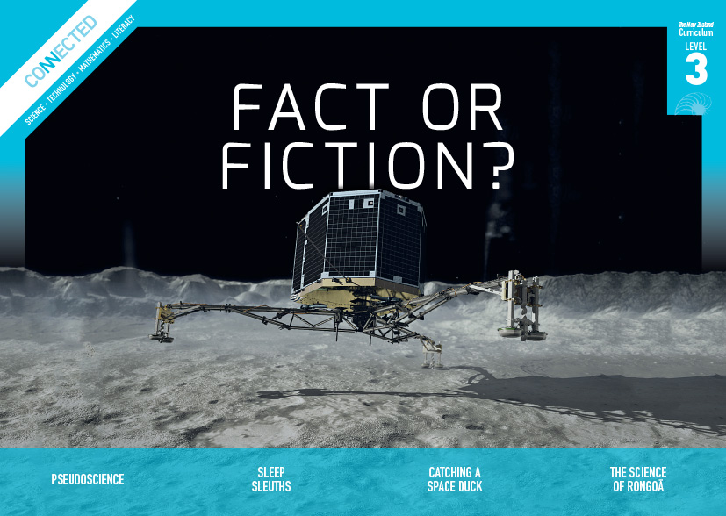  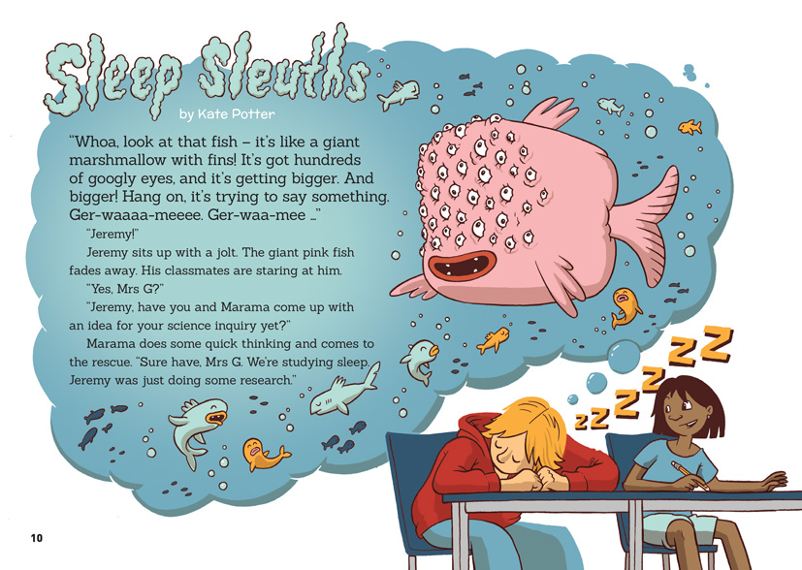
Science capability: Critique evidence |  | Text characteristics

Science knowledge is based on data derived from direct or indirect observations of the natural physical world. An inference is a conclusion drawn from those observations; it is the meaning you make from the observations. Understanding the difference between an observation and an inference is an important step towards being scientifically literate.  Being ready, willing, and able to critique evidence is also an important step towards being scientifically literate. Students must be able to assess the quality and reliability of both the observations (data) and the inferences made from those observations. In order to know what sorts of questions to ask to evaluate the trustworthiness of data, students need both methodological knowledge (how data is generated and collected) and statistical knowledge (how data is collated and analysed).  For more information about the “Critique evidence” science capability, go to http://scienceonline.tki.org.nz/Introducing-five-science-capabilities/Critique-evidence |  | - A mixed text type – the main body of the text is a narrative, but the breakout text includes explanations and some procedural text.  - Breakout text that is written in an informal, conversational voice and includes questions to the reader and rhetorical questions.  - A large number of questions that reinforce the importance of questioning in science.  - Illustrations, breakout text, diagrams, charts, and a graph that clarify or extend the text and may require some interpretation.

Curriculum context

SCIENCE
NATURE OF SCIENCE: Investigating in science  Achievement objectives  L3: Students will build on build on prior experiences, working together to share and examine their own and others’ knowledge.  Students will ask questions, find evidence, explore simple models, and carry out appropriate investigations to develop simple explanations. |  | NATURE OF SCIENCE: Participating and contributing  Achievement objective  L3: Students will explore various aspects of an issue and make decisions about possible actions.  LIVING WORLD: Life processes  Achievement objective  L3: Students will recognise that there are life processes common to all living things and that these occur in different ways. |  | Key Nature of Science ideas  Scientists:  - evaluate the trustworthiness of data by asking questions about investigations carried out by others  - undertake more than one trial to provide sufficient evidence to support a conclusion  - replicate investigations to critique the evidence or data provided by other scientists  - check that there are enough samples to reliably establish a conclusion  - look carefully at the way data has been collected when they consider investigations done by others.  Key science idea  - Sleep is important to keep our body and mind healthy and alert.  - The amount of sleep people need differs during their lifetime.

ENGLISH

READING  Ideas  Students will show a developing understanding of ideas within, across, and beyond texts. |  | INDICATORS  - Uses their personal experience and world and literacy knowledge confidently to make meaning from texts.  - Makes meaning of increasingly complex texts by identifying main and subsidiary ideas in them.  - Starts to make connections by thinking about underlying ideas in and between texts.  - Makes and supports inferences from texts with increasing independence. |  |  |  | THE LITERACY LEARNING PROGRESSIONS  The literacy knowledge and skills that students need to draw on by the end of year 6 are described in The Literacy Learning Progressions.

MATHEMATICS AND STATISTICS
STATISTICS: Statistical investigation  Achievement objectives  L3: Students will conduct investigations using the statistical enquiry cycle:  - gathering, sorting, and displaying multivariate category and whole-number data and simple time-series data to answer questions  - identifying patterns and trends in context, within and between data sets  - communicating findings, using data displays. |  |  |  | Key statistical ideas  - Data can be used for different purposes.  - Data can be used to predict a future event.  - Organising data and looking for patterns and trends can reveal useful information.

Critiquing evidence

The science capability “Critique evidence” is about students evaluating the quality of the data supporting a scientific claim or idea (http://scienceonline.tki.org.nz/Introducing-five-science-capabilities/Critique-evidence).
Scientists use empirical evidence to develop theories about how the world works.
- Empirical evidence is data gathered from observations, experiments, and investigations.
- Scientific claims are only as dependable as the evidence on which they are based.
- Scientists design their investigations carefully to ensure the data they gather is both reliable and valid. Valid data is data that measures what it is supposed to measure – it answers the research question. Reliable data is dependable and consistent. Replicating the experiment and getting the same results makes us more confident that the data is reliable.
- To gather high-quality evidence that is reliable and valid, scientists measure accurately, keep conditions the same or control variables that might influence measurements or observations, repeat tests or investigations many times, investigate multiple examples, and/or use statistical sampling techniques to make their observations or data as representative and accurate as they can.
Students should be critiquing and evaluating the quality of data gathered from their own investigations by:
- engaging in a range of investigation types, exploring, comparing, classifying, identifying, seeking patterns, using models, making things to test ideas, and investigating systems so that they learn different ways to gather different types of data
- identifying ways to make the data they collect in their own investigations as accurate and reliable as possible
- suggesting and developing ways to control conditions or variables or keep things fair, repeating observations or measurements or tests, and developing appropriate sampling methods
- applying their developing understanding of statistics and probability (sampling, variability, and the exploration of relationships in multivariate data) when making decisions about sample size and repetitions, and when working with their data.
Students should also be encouraged to look for, consider, and critique methods and data underpinning scientific claims made by others. This includes critically examining the appropriateness of methods and the quality of evidence used to develop scientific claims in the media and other sources.
Teachers can:
- help students to be more critical consumers of science information by being explicitly critical themselves
- support students to identify correlations as evidence of a potential relationship, but not necessarily cause and effect
- ask questions such as:
  - Would this always happen?
  - How sure are you of your measurements?
  - How many times should you repeat these tests/measurements?
  - Is this a fair result?
  - What may have influenced the data?
  - Was there a big enough sample?
  - Does the data match the claim?
  - How much variation is there in your results? Why might that be?
- support students to evaluate how data is presented; for example, if data is presented graphically, is this done appropriately or is it misleading? (This draws on another science capability, Interpret representations.)
- support students to apply their understanding of statistics and probability when considering claims, evidence, and data.
- establish a science classroom culture by:
  - modelling and encouraging a critical stance
  - encouraging students to consider the quality and interpretation of data underpinning scientific claims
  - using media headlines to introduce learning conversations and demonstrate the relevance of critiquing evidence to everyday life.
A range of questions and activities designed to get students to critique evidence is available on the Science Online website: http://scienceonline.tki.org.nz/Introducing-five-science-capabilities/Critique-evidence

Meeting the literacy challenges

The particular demands of this text include the integrating of information from the body text with the breakout boxes that contain additional information, or further activities, and data tables that have been used to record the results of two investigations. The following strategies will support students to understand, respond to, and think critically about the information and ideas in the text.
You may wish to use shared or guided reading, or a mixture of both approaches, depending on the reading expertise of your students and the background knowledge they bring to the text.
After reading the text, support students to explore the activities outlined in the following pages.

TEACHER resources

Want to know more about instructional strategies? Go to:
- http://literacyonline.tki.org.nz/Literacy-Online/Teacher-needs/Reviewed-resources/Reading/Comprehension/ELP-years-5-8
- “Engaging Learners with Texts” (chapter 5) from Effective Literacy Practice in Years 5 to 8 (Ministry of Education, 2006).
Want to know more about what literacy skills and knowledge your students need? Go to:
- http://literacyonline.tki.org.nz/Literacy-Online/Student-needs/National-Standards-Reading-and-Writing
- http://www.literacyprogressions.tki.org.nz/
“Working with Comprehension Strategies” (chapter 5) from Teaching Reading Comprehension (Davis, 2007) gives comprehensive guidance for explicit strategy instruction in years 4–8.
Teaching Reading Comprehension Strategies: A Practical Classroom Guide (Cameron, 2009) provides information, resources, and tools for comprehension strategy instruction.

INSTRUCTIONAL STRATEGIES

FINDING THE INFORMATION
Introduce the text to the students and provide them with an overall outline of the content and the purpose.
Ask the students to read and DISCUSS the purpose of the illustration and text on page 10.
PROMPT the students to connect to their prior knowledge by conducting a think, pair, and share, focused on what they know about sleep and its importance.
How many hours of sleep do you need each night?
How many do you actually get?
Have the students create a KWL chart about sleep prior to reading. After reading each page, have them update the chart with any new information and any new questions.
What we think we know | What we want to know | What we know now
When the students read the breakout text on page 11, give them time to try the activity and share their responses. When they read the breakout text on page 12, they can share their responses with a partner and then read ahead to check their predictions.
Focus the students’ attention on the teacher’s comment about Jeremy and Marama being good scientists. ASK QUESTIONS to emphasise the importance of thinking critically about data and applying this to their own work.
What was Mrs G referring to when she told Jeremy and Marama they were “really thinking about what [their] data means?” Why would this make them good scientists?
Jeremy and Marama did some online research. How do you locate information online and check that the information is from a source you can trust?
After the reading, have the students SKIM the text and IDENTIFY the questions that the teacher asked, the questions Jeremy and Marama asked, and the questions that they themselves were asked. DISCUSS the role of questions in this article.
What sorts of questions does Mrs G ask? Why do you think she asks these questions?
How did questioning help Jeremy and Marama to develop their inquiry? What is the purpose of these different questions? Can you put them into groups? (To refine their ideas as they developed a good research question, to get data for their inquiry, to critique their inquiry, and to identify new questions that could be looked at in another inquiry.)
Why does Mrs G think that Marama’s question “But how much sleep is enough?” is a good question for inquiry?
What types of questions would you use if you were conducting this research, and how might secondary questions be useful?
What is the author telling us about the importance of questions in scientific inquiry?

USING DIAGRAMS AND TABLES TO BUILD UNDERSTANDING OF THE TEXT
Before the students read the text on page 11, ASK them to look closely at the illustrations and PREDICT what they think they show. They can then read the text to confirm whether their predictions were accurate.
Who do these pictures show?
What ideas are the pictures are showing?
What do you think is the difference between “deep sleep” and “light sleep”?
PROMPT the students to look closely at the illustration on page 12 and recognise that it is a graph.
EXPLAIN that headings in tables or graphs indicate crucial information.
DISCUSS a sequence for reading the information in a graph:
the heading
the labels on the axes
the data within the graph.
ASK QUESTIONS to remind the students of the vocabulary of graphs.
What do we call the column on the left-hand side of the graph? (y-axis)
What do we call the row along the bottom of the graph? (x-axis)
DISCUSS the patterns shown in the graph. Encourage the students to generate and respond to other students’ questions about the data.
What patterns do you notice in the graph?
What questions do you have about this data?
What explanations do you have for the patterns the graph shows?
How might you test your explanations?
ASK QUESTIONS to help the students read the tables on pages 14 and 15 and understand why the data had to be reorganised before it could be analysed.
- What do the headings in the tables mean?
- How did the students get the time in the third column?
- What did they do to their data to put it into groups? How did this make it easier to analyse?
PROMPT the students to read the “body clock” diagram on page 17.
How closely does this match your daily routines?
What do you think about the statements about “highest alertness” and “greatest muscle strength” or “best coordination”? Do you think they are true? How would you test them?

DEALING WITH SCIENTIFIC VOCABULARY
PROMPT the students to IDENTIFY any unknown vocabulary in the text and investigate the meanings. Include these words on a classroom word wall, providing examples of the words being used in sentences. Remind the students that they can refer to this when looking for the right word to use in their writing and discussion.
The term “circadian rhythm” may well be new to the students. EXPLAIN that the word “circadian” comes from two Latin words: “circa”, meaning “around” or “approximately”, and “dies”, meaning “day”. Have the students find other words that come from “circa” and add them to the word wall. Clarify that “body clock” and “circadian rhythms” are not the same thing. Circadian rhythms are physical, mental, and behavioural changes that follow a roughly 24-hour cycle. Our internal body clocks (or “biological clocks”) regulate our response to the natural course of the day.

CRITICAL LITERACY
PROMPT the students to think about the techniques the author uses to communicate with the reader.
How does the author attempt to “hook” the reader in at the beginning of the story? Is this effective?
What text types has the author used? Why do you suppose the author used such a variety of text types? Which did you find the most appealing, and why?
The main body of the text is written in the third person, as a narrative about Marama and Jeremy. What happens when we read the breakout text? What else do you notice about what the author does to speak directly to the reader in these parts of the text? (The conversational style and the direct questions to the reader.)
What effect did the questions directed to you as a reader have on your reading of the text? Did you want to do as the author suggested?
The designer has chosen to present factual, scientific information in a fun, cartoon style. DISCUSS with the students why the designer chose this approach and whether they think it is effective.
Is this an effective way of presenting scientific information? Does it meet the criteria for accuracy that you would expect in an article about science?
Why do you think the designer chose this approach? Do you think they achieved their purpose?
Would you choose this approach for presenting scientific information? When would you do that? For what sort of audience? Why would you choose it?

Key science ideas
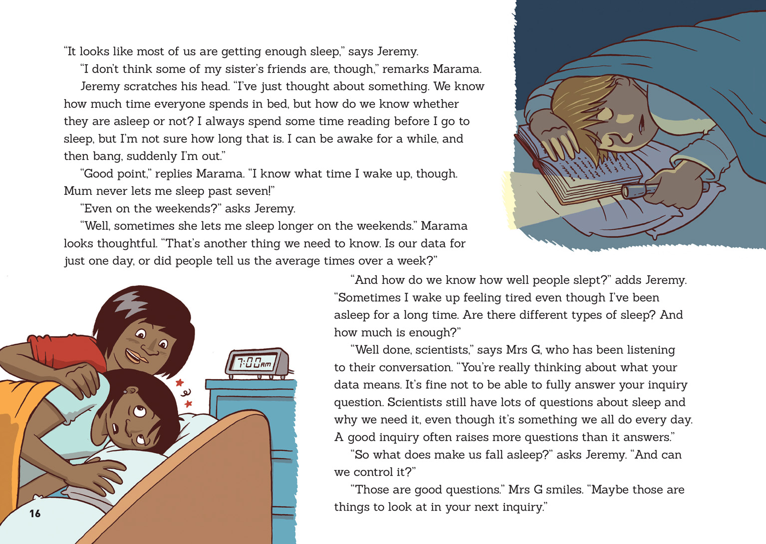 | Scientists evaluate the quality of the data supporting a scientific claim or idea.  Scientists ask questions to evaluate the trustworthiness of data.  Students explore various aspects of an issue.

Learning activities
The following activities and suggestions are designed as a guide for supporting students to explore and develop understandings about the science capability “Critique evidence”. Some activities focus directly on the science capability. Other activities extend student content knowledge across the learning areas. You are encouraged to adapt these activities to support your students’ learning needs.

exploring the science

Activity 1: Sleep sleuths
Tell the students that in this activity, they will have the opportunity to become sleep sleuths themselves. Begin by having the students explore the inquiry cycle that Jeremy and Marama used.
How would this cycle help you with your learning, especially in science?
What part of this inquiry interests you, and why?
On page 16, Jeremy and Marama ask questions about what their data means and how reliable it really is. Have the students look carefully at the data Jeremy and Marama gathered.
What suggestions do you have for how Jeremy and Marama could make their data more reliable? (For example, they could collect data from the same students on several different days to develop a better average, overcoming outliers such as a student staying up unusually late one night because they have a special event.)
Have the students gather similar data about sleep from their class, syndicate, or school and make some comparisons about hours of sleep across different ages. Alternatively, they could design their own investigations about sleep, yawning, or dreaming. For example, they could keep a dream diary for a period of time and consider how dreaming affects the quality of sleep. Or, instead of investigating human sleep patterns, they might prefer to track those of their pets – especially cats in the daytime!
Have the students analyse their data and write an explanation about the patterns their data shows and the possible reasons for any differences. As they work, ask questions to support the students to critique their own and others’ inquiry designs or data sets.
What does this data show?
How reliable is the data?
How representative is the sample we are working with?
How does this limit what we can say about our results?
What factors may have influenced the data we recorded?
Alongside the investigations, provide structured opportunities for the students to deepen their knowledge and understanding about why sleep is necessary for good health. The resource links include materials you could adapt to that purpose.
Remind the students of the interesting ways in which the designer presented some of the information in “Sleep Sleuths”.
How could you present your findings in a way that is engaging for an audience, while still being clear and accurate?
Extension
The teacher support materials for the Connected 2, 2006 article “I Miss My Pet” illustrate how a mathematics statistical investigation can be used to provide opportunities for students to strengthen their capability to critique evidence in the context of science. In this case, students critique data for what it could and couldn’t tell students about the lifespan of their pets.

Activity 2: Getting to know our body clocks
Reread the text on page 17, delving into the relationship between our internal body clocks and the natural rhythms set by external signals, especially changes in lightness and darkness. The resource links provide background information, with several suggesting activities that you and the students could use to explore these concepts, for example:
The first two activities in “Tick-Tock: Biological Clock” would be a useful starter, as they help students connect to their personal sense of the passage of time over a day and over seasons. (http://www.learner.org/jnorth/tm/BioClock.html)
The “Built in Stopwatch” activity in “Biological Rhythms” has students measuring how good they are at estimating time. (https://faculty.washington.edu/chudler/clock.html)
Assignment 5 in the Sleep Health Foundation’s modules provides an opportunity for students to explore the five cycles of sleep and what REM sleep is. (http://www.sleephealthfoundation.org.au/pdfs/simply-healthy/sleep-assignments-2014.pdf). After exploring the module ask:
  - How would scientists have found out about this?
  - How could we work out whether a person is getting high-quality sleep?
Point out that the article tells us that we need to sleep for about one-third of the day, but with the invention of light bulbs, people are staying up longer. Have the students investigate the impact that technological developments, such as digital clocks and mobile devices have had on our sleep patterns. “Cumulative daily screen time linked to teen sleep problems” is an accessible article on a recent sleep study among teenagers (http://blogs.bmj.com/bmjopen/2015/02/02/cumulative-daily-screen-time-linked-to-teen-sleep-problems/). The students could design their own study into the impact of screen time on their own sleeping habits and those of their peers.
The students could then move on to investigate the impact of tiredness. One approach might be to design a memory test that is carried out once during the day and once late at night and to investigate whether there is a variation in response. Prompt the students to critique their investigations and the inferences they draw from them. Remind them about keeping all factors constant, except for the variable being tested (for example, ensuring that the memory test is not performed just before a meal, when they are hungry, and then just after a meal, when they are full).
You could conclude this learning sequence by sharing the article, “Biological clocks defy circadian rhythms” (www.nature.com/news/biological-clocks-defy-circadian-rhythms-1.13833). This reports on research that shows examples of other biological clocks – and how scientists are still discovering new things!

RESOURCE LINKS

“A week’s worth of camping synchs internal clock to sunrise and sunset, CU-Boulder study finds” from News Center. www.colorado.edu/news/releases/2013/08/01/week%E2%80%99s-worth-camping-synchs-internal-clock-sunrise-and-sunset-cu-boulder
“Biological clocks defy circadian rhythms” from Nature. www.nature.com/news/biological-clocks-defy-circadian-rhythms-1.13833
“Biological Rhythms” from the University of Washington. https://faculty.washington.edu/chudler/clock.html
“Brain Basics: Understanding Sleep” from the National Institute of Neurological Disorders and Stroke. www.ninds.nih.gov/disorders/brain_basics/understanding_sleep.htm#dynamic_activity
“Circadian Rhythms Fact Sheet” from the National Institute of General Medical Sciences. www.nigms.nih.gov/Education/Pages/Factsheet_CircadianRhythms.aspx
“Cumulative daily screen time linked to teen sleep problems” from BMJ Blogs. http://blogs.bmj.com/bmjopen/2015/02/02/cumulative-daily-screen-time-linked-to-teen-sleep-problems/
“I Miss My Pet”. Connected 2, 2006, pp. 2–9. http://scienceonline.tki.org.nz/Introducing-five-science-capabilities/Critique-evidence/I-Miss-My-Pet
“Natural Patterns of Sleep” from Healthy Sleep. http://healthysleep.med.harvard.edu/healthy/science/what/sleep-patterns-rem-nrem
“Normal Human Sleep: An Overview” by Mary A. Carskadon and William C. Dement. http://apsychoserver.psych.arizona.edu/jjbareprints/psyc501a/readings/Carskadon%20Dement%202011.pdf
“Sleep” from the Neurological Foundation of New Zealand. http://www.neurological.org.nz/brain-health/sleep

“Sleep Health Facts” from the Sleep Health Foundation. http://www.sleephealthfoundation.org.au/pdfs/simply-healthy/sleep-assignments-2014.pdf
“Tick-Tock: Biological Clock” from Annenberg Learner. http://www.learner.org/jnorth/tm/BioClock.html
“Trouble Sleeping? Go Camping” from Scientific American. http://www.scientificamerican.com/article/trouble-sleeping-go-campi/

exploring the MATHEMATICS AND STATISTICS

Activity 1: Keeping in rhythm
Experiment 1: The Ups and Downs of Body Temperature, from “Biological Rhythms” has students tracking one of their circadian rhythms; in this case, changes in body temperature (https://faculty.washington.edu/chudler/clock.html). The activity requires them to use a thermometer to take careful, accurate measurements at two-hourly intervals from when they get up until when they go to bed. They record their measurements on a graph, with the x-axis labelled “Time of Day” and the y-axis labelled “Body Temperature”. Have the students predict what they think the graph will show and then compare this with the patterns shown in their graphs. Encourage them to ask questions about their data.
Do we all follow the same basic pattern?
Are there differences for different groups?
Are there any outliers in the data? What might have caused these?
Prompt the students to reflect on their data and whether it suggests anything about how they might live better in tune with their natural cycles.
Extension
Consider correlating the body temperature measurements with the reaction time experiment suggested on the same site (https://faculty.washington.edu/chudler/chreflex.html#ruler). You could outline the purpose of the experiment but have the students design their own procedures, following the steps of the statistical inquiry cycle. They will need to think about how they will organise their data to show any correlation.

Activity 2: Taking a critical approach to statistical inquiry
Download “Are You a Data Detective?” from the Census at School site (http://new.censusatschool.org.nz/wp-content/uploads/2012/11/data-detective1.pdf). Have the students create their own versions of the statistical inquiry cycle, annotating each stage with a set of critical questions that need to be asked to ensure that an inquiry is sound. Prompt them to think about the particular questions that are relevant to each phase of the inquiry. You could start them off by suggesting these and asking where these questions might belong:
How reliable do you think this data is?
What factors might have affected the data that was recorded?
Is there any data that you think might be unreliable? What makes you think that?
Use this to create a wall chart that will remind students of the sorts of questions they should be thinking about in any rigorous investigation.

Activity 3: CensusAtSchool
Go to CensusAtSchool and find a new data set to see:
if boys and girls have different sleep patterns
what activities students do before going to sleep
whether these activities affect the amount of sleep they are having.

RESOURCE LINKS

CensusAtSchool
“Are You a Data Detective?” http://new.censusatschool.org.nz/wp-content/uploads/2012/11/data-detective1.pdf
“Resources for teaching statistics”. http://new.censusatschool.org.nz/resources/

The University of Washington
“Biological Rhythms”. https://faculty.washington.edu/chudler/clock.html
“Reflexes”. https://faculty.washington.edu/chudler/chreflex.html#ruler

Google Slides version of “Sleep Sleuths” www.connected.tki.org.nz

