CONNECTED, LEVEL 4 2015, Is That So?  Lighting the Way with Solar Energy  by Andrew and Anna Dickson  Overview  This article describes how tiny Tokelau is “lighting the way” for the use of renewable energy as a way of combatting global warming. It is a switch that has had significant economic benefits for Tokelau and has greatly improved the quality of people’s lives.  A Google Slides version of this article is available at www.connected.tki.org.nz. This text also has additional digital content, which is available online at www.connected.tki.org.nz. |  |  | 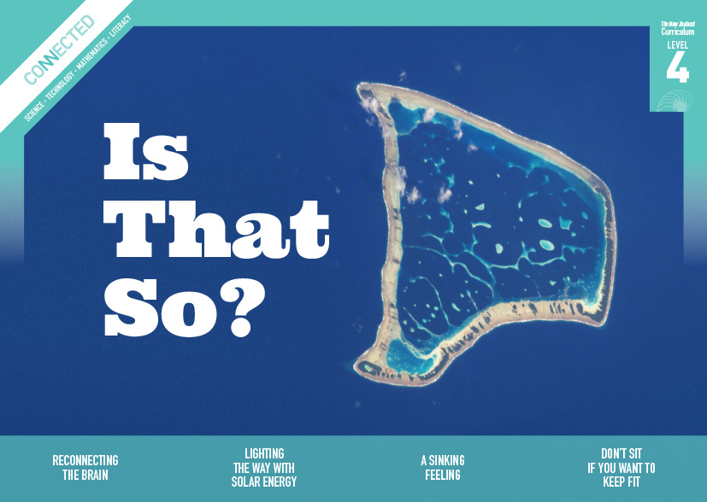  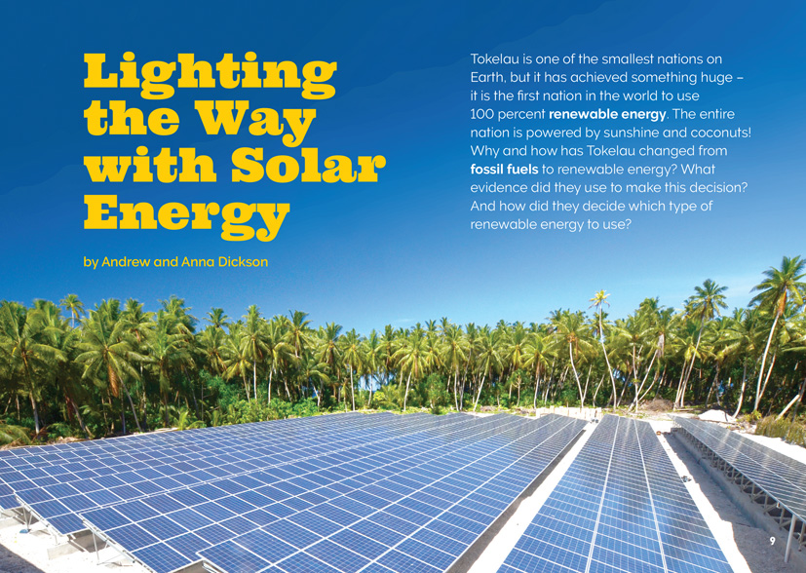
Science capability: Critique evidence |  | Text characteristics

Science knowledge is based on data derived from direct or indirect observations of the natural physical world. An inference is a conclusion drawn from those observations; it is the meaning you make from the observations. Understanding the difference between an observation and an inference is an important step towards being scientifically literate.  Being ready, willing, and able to critique evidence is also an important step towards being scientifically literate. Students must be able to assess the quality and reliability of both the observations (data) and the inferences made from those observations. In order to know what sorts of questions to ask to evaluate the trustworthiness of data, students need both methodological knowledge (how data is generated and collected) and statistical knowledge (how data is collated and analysed).  For more information about the “Critique evidence” science capability, go to http://scienceonline.tki.org.nz/Introducing-five-science-capabilities/Critique-evidence |  | - Complex sentences with dense information.  - Subheadings, illustrations, text boxes, and charts containing main ideas that relate to the text’s content.  - Scientific and technological vocabulary and terminology.  - Complex ideas and concepts.

Curriculum context

SCIENCE
NATURE OF SCIENCE: Participating and contributing  Achievement objective  L4: Students will use their growing science knowledge when considering issues of concern to them. |  | PHYSICAL WORLD: Physical inquiry and physics concepts  Achievement objective  L4: Students will explore, describe, and represent patterns and trends for everyday examples of physical phenomena, such as movement, forces, electricity and magnetism, light, sound, waves, and heat. For example, identify and describe the effect of forces (contact and non-contact) on the motion of objects; identify and describe everyday examples of sources of energy, forms of energy, and energy transformations. |  | Key Nature of Science ideas  Scientists:  - evaluate the trustworthiness of data by asking questions about investigations carried out by others  - undertake more than one trial to provide sufficient evidence to support a theory  - replicate investigations to critique the evidence/data provided by other scientists  - check that there are enough samples to reliably establish a conclusion or theory  - look carefully at the way data has been collected when they consider investigations done by others.  Key science ideas  - Energy appears in different forms and can be transformed within a system. Solar energy (light and heat) can be transformed to electrical energy.  - Some resources are renewable, others are not.

ENGLISH

READING  Ideas  Students will show an increasing understanding of ideas within, across, and beyond texts. |  | INDICATORS  - Makes meaning of increasingly complex texts by identifying and understanding main and subsidiary ideas and the links between them.  - Makes connections by thinking about underlying ideas within and between texts from a range of contexts.  - Recognises that there may be more than one reading available within a text.  - Makes and supports inferences from texts with increasing independence. |  | THE LITERACY LEARNING PROGRESSIONS  The literacy knowledge and skills that students need to draw on by the end of year 8 are described in The Literacy Learning Progressions.

TECHNOLOGY
NATURE OF TECHNOLOGY: Characteristics of technology  Achievement objective  L4: Students will understand how technological development expands human possibilities and how technology draws on knowledge from a wide range of disciplines. |  | Key technology ideas  - We use a wide variety of technologies to harness and transform the energy we get from natural resources.  - Societal and environmental issues can influence what technological outcomes are made.

Critiquing evidence

The science capability “Critique evidence” is about students evaluating the quality of the data supporting a scientific claim or idea (http://scienceonline.tki.org.nz/Introducing-five-science-capabilities/Critique-evidence).
Scientists use empirical evidence to develop theories about how the world works.
- Empirical evidence is data gathered from observations, experiments, and investigations.
- Scientific claims are only as dependable as the evidence on which they are based.
- Scientists design their investigations carefully to ensure the data they gather is both reliable and valid. Valid data is data that measures what it is supposed to measure – it answers the research question. Reliable data is dependable and consistent. Replicating the experiment and getting the same results makes us more confident the data is reliable.
- To gather high-quality evidence that is reliable and valid, scientists measure accurately, keep conditions the same or control variables that might influence measurements or observations, repeat tests or investigations many times, investigate multiple examples, and/or use statistical sampling techniques to make their observations or data as representative and accurate as they can.
Students should be critiquing and evaluating the quality of data gathered from their own investigations by:
- engaging in a range of investigation types, exploring, comparing, classifying, identifying, seeking patterns, using models, making things to test ideas, and investigating systems so that they learn different ways to gather different types of data
- identifying ways to make the data they collect in their own investigations as accurate and reliable as possible
- suggesting and developing ways to control conditions or variables or keep things fair, repeating observations or measurements or tests, and developing appropriate sampling methods
- applying their developing understanding of statistics and probability (sampling, variability, randomness, and the exploration of relationships in multi-variate data) when making decisions about sample size and repetitions and when working with their data.
Students should also be encouraged to look for, consider, and critique methods and data underpinning scientific claims made by others. This includes critically examining the appropriateness of methods and the quality of evidence used to develop scientific claims in the media and other sources.
Teachers can:
- help students to be more critical consumers of science information by being explicitly critical themselves
- support students to identify correlations as evidence of a potential relationship, but not necessarily cause and effect
- ask questions such as:
  - Would this always happen?
  - How sure are you of your measurements?
  - How many times should you repeat these tests/measurements?
  - Is this a fair result?
  - What may have influenced the data?
  - Was there a big enough sample?
  - Does the data match the claim?
  - How much variation is there in your results? Why might that be?
- support students to evaluate how data is presented; for example, if data is presented graphically, is this done appropriately or is it misleading? (This draws on another science capability, Interpret representations.)
- support students to apply their understanding of statistics and probability when considering claims, evidence, and data.
- establish a science classroom culture by:
  - modelling and encouraging a critical stance
  - encouraging students to consider the quality and interpretation of data underpinning scientific claims
  - using media headlines to introduce learning conversations and demonstrate the relevance of critiquing evidence to everyday life.
A range of questions and activities designed to get students to critique evidence is available on the Science Online website: http://scienceonline.tki.org.nz/Introducing-five-science-capabilities/Critique-evidence

Meeting the literacy challenges

The main literacy demands of this text lie in the interpretation and use of complex ideas and information. This requires students to integrate and synthesise information from the body text, as well as from the diagrams, map, a graph and a text box.
The following strategies will support students to understand, respond to, and think critically about the information and ideas in the text. You may wish to use shared or guided reading, or a mixture of both approaches, depending on the reading expertise of your students and the background knowledge they bring to the text.
After reading the text, support students to explore the activities outlined in the following pages.

TEACHER resources

Want to know more about instructional strategies? Go to:
- http://literacyonline.tki.org.nz/Literacy-Online/Teacher-needs/Reviewed-resources/Reading/Comprehension/ELP-years-5-8
- “Engaging Learners with Texts” (chapter 5) from Effective Literacy Practice in Years 5 to 8 (Ministry of Education, 2006)
Want to know more about what literacy skills and knowledge your students need? Go to:
- http://literacyonline.tki.org.nz/Literacy-Online/Student-needs/National-Standards-Reading-and-Writing
- http://www.literacyprogressions.tki.org.nz
“Working with Comprehension Strategies” (chapter 5) from Teaching Reading Comprehension (Davis, 2007) gives comprehensive guidance for explicit strategy instruction in years 4–8.
Teaching Reading Comprehension Strategies: A Practical Classroom Guide (Cameron, 2009) provides information, resources, and tools for comprehension strategy instruction.

INSTRUCTIONAL STRATEGIES

FINDING THE MAIN IDEAS
DISCUSS the title, encouraging the students to think about the author’s purpose for writing.
- Why do you think that this article is called “Lighting the Way with Solar Energy”?
- What do the words “lighting the way” mean when they are used metaphorically?
Have the students read the first page and IDENTIFY the four questions raised by the author., Then have them SCAN the headings, text boxes, diagrams, and photographs to IDENTIFY where they will find answers to these four questions. Give the students sticky dots in four colours to mark these sections. As they read, have them check whether their initial thoughts were correct.
Have the students read the section on Problems with Fossil Fuels. Check that they are aware that this is where they will find answers to the question about why Tokelau has switched from fossil fuels to renewable energy. Ask them to LIST the main reasons for the switch.
Have the students work in six groups to create PMI (plus, minus, and interesting) charts for each of the six types of renewable energy. Have them share their findings and then put their charts on the wall. (Note that this provides evidence for the class to draw on for writing persuasive texts or conducting a debate.)
Type of renewable energy:
Plus | Minus | Interesting
ASK the students to draw upon their analysis of the six types of renewable energy and their prior knowledge of the Tokelauan context to debate which of the options the Tokelauan government might have chosen. Then ask them to read on to check whether their predictions were correct.
- Were your predictions correct? Why or why not?
- What evidence did the government use to make its decision?
- Did you encounter any surprises?
Have the students read to the end and DISCUSS their responses to the text.
- Did you find answers to all of the initial questions on page 9?
- Consider the explanations of different types of renewable energy given in this article. How does the author make sure these explanations are clear and precise?
- What questions would you like to ask the Tokelauan government if you had the opportunity?
- What makes solar power “the winner” for Tokelau?
- Now that you have read the article, what do you think about its title?

USING DESIGN FEATURES FOR DEEPER UNDERSTANDING
PROMPT the students to look closely at the map of Tokelau on page 11 to get a sense of where Tokelau is in relationship to New Zealand. Have them read the sidebar and compare the size of Tokelau’s population to the size of your local community.
Working in the same groups as for the PMI activity, give the students a few minutes to look closely at one of the six examples of renewable energy. Have them integrate the information in the text with their prior knowledge to infer how technology is used to transfer the natural energy of the sun, wind, or tides into energy that people can use. They are to EXPLAIN this to the rest of the class, who should then critique the explanations and add any further information they can share. As an extension, the students could then conduct further research and develop labelled diagrams to show the basic technological processes at work.
ASK the students to look closely at the pie chart on page 13. Encourage them to generate their own questions about what the graph tells them. Back in their groups, have each student ask a question that the rest of the group is to answer, using information from the graph. They cannot ask the same question twice. Next, have the groups report back with either a fact or a question that the graph has prompted but cannot answer. These “wonderings” may be the prompts for later investigations.
By looking at the graph, we learned that … | The graph made us wonder whether …

DEALING WITH SCIENTIFIC AND TECHNICAL VOCABULARY
Have the students IDENTIFY and LIST the vocabulary that is new to them. Then have them SORT the vocabulary according to how they worked out the meanings of the words. Categories could include:
- I know this word from another context.
- I found a clue to the meaning in the text.
- I predicted this meaning from reading the text.
- The word is in the glossary.
- We use this word in technology.
- We use this word in science.
- I can see the meaning from the illustration.
- I found the word in the dictionary.
- I found the word in a thesaurus.
Create a classroom word bank that includes these words.

Teacher support
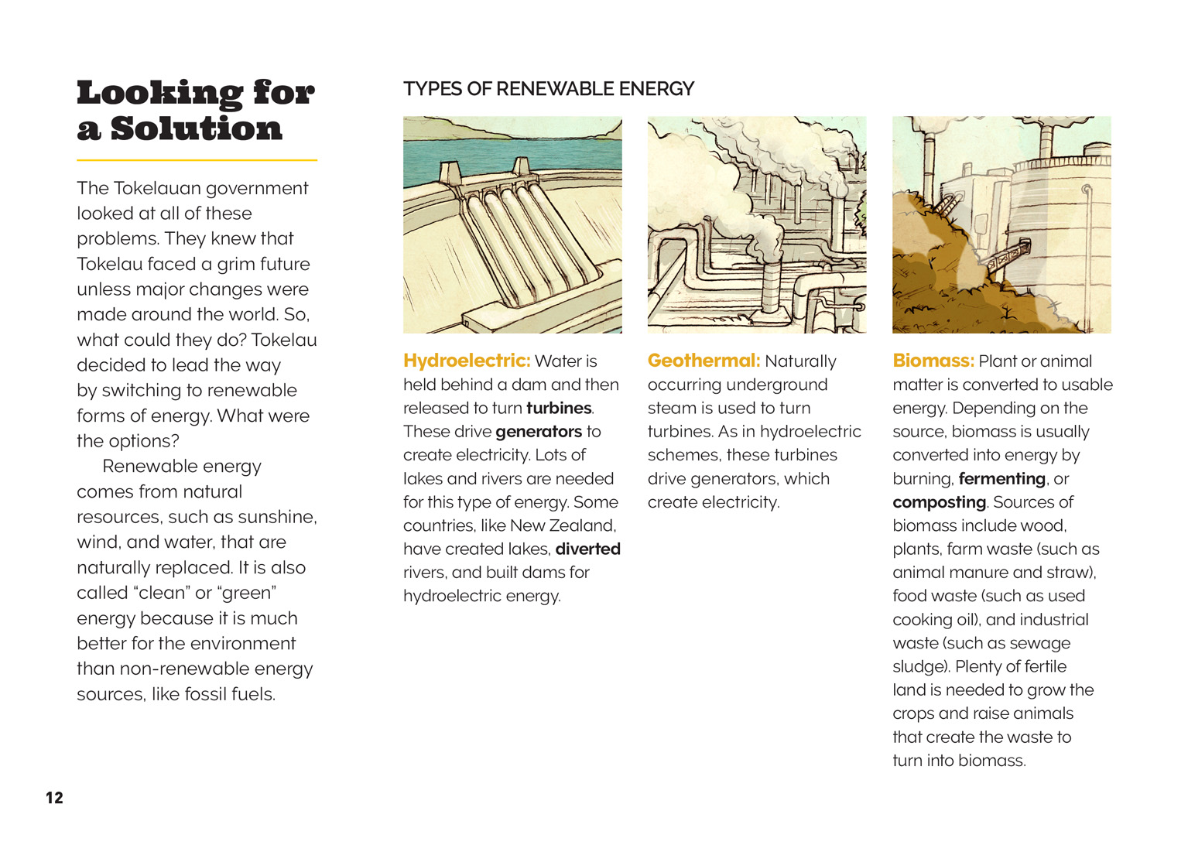 | Students explore everyday examples of sources of energy and energy in different forms.  Students consider information underpinning scientific claims made by others.  Students use their science knowledge to consider an issue of concern.

Learning activities
The following activities and suggestions are designed as a guide for supporting students to explore and develop understandings about the science capability “Critique evidence”. Some activities focus directly on the science capability. Other activities extend student content knowledge across the learning areas. You are encouraged to adapt these activities to support your students’ learning needs.

Exploring the science

Activity 1: What kind of renewable energy would be best for Tuvalu and Tonga?
The article notes that Tuvalu and Tonga are changing to renewable energy. Either you or a student should use a map of the Pacific to show the class where these nations are, relative to New Zealand and Tokelau. You should then share the digital material that provides a map and brief description of each nation. Using this information and the information in the article, have the students write a proposal to the government of either Tuvalu or Tonga, giving them recommendations about the type of renewable energy they should use, and the reasons why. If you have students in the class from Tokelau, Tuvalu, or Tonga, have them share their knowledge with the class.
For background information they can use to add to the persuasiveness of their arguments, the students could read more about Tokelau’s switch to solar energy at “Tokelau Renewable Energy Project” (http://powersmartsolar.co.nz/our_projects/id/185/tokelausolarpowered). The resource links also include a video and game that allow students to get a better understanding of how the change has improved the lives of people in Tokelau.
What might the advantages be for the people of Tuvalu or Tonga?
What might the advantages be for the economies of these nations?
The students will need to think about the perspective of the two governments and the information that they need to make such a significant decision. Their proposals should include:
an analysis of the conditions and potential sources of energy available in the island group
recommendations for a particular form of energy supply, supported by reasons
a consideration of the costs
explanatory diagrams that are labelled to show the basic technological processes at work
maps of the islands showing where the new technology should be located. (These can be created using Google Earth.)
Assessment could include the creation of student panels who evaluate the worth of the proposals, reducing this to a shortlist that is evaluated by the class as a whole. The criteria for consideration of the proposals would need to be discussed and decided before the evaluation process.
Extension
To understand more about the need for change, the students could read “Rising Seas” in Connected 3, 2014, and try some of the activities from the teacher support material to explore global warming and its impact in the Pacific. They could find information about global warming and explain how this has affected the coastline in New Zealand, Tokelau, or another Pacific island over a period of time.

Activity 2: Weighing up the options
Return to the students’ own “wonderings” about energy in New Zealand. Use discussion about this as a catalyst for an inquiry into New Zealand’s carbon emissions, whether this could be reduced through expanding the range of renewable sources we use, and how this could be done.
Do we have a problem with carbon emissions?
Students could start this investigation by finding out about New Zealand’s carbon emissions and sources of electricity. They could critique the evidence provided in the New Zealand government’s report on New Zealand’s carbon emissions (New Zealand’s Greenhouse Gas Inventory 1990–2013, http://www.mfe.govt.nz/sites/default/files/media/Climate%20Change/nz-greenhouse-gas-inventory-snapshot-2015.pdf) and consider whether or not we are reducing our emissions sufficiently. Students may feel that because the pie chart shows that nearly 80% of our energy already comes from non-renewable sources, we are doing well. Encourage them to ask questions of the data so that they notice, for example, that emissions go up when water levels in the hydro lakes fall.
Remind the students about the importance of critiquing evidence, even when it comes from the government.
Evidence is data that has been looked at and interpreted by human beings. Human beings bring their own thoughts and experiences to how they interpret data, so we always have to be aware of that and think about other ways it might be interpreted.
Have the students look at other points of view on how well New Zealand is contributing to the reduction in emissions needed to hold back climate change (for example, political parties such as the Green Party, or sustainability groups such as Greenpeace). Have the students consider what evidence these groups provide to back up their statements.
What are the options for diversification?
In groups, the students could research a range of renewable energy sources that provide an alternative to hydroelectric energy. Each student could then write a persuasive speech arguing for a particular form of renewable energy to be adopted in a particular location in New Zealand. The speech should include an explanation of how the form of renewable energy works and an explanation of its benefits and disadvantages, supported by evidence. The students can support their speeches with visual aids such as slideshow presentations or charts.
The students should critique each other’s speeches with questions such as:
How sure are you of your data?
How did you check that the data you were using was accurate?
Do you think the savings would be achieved in all weathers?
Are there some hidden costs?
Have the students evaluate and vote upon the best-argued options.
Extension
The resource links include items that students could use independently and others that you could use to extend their knowledge as they conduct their inquiries. The latter include:
Books 29 (Solar Energy) and 54 (Windmills and Waterwheels) in the Building Science Concepts series
“After the Spill”, from Connected 4, 2013, which focuses on the negative impact of the oil spill after the wreck of the Rena in the Bay of Plenty
Wind Power, Connected 3, 2010, and its accompanying teacher support materials, which is primarily focused on wind power, but also includes an article looking at “Power Alternatives”
Schoolgen’s resources on renewable energy and photovoltaic cells, which include factsheets, resources on graphing data, solar energy data, posters, and eBooks (www.schoolgen.co.nz/teachers)
The LEARNZ field trips (choose the words “electricity” and “renewable energy”) (http://www2.learnz.org.nz/core-fieldtrips.php)
The item “Switching to Solar at Clyde Quay School”, which might prompt students to think about how they could contribute to change in their own environment (http://www.nzscienceteacher.co.nz/science-education-society/science-education-and-the-environment/switching-to-solar-at-clyde-quay-school/).

RESOURCE LINKS

Building Science Concepts
Book 29 – Solar Energy: Sun Power on Earth
Book 54 – Windmills and Waterwheels: Harnessing the Energy of Wind and Water

Connected
“After the Spill”. Connected 4, 2013
Wind Power. Connected 3, 2010

ESchoolToday
“Non-renewable Energy” www.eschooltoday.com/energy/non-renewable-energy/what-is-non-renewable-energy.html
“Renewable Energy Sources” www.eschooltoday.com/energy/renewable-energy/what-is-renewable-energy.html

Science Learning Hub
“Future Fuels” http://sciencelearn.org.nz/Contexts/Future-Fuels
“Solar Cells” http://sciencelearn.org.nz/Science-Stories/Harnessing-the-Sun/Sci-Media/Video/Solar-cells (video)

Other sources
“Find a field trip” from LEARNZ. www2.learnz.org.nz/core-fieldtrips.php
“Government tries to hide massive deforestation in latest climate report” from the Green Party. https://www.greens.org.nz/news/press-releases/government-tries-hide-massive-deforestation-latest-climate-report
“Hybrid Photovoltaic/Coconut based Power Systems in Tokelau – Consultancy for the Feasibility, Environmental Impact Assessment, System Design and Specifications of Major Components and Financing Strategy – Report on Feasibility, Environmental Impact Assessment, Overall System Design and Specifications and Financing Strategy” from the Government of Tokelau. http://tokelau.org.nz/site/tokelau/files/1363392-v1-Tokelau_-_Renewable_energy_-_report_-_Empower_Consultants_-_March_2008.pdf
“New Zealand’s Greenhouse Gas Inventory 1990–2013” from the Ministry for the Environment. www.mfe.govt.nz/sites/default/files/media/Climate%20Change/nz-greenhouse-gas-inventory-snapshot-2015.pdf
“New Zealand’s Wind Farms” from the New Zealand Wind Energy Assocation. www.windenergy.org.nz/wind-energy/nz-windfarms
“Our renewable energy resources” from the Energy Efficiency and Conservation Authority. www.eeca.govt.nz/efficient-and-renewable-energy/renewable-energy
“Pacific Climate Change Portal.” www.pacificclimatechange.net
“Renewable energy” from Science Daily. www.sciencedaily.com/articles/r/renewable_energy.htm
“Solar Electricity Changing the Way People Live” from PowerSmart Solar Electricity. http://powersmartsolar.co.nz/blog/id/587 (video)
“Stop Climate Change” from Greenpeace. www.greenpeace.org/new-zealand/en/campaigns/climate-change/
“Switching to Solar at Clyde Quay School” from New Zealand Science Teacher. www.nzscienceteacher.co.nz/science-education-society/science-education-and-the-environment/switching-to-solar-at-clyde-quay-school
“Tokelau becomes the first 100 percent solar-powered nation” from Wired. www.wired.co.uk/news/archive/2012-10/31/tokelau-renewable-energy (article and game)
“Tokelau Renewable Energy Project” from PowerSmart Solar Electricity. http://powersmartsolar.co.nz/our_projects/id/185/tokelausolarpowered
“Welcome to the Teacher Section” from Schoolgen. www.schoolgen.co.nz/teachers
“Wind energy student fact sheet” from the New Zealand Wind Energy Association. www.windenergy.org.nz/store/doc/StudentFactSheet.pdf

link to technology

Activity 1: Making renewable energy work for us
The focus of this activity is on the processes through which renewable energy resources are harnessed by machines and made available to people. The main activity is for the students to work in small groups tasked with designing a way to use renewable energy to heat water, light a light, or power a toy.
It is important that students develop theoretical understandings of the underlying systems and processes before they move on to designing and building their own technological solutions. Building Science Concepts books 29 and 54 provide opportunities for students and teachers to develop these understandings. They also include instructions about how students can develop and test their own solar collectors, windmills, or water wheels. Another alternative is for you to purchase a solar kit online. These guided learning opportunities would further embed the students’ understandings before they move on to their own designs.
Working in groups of two or three, the students should conduct research online for existing designs for “alternative energy”. They should then decide what they will design and write a brief that includes a conceptual statement describing what they will do and why, as well as a list of specifications. There will be natural limitations on the materials you are able to supply, so provide them with an initial list of what you can offer, allowing for some reasonable negotiation.
The students should make use of a wide range of modelling when developing their alternative technology designs. They should keep a log of their progress that includes all their data. On completion, they need to demonstrate their products to their peers, explaining how they work and why, and sharing the story of what they tried and what they learned along the way.
The whole experience could be made into a competition, for example, the students might compete to develop a solar-powered toy car that travels the greatest distance. They could also share the products they develop in a technology fair to which their whānau have been invited.

Activity 2: Exploring wind power
You could choose to focus upon wind energy, using the articles “Harnessing the Wind” and “Wind Power: The Debate” in Connected 3, 2010 and activities and approaches suggested in Building Science Concepts Book 54 – Windmills and Waterwheels: Harnessing the Energy of Wind and Water. Students will learn how windmills transform kinetic energy into electricity. They could explore the pros and cons for wind farms and debate whether they want a wind farm in their “backyard”.

RESOURCE LINKS

Building Science Concepts
Book 29 – Solar Energy: Sun Power on Earth
Book 54 – Windmills and Waterwheels: Harnessing the Energy of Wind and Water

Science Learning Hub
“Future Fuels” http://sciencelearn.org.nz/Contexts/Future-Fuels
“Solar Cells” http://sciencelearn.org.nz/Science-Stories/Harnessing-the-Sun/Sci-Media/Video/Solar-cells (video)

Other sources
“Deluxe Solar Educational Kit” from Sitech Systems NZ Ltd. www.sitech.co.nz/product_details/c/455/p/1020/d/1
“New Zealand’s Wind Farms” from New Zealand Wind Energy Association. www.windenergy.org.nz/wind-energy/nz-windfarms
“Our renewable energy resources” from the Energy Efficiency and Conservation Authority. www.eeca.govt.nz/efficient-and-renewable-energy/renewable-energy
“Solar could meet California energy demand three to five times over” from Science Daily. www.sciencedaily.com/releases/2015/03/150316135152.htm
Sustainable Energy Association New Zealand. www.seanz.org.nz
“Switching to Solar at Clyde Quay School” from New Zealand Science Teacher. www.nzscienceteacher.co.nz/science-education-society/science-education-and-the-environment/switching-to-solar-at-clyde-quay-school
“Welcome to the Teacher Section” from Schoolgen. www.schoolgen.co.nz/teachers
Wind Power. Connected 3, 2010

Exploring the mathematics and statistics

Activity 1: Making sense of the figures
Energy from the Figure It Out series could be used to give students the mathematical capabilities they need to carry out the suggested investigations. This includes getting an understanding of the units used to measure energy. See especially “Energy Stations”, “Playing with Energy”, “Wind Power, “Saving Power”, and “Using Electricity”.
You may wish to support your students’ understandings of how we label different units of power with guided reading of the article “A Beginner’s Guide to Energy and Power” (www.rets-project.eu/UserFiles/File/pdf/respedia/A-Beginners-Guide-to-Energy-and-Power-EN.pdf).
The students could use what they have learned about measuring energy and saving power to read and track energy use at home or school. They could investigate the appliances that use the most energy and how much they are used in a day to see where the biggest savings might be made. This could result in their drawing up a list of recommendations for reducing energy use, supported by the statistics they have gathered and presented. If some of these recommendations are adopted, the students could continue to track the data to see if the changes have had any effect.

Activity 2: Coal use over time in New Zealand
The Wikipedia page “Energy in New Zealand” has a graph showing changes in coal consumption from 1878–2009. Have the students read the graph and use it and their general knowledge to make inferences about the role of coal in New Zealand’s history. Discuss the students’ perceptions of coal and ask them to record these in their notebooks.
A Te Ara story on “Coal and Coal Mining” explains the types of coal we have in New Zealand, the methods of extraction, and the cost involved. It helps illuminate the role of coal in New Zealand and how that has changed over time. It contains many statistics that the students could extract to create a timeline that includes graphic representations of the many statistics in the story.
On completion of this investigation, have the students revisit their initial statements and discuss whether their thoughts about coal have changed. For some students, there may have been a shift from thinking about coal simply as a dirty fuel to understanding that it has played a significant role in growing our economy.
Extension
The “Energy in New Zealand” Wikipedia page also has a table comparing energy consumption in twelve countries, including New Zealand. Use this table to give the students the opportunity to ask questions about data. Have the students generate the questions and ask them of each other. They could then select the comparisons they find most interesting and design graphs to highlight the differences in the amount and type of energy consumed by people in the twelve countries.

RESOURCE LINKS

“A Beginner’s Guide to Energy and Power” from the Renewable Energies Transfer System Project. www.rets-project.eu/UserFiles/File/pdf/respedia/A-Beginners-Guide-to-Energy-and-Power-EN.pdf
“Energy in New Zealand” from Wikipedia. https://en.wikipedia.org/wiki/Energy_in_New_Zealand
Energy. Figure It Out, Levels 3+–4+ http://nzmaths.co.nz/figure-it-out-carousel-interface#c=37;p=0
“Measuring Energy Use” from Learning to Give. http://learningtogive.org/lessons/unit527/lesson1.html
“Story: Coal and coal mining” from Te Ara – The Encyclopedia of New Zealand. www.teara.govt.nz/en/coal-and-coal-mining

Google Slides version of “Lighting the Way with Solar Energy” www.connected.tki.org.nz

