CONNECTED, LEVEL 4 2015, Is That So?  Don’t Sit If You Want to Keep Fit  by Neale Pitches  Overview  This article introduces research into the impact of sitting, standing, and movement on learning and general health. It uses this context to support students to think about the importance of questioning the quality of the evidence before deciding whether research findings are trustworthy.  A Google Slides version of this article is available at www.connected.tki.org.nz. |  |  | 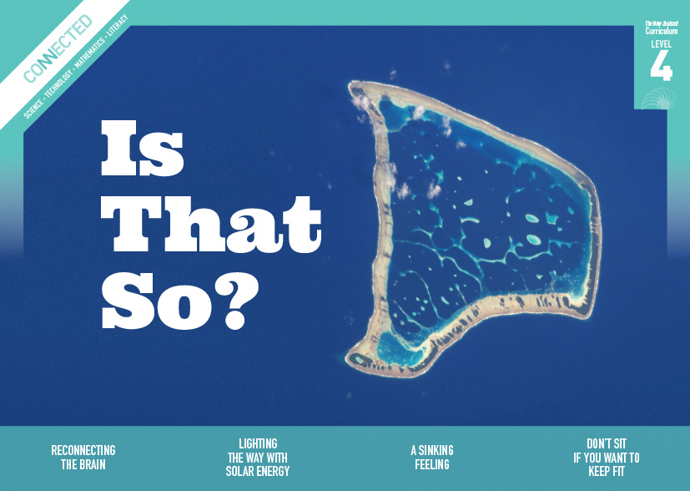  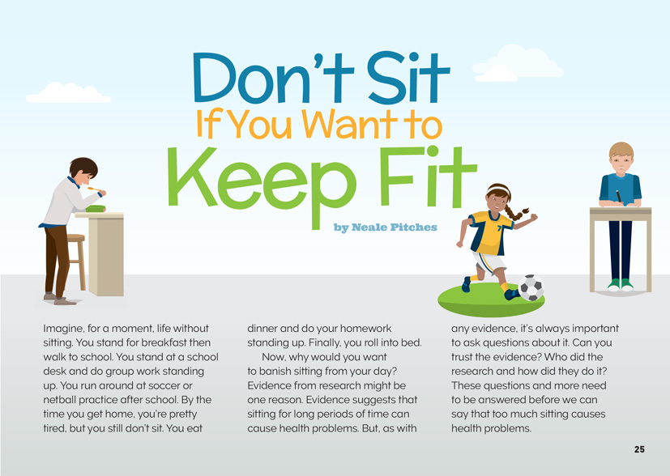
Science capability: Critique evidence |  | Text characteristics

Science knowledge is based on data derived from direct or indirect observations of the natural physical world. An inference is a conclusion drawn from those observations; it is the meaning you make from the observations. Understanding the difference between an observation and an inference is an important step towards being scientifically literate.  Being ready, willing, and able to critique evidence is also an important step towards being scientifically literate. Students must be able to assess the quality and reliability of both the observations (data) and the inferences made from those observations. In order to know what sorts of questions to ask to evaluate the trustworthiness of data, students need both methodological knowledge (how data is generated and collected) and statistical knowledge (how data is collated and analysed).  For more information about the “Critique evidence” science capability, go to http://scienceonline.tki.org.nz/Introducing-five-science-capabilities/Critique-evidence |  | - Abstract ideas about critiquing evidence.  - Subject-specific vocabulary and terminology.  - Illustrations, photographs, text boxes, and diagrams containing main ideas that relate to the text’s content.

Curriculum context

SCIENCE
NATURE OF SCIENCE: Understanding about science  Achievement objective  L4: Students will appreciate that science is a way of explaining the world and that science knowledge changes over time.  NATURE OF SCIENCE: Communicating in science  Achievement objective  L4: Students will engage with a range of science texts and begin to question the purposes for which these texts are constructed.  NATURE OF SCIENCE: Participating and contributing  Achievement objectives  L4: Students will use their growing science knowledge when considering issues of concern to them.  Students will explore various aspects of an issue and make decisions about possible actions. |  | Key Nature of Science ideas  Scientists:  - evaluate the trustworthiness of data by asking questions about investigations carried out by others  - undertake more than one trial to provide sufficient evidence to support a theory  - replicate investigations to critique the evidence or data provided by other scientists  - check that there are enough samples to reliably establish a conclusion or theory  - look carefully at the way data has been collected when they consider investigations done by others.

ENGLISH

READING  Ideas  Students will show an increasing understanding of ideas within, across, and beyond texts. |  | INDICATORS  - Makes meaning of increasingly complex texts by identifying and understanding main and subsidiary ideas and the links between them.  - Makes connections by thinking about underlying ideas within and between texts from a range of contexts.  - Recognises that there may be more than one reading available within a text.  - Makes and supports inferences from texts with increasing independence. |  | THE LITERACY LEARNING PROGRESSIONS  The literacy knowledge and skills that students need to draw on by the end of year 8 are described in The Literacy Learning Progressions.

Critiquing evidence

The science capability “Critique evidence” is about students evaluating the quality of the data supporting a scientific claim or idea (http://scienceonline.tki.org.nz/Introducing-five-science-capabilities/Critique-evidence).
Scientists use empirical evidence to develop theories about how the world works.
- Empirical evidence is data gathered from observations, experiments, and investigations.
- Scientific claims are only as dependable as the evidence on which they are based.
- Scientists design their investigations carefully to ensure the data they gather is both reliable and valid. Valid data is data that measures what it is supposed to measure – it answers the research question. Reliable data is dependable and consistent. Replicating the experiment and getting the same results makes us more confident the data is reliable.
- To gather high-quality evidence that is reliable and valid, scientists measure accurately, keep conditions the same or control variables that might influence measurements or observations, repeat tests or investigations many times, investigate multiple examples, and/or use statistical sampling techniques to make their observations or data as representative and accurate as they can.
Students should be critiquing and evaluating the quality of data gathered from their own investigations by:
- engaging in a range of investigation types, exploring, comparing, classifying, identifying, seeking patterns, using models, making things to test ideas, and investigating systems so that they learn different ways to gather different types of data
- identifying ways to make the data they collect in their own investigations as accurate and reliable as possible
- suggesting and developing ways to control conditions or variables or keep things fair, repeating observations or measurements or tests, and developing appropriate sampling methods
- applying their developing understanding of statistics and probability (sampling, variability, randomness, and the exploration of relationships in multi-variate data) when making decisions about sample size and repetitions and when working with their data.
Students should also be encouraged to look for, consider, and critique methods and data underpinning scientific claims made by others. This includes critically examining the appropriateness of methods and the quality of evidence used to develop scientific claims in the media and other sources.
Teachers can:
- help students to be more critical consumers of science information by being explicitly critical themselves
- support students to identify correlations as evidence of a potential relationship, but not necessarily cause and effect
- ask questions such as:
  - Would this always happen?
  - How sure are you of your measurements?
  - How many times should you repeat these tests/measurements?
  - Is this a fair result?
  - What may have influenced the data?
  - Was there a big enough sample?
  - Does the data match the claim?
  - How much variation is there in your results? Why might that be?
- support students to evaluate how data is presented; for example, if data is presented graphically, is this done appropriately or is it misleading? (This draws on another science capability, Interpret representations.)
- support students to apply their understanding of statistics and probability when considering claims, evidence, and data.
- establish a science classroom culture by:
  - modelling and encouraging a critical stance
  - encouraging students to consider the quality and interpretation of data underpinning scientific claims
  - using media headlines to introduce learning conversations and demonstrate the relevance of critiquing evidence to everyday life.
A range of questions and activities designed to get students to critique evidence is available on the Science Online website: http://scienceonline.tki.org.nz/Introducing-five-science-capabilities/Critique-evidence

Meeting the literacy challenges

The main literacy demands of this text lies in the use of diagrams, illustrations, and text boxes to interpret scientific information and ideas.
The following strategies will support students to understand, respond to, and think critically about the information and ideas in the text. You may wish to use shared or guided reading, or a mixture of both approaches, depending on the reading expertise of your students and the background knowledge they bring to the text.
After reading the text, support students to explore the activities outlined in the following pages.

TEACHER resources

Want to know more about instructional strategies? Go to:
- http://literacyonline.tki.org.nz/Literacy-Online/Teacher-needs/Reviewed-resources/Reading/Comprehension/ELP-years-5-8
- “Engaging Learners with Texts” (chapter 5) from Effective Literacy Practice in Years 5 to 8 (Ministry of Education, 2006)
Want to know more about what literacy skills and knowledge your students need? Go to:
- http://literacyonline.tki.org.nz/Literacy-Online/Student-needs/National-Standards-Reading-and-Writing
- http://www.literacyprogressions.tki.org.nz
“Working with Comprehension Strategies” (chapter 5) from Teaching Reading Comprehension (Davis, 2007) gives comprehensive guidance for explicit strategy instruction in years 4–8.
Teaching Reading Comprehension Strategies: A Practical Classroom Guide (Cameron, 2009) provides information, resources, and tools for comprehension strategy instruction.

INSTRUCTIONAL STRATEGIES

DEALING WITH ABSTRACT IDEAS
Provide an introduction and brief overview of the text.
PROMPT the students to discuss the following questions in pairs:
- What do you already know about keeping fit? How will this prior knowledge help you to make sense of this article?
- How do you know that what you think you know about keeping fit is true? What is your evidence?
Read the first paragraph out loud to the students, or have them read it by themselves, then give them a moment to think, pair, and share their response to the idea of life without sitting.
Have the students read to the end of the page and then check that they understand that this article is not just about fitness; it is also about evidence. DISCUSS what it says about evidence, drawing out the idea that just because something is published, it does not mean that it is correct.
- What are some questions you would want to ask a researcher before trusting their evidence that standing all day is good for you?
Make a chart that the students can use to summarise the evidence given in the article for:
- using standing desks
- regular activity and movement during the day.
As in the example below, the chart should incorporate a column for critiquing the evidence.
Research focus | The evidence in the article | Our questions about this evidence
Using standing desks
Regular activity and movement
As the students read, MODEL the sorts of questions they should be asking. For example, when the students do the pulse-taking activity on page 27, you could ASK:
- Is this good data?
- Why might you wait after standing up?
- Would doing it across the school get you better data?
- How did you track and analyse your data across the whole class?
When reading the diagrams on pages 28 and 29, DIRECT the students to use the subheadings to locate and compare information about the effects on body organs and biological processes when standing and sitting for long periods of time.
In response to the section headed “Stand Up for Your Health”, you could ASK:
- Are ten people enough for the study?
- Can you tell who published the research? What might this mean for the trustworthiness of the data?
- Does the article tell us whether there have been any critical scientific responses to this research? Why might that be important?
- Are there any other reasons that the evidence might not be trusted?
After reading this article, ASK QUESTIONS to support the students to REVIEW the extent to which the article has added to their knowledge about how to keep fit.
- Looking at our chart, does the data provide sufficient information to support the statements in the article?
- Who might benefit from the findings? How might knowing that affect our interpretation of the data?
- How has the evidence in the article informed, changed, or extended what you knew about getting fit?

DEALING WITH UNFAMILIAR VOCABULARY
IDENTIFY the words in the text that are likely to be unfamiliar to the students or that they know but do not know well. Write the words on cards and give the cards to pairs of students, spreading them around the class so that each pair has at least one word. Ask the students to research the meaning of the term they have been given and to complete a second card setting out information that will help other people understand its meaning. DISCUSS the sort of information they could incorporate, for example:
- If they are defining a body part, they should explain its function and give its common name.
- If they are giving a definition for an illness or disorder, they should explain the symptoms and what causes it.
Encourage them to include any visuals that may help understanding. Ensure that each pair has their definition(s) peer-reviewed by at least one other pair. Check the definitions yourself, and then scan the cards to create sets of matching pairs. Note that an alternative is for you to create the cards yourself.
Give sets of cards to the students and have them match each term with its definition. They could do this individually, but if they work in pairs or small groups, they will have opportunities to use the target language at the same time as they are sorting the cards.

Teacher support
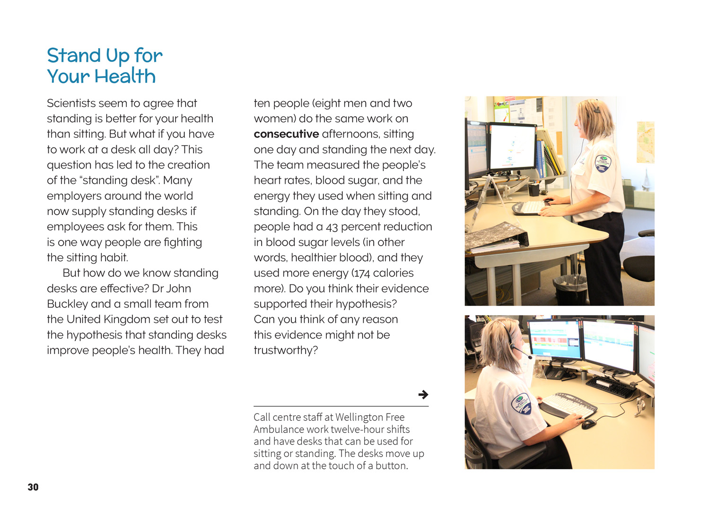 | Scientists evaluate the trustworthiness of data from investigations carried out by others.  Scientists ask questions that lead to investigations.  Scientists check that there are enough samples to reliably establish a conclusion or theory.

Learning activities
The following activities and suggestions are designed as a guide for supporting students to explore and develop understandings about the science capability “Critique evidence”. Some activities focus directly on the science capability. Other activities extend student content knowledge across the learning areas. You are encouraged to adapt these activities to support your students’ learning needs.

Exploring the science

Activity 1: What about me?
Have the students design an investigation into the impact of standing, sitting, and movement on learning and health. Discuss potential approaches with the students before supporting them to design their own investigations. Have the students critique each other’s research designs and, later, the rigour of the evidence they gather and the validity and reliability of the interpretations they make. (Do their findings answer their question (validity)? Would someone else be able to repeat their experiment (reliability)?)
Students might choose to focus on how much they move and the effect of this on their ability to concentrate and on their general fitness. Note that this topic would need to be handled with care. The students will need to decide on the period over which they will collect their data and how. They might, for example, keep a written log of their movements, use a pedometer, or find out whether they could use an app that detects movement. (The resource links include an item on apps and the article “How Much Does Sitting Negate Your Workout Benefits?”, which discusses the use of an accelerometer.)

Other options for investigation include:
surveying a range of people to determine how much time is spent sitting and standing
contrasting the concentration levels of students allowed to stand or move occasionally with those of others who are not
experimenting with the impact of changes in the school timetable design to allow regular periods of movement
finding out more about NEAT movements and the impact on health when people deliberately fidget while sitting or standing.
Following this investigation, have the students write an explanation about how sitting can affect their health. If it is supported by their investigation, have students list the ways they could incorporate more movement into their daily programme while maintaining (or increasing) the amount of learning that takes place. They could make a plan to enact these changes.
Extension
Connect this learning activity to student learning in the context of health and physical education. Support the students to explore how physical health interacts with other dimensions of health and well-being. Mental health is an obvious connection, but so are emotional and spiritual well-being.
What changes can we make in the way we organise our learning that will help improve our health and well-being and make us more effective learners?
This could be the start of a blog in which the learning community seeks ideas to improve the ways in which you work so that everybody’s health is enhanced.

Activity 2: What is the evidence?
Have the students consider that while we are focusing on critiquing our evidence when carrying out scientific investigations, we live in a world where we are constantly being told what to do and buy on the basis of scientific research. However, we don’t always remember to evaluate that research … and sometimes it’s not even obvious that we need to evaluate it.
Can you think of a time when you have been encouraged to do or buy things because you are told that science says it is good for you?
Did you know whether the research was credible? Who did it? How they did it? Why they did it?
Do you think that the general public should know enough to evaluate scientific claims? Can you give an example?
What are some possible effects of not knowing how to critique evidence?
Ask each of the students to engage with at least one of the items in the resource links that suggest ways to critically evaluate research findings: “A rough guide to spotting bad science” or “Working out what’s reliable evidence”. As a class, use this reading and your prior knowledge to construct a list of the questions the students should ask before accepting scientific research as fact.
Talk about how these questions could be reconstructed so that they are of use to people in the general public, such as the students’ whānau and fellow students. Refer to the two items they read and consider how the authors organised their information to make it interesting and accessible to readers (for example, organisation under headings, the use of visuals, the digital text with sliders from one topic to the next). Have the students consider how they could organise and present their questions in a way that achieves the same goal. Consider using Read Write Think’s “Student Interactive: Printing Press” as one way of creating posters, flyers, or brochures. Create drafts, but do not get them ready for publication at this point. Instead, have the students refine their drafts as they continue with this activity.
Have the students use the questions they have developed to critically evaluate research into the effects on fitness of standing versus sitting. They could use a platform such as Google docs to undertake this as a jigsaw exercise, with all students evaluating different examples of the research and contributing to the analysis.
The item (full bibliographical details) | Research focus | The evidence in the item | Our questions about this evidence
Note that the examples suggested in the resource links include some research articles that the students will not be able to open. This can itself be the subject of discussion.
Why do you think scientists’ findings are often published in publications that we cannot read without a subscription?
What do you notice about the language used in the academic articles? What might be the reasons for this?
What do you think is the effect of scientists’ findings being published in publications that we cannot read without a subscription?
It seems that scientific research has to be rewritten to make it accessible to the public. What are the reasons for this? What are some possible effects?
When they have completed their chart, have the students reflect for themselves about whether they are convinced that standing desks would be a good option for your school. Depending upon their conclusion, the students could:
Write a persuasive letter to the principal and board of trustees using evidence to argue for or against the purchase of standing desks for the classroom.
Design a poster encouraging an audience to spend less time sitting and/or to increase the time they spend moving around and exercising. Have them develop a catchy slogan and include information and key points to back up their message.
Return to the set of questions the students developed earlier. Have them review the questions and their earlier thinking about how they would present this scientific information to an audience of non-scientists. Suggest that they take into consideration the variety of ways they have seen scientific information presented during their critiquing exercise. Having seen the videos, they may consider making a video and posting it on YouTube as an alternative.
Have the students revise their presentations and publish them. Assessment could be through audience feedback.

RESOURCE LINKS

Critiquing evidence
“A Rough Guide to Spotting Bad Science” from Compound Interest. http://www.compoundchem.com/wp-content/uploads/2014/04/A-Rough-Guide-to-Spotting-Bad-Science-2015.pdf
“Working out what’s reliable evidence” from Ask for Evidence. http://askforevidence.org/help/evidence

Sitting versus standing
“Balancing green time with screen time” from the Department of Conservation. www.doc.govt.nz/getting-involved/conservation-activities/balancing-green-time-with-screen-time/
“Don’t Just Sit There – Do Something” from Radio New Zealand National. www.radionz.co.nz/national/programmes/ourchangingworld/audio/201754973/don't-just-sit-there-do-something
“Global Health Risks: Mortality and burden of disease attributable to selected major risks” from the World Health Organisation. www.who.int/healthinfo/global_burden_disease/GlobalHealthRisks_report_full.pdf (page 36)
“How Much Does Sitting Negate Your Workout Benefits?” from Runner’s World. http://www.runnersworld.com/health/how-much-does-sitting-negate-your-workout-benefits
“Is ‘sitting the new cancer’? What Apple CEO Tim Cook really meant” from The Guardian http://www.theguardian.com/technology/2015/feb/11/tim-cook-apple-sitting-the-new-cancer
“Morning workout vs breaks from sitting – which is better for blood sugar?” from PLOS Blogs. http://blogs.plos.org/obesitypanacea/2014/04/09/morning-workout-vs-breaks-from-sitting-which-is-better-for-blood-sugar/

“Obesity expert says daily workouts can’t undo damage done from sitting all day” from NBC News. http://rockcenter.nbcnews.com/_news/2013/01/09/16431050-obesity-expert-says-daily-workouts-cant-undo-damage-done-from-sitting-all-day?lite (article and video)
“Sedentary living is the ‘new smoking’ and we’re paying for it, study says” from CBC News. www.cbc.ca/news/business/sedentary-living-is-the-new-smoking-and-we-re-paying-for-it-study-says-1.2811872
“Sedentary time in adults and the association with diabetes, cardiovascular disease and death: systematic review and meta-analysis” from SpringerLink. http://link.springer.com/article/10.1007%2Fs00125-012-2677-z
“Sitting is Killing You (Infographic)” from FIX: Fitness Interactive Experience. http://sittingissmoking.com/sitting-is-killing-you-infographic/
“Sitting for long periods increases risk of disease and early death, regardless of exercise” from Science Daily. http://www.sciencedaily.com/releases/2015/01/150119171701.htm
“Sitting is the new smoking” from Stuff.co.nz. www.stuff.co.nz/life-style/well-good/8735754/Sitting-is-the-new-smoking
“Standing Desks Keep Kids Better Tuned In” from The Journal. http://thejournal.com/articles/2015/04/27/standing-desks-keep-kids-better-tuned-in.aspx
“Tim Cook hails Apple Watch health benefits: ‘Sitting is the new cancer’” from The Guardian. http://www.theguardian.com/technology/2015/feb/11/tim-cook-apple-watch-health-benefits
“Too Much Sitting and Chronic Disease Risk: Steps to Move the Science Forward” from Annals of Internal Medicine. http://annals.org/article.aspx?articleid=2091332
“UK study finds significant health benefits associated with standing” from the University of Chester. www.juststand.org/Portals/3/literature/UofChesterStudyResults.pdf
“Walking an extra two minutes each hour may offset hazards of sitting too long” from Science Daily. http://www.sciencedaily.com/releases/2015/04/150430170715.htm
“Why doctors are now warning that sitting is the new smoking” from the Mirror.
www.mirror.co.uk/lifestyle/health/doctors-now-warning-sitting-new-3393908
“Why sitting is bad for you – Murat Dalkilinç” from TedEd. http://ed.ted.com/lessons/why-sitting-is-bad-for-you-murat-dalkilinc (video)
“Why Sitting Is Killing You (Infographic)” from Mind Body Green. www.mindbodygreen.com/0-13574/why-sitting-is-killing-you-infographic.html
“Why you need to get rid of desk chairs now” from Stuff.co.nz. www.stuff.co.nz/life-style/well-good/motivate-me/67714631/why-you-need-to-get-rid-of-desk-chairs-now

The studies referred to in the text are:
Get Up!: Why Your Chair is Killing You and What You Can Do About It. Dr James A. Levine, St Martin’s Griffin, 2014.
“Calorie Burner: How much better is standing up than sitting?”, with Dr John Buckley, from BBC News. www.bbc.com/news/magazine-24532996
“Too Little Exercise and Too Much Sitting: Inactivity Physiology and the Need for New Recommendations on Sedentary Behavior”, by Dr Marc Hamilton and colleagues, from the National Center for Biotechnology Information. www.ncbi.nlm.nih.gov/pmc/articles/PMC3419586/
“Sitting and Standing at Work” from Cornell University Ergonomics. http://ergo.human.cornell.edu/CUESitStand.html
“Sedentary Time and Its Association with Risk for Disease Incidence, Mortality, and Hospitalization in Adults: A Systematic Review and Meta-analysis” by Dr David Alter and colleagues, from Annals of Internal Medicine. http://annals.org/article.aspx?articleid=2091327

Other sources
“Student Interactive: Printing Press” from ReadWriteThink. www.readwritethink.org/classroom-resources/student-interactives/printing-press-30036.html
“The Best Fitness Tracking Apps for Every Type of Exercise” from Lifehacker. http://lifehacker.com/the-best-fitness-tracking-apps-for-every-type-of-exerci-1482693352

link to technology

Activity 1: Meeting the brief
The students could investigate and design school furniture that gives options for standing and sitting and that accommodates students moving around regularly.
Initiate this activity by telling the students about the standing cardboard desk developed by a team of young New Zealand designers. Ask:
If you were to interview the Refold team, what questions would you ask to find out their motivation, purpose, and design process?
Have the students conduct online research to find the answers to their questions.
The students could then move to designing their own standing desks and making a scale model. They could begin by interviewing a stakeholder – perhaps another student or someone else who works using a desk – and using this information to write a design brief for a desk or work station that suits that person. Assessment could incorporate feedback from the “client” about how effective the student was in responding to their requirements.

Activity 2: Redesigning our learning environments
The students could research what is meant by the term “a modern learning environment”. While the material on TKI is directed at adults, the video links provide an opportunity for students to see what is meant. They could discuss how they like to learn and what sort of changes they would like to see in their learning environment. They need to research their suggestions to make realistic proposals, supported by evidence.

RESOURCE LINKS

“Innovative learning environments” from TKI. http://elearning.tki.org.nz/Technologies/Modern-learning-environments
Refold’s Portable Cardboard Standing Desk. www.refold.co/#about

Google Slides version of “Don’t Sit If You Want to Keep Fit” www.connected.tki.org.nz

