CONNECTED, LEVEL 4 2014, What’s the Evidence?  Black is Back  by Rangi Te Kanawa  Overview  In this article, students learn how Te Papa conservator Rangi Te Kanawa uses her knowledge of traditional dyeing practices, of science, and of scientific experimentation to preserve fibres in textiles that have been treated with iron-tannate black dyes.  A Google Slides version of this article is available at www.connected.tki.org.nz. |  |  | 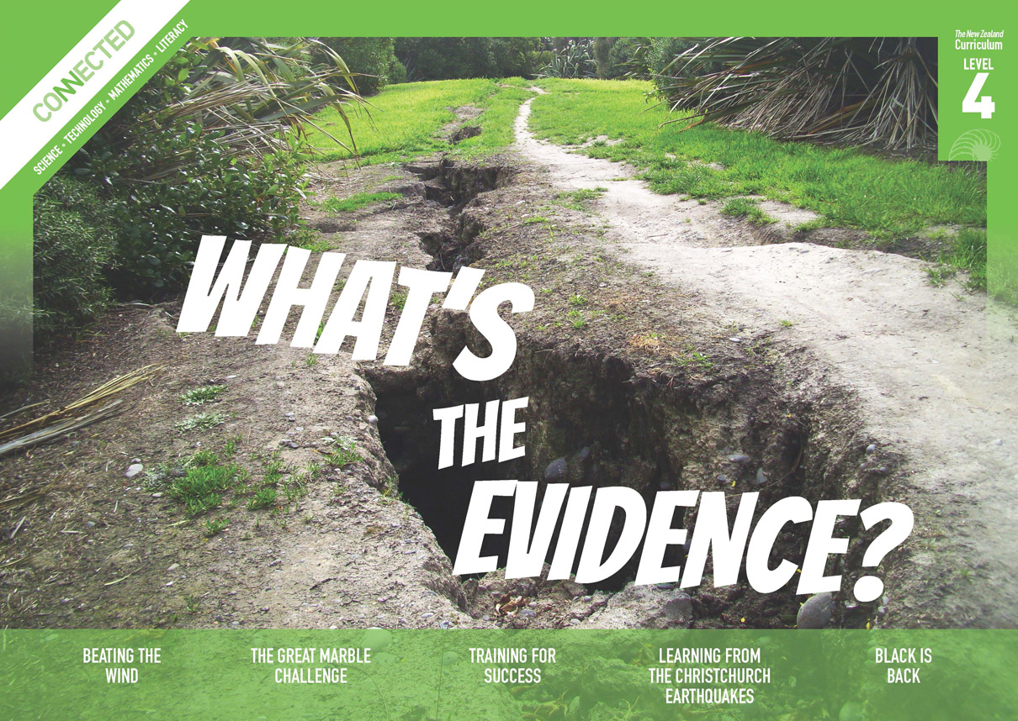  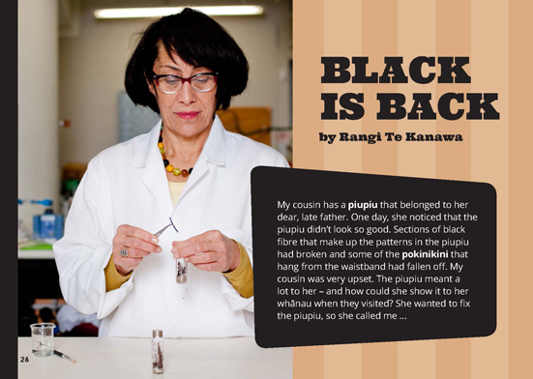
Science capability: Use evidence |  | Text characteristics

Science is a way of explaining the world. Science is empirical and measurable. This means that in science, explanations need to be supported by evidence that is based on, or derived from, observations of the natural world. Students should be encouraged to support their ideas with evidence and look for evidence that supports or contradicts other explanations.  At the core of science is theory building – making better explanations. What sets scientific explanations apart from other ways of explaining the world is their reliance on evidence and their ability to evolve as new evidence comes to light.  For more information about the “Use evidence” science capability, go to http://scienceonline.tki.org.nz/Introducing-five-science-capabilities/Use-evidence |  | - Complex sentences with dense information.  - A mixed text type - a procedural text written as a narrative that includes explanations.  - Subheadings, photographs, text boxes, a graph, and a glossary.  - A significant amount of subject-specific, scientific, and academic language, including terms in te reo Māori.

Curriculum context

SCIENCE
NATURE OF SCIENCE: Understanding about science  Achievement objective(s)  L4: Students will identify ways in which scientists work together and provide evidence to support their ideas. |  | MATERIAL WORLD: Chemistry and society  Achievement objective(s)  L4: Students will relate the observed, characteristic chemical and physical properties of a range of different materials to technological uses and natural processes. |  | Key Nature of Science ideas  - Evidence is based on, or derived from, observations of the natural world.  - Scientific ideas and explanations are supported by evidence.  - Scientists use evidence to support or revise their predictions and explanations.  Key science ideas  - Different materials can be grouped according to their chemical and physical properties.  - Changes in materials can be explained by the reactions of different particles.  - The chemical and physical properties of materials make them useful for different purposes and processes.

ENGLISH

READING  Ideas  Students will show an increasing understanding of ideas within, across, and beyond texts. |  | INDICATORS  - Makes meaning of increasingly complex texts by identifying and understanding main and subsidiary ideas and the links between them.  - Makes connections by thinking about underlying ideas within and between texts from a range of contexts.  - Recognises that there may be more than one reading available within a text.  - Makes and supports inferences from texts with increasing independence. |  | THE LITERACY LEARNING PROGRESSIONS  The literacy knowledge and skills that students need to draw on by the end of year 8 are described in The Literacy Learning Progressions.

Using evidence

- Scientists use empirical evidence to develop theories about how the world works.
- Empirical evidence is data gathered from observations and experiments.
The science capability, Use evidence, is about students developing and considering theories and explanations in the light of evidence (http://scienceonline.tki.org.nz/Introducing-five-science-capabilities/Use-evidence).
Students should be:
- using evidence they have gathered to develop their own explanations about the way the world works
- critiquing explanations offered by others, including scientifically accepted explanations, by considering the evidence that supports them.
Scientific explanations, including those found in museums, in television programmes, on the Internet, and in non-fiction books and texts, often fail to discuss the evidence and testing that led to the development of these explanations.
Teachers can:
- help students to be more critical consumers of science information by being explicitly critical themselves
- model a sceptical stance
- ask questions such as:
  - How do you think people found that out about that?
  - What kind of evidence would support that idea?
  - How could a scientist test that idea?
- use concept cartoons to propose possible explanations. (See http://conceptcartoons.com/what-is-a-concept-cartoon-.html)
When doing practical investigations, teachers can support students to:
- consider a range of possible explanations for their findings
- think about how these explanations fit with the evidence they have gathered
- avoid suggesting that scientific investigations prove anything – rather, investigations provide evidence that supports or refutes a hypothesis or idea.
Establish a science classroom culture by:
- welcoming a range of possible explanations
- encouraging students to consider possible explanations in the light of evidence
- having students draw evidence from their experience
- using questions such as:
  - What have we seen today that supports X’s idea?
  - Has anyone seen anything somewhere else that might be evidence for X’s idea?
- encouraging investigation:
  - What could we do to test X’s idea?
  - What would we expect to happen? Why?
A range of questions and activities designed to get students to use evidence is available on the Science Online website: http://scienceonline.tki.org.nz/Introducing-five-science-capabilities/Use-evidence

Meeting the literacy challenges

The following instructional strategies will support students to understand, respond to, and think critically about the information and ideas in the text. After reading the text, support students to explore the key science ideas outlined in the following pages.

TEACHER resources

Want to know more about instructional strategies? Go to:
- http://literacyonline.tki.org.nz/Literacy-Online/Teacher-needs/Reviewed-resources/Reading/Comprehension/ELP-years-5-8
- “Engaging Learners with Texts” (Chapter 5) from Effective Literacy Practice in Years 1 to 4 (Ministry of Education, 2003).
Want to know more about what literacy skills and knowledge your students need? Go to:
- http://literacyonline.tki.org.nz/Literacy-Online/Student-needs/National-Standards-Reading-and-Writing
- www.literacyprogressions.tki.org.nz/
“Working with Comprehension Strategies” (Chapter 5) from Teaching Reading Comprehension (Davis, 2007) gives comprehensive guidance for explicit strategy instruction in years 4–8.
Teaching Reading Comprehension Strategies: A Practical Classroom Guide (Cameron, 2009) provides information, resources, and tools for comprehension strategy instruction.

INSTRUCTIONAL STRATEGIES

FINDING THE MAIN IDEAS
IDENTIFY aspects of the structure, such as the title, headings, text boxes, and photographs that will help students navigate the article.
What do the title and photograph on page 26 suggest the article is about?
Find the information that identifies the problem.
Find the information that identifies the solution.
What is Rangi going to do before she applies her solution?
What helped you to find the problem and solution?
ASK QUESTIONS to support the students to identify the main ideas.
Read the first paragraph. What do you infer about the cousin’s father and the piupiu?
What do you think had happened to the piupiu and why?
PROMPT the students to make connections with their prior knowledge.
When and where have you seen piupiu?
Who wears them and when? Why?
What do you think they mean to the people who own them?
Does your family have precious items of clothing that have been handed down through the generations? What condition are they in? How do you care for them? How have they changed over time? Why do you think this is?
Have the students read page 27. ASK QUESTIONS to help them clarify the problem.
What is the central problem?
What did Rangi have to do before she could stop the muka breaking down?
How might an understanding of science help solve the problem?
What other questions did you have as you read to clarify the problem?
EXPLAIN that this text includes a lot of tricky scientific concepts. The students will need to track through the article step by step, relating previous information with new information. As they read, PROMPT them to record a summary of what Rangi did to stop the muka breaking down. MODEL how to do this, for example, Rangi:
identified what she needed to find out
used scientific knowledge handed down in her family to understand how the piupiu had been dyed
met with other scientists to discuss how to stop the paru breaking down the muka fibres
investigated what other people have done and learned that consolidation is the only possible treatment
developed a hypothesis that funori or sodium alginate might work.
RECORDING these details will support students' comprehension as they work through the article.
Have the students work in pairs to unpack the sequence of steps in the dyeing process on page 28. Give each pair a set of cards to SORT.

DYEING THE MUKA
Scrape sections of harakeke leaf
Soak the strips of harakeke leaves in water, with bark from the hinau tree
Bury the strips in paru
Wash the strips in cold water
PROMPT the students to notice the signal words that indicate connections and relationships in sentences or paragraphs. Examples include “first”, “then”, “next”, “so”, and “as a result”. Look closely to see how the signal words in the following sentences indicate a list or sequence, a consequence or result, a condition or modification, or the time when something happened. Note that some of these words can be used in different ways, for example, “but” can mean a “change of direction”.
“Overnight, the muka would have turned black because it had soaked up the tannins from the hinau bark.” [consequence]
“First, we decided to find out what other methods are used to treat similar fibres.” [list]
“Then we thought about substances that we might use to consolidate the muka.” [list]
“The chemical properties of muka are much the same as paper, so we decided to experiment with funori, which is used as a consolidation treatment for paper.” [consequence]
“Conservators hadn't used it before, but it is used as a gelling agent in the food industry.” [a modification is coming up]
“When we compared the results of the tests, we found that the sodium alginate performed best.” [time]
“I thought that the gentlest way of doing this would be to vaporise the sodium alginate and spray it onto the fibres, so I tried doing this with a nebuliser.” [sequence]
After the reading, have the students use their recorded summaries to DISCUSS what they have learned about how Rangi used an understanding of science to stop the muka breaking down. IDENTIFY the main ideas.
ASK QUESTIONS to help the students reflect on their strategies for locating and understanding information and ideas.
Which text features helped you to find information and track ideas in the text?
How did you use sentence structure to work out the sequence of events and to connect ideas across the text?

USING DESIGN FEATURES FOR DEEPER UNDERSTANDING
ASK QUESTIONS to draw out the idea that articles often contain additional information that supports the main ideas.
- What do you learn from the photographs? How are they connected to the text? [They illustrate key steps in the scientific process]
- What is the purpose of the text box on page 29? Why has the designer illustrated it like this? [It illustrates the pH scale.]
- How effective were these supports in helping you to gain a deeper understanding of the text?

DEALING WITH SCIENTIFIC VOCABULARY
EXPLAIN that the glossary is an important part of this article, which uses a large number of scientific and academic words, as well as words in te reo Māori. The glossary helps readers understand the ideas.
Students can use the following graphic organiser to present key terms from the article, along with contextual information. These can be displayed and used for reference as they take part in science learning activities.
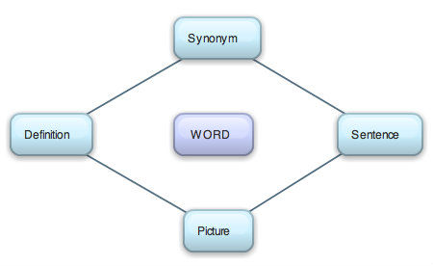

[Graphic organiser from www.learnnc.org/lp/pages/7079]

Key science ideas
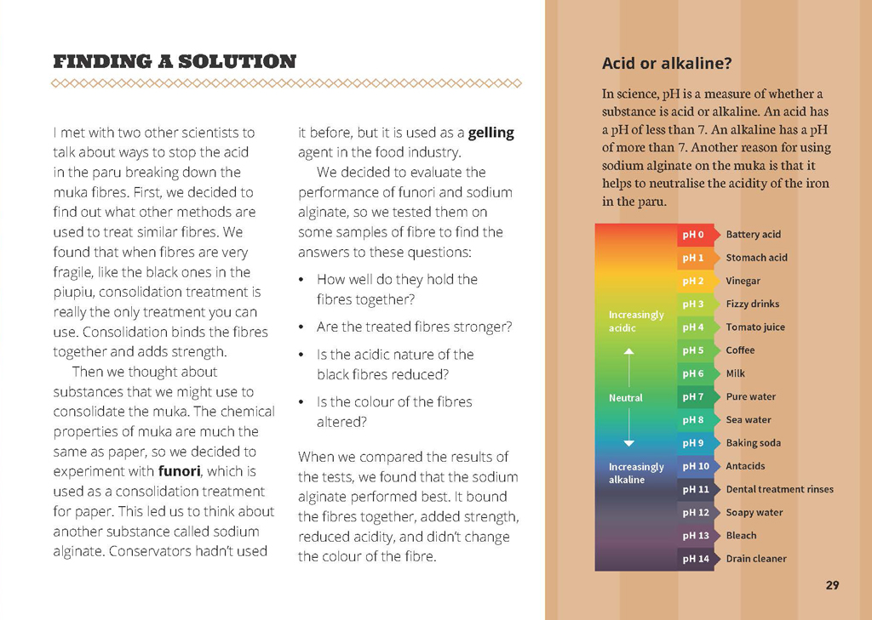 | Scientists think creatively to find solutions and develop explanations.  Scientists use evidence from the work of other scientists.  Evidence is based on observations of the natural world.  Scientists work together to generate ideas.
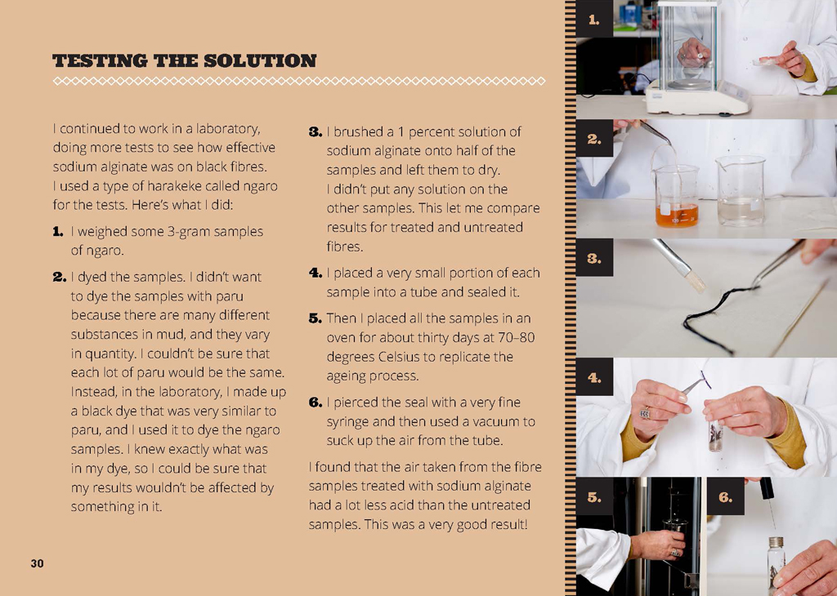  Students identify ways in which scientists work together to provide evidence to support their ideas. | When investigating their ideas, scientists consider the different chemical properties of materials.  Scientific ideas and explanations are supported by evidence.

Exploring the science
Some activities focus directly on the science capability of “using evidence to support ideas” and the Nature of Science strand. Other activities extend student content knowledge. You are encouraged to adapt these activities to make the focus on Nature of Science explicit and to support students to develop the capability of using evidence to support ideas.

LEARNING FOCUS
Scientists use evidence from observations to support ideas.

LEARNING ACTIVITIES

Activity 1: Preserving our past
Have the students work in groups to identify the science investigation process used in this article: Question; background research; hypothesise; test the hypothesis by observing, gathering data, or conducting experiments; analyse and interpret the data; draw a conclusion; and communicate the results. Encourage them to draw on the summaries they created during the reading, matching the detail to the steps in the science investigation process.
What ideas did Rangi have about what might be going wrong?
Where did her ideas come from?
How did she identify and select possible ways to protect the fibres?
What data did she collect?
How did she use what she found out?
What was scientific about the investigation?
View Project Mātauranga, Series 2, Episode 1 (available at www.maoritelevision.com/tv/shows/project-matauranga/S02E001/project-matauranga-series-2-episode-1) to learn more about why it is important to preserve harakeke garments and how Rangi and her colleagues are going about this. The video reinforces the message that this process can be used to preserve textiles from around the world, many of which are also coloured with iron-tannate dyes.
Discuss why it is important to develop processes for preserving dyed artefacts. Have the students work in their groups to design posters that describe the process Rangi and her colleagues developed and explain why this research is important.

Activity 2: Research about piupiu
Research how piupiu are traditionally made.
What materials do Māori use?
How do they get the different colours?
What patterns are used and what do they mean?
How has the process changed over time?
Why is this tradition important?
Why is it important to preserve piupiu that were made many years ago?
Begin by discussing the stages in the research process.
Stage 1: Focusing and planning
Stage 2: Sourcing information
Stage 3: Analysis
Stage 4: Reporting
The Project Mātauranga video is an excellent starting point. The class could also visit Te Papa (physically or online) and view some of their textile exhibits, including Māori piupiu. The Kākahu collection is extensive and includes further information about Rangi's mother and grandmother.

Activity 3: Acid versus alkaline
View the Project Mātauranga video to learn more about the use of sodium alginate to neutralise the acid that degrades natural fibres. Have the students research experiments about acid versus alkaline.
What methods do these experiments use?
How would you use the evidence from these experiments to solve problems like the one in this article?
Conduct your own investigations using household acids (for example, lemon juice, Coca Cola, or vinegar) on pieces of a natural fabric (for example, cotton or calico) and record the effect the acids have over a period of time. Make connections to the text and discuss how the fabric could be protected.

Activity 4: Dyeing to try it
Have the students experiment with natural resources to make dyes of different colours and to find out about mordants – the substance used to set dyes. You could use the questions on page 29 of the article to focus the investigation.
“Science Focus: Dyeing to Try It” from Making Better Sense of the Material World describes activities you could try.
“Traditional Uses of the Vegetable Caterpillar Fungus” is a brief video on the Science Learning Hub (www.sciencelearn.org.nz/Contexts/Hidden-Taonga/Sci-Media/Video/Traditional-uses-of-the-vegetable-caterpillar-fungus) in which a scientist talks about how the vegetable caterpillar fungus was once used as an ingredient in the ink used to create moko.
Link this learning to the way another group of people used natural pigments to create cultural treasures. In the fifteenth and sixteenth centuries, artists in Italy created frescoes that we can still enjoy today. They did this by applying their pigment to a fresh surface of lime plaster. “Fresco Painting Chemistry” on the Science Learning Hub (www.sciencelearn.org.nz/Contexts/A-Fizzy-Rock/Teaching-and-Learning-Approaches/Fresco-painting-chemistry) is an activity in which students prepare a tile of lime plaster and then paint it in the fresco style. They explore the chemistry behind this technique.
Extension
Visit www.sciencelearn.org.nz/Contexts/Light-and-Sight/Science-Ideas-and-Concepts/Colours-of-light to explore what colour is and how we are able to see colour.
Google Slides version of “Black is Back” www.connected.tki.org.nz

RESOURCE LINKS

“Science Focus: Dyeing to Try It”. In Making Better Sense of the Material World, pp 109–116.Project Mātauranga, Series 2, Episode 1 (2013). Māori Television. Available at www.maoritelevision.com/tv/shows/project-matauranga/S02E001/project-matauranga-series-2-episode-1
Science Learning Hub
“Harakeke under the Microscope” at www.sciencelearn.org.nz/Contexts/Exploring-with-Microscopes/NZ-Research/Harakeke-under-the-microscope
“Vegetable Caterpillar” at www.sciencelearn.org.nz/Contexts/Hidden-Taonga/NZ-Research/Vegetable-caterpillar
“Traditional Uses of the Vegetable Caterpillar Fungus” at www.sciencelearn.org.nz/Contexts/Hidden-Taonga/Sci-Media/Video/Traditional-uses-of-the-vegetable-caterpillar-fungus
“Fresco Painting Chemistry” at www.sciencelearn.org.nz/Contexts/A-Fizzy-Rock/Teaching-and-Learning-Approaches/Fresco-painting-chemistry
“Colours of Light” at www.sciencelearn.org.nz/Contexts/Light-and-Sight/Science-Ideas-and-Concepts/Colours-of-light
Te Papa
Collections Online. http://collections.tepapa.govt.nz/
“Caring for Māori Textiles” at www.tepapa.govt.nz/sitecollectiondocuments/tepapa/nationalservices/pdfs/resourceguides/collectioncare/tpnsmaori_textiles.pdf
“Kākahu: Māori Cloaks” at www.tepapa.govt.nz/Collectionsandresearch/taongamaori/maoricloaks/Pages/default.aspx

