CONNECTED, LEVEL 3 2014, Why Is That?  Elephant Toothpaste  by Nikki Reid and Rex Bartholomew  Overview  A class arrives at school to find their room transformed into a laboratory and their teacher transformed into an animal dental hygiene scientist. This text provides a good model of teaching science and engaging kids with an interesting, slightly wacky topic. It focuses on chemical reactions that make things bubble.  A Google Slides version of this article is available at www.connected.tki.org.nz. |  |  | 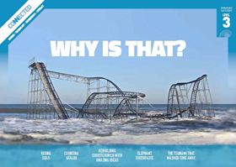  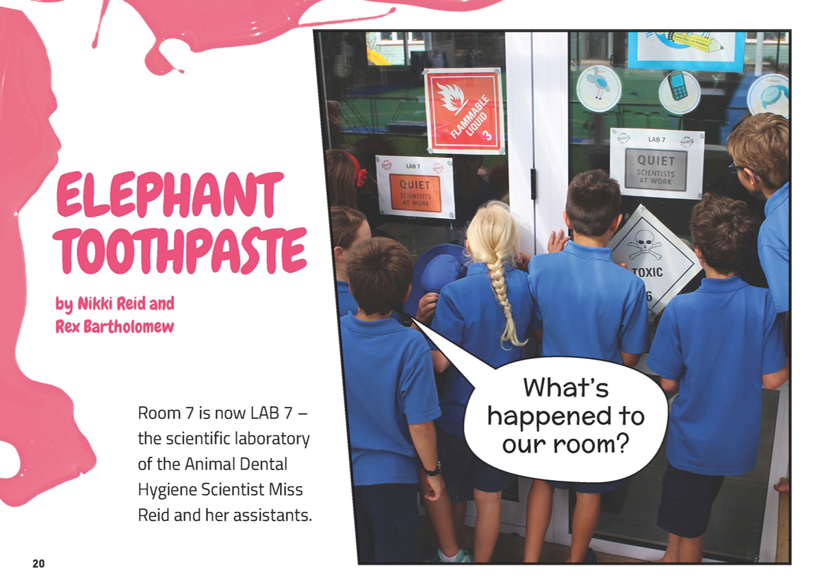
Science capability: Use evidence |  | Text characteristics

Science is a way of explaining the world. Science is empirical and measurable. This means that in science, explanations need to be supported by evidence that is based on, or derived from, observations of the natural world. Students should be encouraged to support their ideas with evidence and look for evidence that supports or contradicts other explanations.  At the core of science is theory building – making better explanations. What sets scientific explanations apart from other ways of explaining the world is their reliance on evidence and their ability to evolve as new evidence comes to light.  For more information about the “Use evidence” science capability, go to http://scienceonline.tki.org.nz/Introducing-five-science-capabilities/Use-evidence |  | - A graphic story in which much of the information is conveyed visually.  - A mixed text type that combines procedure with narrative and dialogue.  - The scientific language, which is generally explained by words or illustrations.

Curriculum context

SCIENCE
NATURE OF SCIENCE: Investigating in science  Achievement objective(s)  L3: Students will ask questions, find evidence, explore simple models, and carry out appropriate investigations to develop simple explanations. |  | MATERIAL WORLD: Properties and changes of matter  Achievement objective(s)  L3: Students will compare chemical and physical changes.  MATERIAL WORLD: Chemistry and society  Achievement objective(s)  L3: Students will relate the observed, characteristic chemical and physical properties of a range of different materials to technological uses and natural processes. |  | Key Nature of Science ideas  - Evidence is based on, or derived from, observations of the natural world.  - Scientific ideas and explanations are supported by evidence.  - Scientists make use of relevant evidence to support or revise their predictions and explanations.  Key science ideas  - Materials can be grouped according to the chemical and physical properties we can observe and measure.  - Chemical and physical changes occur under different circumstances.  - Gas production and heating are evidence of chemical change.

ENGLISH

READING  Ideas  Students will show a developing understanding of ideas within, across, and beyond texts. |  | INDICATORS  - Uses their personal experience and world and literacy knowledge confidently to make meaning from texts.  - Makes meaning of increasingly complex texts by identifying main and subsidiary ideas in them.  - Starts to make connections by thinking about underlying ideas in and between texts.  - Makes and supports inferences from texts with increasing independence. |  | THE LITERACY LEARNING PROGRESSIONS  The literacy knowledge and skills that students need to draw on by the end of year 6 are described in The Literacy Learning Progressions.

Using evidence

- Scientists use empirical evidence to develop theories about how the world works.
- Empirical evidence is data gathered from observations and experiments.
The science capability, Use evidence, is about students developing and considering theories and explanations in the light of evidence (http://scienceonline.tki.org.nz/Introducing-five-science-capabilities/Use-evidence).
Students should be:
- using evidence they have gathered to develop their own explanations about the way the world works
- critiquing explanations offered by others, including scientifically accepted explanations, by considering the evidence that supports them.
Scientific explanations, including those found in museums, in television programmes, on the Internet, and in non-fiction books and texts, often fail to discuss the evidence and testing that led to the development of these explanations.
Teachers can:
- help students to be more critical consumers of science information by being explicitly critical themselves
- model a sceptical stance
- ask questions such as:
  - How do you think people found that out?
  - What kind of evidence would support that idea?
  - How could a scientist test that idea?
- use concept cartoons to propose possible explanations. (See http://conceptcartoons.com/what-is-a-concept-cartoon-.html)
When doing practical investigations, teachers can support students to:
- consider a range of possible explanations for their findings
- think about how these explanations fit with the evidence they have gathered
- avoid suggesting that scientific investigations prove anything – rather, investigations provide evidence that supports or refutes a hypothesis or idea.
Establish a science classroom culture by:
- welcoming a range of possible explanations
- encouraging students to consider possible explanations in the light of evidence
- having students draw evidence from their experience
- using questions such as:
  - What have we seen today that supports X’s idea?
  - Has anyone seen anything somewhere else that might be evidence for X’s idea?
- encouraging investigation:
  - What could we do to test X’s idea?
  - What would we expect to happen? Why?
A range of questions and activities designed to get students to use evidence is available on the Science Online website: http://scienceonline.tki.org.nz/Introducing-five-science-capabilities/Use-evidence

Meeting the literacy challenges

The following instructional strategies will support students to understand, respond to, and think critically about the information and ideas in the text. After reading the text, support students to explore the key science ideas outlined in the following pages.

TEACHER resources

Want to know more about instructional strategies? Go to:
- http://literacyonline.tki.org.nz/Literacy-Online/Teacher-needs/Reviewed-resources/Reading/Comprehension/ELP-years-5-8
- “Engaging Learners with Texts” (Chapter 5) from Effective Literacy Practice in Years 1 to 4 (Ministry of Education, 2003).
Want to know more about what literacy skills and knowledge your students need? Go to:
- http://literacyonline.tki.org.nz/Literacy-Online/Student-needs/National-Standards-Reading-and-Writing
- www.literacyprogressions.tki.org.nz/
“Working with Comprehension Strategies” (Chapter 5) from Teaching Reading Comprehension (Davis, 2007) gives comprehensive guidance for explicit strategy instruction in years 4–8.
Teaching Reading Comprehension Strategies: A Practical Classroom Guide (Cameron, 2009) provides information, resources, and tools for comprehension strategy instruction.

INSTRUCTIONAL STRATEGIES

FINDING INFORMATION IN THE TEXT
ASK QUESTIONS to prompt the students to use the title, hook, and photo on page 20 to predict the science angle in the story.
Where are these students?
From the photo, what do you think has happened to their classroom?
What does the opening paragraph tell you?
PROMPT the students to read and DISCUSS the letter from the zoo on page 21. Using the Google Slides version of the article, show the letter on a screen or interactive whiteboard so you can highlight the key words.
What words in the letter give the reader clues about Room 7’s task?
What are the elephant keepers asking Room 7 to do and why?
As the students read, PROMPT them to follow the photo sequence to work out what is happening and keep track of who is speaking.
On page 22, someone says “here are the ingredients the zoo sent”. Who do you think this is?
What order did Scientist Reid mix the ingredients? Why do you think she mixed them in this order?
PROMPT the students to notice the measurements.
On page 23, Scientist Reid reminds the “LAB 7 team” about the importance of measurement. SKIM the text and see if you can find all the examples of measurements.
The students could summarise the investigation in the form of a letter to the zoo, outlining how they planned to solve the elephant keepers’ problem.

DEALING WITH SCIENTIFIC VOCABULARY
PROMPT the students to IDENTIFY any unknown vocabulary and investigate the meanings. Decide together which words are important for the science investigation. Put these words and their meanings on a word wall, including examples of how the words are used in sentences.

Key science ideas
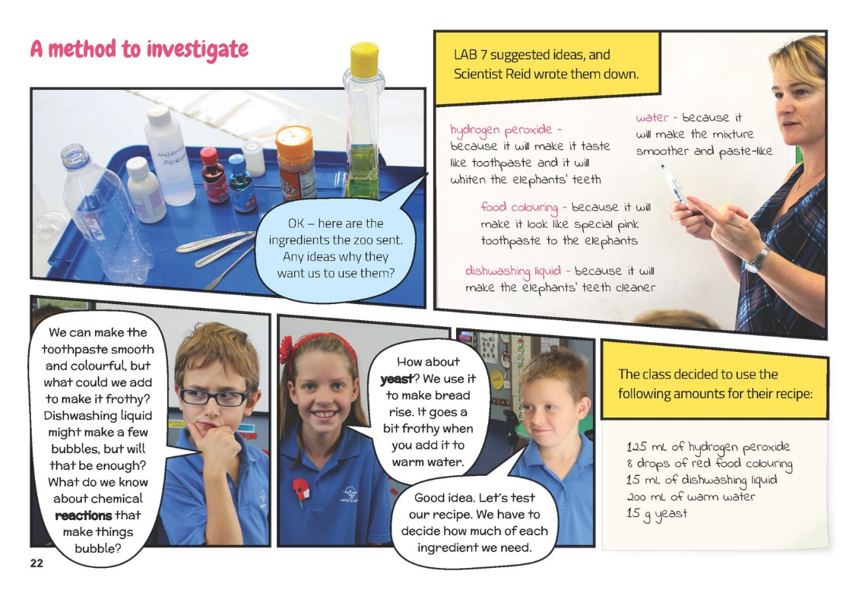 | Chemical reactions can occur when materials are mixed.  Students carry out an appropriate investigation to test their ideas.  Students ask questions that can lead to investigations.
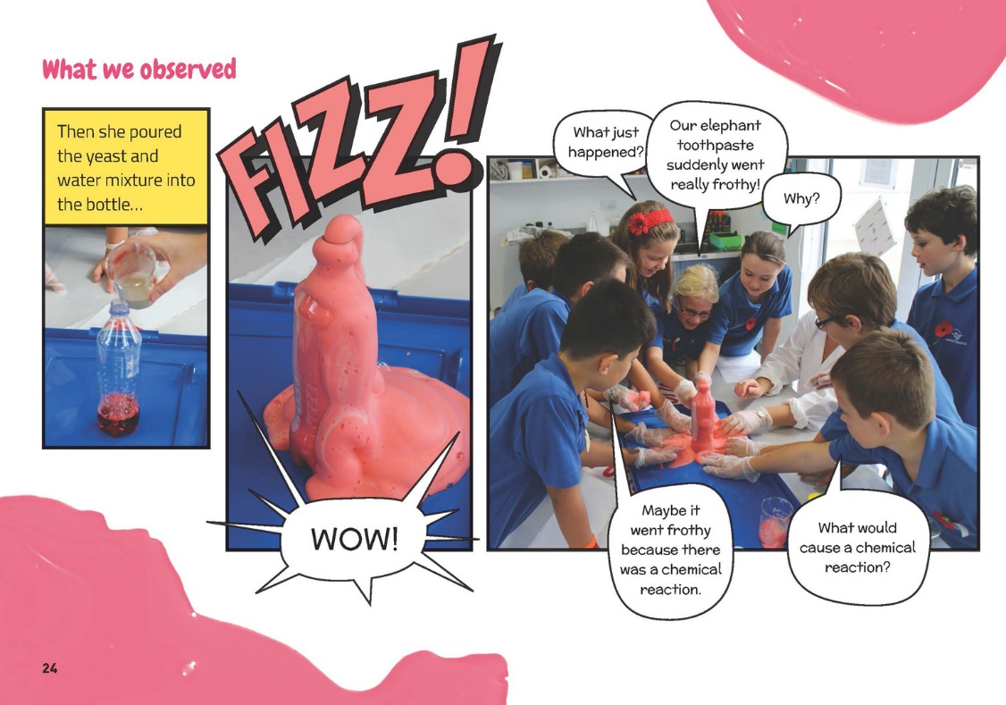 | Students ask questions to develop explanations about their observations.  Evidence is based on observations.  Gas production and heating are evidence of chemical change.

Exploring the science
Some activities focus directly on the science capability of “using evidence to support ideas” and the Nature of Science strand. Other activities extend student content knowledge. You are encouraged to adapt these activities to make the focus on Nature of Science explicit and to support students to develop the capability of using evidence to support ideas.

LEARNING FOCUS
Students use evidence from observations to support their ideas.

LEARNING ACTIVITIES

Activity 1: The experiment
After reading this story, the students are sure to want to make their own elephant toothpaste! However, Science Bob (www.sciencebob.com/experiments/elephants_toothpaste.php) points out that this project is a demonstration, not an experiment. To turn it into an experiment, he suggests encouraging the students to wonder, for example:
Does the amount of yeast change the amount of foam produced?
Does the experiment work as well if you add the dry yeast without mixing it with water?
Does the size of the bottle affect the amount of foam produced?
Can we measure the amount of heat produced?
How could we make the toothpaste froth and stay in a tube?
What else do you wonder?
For the first experiment, have the students talk you through the methodology as you perform the experiment.
Subsequent investigations could be done in groups. Their brief could be to continue the work started in LAB 7 and improve the toothpaste. Each group could be responsible for a different investigation and then share their findings with the class.
Support students to record the key evidence on a photo/story board or in a video to demonstrate how reliable their evidence is. Groups could combine their evidence to suggest and then test an improved formula. Remind students that scientists often work in teams, and share and check each other’s evidence.
Extension
The students could design a toothbrush for an elephant. Have them consider all the factors necessary, for example:
the size of elephants and their teeth
the length of handle
the properties of the materials that would withstand brushing an elephant's teeth.

Activity 2: Fun with yeast
Explore how yeast makes bread rise. The students could conduct two experiments with yeast and water in a bottle with a balloon over the top. They could make one mixture with warm water and one with cold so they can observe the evidence that heat affects yeast activity.
You could select activities from the Biotechnology Learning Hub unit on “Making Fermented Drinks” (www.biotechlearn.org.nz/themes/biotech_at_home/making_fermented_drinks2) to further explore the properties of yeast and how it can be used to produce a fermented drink.
Extension
The Making Better Sense of the Material World unit “Fizzing and Foaming” suggests investigations students could do with other materials that are commonly used to create pressurised gases. In particular, “Billowing Balloons” provides a way of comparing the actions of yeast to bicarbonate of soda, and “Sherbert Fizz” and “Make Mine Green and Fizzy” show how these properties are applied to the creation of carbonated drinks.

Google Slides version of “Elephant Toothpaste” www.connected.tki.org.nz

RESOURCE LINKS

Biotechnology Learning Hub
“Unit Plan: Making Fermented Drinks” at www.biotechlearn.org.nz/themes/biotech_at_home/making_fermented_drinks2
“Student Worksheets: Fermented Drinks” www.biotechlearn.org.nz/themes/biotech_at_home/student_worksheets_fermented_drinks
“Fizzing and Foaming” in Making Better Sense of the Material World pp. 74–83.

Elephant toothpaste
“Can You Use Hydrogen Peroxide on Your Teeth?” from How Stuff Works at http://health.howstuffworks.com/wellness/oral-care/products/use-hydrogen-peroxide-on-teeth.htm
“Elephant Toothpaste – A Hydrogen Peroxide Chemistry Experiment” (includes a variety of options for making the toothpaste and videos of the various stages) www.using-hydrogen-peroxide.com/elephant-toothpaste.html
“Elephant’s Toothpaste – Kid Version” from Steve Spangler Science www.stevespanglerscience.com/lab/experiments/elephants-toothpaste
“Elephant Toothpaste Experiment” from Kiwi Kids Science at www.kiwikidsnews.co.nz/science/elephant-toothpaste-experiment/
“Fantastic Foamy Fountain (The Elephant's Toothpaste Experiment)” at www.sciencebob.com/experiments/elephants_toothpaste.php
“How to Make Elephant Toothpaste” (includes home and laboratory versions and video) from WikiHow. www.wikihow.com/Make-Elephant-Toothpaste
Video: “How to Make Elephant Toothpaste” from About.com at http://video.about.com/chemistry/How-to-Make-Elephant-Toothpaste.htm
“Magic Balloon Experiment” from Explorable at https://explorable.com/magic-balloon-experiment
“Yeast-air Balloons” from The Accidental Scientist: The Science of Cooking at www.exploratorium.edu/cooking/bread/activity-yeast.html

