CONNECTED, LEVEL 3 2014, Why Is That?  Rising Seas  by Kate Potter  Overview  Scientists know that global warming is leading to rising sea levels, but the rate of change and its likely impact are less clear. This article describes how scientists investigate what is happening and use the evidence to suggest how we might adapt to the changes.  A Google Slides version of this article is available at www.connected.tki.org.nz. This text also has additional digital content, which is available online at www.connected.tki.org.nz. |  |  | 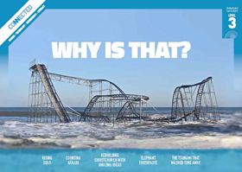  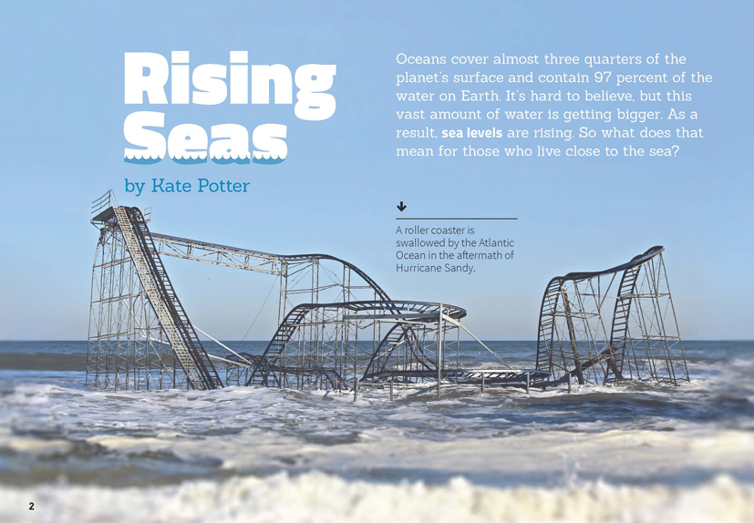
Science capability: Use evidence |  | Text characteristics

Science is a way of explaining the world. Science is empirical and measurable. This means that in science, explanations need to be supported by evidence that is based on, or derived from, observations of the natural world. Students should be encouraged to support their ideas with evidence and look for evidence that supports or contradicts other explanations.  At the core of science is theory building – making better explanations. What sets scientific explanations apart from other ways of explaining the world is their reliance on evidence and their ability to evolve as new evidence comes to light.  For more information about the “Use evidence” science capability, go to http://scienceonline.tki.org.nz/Introducing-five-science-capabilities/Use-evidence |  | - Abstract ideas, accompanied by concrete examples that support the students’ understanding.  - A graph, captions, and photographs that clarify or extend the text and may require some interpretation.  - A significant amount of vocabulary that is unfamiliar to the students (including academic and scientific words and phrases), which is generally explained through words or illustrations.

Curriculum context

SCIENCE
NATURE OF SCIENCE: Understanding about science  Achievement objective(s)  L3: Students will identify ways in which scientists work together and provide evidence to support their ideas. |  | NATURE OF SCIENCE: Investigating in science  Achievement objective(s)  L3: Students will ask questions, find evidence, explore simple models, and carry out appropriate investigations to develop simple explanations.  PLANET EARTH AND BEYOND: Interacting systems  Achievement objective(s)  L3: Students will investigate the water cycle and its effect on climate, landforms, and life. |  | Key Nature of Science ideas  - Evidence is based on, or derived from, observations of the natural world.  - Scientific ideas and explanations are supported by evidence.  - Scientists make use of relevant evidence to support or revise their predictions and explanations.  Key science ideas  - Landscapes change and adapt with weather fluctuations.  - One change to the landscape may lead to other changes.  - Extremes of weather can result in rapid changes to the landscape and may have a significant impact on living things.

ENGLISH

READING  Ideas  Students will show a developing understanding of ideas within, across, and beyond texts. |  | INDICATORS  - Uses their personal experience and world and literacy knowledge confidently to make meaning from texts.  - Makes meaning of increasingly complex texts by identifying main and subsidiary ideas in them.  - Starts to make connections by thinking about underlying ideas in and between texts.  - Makes and supports inferences from texts with increasing independence. |  | THE LITERACY LEARNING PROGRESSIONS  The literacy knowledge and skills that students need to draw on by the end of year 6 are described in The Literacy Learning Progressions.

Using evidence

- Scientists use empirical evidence to develop theories about how the world works.
- Empirical evidence is data gathered from observations and experiments.
The science capability, Use evidence, is about students developing and considering theories and explanations in the light of evidence (http://scienceonline.tki.org.nz/Introducing-five-science-capabilities/Use-evidence).
Students should be:
- using evidence they have gathered to develop their own explanations about the way the world works
- critiquing explanations offered by others, including scientifically accepted explanations, by considering the evidence that supports them.
Scientific explanations, including those found in museums, in television programmes, on the Internet, and in non-fiction books and texts, often fail to discuss the evidence and testing that led to the development of these explanations.
Teachers can:
- help students to be more critical consumers of science information by being explicitly critical themselves
- model a sceptical stance
- ask questions such as:
  - How do you think people found that out?
  - What kind of evidence would support that idea?
  - How could a scientist test that idea?
- use concept cartoons to propose possible explanations. (See http://conceptcartoons.com/what-is-a-concept-cartoon-.html)
When doing practical investigations, teachers can support students to:
- consider a range of possible explanations for their findings
- think about how these explanations fit with the evidence they have gathered
- avoid suggesting that scientific investigations prove anything – rather, investigations provide evidence that supports or refutes a hypothesis or idea.
Establish a science classroom culture by:
- welcoming a range of possible explanations
- encouraging students to consider possible explanations in the light of evidence
- having students draw evidence from their experience
- using questions such as:
  - What have we seen today that supports X’s idea?
  - Has anyone seen anything somewhere else that might be evidence for X’s idea?
- encouraging investigation:
  - What could we do to test X’s idea?
  - What would we expect to happen? Why?
A range of questions and activities designed to get students to use evidence is available on the Science Online website: http://scienceonline.tki.org.nz/Introducing-five-science-capabilities/Use-evidence

Meeting the literacy challenges

The following instructional strategies will support students to understand, respond to, and think critically about the information and ideas in the text. After reading the text, support students to explore the key science ideas outlined in the following pages.

TEACHER resources

Want to know more about instructional strategies? Go to:
- http://literacyonline.tki.org.nz/Literacy-Online/Teacher-needs/Reviewed-resources/Reading/Comprehension/ELP-years-5-8
- “Engaging Learners with Texts” (Chapter 5) from Effective Literacy Practice in Years 1 to 4 (Ministry of Education, 2003).
Want to know more about what literacy skills and knowledge your students need? Go to:
- http://literacyonline.tki.org.nz/Literacy-Online/Student-needs/National-Standards-Reading-and-Writing
- www.literacyprogressions.tki.org.nz/
“Working with Comprehension Strategies” (Chapter 5) from Teaching Reading Comprehension (Davis, 2007) gives comprehensive guidance for explicit strategy instruction in years 4–8.
Teaching Reading Comprehension Strategies: A Practical Classroom Guide (Cameron, 2009) provides information, resources, and tools for comprehension strategy instruction.

INSTRUCTIONAL STRATEGIES

FINDING INFORMATION IN THE TEXT
This text is clearly written and contains a range of supports. However, it also contains a lot of information, which readers will need accurate background knowledge to interpret. The nature of the topic means that some students may have some misconceptions that you will need to address.
EXPLAIN that when we read a lot of information, we need to make sure we understand what the important ideas are. A useful way is to think about what each part of the text is about. In this article, the author has helped us by giving headings like “Why are rising seas a problem?” on page 4. Immediately, we know this part of the text is about a problem. We can then look for that problem. Have the students identify the headings that are questions and predict what the paragraphs will contain. If the headings are not questions, PROMPT them to turn the headings into questions. These questions will help to guide the students’ reading.

DEALING WITH ABSTRACT IDEAS
Ask the students to complete a KWL chart, using what they already know about rising sea levels to make predictions for why seas are rising.

What we know | What we want to know | What we learnt

Have the students use their charts to RECORD the answers to their questions. Before reading, ASK QUESTIONS to get them started:
- What do you already know about rising sea levels?

After reading the introduction, ask:
- What ideas might you add?
- What questions do you have about the ideas?
- Read the information about global warming on page 3. What questions do you have about this?
Have the students read the text in pairs, adding to their chart as they complete each part of the article.
PROMPT them to explain the concepts to each other in their own words.
- I’m finding this explanation a bit hard to follow. What does the author mean by “And things aren’t slowing down …”? Re-read this page (3) with your partner and then paraphrase each sentence to work out what you think it means. It may help to get a ruler to see what 80 centimetres and 2 metres look like.
EXPLAIN how the author uses cause and effect structures to help the reader locate and track information, for example, “Rising sea levels mean ...,” “Another effect of global warming is …,” “If an island floods …,” “If you have ever swallowed a mouthful of sea water …,” “As a result …”. To help students locate and track the ideas, enlarge the text on an interactive whiteboard, use the Google Slides version, or photocopy the page, and have the students highlight the words that show cause and effect.
After reading the whole article, DISCUSS what the students found out and whether they have any unanswered questions. ASK what evidence was provided in this article about rising sea levels. “What other evidence would scientists need to link sea-level rise with global warming and human activity?” Use their responses when you select activities for exploring the science.
After the students have explored this topic further, you could have them apply their knowledge by writing a diary entry from the perspective of a person living in Tuvalu who is concerned about the effect on their crops of extreme high tides. ASK QUESTIONS to prompt the students to think about the impact of rising sea levels on people in small Pacific nations.
- What would their main concerns be?
- What would they need to do?
How would they feel?

READING TABLES AND PHOTOGRAPHS
DISCUSS the phrase, “To get a picture of how much the sea has dropped or risen ...”
How does this relate to the graph on the same page?
EXPLAIN that headings in tables or graphs indicate crucial information.
DISCUSS a sequence for reading the information in a graph:
- the title
- the labels on the axes
the data within the graph.
ASK QUESTIONS to remind the students of the vocabulary of graphs.
- What do we call the column on the left-hand side of the graph? (y-axis)
What do we call the row along the bottom of the graph? (x-axis)
DISCUSS the patterns and trends shown in the graph. Encourage the students to generate and respond to other students’ questions about the data.
- What does the jagged line represent?
- What patterns do you notice in the graph?
- What questions do you have about this data?
- What does the shape of the graph tell you?
- What explanations do you have for the patterns in the graph?
How might you test your explanations?
EXPLAIN that photographs can provide information that supports the text. ASK QUESTIONS to prompt the students to find information in the photographs and infer the purpose for including them.
- How does the photograph on page 2 relate to the text on the same page?
- Look closely at all the photographs. What do they have in common? Why have they been included?

Key science ideas
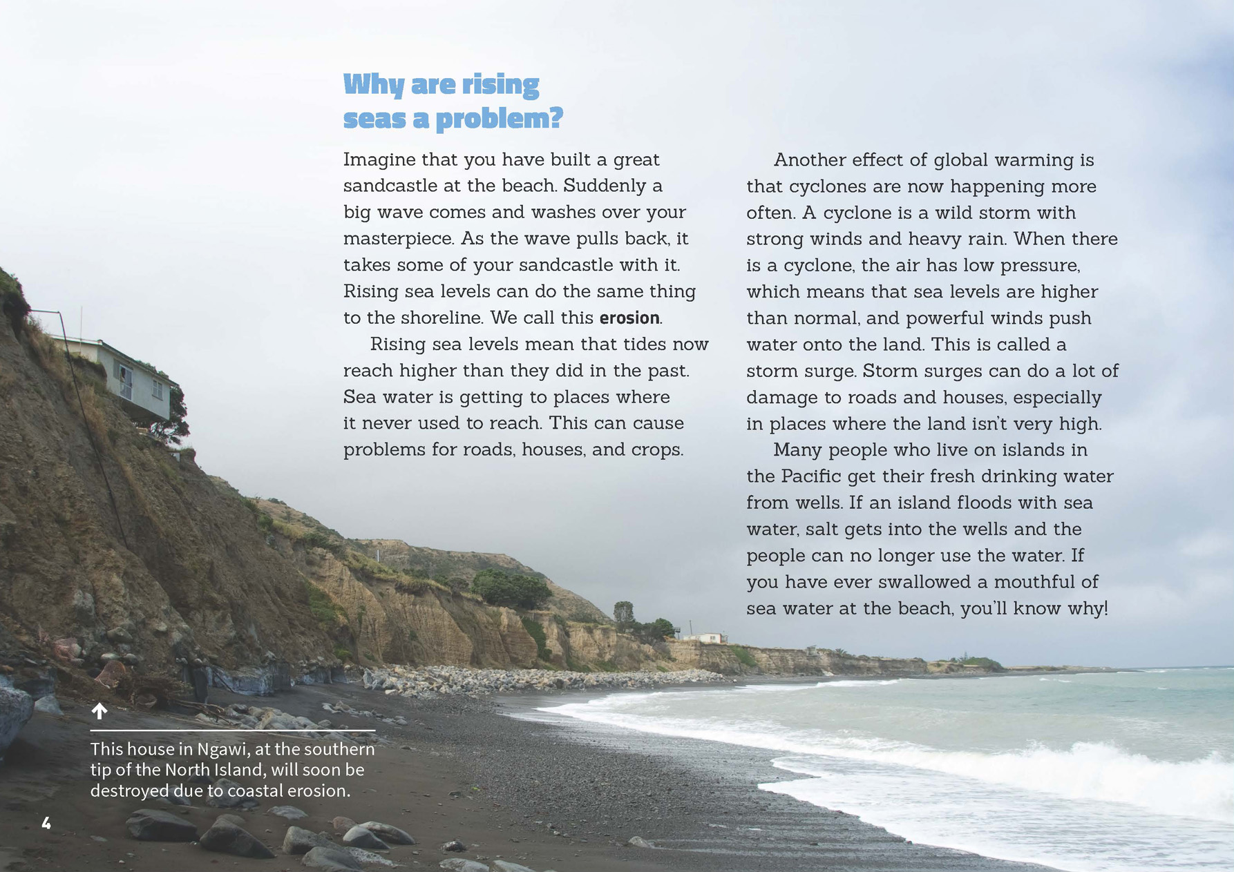 | Students will use prior knowledge to develop simple explanations.  One change to the landscape may lead to other changes.  Extremes of weather can result in rapid changes to the landscape and may have a significant impact on living things.
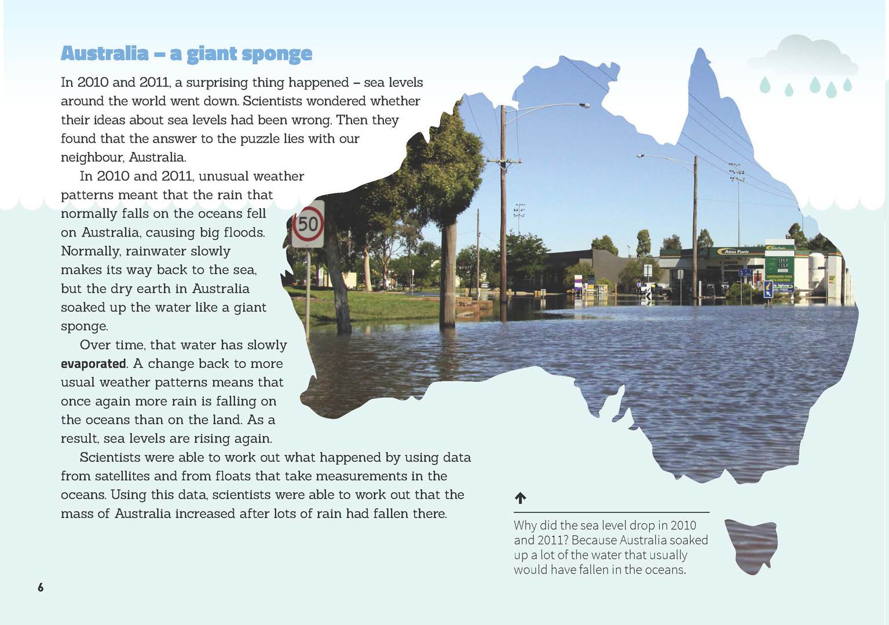 | The water cycle affects climate, landforms, and life.  Evidence is based on observations of the natural world.  Scientists use evidence to support or revise their predictions and explanations.

Exploring the science
Some activities focus directly on the science capability of “using evidence to support ideas” and the Nature of Science strand. Other activities extend student content knowledge. You are encouraged to adapt these activities to make the focus on Nature of Science explicit and to support students to develop the capability of using evidence to support ideas.

LEARNING FOCUS
Scientists use evidence from observations to support (or refute) their ideas.

LEARNING ACTIVITIES

Activity 1: Is climate change real?
Discuss the relationship between weather and climate. The “Climate Concepts” page of A Students’ Guide to Global Climate Change (www.epa.gov/climatechange/kids/basics/concepts.html) explains this further.
Research indicates that climate change has a significant effect on our planet. However, not everyone believes that human-caused climate change is real. Ask questions to encourage the students to think critically and use evidence to justify their views.
Earth’s history is very long. How do you know that the same patterns haven’t occurred in the past?
Even if climate change is real, why are humans to blame?
In the article, the scientists found that the sea levels actually went down for two years. They worked out that it was because of the floods in Australia. What evidence did they use to support this idea? Maybe there are alternative explanations for what is happening that scientists haven’t yet thought of.
Construct cartoons to set out the alternative viewpoints. Then allow the students to develop their own explanations by getting them to compare data, such as the average temperature over a large number of years, to look for trends and patterns. The NIWA, EPA, and NASA websites are all good sources of information. NASA’s Climate Time Machine allows students to see into the past and ahead to a possible future. Have the students present their hypotheses and explanations, supported by evidence from their investigations.
To complete this activity, students will need to understand how the carbon cycle causes climate change. The following two resources provide useful explanations:
“Oceans: An Inquiry Unit” (http://seaweek.org.nz/wp-content/uploads/sites/26/2013/10/Ocean-Unit.pdf)
The Science Learning Hub: Ocean in Action (www.sciencelearn.org.nz/Contexts/The-Ocean-in-Action/Sci-Media/Interactive/Carbon-cycle).

Activity 2: What can we do?
Students may be concerned about their own community’s vulnerability and preparedness concerning sea level rise. The Ministry for the Environment website has a map students can click on to find out about the likely impact of climate change in their region. Use this information to prompt them to think about how people in the region will adapt to the change. Your region may not be affected by rising sea levels, but what are the other effects?
The students could invite local government planners to talk to them about what is being done in preparation for sea level rise and the other impacts of climate change.
Prompt the students to consider how they could help reduce the greenhouse gas emissions that lead to climate change. “Play it Cool” (www.climatechange.govt.nz/reducing-our-emissions/schoolstuff/playitcool/) is a game students could play to learn about ways to make a difference. “Oceans: An Inquiry Unit” (http://seaweek.org.nz/wp-content/uploads/sites/26/2013/10/Ocean-Unit.pdf) has ideas about what people can do at school.
What other ideas do you have about what we might do as a class?

Activity 3: Essential water
The article highlights the impact of rising sea levels on Pacific Islanders’ access to fresh drinking water. Use the Science Learning Hub activity “Constructing an Aquifer Model” (www.sciencelearn.org.nz/Contexts/H2O-On-the-Go/Teaching-and-Learning-Approaches/Constructing-an-aquifer-model) to support your students to understand how water gets into an aquifer and how people extract water from aquifers.
How do you suppose the sea water gets into the wells?
What impact would salt-contaminated water have on the people?
Explain that it is possible to change saltwater into freshwater in a process called desalination. Have the students make a simple desalination plant to see how this works.
Extension
You could focus more broadly on the Pacific Islands and look at other effects of rising sea levels besides those on drinking water and food growing, such as housing. You could do this by constructing a consequence wheel, as described on the Education for Sustainability site (http://efs.tki.org.nz/Curriculum-resources-and-tools/Consequence-Wheel). This involves placing the statement “Rising sea levels in the Pacific” in the centre of a circle and then using radiating sections of the circle to discuss the possible consequences. Note the comments in the instructions about the importance of careful scaffolding to get the best out of this activity.

Activity 4: Peyton’s sandless sandbags
This YouTube video clip about the 2013 USA Young Scientist Challenge Winner Peyton Robertson shows how he designed a new sandbag to control flood damage (www.youtube.com/watch?v=TWTEceGEyYU). Have the students watch the video and record:
his original hypothesis/idea
what data he collected
how he collected his data
how he tested his hypothesis
how he used his evidence to support his ideas and develop the new product.
Invite them to think about a product they could design as an adaptation to climate change.

Google Slides version of “Rising Seas” www.connected.tki.org.nz

RESOURCE LINKS

Building Science Concepts
Book 29 – Solar Energy: Sun Power on Earth
Book 50 – Storms: Extreme Weather
Book 52 – The Land Changes: Keeping Earth’s Systems in Balance to Sustain Life

Science Learning Hub
“Bubbler Gauge Tubing” (image) www.sciencelearn.org.nz/Science-Stories/Tsunamis-and-Surf/Sci-Media/Images/Bubbler-gauge-tubing
“Building an Aquifer Model” at www.sciencelearn.org.nz/Contexts/H2O-On-the-Go/Sci-Media/Video/Building-an-aquifer-model
“Carbon Cycle” at www.sciencelearn.org.nz/Contexts/The-Ocean-in-Action/Sci-Media/Interactive/Carbon-cycle
“Dynamic and Complex: The Global Water Cycle” at www.sciencelearn.org.nz/Contexts/H2O-On-the-Go/Sci-Media/Animations-and-Interactives/Dynamic-and-complex-the-global-water-cycle
“Measuring Instruments” at www.sciencelearn.org.nz/Science-Stories/Tsunamis-and-Surf/Measuring-instruments (includes a section on measuring sea level)
“Satellites Measure Ice Sheet Thickness” (video) at www.sciencelearn.org.nz/Contexts/Satellites/Sci-Media/Video/Satellites-measure-ice-sheet-thickness
“Satellites Measure Sea Ice Thickness” at www.sciencelearn.org.nz/Contexts/Satellites/NZ-Research/Satellites-measure-sea-ice-thickness
“Student Activity – Constructing an Aquifer Model” at www.sciencelearn.org.nz/Contexts/H2O-On-the-Go/Teaching-and-Learning-Approaches/Constructing-an-aquifer-model
“Studying Storm Surges and Coastal Hazards” at www.sciencelearn.org.nz/Science-Stories/Tsunamis-and-Surf/Studying-storm-surge-and-coastal-hazards
“The Water Cycle” at www.sciencelearn.org.nz/Contexts/H2O-On-the-Go/Science-Ideas-and-Concepts/The-water-cycle
“Water and Weather” at www.sciencelearn.org.nz/Contexts/H2O-On-the-Go/Science-Ideas-and-Concepts/Water-and-weather

Climate Change Information New Zealand
“Climate Change Science” at http://climatechange.govt.nz/science/
“Play It Cool” at www.climatechange.govt.nz/reducing-our-emissions/schoolstuff/playitcool/

Ministry for the Environment
“Adapting to Sea-level Rise” at www.mfe.govt.nz/issues/climate/adaptation/sea-level-rise.html
“How Might Climate Change Affect My Region?” at www.mfe.govt.nz/issues/climate/about/climate-change-affect-regions/index.html

NIWA
“Climate and Weather” at www.niwa.co.nz/education-and-training/schools/students/climate
“Climate Change, Global Warming, and Greenhouse Gases” at
www.niwa.co.nz/education-and-training/schools/students/climate-change-global-warming-and-greenhouse-gases

Peyton Robertson – Sandless Sandbags
“2013 Young Scientist Challenge Winner: Peyton Robertson” at www.youtube.com/watch?v=TWTEceGEyYU
“3 brilliant interventions from a 12-year-old scientist” at http://ideas.ted.com/2014/01/13/this-scientist-has-three-patents-pending-he-also-happens-to-be-12/
“Hurricane Inspires Boy Aged 11 To Invent ‘Sand-Less Sandbags’ For Use in Flood Defence” at www.youtube.com/watch?v=HOgjoePnejw

Other resources
A Students’ Guide to Global Climate Change from www.epa.gov/climatechange/kids/basics/concepts.html
Climate Kids: NASA’s Eyes on the Earth from http://climatekids.nasa.gov/
ClimatePrediction.net – The World’s Largest Climate Modelling Experiment for the 21st Century at http://weatherathome.net/
“Consequence Wheel” from Education for Sustainability at http://efs.tki.org.nz/Curriculum-resources-and-tools/Consequence-Wheel
“Desalinating Salt Water” from Citizen Kid Central www.citizenkidcentral.com/Learn/Water.aspx?activityId=8
“Oceans: An Inquiry Unit” from http://seaweek.org.nz/wp-content/uploads/sites/26/2013/10/Ocean-Unit.pdf
Pacific Climate Change Portal at www.pacificclimatechange.net/

