CONNECTED, LEVEL 2 2014, How Do You Know?  The Cardboard Cathedral  by Bruce Granshaw  Overview  During the Christchurch earthquake, the cathedral was so badly damaged it couldn’t be used. This article describes how the people in charge of the cathedral worked with architects, engineers, and builders to build an innovative new temporary cathedral.  Be aware of possible sensitivities around this subject, especially for those who may have lost friends or family/whānau in the February 2011 Christchurch earthquake.  A Google Slides version of this article is available at www.connected.tki.org.nz. |  |  | 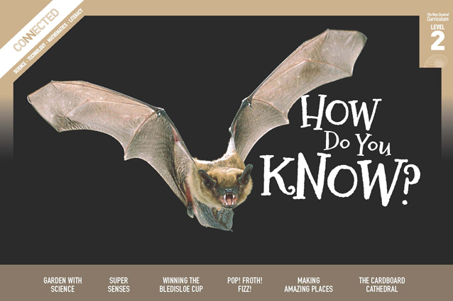  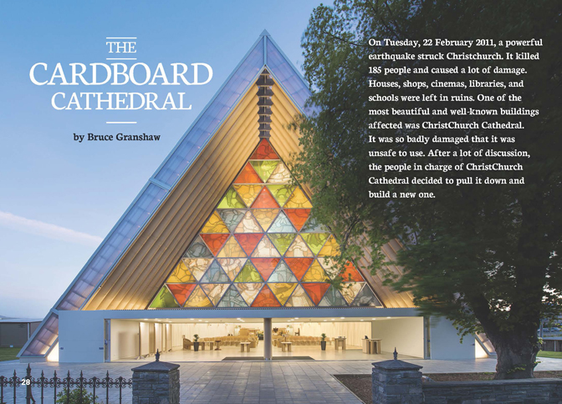

Text characteristics
- A clearly structured article with headings that indicate the content in each section and help the reader to navigate the text.
- Photographs, diagrams, and coloured text boxes that clarify the text and require some interpretation.
- A mixture of text types, combining a recount with some elements of a procedural text.
- Technical and subject-specific vocabulary.

Curriculum context

TECHNOLOGY
TECHNOLOGICAL PRACTICE: Outcome development and evaluation  Achievement objective(s)  L2: Students will investigate a context to develop ideas for potential outcomes. Evaluate these against the identified attributes; select and develop an outcome. Evaluate the outcome in terms of the need or opportunity. |  | TECHNOLOGICAL KNOWLEDGE: Technological modelling  Achievement objective(s)  L2: Students will understand that functional models are used to explore, test, and evaluate design concepts for potential outcomes and that prototyping is used to test a technological outcome for fitness of purpose. |  |  | Key technology ideas  - Some technological outcomes are made from unusual materials.  - The technologist considers the performance properties of each material when selecting them for a technological outcome.  - Technological modelling is an essential part of the process when developing a new technological outcome.

ENGLISH

READING  Ideas  Students will show some understanding of ideas within, across, and beyond texts. |  | INDICATORS  - Uses their personal experience and world and literacy knowledge to make meaning from texts.  - Makes meaning of increasingly complex texts by identifying main ideas.  - Makes and supports inferences from texts with some independence. |  | THE LITERACY LEARNING PROGRESSIONS  The literacy knowledge and skills that students need to draw on by the end of year 4 are described in The Literacy Learning Progressions.

Meeting the literacy challenges

The following instructional strategies will support students to understand, respond to, and think critically about the information and ideas in the text. After reading the text, support students to explore the key technology ideas outlined in the following pages.

TEACHER resources

Want to know more about instructional strategies? Go to:
- http://literacyonline.tki.org.nz/Literacy-Online/Teacher-needs/Reviewed-resources/Reading/Comprehension/ELP-Years-1-4
- “Engaging Learners with Texts” (Chapter 5) from Effective Literacy Practice in Years 1 to 4 (Ministry of Education, 2003).
Want to know more about what literacy skills and knowledge your students need? Go to:
- http://literacyonline.tki.org.nz/Literacy-Online/Student-needs/National-Standards-Reading-and-Writing
- www.literacyprogressions.tki.org.nz/
“Working with Comprehension Strategies” (Chapter 5) from Teaching Reading Comprehension (Davis, 2007) gives comprehensive guidance for explicit strategy instruction in years 4–8.
Teaching Reading Comprehension Strategies: A Practical Classroom Guide (Cameron, 2009) provides information, resources, and tools for comprehension strategy instruction.

INSTRUCTIONAL STRATEGIES

FINDING THE MAIN IDEAS
DISCUSS the title, prompting the students to predict what this story might be about.
- Why do you think this story is called, “The Cardboard Cathedral”?
Have the students read the first paragraph. ASK QUESTIONS to support them to use inferences to check whether their predictions were correct.
- What do you think now?
- What information did you use to make your predictions and did your predictions change?
- If your predictions changed, why did they change?
Activate the students’ prior knowledge by DISCUSSING what they what they already know.
- What do you know about the earthquake in Christchurch?
- How did it affect the people?
- How did it affect the buildings and infrastructure? (You may need to explain what infrastructure is.)
- What happened to the cathedral?
Ask the students to create a KWL chart.
What we know | What we want to know | What we learnt
Before reading, have them use the chart to IDENTIFY what they know in column 1 and what they want to know in column 2. As they read, encourage them to REVIEW the questions in column 2, checking off any questions that they can answer and adding any new questions. After the reading, have them review column 1 so they can identify any misconceptions they may have held prior to reading the article.
Pause on page 30 and PROMPT the students to think, pair, and share their responses to the list of questions. Then remind them to REVIEW their KWL charts.
After reading the whole text, DISCUSS what the students found out and whether they have questions that remain unanswered. Research online to fill any gaps in their knowledge.
ASK QUESTIONS to encourage the students to make inferences about how the people of Christchurch might have felt about:
- the earthquake
- the damage to the cathedral
- the new structure.
You could support this discussion by finding articles, pictures, and community views online.
The students could RECORD what they have learned about the design of the cardboard cathedral on a poster.

DEALING WITH UNFAMILAR VOCABULARY
DISCUSS the concept of a “cathedral”. Some students may have prior knowledge that they can share. Compare the images in the text with images of other cathedrals and draw on these ideas to help the students create their own personal image of a cathedral.
PROMPT the students to find meaning. Have them use the text, the glossary, and a dictionary to find out what these words mean: “architects”, “engineers”, “builders”, “scientists”. Draw a chart to RECORD these words and their definitions.
- Which part of the building process were each of these workers responsible for, and why?
EXPLORE the concept of “permanent” versus “temporary”.
- I once lost a filling during the weekend. My dentist put in a temporary filling and then during the week, she put in a permanent one. Have you had experiences like that? What words or phrases could we use to describe “temporary” and “permanent”?
DISCUSS the differences between “waterproof”, “windproof”, and “flameproof”, using the different prefixes and the shared suffix.
- What do you think the suffix “-proof” means? (“resistant”)
- When you put those prefixes together with that shared suffix, what do you think those words mean?
- Can you think of other words that end with “proof”?

USING DIAGRAMS TO CLARIFY THE TEXT
PROMPT the students to look closely at the diagram on page 30.
- What does the diagram show us? How do we know what is inside the tube?
- Why do designers create drawings and models?
- What are the features of a good diagram?
- How does this diagram help you to understand how the cardboard tubes are made?
List those features, and then have the students use the story to make a diagram to show the complete design process of the cardboard cathedral.

Key technology ideas
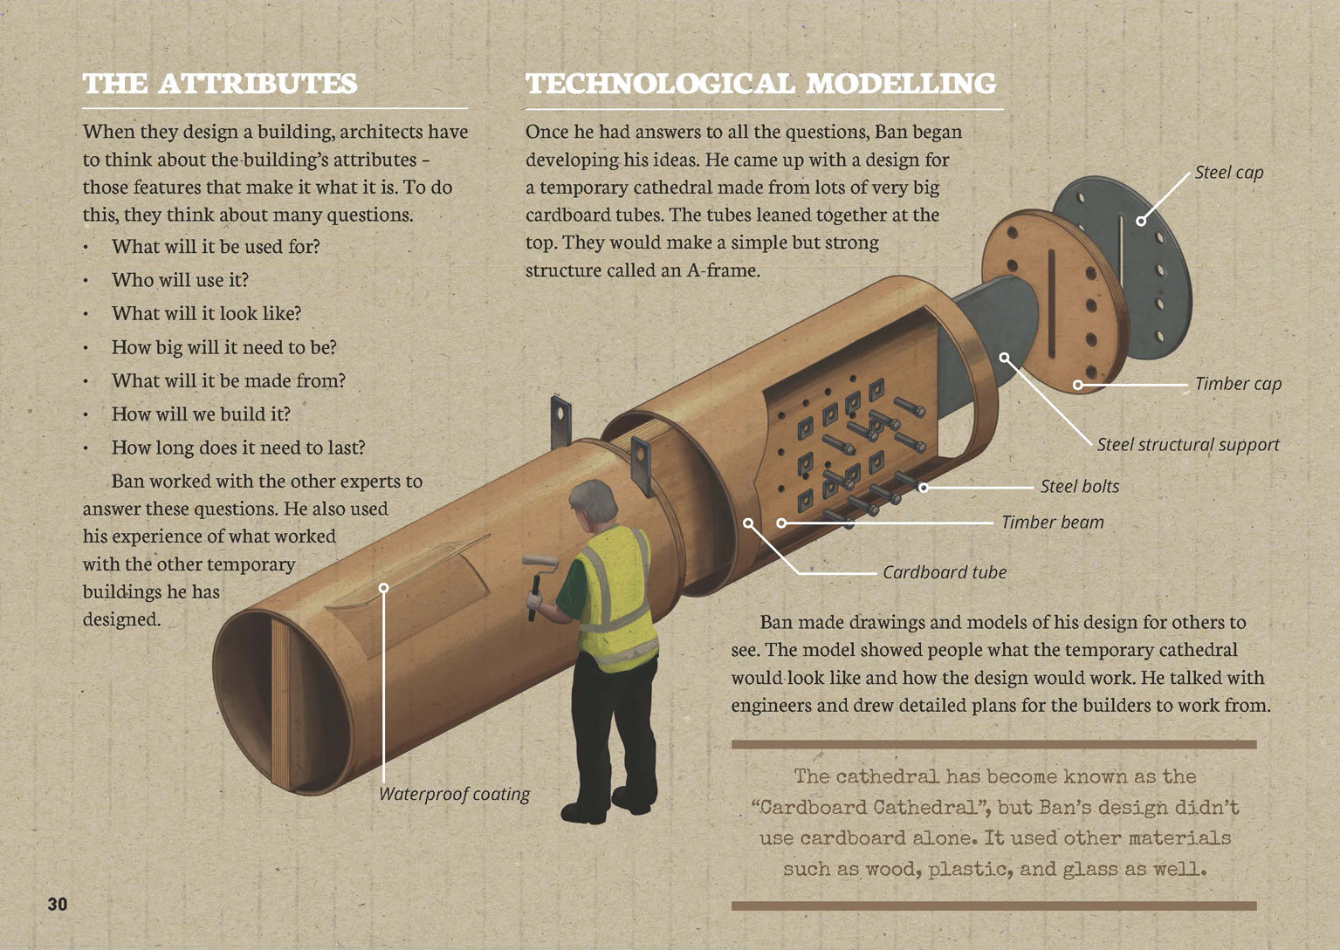 | Models are used to explore, test, and evaluate design concept.  Technologists evaluate ideas in terms of the needs and potential outcomes.  Some technological outcomes are made from unusual materials.
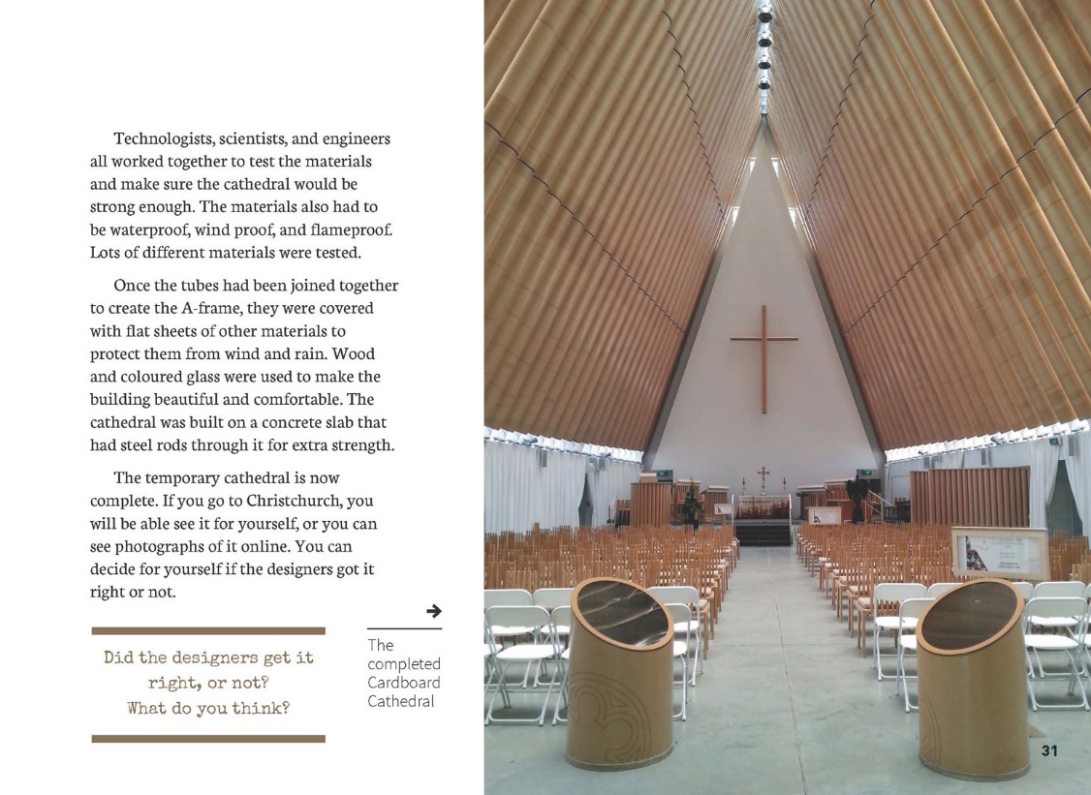 | Students evaluate the outcome in terms of the needs and opportunities.  A technological outcome needs to be fit for purpose.  Technologists consider the performance properties of each material.

Link to technology
The following activities and suggestions are designed as a guide for supporting students to explore and develop understandings about technological modelling and technological products.
You are encouraged to adapt the activities to suit the specific needs of your students.

LEARNING FOCUS
Students use evidence to problem solve as they investigate, plan, create, evaluate, and discuss technological outcomes based on the products they construct.

LEARNING ACTIVITIES

Activity 1: Christchurch – an amazing place
Investigate the types of materials used to construct the temporary cathedral by trying out the BP tech challenge activities on rolled paper construction (www.starters.co.nz/download/get/design-a-playground/64.html).
What folding/rolling methods make the design stronger when you test it?
Develop and conduct simple investigations to test how waterproof, windproof, and/or flameproof cardboard tubes can be. Finally, create a labelled diagram of the temporary cathedral, explaining the materials and their purpose.
Extension
Link this article to the articles “Making Amazing Places” (Connected 2, 2014) and “Rebuilding Christchurch with Amazing Ideas” (Connected 3, 2014).
A competition was run to give students in Christchurch the opportunity to design ideas for their amazing city. Your students could explore the information about the competition and the designs that were created in preparation for Activity 2.

Activity 2: Designing your own temporary building
Have the students reread the final page of the article and respond to the challenge. They could design a temporary home, or they could design a solution to a problem, challenge, or opportunity in their own environment (for example, the need for a new playground or an emergency shelter). Have them list the headings in the article and use this to plan and record their own design process. The table below lists headings and suggests prompts, questions, and activities you could use to support the students.

Design process | Prompts | Activities
Technological practice  The problem | - What needs do you see around you?  - What opportunities have you noticed? | - Have the students research the possibilities for developing a new technological outcome.  - If the students are unsure of the term “technological outcome”, you could discuss this, using the checklist in the teacher support materials for “Building a Wharenui” in Connected 2, 2011.
Developing the design brief | - What will your new design look like, and what should it be able to do? | - If the students are unsure of the concept of a “design brief”, they could view the online video on www.businessdictionary.com/videos/?265106803  - Have them write a simple statement that captures what the design has to achieve, how it will achieve it, and the timeframe for development.

Design process | Prompts | Activities
The attributes | - Based on the design brief, what attributes does your design need to have? | - Have the students use the questions on page 30 to identify the attributes their design needs to have. Encourage them to think about both the function of their design solution and its aesthetics.  - The students should create a checklist of the attributes they are looking for.
Technological modelling | - Have you shown all the key parts of your design?  - When you look at X’s diagram, can you see how it is meant to work?  - Do you think it will achieve the outcome X has set out in his/her design brief? Why or why not?  - Which design do you think looks best? Which would work best? Why?  - What materials would be suitable for use in your design? | - Have the students describe their outcomes by drawing labelled diagrams or creating models. The representations should show what their outcome will look like and how it would work.  - The students could test the clarity of their representations by showing them to others in the class. Encourage them to ask each other questions that will help them to refine their designs.  - Students could consider what materials would be suited for their designs.
Technological knowledge | During development  - How can you test the materials you are considering to find out whether they have the necessary attributes?  - Where could you find this information without doing the testing yourself?  During the evaluation  - How well does your design solve the problem of …?  - Is it fit for purpose? Will it work well?  - How does it stack up against the list of key attributes you identified?  - How effective are your key attributes? | - Have the students test the physical properties of the materials they are considering. Select activities from “Science Focus: Fibres and Fabrics” in Making Better Sense of the Material World (pages 101–107) and from books 48 and 51 in the Building Science Concepts series.  - If the students are interested in constructing their outcome from paper, they could try the “Emergency Shelters” activities in Figure It Out: Technology in Practice (Levels 3+–4+).  - The students could research what other people have found.  - Have the students use the evidence they have gathered to support their decisions about the materials.  - Depending on what’s realistic, the students could produce their outcome or produce a working model.  - Finally, have the students evaluate their outcomes in terms of how successfully they address their design brief.
Note that, if your students decide they would like to design a playground or an emergency shelter, the Resource Links for this Connected suggest resources you could use to support this investigation. In particular, Connected 3, 2008 describes how students at a school in Matauri Bay planned a new playground.

Activity 3: The marshmallow challenge
The architects and engineers behind the cardboard cathedral used innovative thinking and materials to quickly build a church that is both stylish and safe. “The marshmallow challenge” activity from the Science Learning Hub (www.sciencelearn.org.nz/Innovation/Teach-about-Innovation/The-marshmallow-challenge) introduces students to several key aspects of innovation – idea generation, collaboration, creativity, and teamwork – as they build a structure that will support the weight of one marshmallow.
Google Slides version of “The Cardboard Cathedral” www.connected.tki.org.nz

Resource Links

Building Science Concepts
Book 48 – Fabrics: Origins, Properties, and Uses
Book 51 – Standing Up: Skeletons and Frames

Connected
“Making Amazing Places” in How Do You Know? Connected 2, 2014, pp. 24–27.
“Rebuilding Christchurch with Amazing Ideas” in Why Is That? Connected 3, 2014, pp. 14–19.
Structure. Connected 2, 2011.
“Planning a Playground” in Connected 3, 2008 (article and TSM).

The Amazing Place design competition
www.theamazingplace.co.nz/
“The Amazing Place Christchurch design competition” from www.techlink.org.nz/stories.cfm?area=7&SID=80
“The Amazing Place: Children Help Reshape Christchurch” from Education Gazette, available at www.edgazette.govt.nz/Articles/Article.aspx?ArticleId=8727
“The Amazing Place” videos available at http://ccdu.govt.nz/plan/the-amazing-place

Playground design
“The Amazing Playground Challenge” from www.techlink.org.nz/stories.cfm?area=7&SID=118
“Planning and Designing a Children’s Playground” in Starters and Strategies Term 1, 2014, p. 31.
“Design a Playground” BP Challenge Starter from www.starters.co.nz/download/get/design-a-playground/64.html [subscription needed]
“Children’s Playground Design and Construction” from Educational Landscapes UK https://www.youtube.com/watch?v=qgKdS9JLVl4
“Unit 3: Blowin’ in the Wind” from PBS Kids www-tc.pbskids.org/designsquad/pdf/parentseducators/ds_pe_ed_guide_unit3.pdf
Virtual field trips, available from LEARNZ, www2.learnz.org.nz/core-fieldtrips.php
- Geospatial – the use of skills, tools, and data by people in Canterbury
- Geospatial – how location-based information is helping the rebuild of Christchurch

Other resources
“Emergency Shelters” in Figure It Out: Technology in Practice (Levels 3+–4+).
“Science Focus: Fibres and Fabrics” in Making Better Sense of the Material World, pp. 101–107.
Shigeru Ban
“Shigeru Ban wins 2014 Pritzker Prize”. Architecture Now, available at http://architecturenow.co.nz/articles/shigeru-ban-wins-2014-pritzker-prize/
Shigeru Ban: Cardboard Cathedral by Andrew Barrie. Auckland University Press, 2014.
“Earthquake Shelter” in BP Challenge Flip-book 4: Structures available from www.starters.co.nz/bpchallenge-index (or download the activity from www.starters.co.nz/download/get/earthquake-shelter/64.html)
How to Design a House 1 – The Brief: www.businessdictionary.com/videos/?265106803
Once in a Lifetime: City-building after Disaster in Christchurch. Freerange Press, 2014.

