CONNECTED, LEVEL 2 2014, How Do You Know?  Garden with Science  by Sophie Fern  Overview  This article explores the idea of gardeners as scientists and introduces some of the scientific knowledge and skills that gardeners use to grow healthy plants.  A Google Slides version of this article is available at www.connected.tki.org.nz. This text also has additional digital content, which is available online at www.connected.tki.org.nz. |  |  | 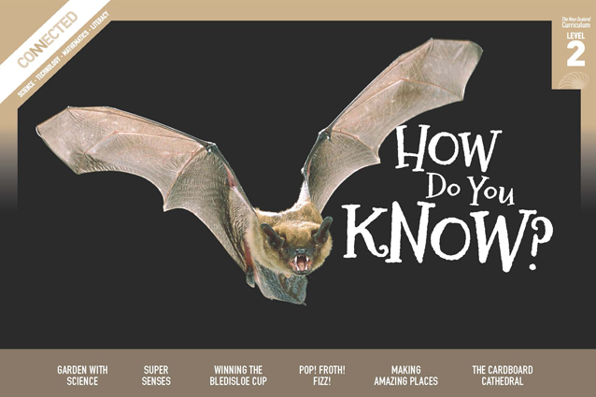  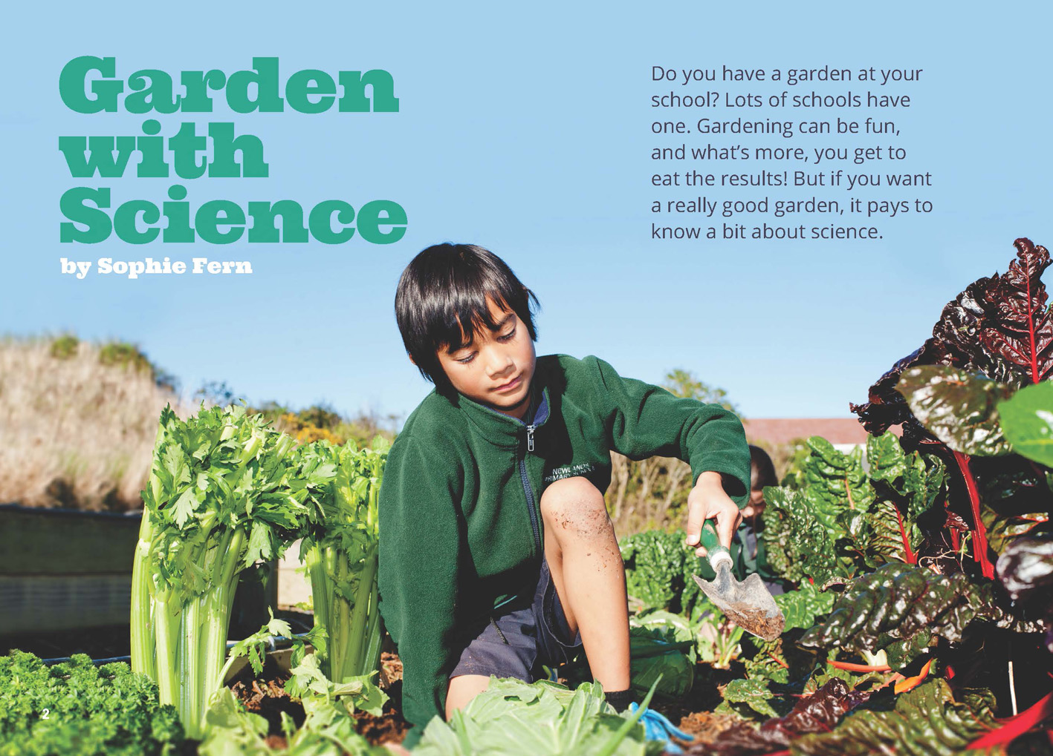
Science capability: Use evidence |  | Text characteristics

Science is a way of explaining the world. Science is empirical and measurable. This means that in science, explanations need to be supported by evidence that is based on, or derived from, observations of the natural world. Students should be encouraged to support their ideas with evidence and look for evidence that supports or contradicts other explanations.  At the core of science is theory building – making better explanations. What sets scientific explanations apart from other ways of explaining the world is their reliance on evidence and their ability to evolve as new evidence comes to light.  For more information about the “Use evidence” science capability, go to http://scienceonline.tki.org.nz/Introducing-five-science-capabilities/Use-evidence |  | - Clearly structured text with headings that signify the information in each section and help the reader to navigate the text.  - Many subject-specific words with their meanings explained in the running text or the glossary.  - Photographs with captions, a webpage, diagrams, and a map that clarify the text and require some interpretation.

Curriculum context

SCIENCE
NATURE OF SCIENCE: Investigating in science  Achievement objective(s)  L2: Students will extend their experiences and personal explanations of the natural world through exploration, play, asking questions, and discussing simple models. |  | LIVING WORLD: Life processes  Achievement objective(s)  L2: Students will recognise that all living things have certain requirements so they can stay alive. |  | Key Nature of Science ideas  - Evidence is based on, or derived from, observations of the natural world.  - Scientific ideas and explanations are supported by evidence.  - Scientists make use of relevant evidence to support or revise their predictions and explanations.  Key science idea  - Environmental changes affect the survival of living organisms.

ENGLISH

READING  Ideas  Students will show some understanding of ideas within, across, and beyond texts. |  | INDICATORS  - Uses their personal experience and world and literacy knowledge to make meaning from texts.  - Makes meaning of increasingly complex texts by identifying main ideas.  - Makes and supports inferences from texts with some independence. |  | THE LITERACY LEARNING PROGRESSIONS  The literacy knowledge and skills that students need to draw on by the end of year 4 are described in The Literacy Learning Progressions.

Using evidence

- Scientists use empirical evidence to develop theories about how the world works.
- Empirical evidence is data gathered from observations and experiments.
The science capability, Use evidence, is about students developing and considering theories and explanations in the light of evidence (http://scienceonline.tki.org.nz/Introducing-five-science-capabilities/Use-evidence).
Students should be:
- using evidence they have gathered to develop their own explanations about the way the world works
- critiquing explanations offered by others, including scientifically accepted explanations, by considering the evidence that supports them.
Scientific explanations, including those found in museums, in television programmes, on the internet and in non-fiction books and texts, often fail to discuss the evidence and testing that led to the development of these explanations.
Teachers can:
- help students to be more critical consumers of science information by being explicitly critical themselves
- model a sceptical stance
- ask questions such as:
  - How do you think people found that out?
  - What kind of evidence would support that idea?
  - How could a scientist test that idea?
- use concept cartoons to propose possible explanations. (See http://conceptcartoons.com/what-is-a-concept-cartoon-.html)
When doing practical investigations, teachers can support students to:
- consider a range of possible explanations for their findings
- think about how these explanations fit with the evidence they have gathered
- avoid suggesting that scientific investigations prove anything – rather, investigations provide evidence that supports or refutes a hypothesis or idea.
Establish a science classroom culture by:
- welcoming a range of possible explanations
- encouraging students to consider possible explanations in the light of evidence
- having students draw evidence from their experience
- using questions such as:
  - What have we seen today that supports X’s idea?
  - Has anyone seen anything somewhere else that might be evidence for X’s idea?
- encouraging investigation:
  - What could we do to test X’s idea?
  - What would we expect to happen? Why?
A range of questions and activities designed to get students to use evidence is available on the Science Online website: http://scienceonline.tki.org.nz/Introducing-five-science-capabilities/Use-evidence

Meeting the literacy challenges

The following instructional strategies will support students to understand, respond to, and think critically about the information and ideas in the text. After reading the text, support students to explore the key science ideas outlined in the following pages.

TEACHER resources

Want to know more about instructional strategies? Go to:
- http://literacyonline.tki.org.nz/Literacy-Online/Teacher-needs/Reviewed-resources/Reading/Comprehension/ELP-Years-1-4
- “Engaging Learners with Texts” (Chapter 5) from Effective Literacy Practice in Years 1 to 4 (Ministry of Education, 2003).
Want to know more about what literacy skills and knowledge your students need? Go to:
- http://literacyonline.tki.org.nz/Literacy-Online/Student-needs/National-Standards-Reading-and-Writing
- http://www.literacyprogressions.tki.org.nz/
“Working with Comprehension Strategies” (Chapter 5) from Teaching Reading Comprehension (Davis, 2007) gives comprehensive guidance for explicit strategy instruction in years 4–8.
Teaching Reading Comprehension Strategies: A Practical Classroom Guide (Cameron, 2009) provides information, resources, and tools for comprehension strategy instruction.

INSTRUCTIONAL STRATEGIES

FINDING THE MAIN IDEAS
DISCUSS the title and read page 2, focusing on the sentence, “But if you want a really good garden, it pays to know a bit about science”. Support the students to make connections to their prior knowledge.
- What do you know about gardening?
- What do you think gardening has to do with science?
- What science learning might help you be a really good gardener?
RECORD the students’ ideas and then PROMPT them to compare their ideas with the author’s statements on page 3. Focus specifically on the verbs in common: “build (on the knowledge)”, “observe”, and “experiment”. EXPLAIN that these verbs tell us what gardeners and scientists do. PROMPT the students to notice the repetitive structure that highlights these verbs, reinforcing the idea that gardeners and scientists use the same skills but in different contexts.
Draw up a Venn diagram to RECORD the words in the text that are common to science and gardening and the words that are special. Add words to the diagram as you read and discuss the article.

Gardening
Science

IDENTIFY aspects of the text structure, such as the headings, photographs, and diagrams that will help your students navigate the article and find the main ideas. Support your students to make predictions about the key ideas and information by SKIMMING the text. PROMPT them to notice that most of the headings are framed as questions. DISCUSS the concept that scientists work by asking questions and doing investigations to answer those questions.

USING DIAGRAMS TO CLARIFY THE TEXT
EXPLAIN how the diagram on page 4 shows the process of photosynthesis. You may need to MODEL how to navigate the page and use all of the information to understand the basic process: carbon dioxide + water + energy from sunlight sugars + oxygen. Plants use sunlight, water, and carbon dioxide to make sugars. These sugars are the “food” of the plants – things they use for energy and growing new parts. Minerals from the soil are needed in tiny amounts for the different parts of the plants to function properly. Oxygen is produced as a by-product of this process.
Help the students make connections between the text on the left-hand side of the page explaining the process of photosynthesis and the diagram on the right showing the process. Make sure they can identify the labels and captions. Also, make sure that they refer to the definitions for chlorophyll and nutrients. Check that the students understand that plants absorb sunlight through their leaves and water through their roots. Ask them to explain the diagram to a partner.
Look closely at the map on page 5. ASK QUESTIONS to help the students make connections between the information in the map and their own context.
- Where do we live? So what sort of climate do we have?
- How would you describe the weather here today?
EXPLAIN that the illustrations on page 6 show the scientific procedure described in the text. The students may be keen to try this investigation straight away. Be prepared with jars, vinegar, and baking soda. They could then write a report, using some of the language in the text.

DEALING WITH UNFAMILAR VOCABULARY
EXPLAIN to the students that many of the words may be unfamiliar. Point out that some of these words are explained in the glossaries on pages 4 and 6 and some are explained in the text. PROMPT the students to read on when they are unsure about a word and to look for clues in the text that will help them figure out the word’s meaning. Remind them to look for information in the diagrams or illustrations that will help them solve the word. If they are still unsure, have them look the word up in a dictionary (either online or in print).
DISCUSS the concept “scientific evidence”, which is introduced on page 5. EXPLAIN that scientific evidence is derived from observations of the natural world. We can use our own observations as evidence or we can use other people's observations.
- Where would a gardener scientist typically look for scientific evidence? For example, how could you find out where different kinds of plants grow? (Talking to other gardeners, gardening books and magazines, television programmes, the Internet, and so on.)
Read the information about acid and alkaline soils on page 6. EXPLAIN that scientific investigation often involves identifying objects and events and then classifying (sorting) them into groups or categories. REVIEW the words in the Venn diagram. DISCUSS why scientist gardeners need special words.
- What other groups of people use specialised language? Why do you think that is?

Key science ideas
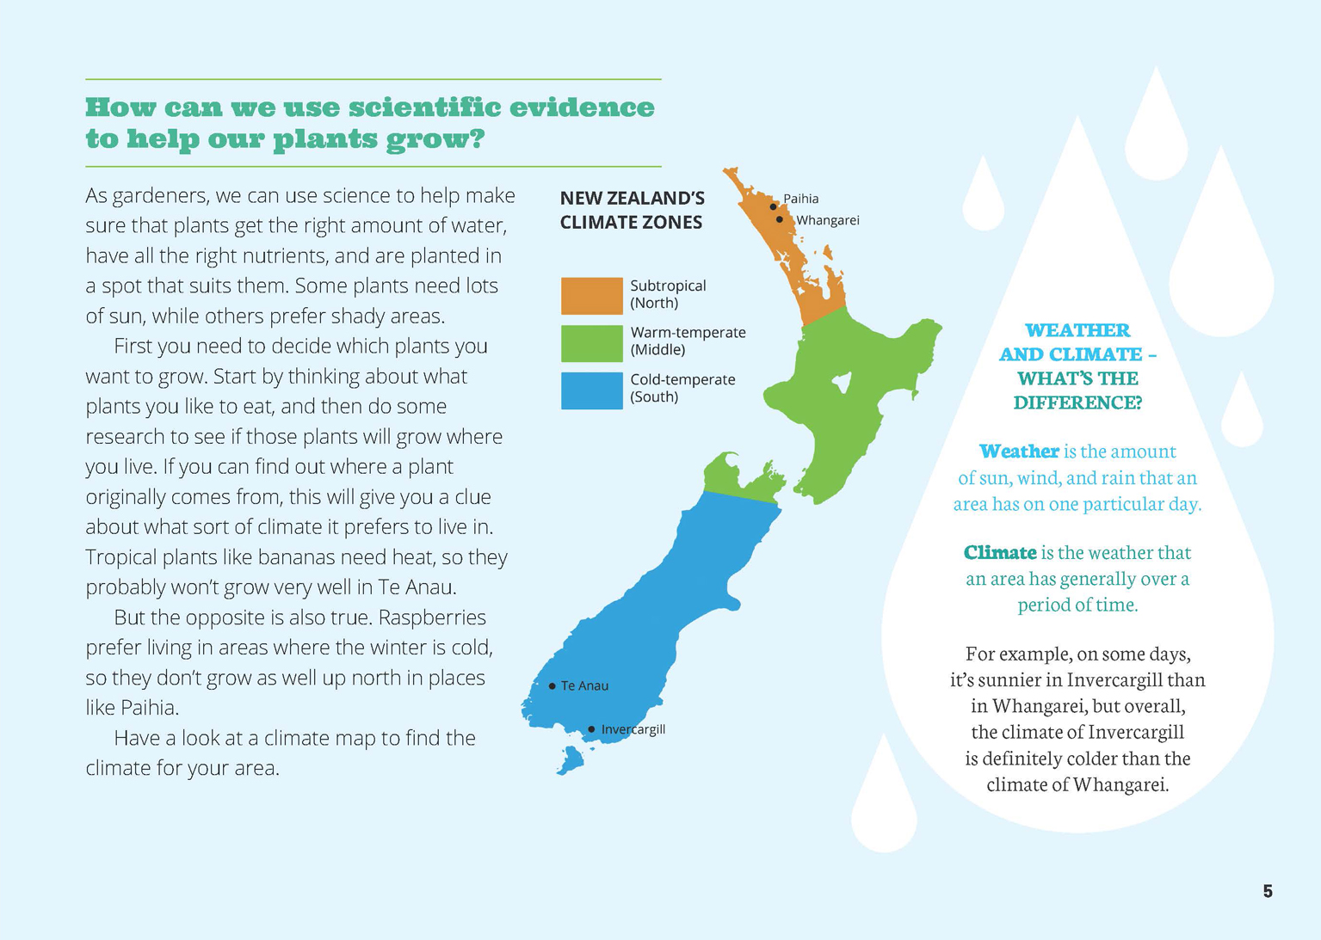 | Environmental changes affect the survival of living organisms.  Students recognise that all living things have requirements.  Scientists use relevant evidence to support or revise their ideas.
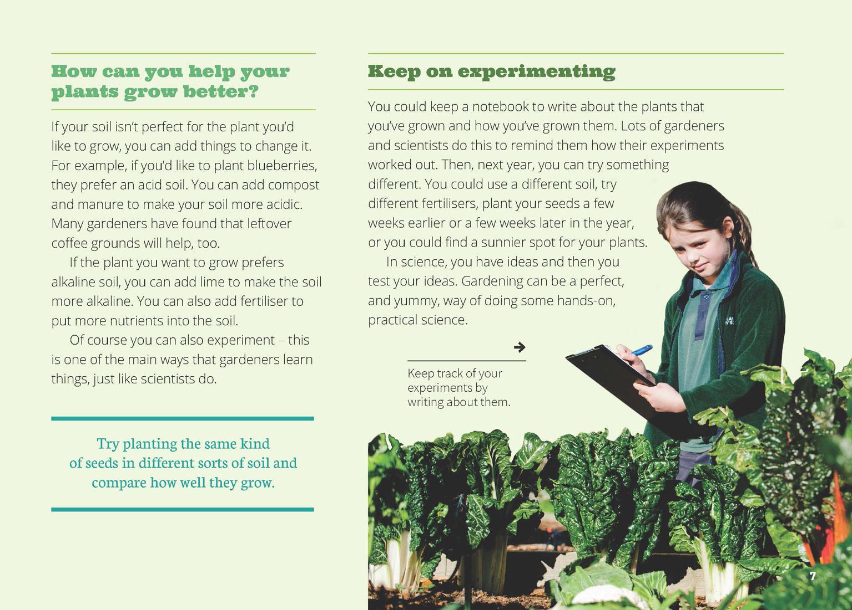  Different plants grow better in different conditions. | Scientific ideas are supported by evidence.  Changing the conditions of the environment can affect plant growth.  Evidence is based on observations of the natural world.

Exploring the science
Some activities focus directly on the science capability of “using evidence to support ideas” and the “Nature of Science” strand. Other activities extend student content knowledge. You are encouraged to adapt these activities to make the focus on Nature of Science explicit and to support students to develop the capability of using evidence to support ideas.

LEARNING FOCUS
Students use evidence to support their ideas about gardening.

LEARNING ACTIVITIES

Activity 1: Scientist gardeners in action
In the role of scientist gardeners, the students could create their own garden. This is an extended activity that involves students using evidence and information gathered from other sources (such as seed packets or gardening sites on the Internet) to identify a suitable site, select suitable plants, and grow them successfully. Students could conduct investigations in groups and bring their evidence as they plan their garden and monitor how it does. Be selective about the investigations you do so that the students can plant their gardens and see them grow!
Have the students create a word wall, recording the meanings of the specialised terms. They could add more words as they encounter them during their investigation. If the students are interested in making this a bilingual word wall, they can refer to the Te Ara item on Māori names for soil and the glossary in Is This a Plant?: Introducing the Plant Kingdom, Building Science Concepts book 35. Use the word wall as a point of reference so that the students use the language throughout their inquiry.
If the concept of gardeners as scientists is unfamiliar to the students, the article in this Connected, “Winning the Bledisloe Cup”, provides some real-life examples of gardeners using science to solve problems.
Visit a garden
A visit to a local community garden would allow students to gather information to use in their planning. Prompt the students to think about the questions a scientist gardener might ask. Link this to the verbs activity:
What questions might you ask to build on your current knowledge?
What are the features that you will want to observe and how will you record your observations?
How have these gardeners experimented?
The visit may prompt more questions for the students to investigate, for example:
What did you notice about the kinds of plants? Were they what you expected? Why?
What did you find out about planting methods? Do you think there are other methods that might work better?
Based on their interests, students could work in groups to carry out the following inquiries. They should record what they observed and their explanations so they can share the information with the whole class.
Testing the soil
If the students want to know more about the type of soil in their garden, they could conduct the pH test described in the article or you could purchase a soil testing kit from a garden centre. Explain that this will tell them exactly how acid or alkaline their soil is. They can use the evidence to identify good places to grow acid- or alkaline-loving plants and to decide on the sort of fertiliser they should use. They may find that some spots are very strongly acid or alkaline and are not suitable for growing anything. For further information, see the two Science Learning Hub activities on soil properties (www.sciencelearn.org.nz/Contexts/Soil-Farming-and-Science/Science-Ideas-and-Concepts/Soil-properties and www.sciencelearn.org.nz/Contexts/Soil-Farming-and-Science/Teaching-and-Learning-Approaches/Visual-soil-assessment).

Gathering weather data
The article and their visit to the garden will have given the students a general picture of the climate. However, they will also need to observe the temperature and rainfall. They could use a rain gauge, a maximum/minimum thermometer, and a barometer to collect data to decide whether their garden will get sufficient sun and water. Students who wish to know more about plants and their water needs could try the “Water Supporter” activity in Making Better Sense of the Living World (page 63). “My First Garden” has useful tips for setting up a school garden and includes an explanation of how to make a sun chart (http://urbanext.illinois.edu/firstgarden/planning/index.cfm).
Germinating seeds
The students may have observed the community gardeners germinating their own seeds. If they want to know more about the conditions for germination and growth, they could carry out one of the activities listed below. Each of these activities involves students in setting up a fair test that helps build their understandings that plants make their own food, respond to things around them, and produce new plants:
Activity 2 in Flowers, Fruits, and Seeds: Plants and Their Reproductive Parts, Building Science Concepts book 25
Activity 25 in Flowers, Fruits, and Seeds: Plants and Their Reproductive Parts, Building Science Concepts book 25
“Seeds, Stems, and Spores”, a resource on the Science Learning Hub (www.sciencelearn.org.nz/Science-Stories/Seeds-Stems-and-Spores).
Some of your students may have questions about the depth at which a seed should be planted. “How Low Can You Go” is an eat.think.grow science investigation that can be carried out by students individually or in pairs (http://eatthinkgrow.org/wp-content/uploads/2012/04/3S2.pdf).
Recording data
Discuss what the students have learned and have them use that learning to plan their own class garden. Have them record the details of their garden in a notebook, as suggested in the article. Their record can include details of the fertiliser used and the amount, how often they water their garden and when it rains. As the garden grows, they could monitor plant growth and health and make inferences about how this is connected to their care of the garden. Students could use photography to show a time-lapse record of growth (they should include a ruler in the background of the photos). They could upload the details to the school Intranet to be used as part of an ongoing experiment by the same or different students each year.

Activity 2: Plant parts
The Science Learning Hub has an activity called “Plant Parts” (www.sciencelearn.org.nz/Contexts/Pollination/ Teaching-and-Learning-Approaches/Plant-parts) that supports students to relate foods to different parts of the plant life cycle. Using an interactive or paper-based graphic organiser, students learn to:
recognise different parts of flowering plants (roots, stems, leaves, flowers, seeds, fruit)
understand the roles these parts play in the life cycle of flowering plants.

Activity 3: Further reading
For follow-up reading, see Connected 2, 2010, “Working with Nature” and Connected 1+2, 2008, “Fossils, Dinosaurs, Climate Change + More”.
Google Slides version of “Garden with Science” and additional digital content www.connected.tki.org.nz

RESOURCE LINKS

Building Science Concepts
Book 25 – Flowers, Fruits, and Seeds: Plants and Their Reproductive Parts
Book 26 – Making New Plants: How Flowering Plants Reproduce
Book 35 – Is This a Plant?: Introducing the Plant Kingdom
Book 43 – Spring: Observing Seasonal Changes
Book 63 – Growing Plants Indoors: What an Indoor Plant Needs

Connected
Working with Nature. Connected 2, 2010.
Fossils, Dinosaurs, Climate Change + More. Connected 1+2, 2008.
“Winning the Bledisloe Cup”. How Do You Know? Connected 2, 2014, pp.14–18.
“Science Focus: Relationships among Living Organisms and Their Environment”. In Making Better Sense of the Living World, p. 98.

Science Learning Hub
“Fertiliser” www.sciencelearn.org.nz/Contexts/Soil-Farming-and-Science/Looking-Closer/Fertiliser
“Modified soil” www.sciencelearn.org.nz/Contexts/Soil-Farming-and-Science/Sci-Media/Images/Modified-soil
“Pollination” www.sciencelearn.org.nz/Contexts/Pollination
“Seeds, Stems, and Spores” www.sciencelearn.org.nz/Science-Stories/Seeds-Stems-and-Spores
“Soil Properties” www.sciencelearn.org.nz/Contexts/Soil-Farming-and-Science/Science-Ideas-and-Concepts/Soil-properties
“Student Activity – Plant Parts” www.sciencelearn.org.nz/Contexts/Pollination/Teaching-and-Learning-Approaches/Plant-parts
“Student Activity – Visual soil assessment” www.sciencelearn.org.nz/Contexts/Soil-Farming-and-Science/Teaching-and-Learning-Approaches/Visual-soil-assessment

Other resources
“Digging Around For a Good Idea”. From Education for Sustainability. http://efs.tki.org.nz/Curriculum-resources-and-tools/Digging-around-for-a-good-idea
“Technology Exemplar: Luscious Lunchtime Lettuces”. http://legacy.tki.org.nz/r/assessment/exemplars/tech/products/pdfs/pp_3a_e.pdf
“Tech Systems for Year 3–4 Students: Hydroponics”. From Technology Online. http://technology.tki.org.nz/Resources/Case-studies/Classroom-practice-case-studies/Food-and-biotechnology/Tech-systems-for-year-3-4-students-Hydroponics
“Bledisloe Cup for Services to Horticulture”. www.stuff.co.nz/auckland/local-news/manukau-courier/9012161/Bledisloe-Cup-for-service-to-horticulture
“Growing Plants”. From WickEd. www.wicked.org.nz/Themes/Themes-gallery/Growing-Plants
“How Low Can You Go?”. From eat.think.grow. http://eatthinkgrow.org/wp-content/uploads/2012/04/3S2.pdf
“Lessons for the School Garden”. From eat.think.grow. http://eatthinkgrow.org/3rd-grade
“Māori Names for Soil”. From Te Ara. www.teara.govt.nz/en/diagram/19110/maori-names-for-soil
“My First Garden”. From the University of Illinois Urban Programs Resource Network. http://urbanext.illinois.edu/firstgarden/planning/index.cfm
Wellington Botanic Garden is creating a garden for children
http://wellington.govt.nz/recreation/gardens/botanic-garden/attractions/childrens-garden-2016

