CONNECTED, LEVEL 3 2013, Food for Thought  Why Is the Moon Upside Down?  by Trish Puharich  Overview  This article explore how three friends made observations of the phases of the Moon from different locations. It discusses how they interpreted their observations.  A Google Slides version of this article is available at www.connected.tki.org.nz. This text also has additional digital content, which is available online at www.connected.tki.org.nz too. |  |  |  |  |  | 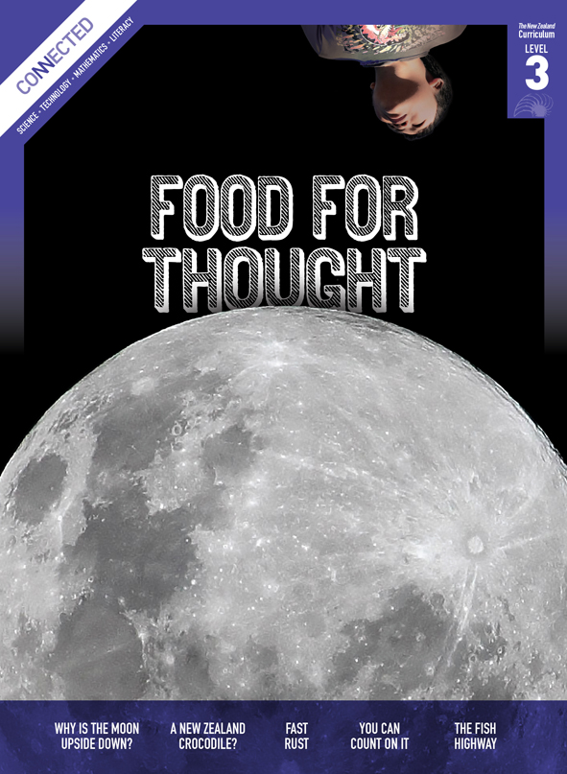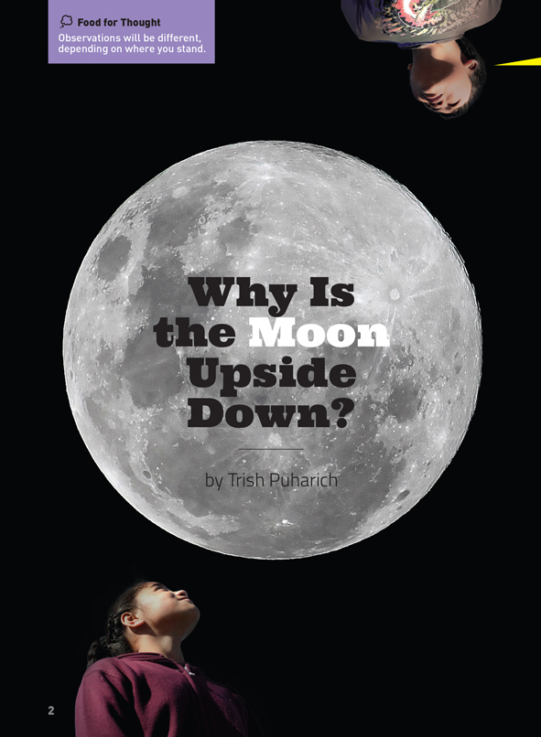
Science capability  Students need to develop a set of capabilities that support them to ask informed questions if they are to participate as “critical, informed, responsible citizens in a society in which science plays a significant role”. The capabilities enable students to meet the achievement objectives in a way that supports the purpose of science in The New Zealand Curriculum and the development of the key competencies. These capabilities include being ready, willing, and able to gather and interpret data. Students need to understand what counts as evidence in science, the importance of observation, and the difference between observation and inference. |  |  |  | Text characteristics  - Abstract ideas accompanied by concrete examples in the text that help support students’ understanding  - Diagrams, illustrations, and photographs that clarify the text and may require some support for students to interpret  - A mixed text type that also includes narrative, dialogue, and email  - An informal, conversational voice that includes the use of idiom.

Curriculum context

SCIENCE
NATURE OF SCIENCE: Investigating in science  Achievement objective(s)  L3: Students will build on prior experiences, working together to share and examine their own and others’ knowledge.  L3: Students will ask questions, find evidence, explore simple models, and carry out appropriate investigations to develop simple explanations. |  | PLANET EARTH AND BEYOND: Astronomical systems  Achievement objective(s)  L3: Students will investigate the components of the solar system, developing an appreciation of the distance between them. |  |  |  |  | Key Nature of Science ideas  - Science knowledge is based on direct, or indirect, observations of the natural physical world.  - Scientists gather data, using their senses to make observations.  - Making careful observations often involves measuring something.  - Observations are influenced by what you already know.  Key science ideas  - We see the Moon most clearly at night.  - The Moon orbits Earth near the equator.  - Light from the Sun is reflected off the surface of the Moon.  - The shape of the part of the Moon we can see (which is lit up by the Sun) changes due to the relative positions of the Sun and Earth.  - People in different hemispheres see the Moon from different perspectives.

ENGLISH
READING  Ideas  L3: Students will show a developing understanding of ideas within, across, and beyond texts. |  | INDICATORS  - Uses their personal experience and world and literacy knowledge confidently to make meaning from texts.  - Makes meaning of increasingly complex texts by identifying main and subsidiary ideas in them.  - Starts to make connections by thinking about underlying ideas in and between texts.  - Makes and supports inferences from texts with increasing independence. |  |  |  | THE LITERACY LEARNING PROGRESSIONS  The literacy knowledge and skills that students need to draw on by the end of year 6 are described in The Literacy Learning Progressions.

Scientific investigation
A science investigation where you change or try something and observe what happens is called an experiment. Not all scientific investigations are experiments; there are many ways of investigating in science. The New Zealand Curriculum science achievement aims indicate that students should experience a range of approaches to scientific investigation including classifying and identifying, pattern seeking, exploring, investigating models, fair testing, making things, and developing systems. Many scientific investigations involve systematic observation over time of an object, an event, a living thing, or a place.  Some important things to remember when you do a scientific investigation are: to be systematic and fair; to make sure that only one thing is changed at a time if you are doing an experiment or fair test so you are sure which changes result in which outcome; to observe and record what happens very carefully; and to be open minded so you notice things you are not expecting. |  |  |  | Sound data is obtained when you are able to get similar outcomes each time you do the same thing, or when data has been collected in the same way and in a systematic manner. No investigation or experiment results in a “wrong” outcome. You may have done something differently from others or the conditions may be slightly different so you don’t get the same result as others do, but it is not “wrong”.  Thinking about and developing explanations about why things happen the way they do, based on evidence, is an important aspect of science. Another important aspect is critically evaluating methods and ideas. Part of a scientist’s work is critiquing and evaluating the methods and ideas of other scientists. They expect their work to be subject to critique. If they are going to be able to make informed decisions about scientific issues as responsible citizens, students first need to experience a range of approaches to scientific investigation and to practise critique and evaluation of scientific methods and ideas – both their own and those of others – just like scientists do!

Meeting the literacy challenges

The following strategies will support students to understand, respond to, and think critically about the information and ideas in the text. After reading the text, support students to explore the key science ideas outlined in the following pages.  TEXT CHARACTERISTICS  - Abstract ideas accompanied by concrete examples in the text that help support students’ understanding  - Diagrams, illustrations, and photographs that clarify the text and may require some support for students to interpret  - A mixed text type that also includes narrative, dialogue, and email  - An informal, conversational voice that includes the use of idiom. |  | TEACHER SUPPORT  Want to know more about instructional strategies? Go to:  http://literacyonline.tki.org.nz/Literacy-Online/Teacher-needs/Pedagogy/Reading#Years5-8  http://literacyonline.tki.org.nz/Literacy-Online/Student-needs/National-Standards-Reading-and-Writing  http://www.literacyprogressions.tki.org.nz/  “Working with Comprehension Strategies” (Chapter 5) from Teaching Reading Comprehension (Davis, 2007) gives comprehensive guidance for explicit strategy instruction in years 4–8.  Teaching Reading Comprehension Strategies: A Practical Classroom Guide (Cameron, 2009) provides information, resources, and tools for comprehension strategy instruction.

INSTRUCTIONAL STRATEGIES
This text also has additional digital content, which is available online at www.connected.tki.org.nz  FINDING INFORMATION IN THE TEXT  MODEL by thinking aloud how to skim headings and diagrams to get an overview of the text.  - By skimming pages 6–7, I notice that there are diagrams of the Moon viewed from different hemispheres. They seem to show that the Moon looks different according to whether someone is in the northern or southern hemisphere.  DEALING WITH ABSTRACT IDEAS  ASK QUESTIONS to help the students engage with the text and to assess and support their understanding.  - How would you answer the question that the title poses? Why?  - What data would you need to answer this question?  Have the students draw up a chart with the information they require listed on one side of table. On the other side, they can RECORD the information they gain from reading the text. They can do this in pairs.  Have the students read the text on page 6 and EXPLAIN to their partners what they have learnt about the relationship between pre-European Polynesian people (including Māori) and the Moon.  When they have finished reading, ask the students to use the information they have gathered in their chart to RECORD shared explanations of why the Moon can appear to be upside down. The class can share their explanations and decide on the one that seems most accurate. This activity allows students to SYNTHESISE INFORMATION and to make it their own. |  | INTERPRETING ADDITIONAL INFORMATION TO CLARIFY THE TEXT  Have the students read the first of the emails to CLARIFY the central problem.  MAKE CONNECTIONS between the text box recounting the legend of Rona and the Moon and the students’ own perceptions of the Moon.  - What do you see when you look at the Moon?  - What other stories do you know about the Moon?  There may be students who can recount the story of Sina and the Moon.  Have the students EXPLORE the diagram on page 7 (Sam’s idea) in pairs and RECORD their own conclusions about what they see. Then have them read the text and COMPARE what they observed to what the young people in the article observed.

Teacher support
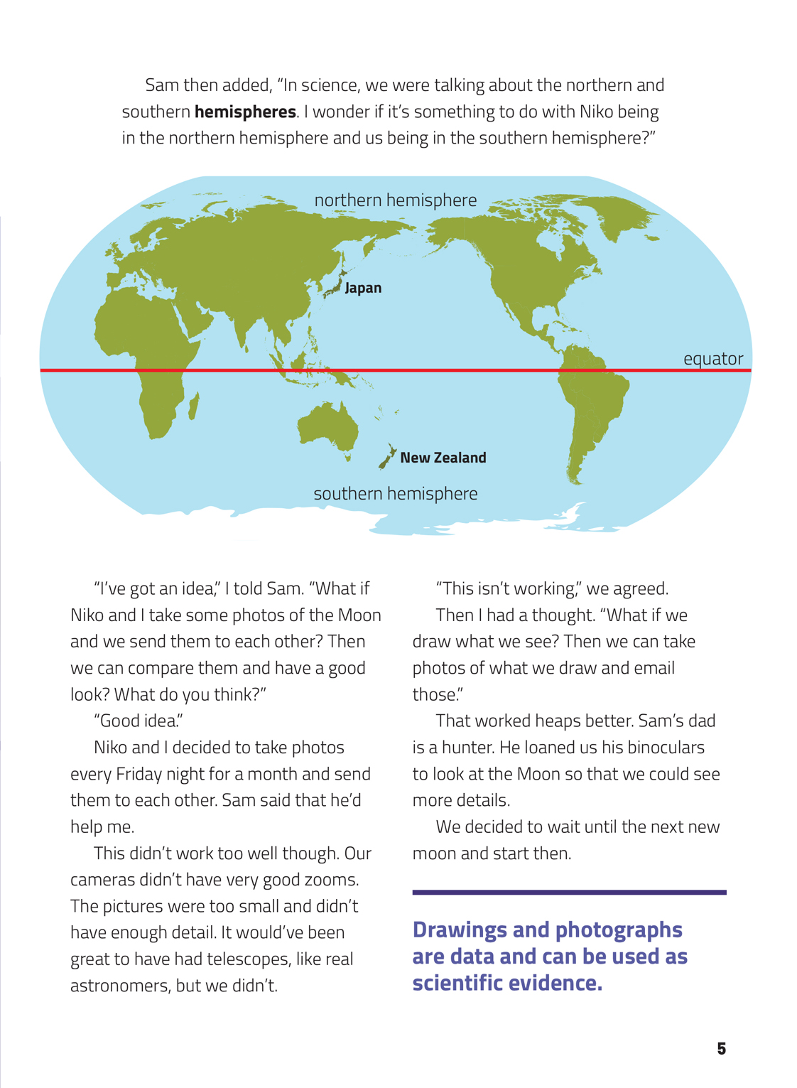 | Students asking questions, finding evidence, and carrying out an investigation to develop a simple explanation  Students building on prior experiences  Working together to share and examine their own knowledge
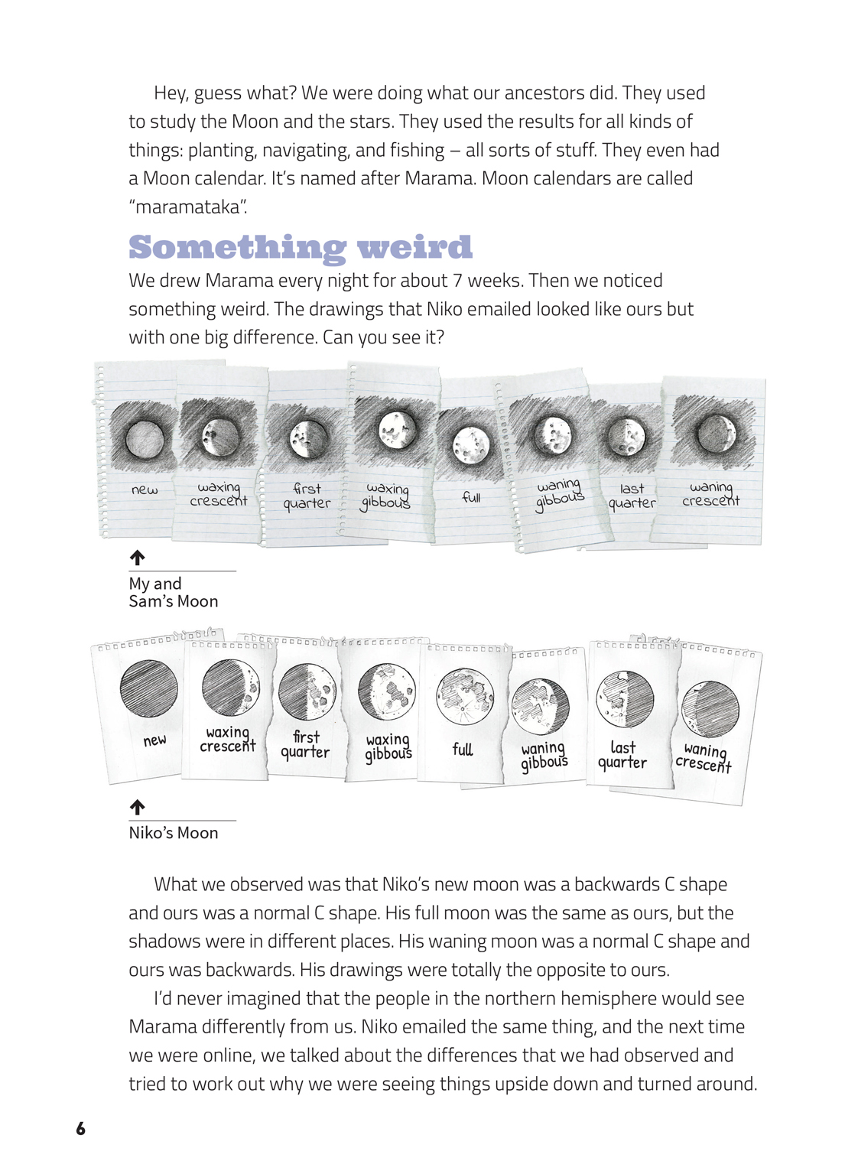 | People in different hemispheres see the Moon from different perspectives.  Making careful observations often involves accurately recording what you see.  Science knowledge is based on direct observations of the natural physical world.  The shape of the part of the Moon that we can see is lit up by the Sun and changes due to the relative positions of the Sun and the Earth.

Exploring the science
Some activities focus directly on the science capability of “gathering and interpreting data” and the Nature of Science strand. Other activities extend student content knowledge. You are encouraged to adapt these activities to make the focus on Nature of Science explicit and to support students to develop the capability to collect and interpret data.
LEARNING FOCUS |  | KEY SCIENCE IDEAS
Students make observations, gather data, and interpret and discuss outcomes based on their observations. |  | Key Nature of Science ideas  - Science knowledge is based on direct, or indirect, observations of the natural physical world.  - Scientists gather data, using their senses to make observations.  - Making careful observations often involves measuring something.  - Observations are influenced by what you already know.  Key science idea  - We see the Moon most clearly at night.  - The Moon orbits Earth near the equator.  - Light from the Sun is reflected off the surface of the Moon.  - The shape of the part of the Moon we can see (which is lit up by the Sun) changes due to the relative positions of the Sun and Earth.  - People in different hemispheres see the Moon from different perspectives.

LEARNING ACTIVITIES

Activity 1: Exploring the phases of the Moon
The changes in the apparent shape of the Moon as it orbits Earth are called its phases. It takes the Moon 27.3 days to complete one orbit and the same time to make one revolution on its own axis.
Get the class to observe and draw the Moon every night for a month before reading this article. What observations would they make? How would they explain what they observed? They could use a blank calendar or a recording sheet like the one for Activity 11 in Making Better Sense of Planet Earth and Beyond. Note: the point made there – if there are nights when the Moon can’t be seen because of the clouds, the students will be able to infer the shape of the Moon by extrapolating from the shape of the Moon on the preceding and following nights.
For a more complete description of how to support students to keep a Moon journal, see the link to the Teachers’ Lab activity.

Extension activities
With what they have learnt from their own observations and from reading the article, the class could share and discuss the YouTube clip showing the phases of the Moon in fast forward.
Alternatively, the students could try using the link to the Lunar Phase Simulator. You could use the activities in the student guide to clarify the students’ understandings of the terms “gibbous”, “waxing”, and “waning”.
The students could read the Connected article “Galileo’s Legacy” to find out how Galileo relied on his observations of the night sky to make new discoveries about the universe.

Activity 2: The Moon and its Orbit
Activity 12 in Making Better Sense of Planet Earth and Beyond describes how students can use a torch and a tennis ball to demonstrate the phases of the Moon as it orbits the Earth. Explain to the students that we often use models when we can’t directly observe something.
You can use an overhead projector or some other large static light source as the model of the Sun to make it easier for students to keep their “moon” in its beam. Have the student kneel and hold the ball at arm’s length out from, and above, their head to ensure their head doesn’t cause shadows on the “Moon”.

Extension activities
The class could read the Connected article “Night Lights” to learn more about the phases of Earth’s moon and to find out about the number of moons orbiting other planets of the Solar System.
The link to the Science Online page, “Using Online Models to Understand the Phases of the Moon” provides teaching suggestions for using the interactive resource, Day and Night: Views from the Southern Hemisphere.

Activity 3: Exploring the similarities and differences between the northern and southern hemispheres
Have the students use their prior knowledge to predict what the phases of the Moon will look like in Sāmoa, which is near the equator. Get them to draw their predictions and then check them using the website “The Moon: The Phases of the Moon” or using photos from that region.

Activity 4: Exploring the impact of the phases of the Moon on the Earth
Use Building Science Concepts, Book 8 – The Moon: Orbits, Appearances, and Effects to explore the concept that the relationship between the Earth, the Moon, and the Sun causes regular effects on Earth (for example, tides) that are physical phenomena easily observed by students and that form part of their everyday lives. For example, people in many cultures use the phases of the Moon to decide when to plant and to harvest or when it is best to fish.
Have the students design and conduct an investigation into the relationship between the shape of the Moon and planting and how the shape of the Moon changes outcomes. They could do this by planting bean seeds at different times – some at “good times” and some at “bad” times, according to the calendar. They could use line graphs to record the growth of the beans. They can interpret the data by comparing the growth of the different plantings after the same period of time.
Using what they have learnt from the article, their own experiment, and any other sources, have the students write an explanation to tell the reader how and why the Moon affects plant growth.

Activity 5: Modern uses for traditional Māori knowledge
The article tells us that Māori used the phases of the Moon to devise maramataka that were used to track time, plant and harvest crops, fish, and hold festivals. Different iwi have their own maramataka based on their own observations and local conditions.
Have the students make connections to their prior knowledge about maramataka. For example, they may already know about Matariki, the Māori New Year. What questions do they have? The students could use the resources above to find out more about maramataka and construct their own calendar, setting out the activities they believe to be appropriate at different times. As they do this, they could record the answers to their questions, as well as any new questions that arise. They could then ask a member of the local iwi to speak about the maramataka they use and answer any unanswered questions. The students could use the information from the interview to refine their maramataka.
Finally, the students could consider the applicability of this traditional Māori knowledge to the present day. They can write statements, using evidence from their investigations to justify their conclusions.

Extension
Students may wish to follow this up by investigating calendars and time measuring devices from a range of cultures. They could work in groups to focus on particular examples, creating and testing working models that could be shared with the rest of the class.

Activity 6: Stories about the Moon
Discuss the fact that different cultures have different stories that they use to make sense of the phenomena they observe. The article refers to the story of Rona me te Mārama and a Sāmoan story about Sina.
Science Online has a set of activities that could be conducted alongside a reading of the School Journal play “Rona me te Mārama”. You could also share the story of Sina and the Moon and invite the students to share any other stories they know about the Moon.
What are the similarities and what are the differences?
Use this sharing to explore how cultural narratives and understandings and science thinking link, and the idea that those scientific ideas from other cultures are valuable. The following reflective questions are from Science Online:
Why might different groups of people have different stories about the patterns they see in the Moon?
Why have people developed so many stories about the Moon? (For example, because of its observability and because of its association with growing seasons and fishing times.)
What skills do you think scientists and people who fish and plant according to a lunar calendar have in common?
What is the purpose of a traditional or cultural narrative? How is this purpose the same and different from the purpose of a scientific explanation?
Google Slides version of “Why Is the Moon Upside Down?” and additional digital content www.connected.tki.org.nz

RESOURCE LINKS

Making Better Sense of Planet Earth and Beyond – “Astronomy” (activities 11 and 12, pages 104–105); “Te Maramataka Māori” (page 124)
Building Science Concepts, Book 8 – The Moon: Orbits, Appearances, and Effects
Science Online: Using Online Models to Understand the Phases of the Moon http://scienceonline.tki.org.nz/Nature-of-science/Nature-of-Science-Teaching-Activities/Using-online-models-to-understand-the-phases-of-the-Moon
Science Online: http://scienceonline.tki.org.nz/Nature-of-science/Nature-of-Science-Teaching-Activities
Rona and the Moon http://scienceonline.tki.org.nz/Nature-of-science/Nature-of-Science-Teaching-Activities/Different-stories-about-the-Moon-Rona-me-te-Marama
Assessment Resource Banks http://arb.nzcer.org.nz/resources/science/bsc.php
Learnz http://www.learnz.org.nz
2013 Moon Phases in Fast Forward – Lunar cycle NASA video http://www.youtube.com/watch?v=b7PrVepWRPM
The Moon: The Phases of the Moon http://www.primaryhomeworkhelp.co.uk/moon/phases.html
Teachers’ Lab: Moon Journal Activity http://www.learner.org/teacherslab/pup/act_moonjrnl.html
Lunar Phase Simulator http://astro.unl.edu/classaction/animations/lunarcycles/lunar_phaser.html
Lunar Phase Simulator – Student Guide http://astro.unl.edu/naap/lps/lps.html
Modern Uses for Ancient Māori Knowledge http://www.victoria.ac.nz/home/about/newspubs/news/newslatest#a189934
Paul Meredith. “Maramataka – The Lunar Calendar – Lunar Months”, Te Ara – the Encyclopedia of New Zealand, updated 22 September 2012 http://www.TeAra.govt.nz/en/maramataka-the-lunar-calendar/page-1
Paul Meredith. “Maramataka – The Lunar Calendar – Nights of the Month”, Te Ara – the Encyclopedia of New Zealand, updated 14 November 2012 http://www.TeAra.govt.nz/en/speech/5389/when-to-plant-and-fish
Te Papa: Matariki Education Resource http://www.tepapa.govt.nz/education/onlineresources/Matariki/Pages/overview.aspx
“Rona me te Mārama” SJ 2.4.93
“Galileo’s Legacy” Connected 3, 2009
“Night Lights” Connected 3, 1999
Translated by Galuamalemana Afeleti L. Hunkin. Sina in the Moon: A Sāmoan Legend – Pasifika Education Centre, 2005.

