Our Changing World (Reading): Unit standard 2986

Writers: Jenni Bedford and Breda Matthews

NCEA LEVEL 2
Unit standard | Elements and performance criteria
Unit standard 2986, version 7  Read information texts in familiar contexts (ESOL) | Element 1: Read information texts in familiar contexts (ESOL).  Range: Two texts, each from a separate familiar  context.  Performance criteria  1.1 The main idea of the overall text is  identified with reference to layout and any  headings, illustrations, or diagrams.  1.2 Main points and supporting detail in each  text are identified.  1.3 The effect on meaning of cohesive devices in the text is identified.  Range: Cohesive devices may include but are  not limited to – repetition of key nouns, pronoun  reference, conjunctions.  1.4 The meaning of essential vocabulary as  used in each text is given.  Range: Ten words.

RESOURCES

Assessment activities, for other unit standards, that could be used in conjunction with unit standard 2986:
- Listening: ‘Our Changing World’ (US15007)
- Speaking: ‘Our Changing World’ (US 17360)
- Writing: ‘Our Changing World’ (US 17368)
Teacher sheet: Task 1

Unit standard 2986, version 7
Read information texts in familiar contexts (ESOL)

Level 2 4 credits
This unit standard has one element:
Element 1: Read information texts in familiar contexts (ESOL).
Range: Two texts, each from a separate familiar context.
Conditions
- Understanding may be demonstrated by oral or written response.
- Written responses need not be grammatically correct but errors must not interfere with meaning.
- A bilingual and/or English dictionary but not an electronic translator may be used.
- Assistance may be given to understand the requirements of the task.

Learning context
Assessment should follow class activities in which the students have had the opportunity to become familiar with the topic and vocabulary through a range of listening, speaking and writing activities. The question types should also be familiar to the students and this can be achieved by including similar question types in the formative work. The English Language Intensive Programme (ELIP) Stage 2, has suggested teaching components, strategies, language features and sample texts on information report genre: ‘Kiwi’ (5c); ‘Sharks’ (5d); ‘Kangaroos’ (11c); ‘Antarctica’ (11d); ‘New Zealand’ (20c) and ‘Drugs’ (20d).

Notes for Assessors
- It is important that students are familiar with the requirements of the performance criteria and the special notes.
- Each of the two texts should be assessed at a different time as part of a wider area of study.
- Students should not have seen the text before the assessment activity.
- Refer to your institution’s policies on resubmission and reassessment before offering further assessment opportunities.
- If resubmission takes place, the assessor should ensure that the correct answers are not inadvertently indicated prior to the resubmission opportunity. For example, in a true or false exercise, students should redo that part of the assessment on an unmarked copy.

Student instructions: Task 1

Unit standard 2986, version 7
Read information texts in familiar contexts (ESOL)

Level 2 4 Credits
Element 1: Read information texts in familiar contexts (ESOL).
Range: Two texts, each from a separate familiar context.
Task 1: The Secret Life of Estuaries

Name: ______________________________

Date: _______________________________

Conditions
- Do this activity in class.
- You may ask for help to understand the instructions.
- You may use a bilingual and/or English dictionary but not an electronic translator.
- Your spelling and grammar do not need to be perfect but your teacher needs to be able to understand what you mean.

Student checklist: Task 1

In this assessment task you will need to show that you can do the following:
Identify the main idea of the overall text using layout, and any headings, illustrations or diagrams. | 1.1
Identify the main points and supporting detail in the text. | 1.2
Identify the effect cohesive devices have on the meaning of the text. This may include:  - repetition of key nouns e.g. The Iguasu waterfall, many waterfalls, this waterfall.  - pronoun reference e.g. it, they, these.  - conjunctions e.g. because, and, or. | 1.3
Give the meaning of ten important words from the text. | 1.4
Reading text: Task 1

‘The Secret Life of Estuaries’
Adapted from ‘The Secret Life of Estuaries’ by Andrew Innes (in Connected 3, 2006, Learning Media, Wellington).

On the move

Estuaries are those parts of a bay or harbour where fresh water and sea water meet. Fresh water moves over land or travels down rivers and streams to the sea and the tide brings sea water into the estuary twice every day.

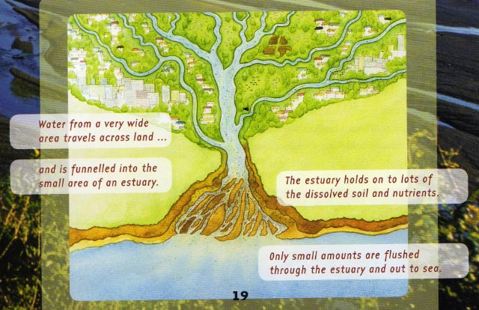

Keeping the estuary clean

The fresh water brings soil, nutrients and detritus (rotting plants and animals) into the estuary. The estuary plants and animals recycle the soil, nutrients and detritus. Plants use the soil and nutrients. Lugworms, crabs, shellfish and bacteria digest the detritus. The tide cleans out the estuary twice a day.

Healthy estuaries and food chains

A healthy estuary has a healthy food chain. The first part of a food chain is always a living or dead plant. Zooplankton, worms and other herbivores eat the plants and detritus. Next, small carnivores such as shrimps and fish eat the herbivores. Then, larger fish eat the small carnivores. Finally, seabirds and mammals, such as seals and people, eat the larger fish.

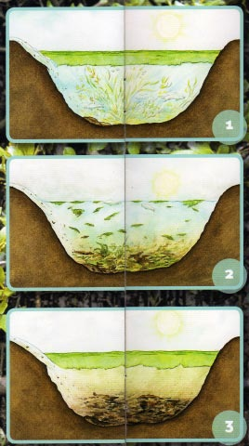

When good nutrients go bad

We must keep nutrients out of estuaries because having too many nutrients kills estuaries. They make the estuary plants grow out of control. These plants die when the weather gets cold and then they sink to the bottom of the estuary. There they are digested by aerobic bacteria. The bacteria use up all of the oxygen in the water because there is such a lot of detritus. When this happens, the bacteria and the animals living in the water die and eventually the food chain is broken.

276 words

Student sheet: Assessment task 1

Unit standard 2986, version 7
Read information texts in familiar contexts (ESOL)
Level 2 4 credits

Name ……………………………………………………... Date ………………

Read the text and answer the questions below.

1. The main idea of the overall text is identified with reference to layout and any headings, illustrations and diagrams in the text (1.1)

Read the text and look carefully at the layout and any headings, illustrations and diagrams in the text.

1a. What is the main idea of this text?

I think the main idea of this text is …………………………………………………

………………………………………………………………………………………….

………………………………………………………………………………………….

1b. What things from the text make you think this? Think about the layout, and headings, illustrations and diagrams.

I think this is the main idea of the text because …………………………

………………………………………………………………………………………….

………………………………………………………………………………………….

………………………………………………………………………………………….

………………………………………………………………………………………….

………………………………………………………………………………………….

2. Main points and supporting detail are identified (1.2)

Use these main ideas and supporting details to complete the chart on the next page. The first one has been done for you.

a. Finally the food chain is broken.
b. When the plants die they sink to the bottom of the estuary.
c. Next small carnivores eat the herbivores.
d. They contain fresh water from rivers and land and sea water.
e. Estuaries die when there are too many nutrients.
f. The first part of a food chain is a plant.
g. How estuaries are kept clean.
h. The bacteria use up all the oxygen.
i. The tide cleans the estuary twice a day.
Write the main ideas and supporting details from the list on the previous page in the spaces below. Think carefully about where each one goes. The first one has been done for you.

Main idea | Supporting detail
Estuaries are parts of bays or harbours. | i) …d… They contain fresh water from rivers and the land and sea water.  They are cleaned by the tide.
ii) ……………………………….. | Soil, nutrients and detritus are used by plants and animals.  iii)…………………………………………………
Healthy estuaries have healthy food chains. | iv) ……………………………………………….  Then herbivores eat the plants.  v) ……………………………………………….  Finally larger carnivores eat the small carnivores.
vi) …………………………….. | They make the plants grow out of control.  vii) ……………………………………………….  Then the dead plants are digested by aerobic bacteria.  viii) ………………………………………………  The bacteria and animals die because there is no oxygen.  ix) ………………………………………………..

3. The effect on meaning of cohesive devices in the text is identified (1.3)

When good nutrients go bad

We must keep nutrients out of estuaries because having too many nutrients kills estuaries. They make the estuary plants grow out of control. These plants die when the weather gets cold and then they sink to the bottom of the estuary. There they are digested by aerobic bacteria. The bacteria use up all of the oxygen in the water because there is such a lot of detritus. When this happens the bacteria and the animals living in the water die and eventually the food chain is broken.

3a. Pronoun reference

Look at the words in bold in the text above. Choose the word that refers to:

i) nutrients
ii) all of the oxygen is used up
iii) people
iv). the estuary plants

3b. Connectives

Look at the underlined words in the text above. Which word introduces

i) a reason?
ii) the last event?
iii) the next event?
iv) another piece of information?
4. The meaning of essential vocabulary used in the text is given (1.4)

Match the words with their meaning in the text. Choose from the list of words in the box. Be careful that you choose the meaning in this text as some words have more than one meaning.

rotting  the tide  a food chain | to recycle  to sink  soil | a bay  to digest  nutrients | bacteria  healthy  a carnivore

Word | Meaning
i) | to use something more than once
ii) | the feeding relationships between living things
iii) | a curved part of the coast
iv) | in good condition
v) | going bad or decaying
vi) | to go under the water
vii) | earth
viii) | the regular rise and fall of the sea level
ix) | something that is food for plants or animals
x) | to eat and use food
xi) | an animal that eats other animals
xii) | very small living things, you need a microscope to see them

Student instructions: Task 2

Unit standard 2986, version 7
Read information texts in familiar contexts (ESOL)
Level 2 4 Credits
Element 1: Read information texts in familiar contexts (ESOL).
Range: two texts, each from a different familiar context.
Task 2: Cleaning Up

Name: ___________________________________

Date: ___________________________________

Conditions
- Do this activity in class.
- You may ask for help to understand the instructions.
- You may use a bilingual and/or English dictionary but not an electronic translator.
- Your spelling and grammar do not need to be perfect but your teacher needs to be able to understand what you mean.

Student checklist: Task 2

In this assessment task you will need to show that you can do the following:
Identify the main idea of the overall text using layout and any headings, illustrations or diagrams. | 1.1
Identify the main points and supporting detail in the text. | 1.2
Identify the effect cohesive devices have on the meaning of the text. This may include:  - repetition of key nouns e.g. The Iguasu waterfall, many waterfalls, this waterfall.  - pronoun reference e.g. it, they, these.  - conjunctions e.g. because, and, or. | 1.3
Give the meaning of ten important words from the text. | 1.4
Reading text: Task 2

‘Cleaning up’

Adapted from X-zone “Who’s for dinner” by David Harris, Scholastic, 2005

An important group in the food chain is the organisms that clean up after other animals. These animals and organisms are called decomposers.

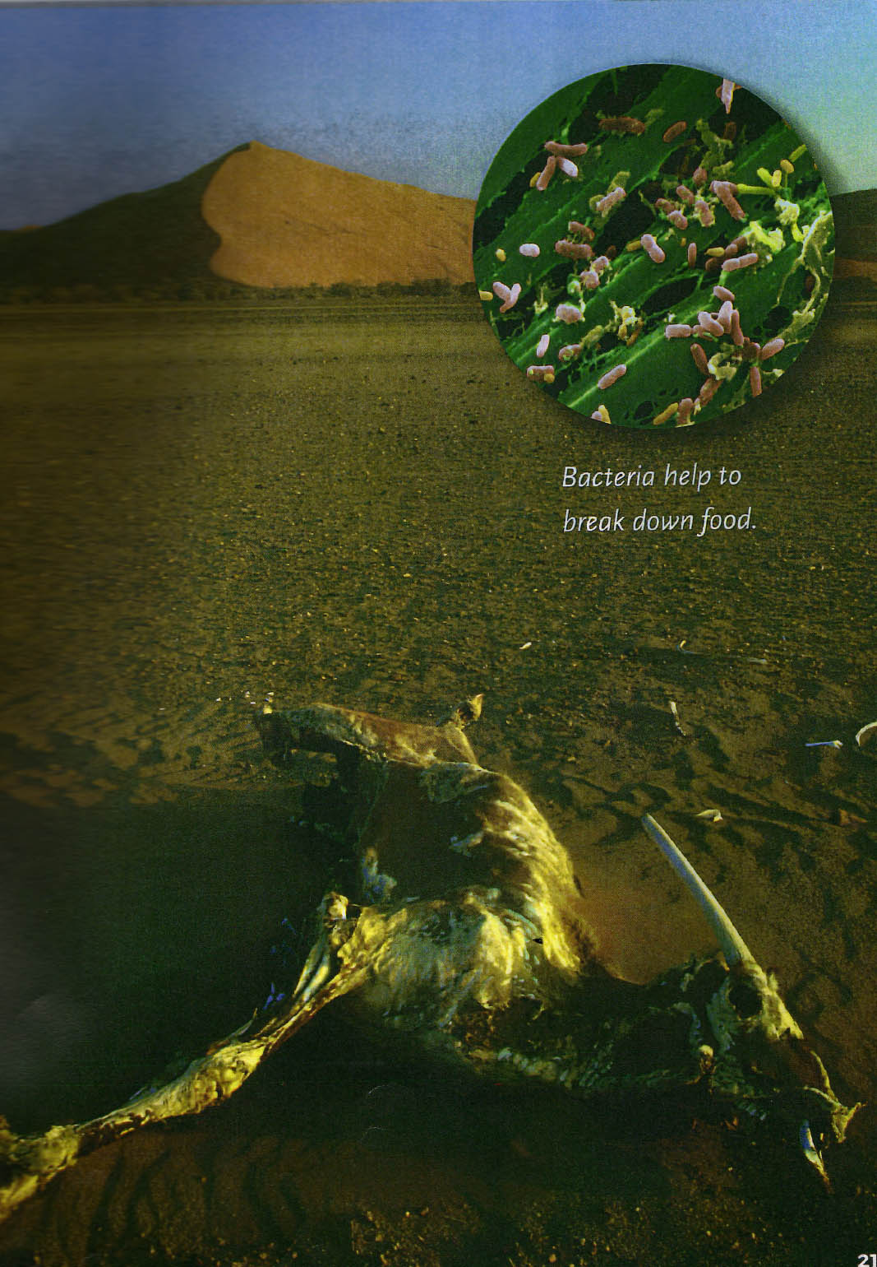

Breaking down waste

Decomposers are very important in the environment. This is because they eat the leftovers of the animal community – food scraps, bits of vegetation and other litter. But decomposers don’t just eat these leftovers to be helpful. They get their nutrition from these scraps. Furthermore, their waste contains minerals which go back into the soil and are then used by plants.

Bacteria help to break down food

Types of decomposers
The main decomposers are bacteria. These are some of the smallest living things on earth. Bacteria help you to digest your food and they get rid of other harmful bacteria. Bacteria help turn milk into cheese. When food gets old, bacteria multiply and start to decompose the food.

Some plants are also decomposers. Fungi such as mushrooms, toadstools, mildew and mould are also decomposers. They get their food by living on and eating parts of other plants, such as bark on trees and dead leaves from the forest floor.

There are also animal decomposers such as earthworms. Earthworms burrow underground eating bits of dead animals and plants. When they have extracted all the nourishment they need, the worms excrete waste called casts. These casts are full of minerals like nitrogen, phosphorous and potash, which go back into the soil. Living plants use these minerals to help them grow.

237 words

Student sheet: Assessment task 2

Unit standard 2986, version 7
Read information texts in familiar contexts (ESOL)
Level 2 4 credits

Name …………………………………………………….. Date …………………

Read the text and answer the questions below.

1. The main idea of the overall text is identified with reference to layout and any headings, illustrations or diagrams (1.1)

1a. Tick the overall main idea of the text?

- What causes decomposition.
- Why decomposers are important.
- Keeping the world clean.
- Decomposers and what do they do.

1b. What things from the text make you think this? Think about the layout, and headings, illustrations and diagrams.

I think this is the main idea of the overall text because …………………………

………………………………………………………………………………………….

………………………………………………………………………………………….

………………………………………………………………………………………….

………………………………………………………………………………………….

………………………………………………………………………………………….

2. Main points and supporting detail are identified (1.2)

Use these main ideas and supporting details to complete the chart on the next page. The first one has been done for you.

a. They include animals and other organisms
b. Fungi live on and eat other plants.
c. They are bacteria, plant and animal decomposers.
d. Fungi are plants that are decomposers.
e. Plants use the minerals that earthworms excrete.
f. Decomposers do important jobs.
g. Earthworms eat dead animals and plants.
h. Bacteria are very small living things.
i. Decomposers’ waste has the minerals that plants need to grow.

Write the main ideas and supporting details from the list on the previous page in the spaces below. Think carefully about where each one goes. The first one has been done for you.

Main idea | Supporting detail
Decomposers clean up after other animals. | i) ..a..They include animals and other organisms.
ii) ……………………. | The jobs are:  Decomposers eat food scraps and litter.  iii) ……………………………………………………….
There are three types of decomposers. | iv) ………………………………………………………
v) …………………….. | Bacteria help  - animals to digest food,  - kill harmful bacteria,  - turn milk into cheese  - decompose food
vi) ……………………. | Fungi include mushrooms, toadstools. mildew and moulds.  vii) ……………………………………………….
Earthworms are animals that are decomposers. | viii) ……………………………………………..  They excrete waste that is full of minerals.  ix) ………………………………………………
3. The effect on meaning of cohesive devices in the text is identified (1.3)

3a. Class and sub-class

Look at the whole text on pages 4 and 5. Write down three words that are a sub-class of ‘decomposers’. One example has been done for you.

Decomposers | Bacteria  i) …………………………………………  ii) ………………………………………..  iii) ………………………………………..

3b. Connectives

Decomposers are very important in the environment. This is because they eat the leftovers of the animal community – food scraps, bits of vegetation and other waste. But decomposers don’t just eat these leftovers to be helpful. They get their nutrition from these scraps. Furthermore their waste contains minerals, which go back into the soil and are then used by plants.

Look carefully at the text in the box above. Find the word in bold that introduces:

i) an extra piece of information. …………………………..

ii) a reason. …………………………..

iii) a contrasting or opposite piece of information. …………………………..

4. The meaning of essential vocabulary used in the text is given (1.4)

minerals  organisms  decomposes | excrete  chain  nutrition | waste  environment  litter | fungi  communities  vegetation

Choose words from the box above that match the meaning of the words in bold in the questions. The meanings must be the same as those used in the text.

Many (i) ……………………………………. (groups of people) recycle things

they no longer need.

People do this because it is good for the (ii) ………………………….. (natural

world)

Food (iii) ……………………(leftover food) is put in compost bins.

When this (iv) …………………………. (rots) it can be used in gardens.

Lots of different (v) ……………….. (living things) eat the leftover food and

dead (vi)………………….. (plants)

Earthworms eat these leftovers which provides them with

(vii) …………………… (food)

The earthworms then viii) ………………. (expel) casts.

These casts are full of important ix) …………………….. (inorganic

material) such as nitrogen and phosphorous and potash.

(x) ………………………. (a special type of plant) are plant decomposers.

Decomposers are a very important part of the food xi) ………………………….

(a series of linked events)

If we didn’t have decomposers the world would be full of (xii) …………………

(rubbish)

Assessment schedule: Task 1 - The Secret Life of Estuaries

Unit standard 2986, version 7
Read information texts in familiar contexts (ESOL)
Level 2 4 credits
Element 1: Read information texts in familiar contexts (ESOL).
Range: Two texts, each from a separate familiar context.
PC | Evidence | Judgement
1.1 | 1a. Answers similar to:  Information about estuaries / looking after estuaries  1b. Answers show that layout, headings, illustrations and diagrams have been used to identify the main idea of the overall text e.g.  Information about estuaries – there is a diagram of an estuary and the word estuary is used in three of the four paragraphs.  Looking after estuaries - the headings are about keeping estuaries clean and healthy. | The main idea of the overall text is identified.  1a. Any reasonable answer.  1b. Any reasonable answer that uses text, layout, illustrations or diagrams to support answer to 1a.
1.2 | 2.  ii) g - How estuaries are kept clean.  iii) i - The tide cleans the estuary twice a day.  iv) f - The first part of a food chain is a plant.  v) c - Next small carnivores eat the herbivores.  vi) e - Estuaries die when there are too many nutrients.  vii) b - When the plants die they sink to the bottom of the estuary.  viii) h - The bacteria use up all the oxygen.  ix) a – Finally the food chain is broken. | Main points and supporting details are identified.  6 out of 8 answers are correct.  Students may write the correct letter or sentence or both.
1.3 | 3a.  i) They  ii) this  iii) we  iv) these  3b.  i) because  ii) eventually  iii) then  iv) and | The effect on meaning of cohesive devices in the text is identified.  3a. 3 out of 4 answers are correct.  3b. 3 out of 4 answers are correct.
1.4 | Correct answers are  - to recycle  - a food chain  - a bay  - healthy  - rotting  - to sink  - soil  - the tide  - nutrients  - to digest  - a carnivore  - bacteria | The meaning of essential vocabulary as used in the text is given.  10 out of 12 answers are correct.

Assessment schedule: Task 2 - Cleaning Up

Unit standard 2986, version 7
Read information texts in familiar contexts (ESOL)
Level 2 4 credits
Element 1: Read information texts in familiar contexts (ESOL).
Range: Two texts, each from a separate familiar context.
PC | Evidence | Judgement
1.1 | 1a. iv  1b. Answers show that layout, and headings, illustrations and/or diagrams have been used to identify the main idea of the overall text e.g.  The paragraphs tell you what they are and what they do.  The paragraph headings are ‘Breaking down waste’ and ‘Types of decomposers’  The picture shows you what decomposers do. | The main idea of the overall text is identified.  1a. Answer is correct  1b. Any reasonable answer that uses text, layout, illustrations or diagrams to support answer to 1a.
1.2 | 2.  ii) f - Decomposers do important jobs.  iii) i - Decomposers waste has the  minerals that plants need to  grow.  iv) c - They are bacteria, plants and  animals.  v) h - Bacteria are very small living  things.  vi) d - Fungi are plants that are  decomposers.  vii) b -Fungi live on and eat other  plants.  viii) g -Earthworms eat dead animals  and plants.  ix) e - Plants use the minerals that  earthworms excrete. | Main points and supporting details are identified.  6 out of 8 answers are correct.
1.3 | 3a. Any 3 of  organisms, bacteria, fungi, mushrooms, toadstools, mildew, mould, earthworms, worms, plants, animal (decomposers)  3b.  i) Furthermore  ii) because  iii) But | The effect on meaning of cohesive devices in the text is identified.  3a. 2 out of 3 answers are correct.  3b. 2 out of 3 answers are correct.
1.4 | Correct answers are:  - communities  - environment  - waste  - decomposes  - organisms  - vegetation  - nutrition  - excrete  - minerals  - fungi  - food chain  - litter | The meaning of ten items of essential vocabulary as used in the text is given.  10 out of 12 answers are correct.

