Waterfalls (J)
A waterfall is a landform where water flows over the edge of a high cliff and falls on the ground below. Waterfalls are found in areas where there are hills and mountains and where there is a sudden change in the height of the land.
A waterfall in the Tongariro National Park showing a change in the height of the land.
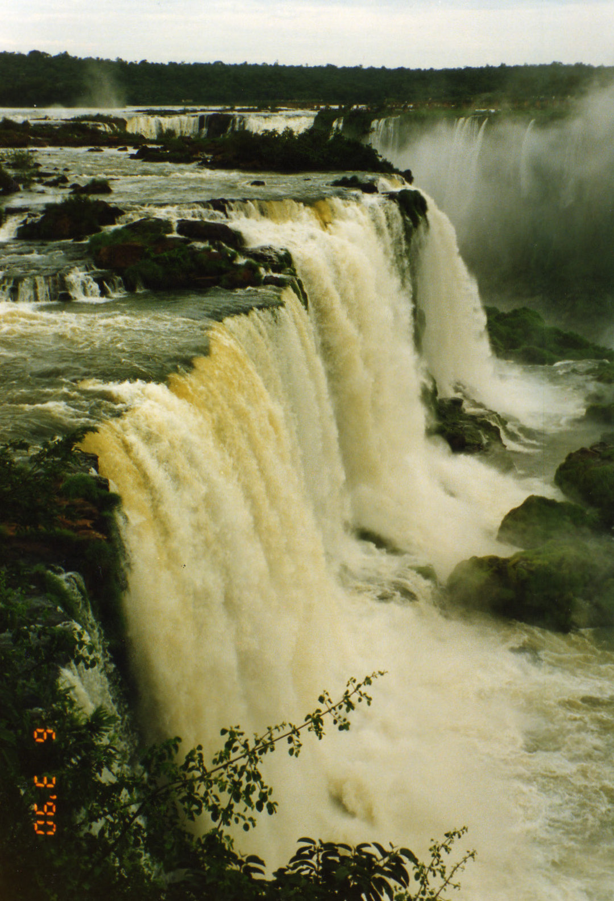
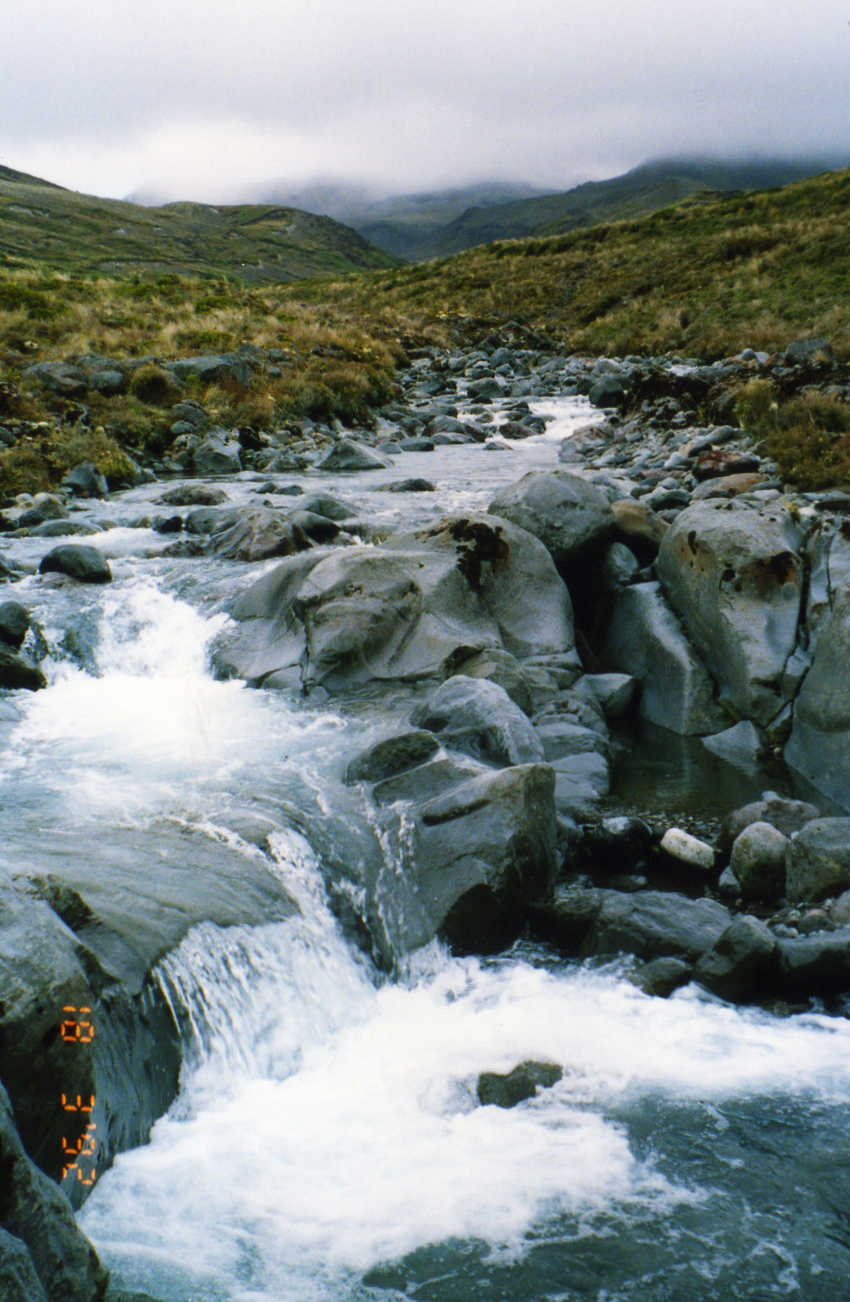
The Iguasu Waterfall on the border of Brazil, Paraguay and Argentina is one of the world’s largest waterfalls.
There are waterfalls all over the world. The world’s largest waterfall is the Victoria Falls in Africa. It is more than a mile long. Another large waterfall is the Niagara Falls, in North America. The Angel Falls is the world’s highest waterfall and the Iguazu Waterfall is one of the tallest and widest waterfalls. They are both in South America.
Waterfalls can also be grouped by type and by class. There are several different types of waterfalls. These include block, cascade, cataract, fan, horsetail, plunge, punchbowl, segemented, tiered and multi-step waterfalls. Waterfalls are also grouped into ten different classes. Class 10 waterfalls have the most water and class 1 have the least water.
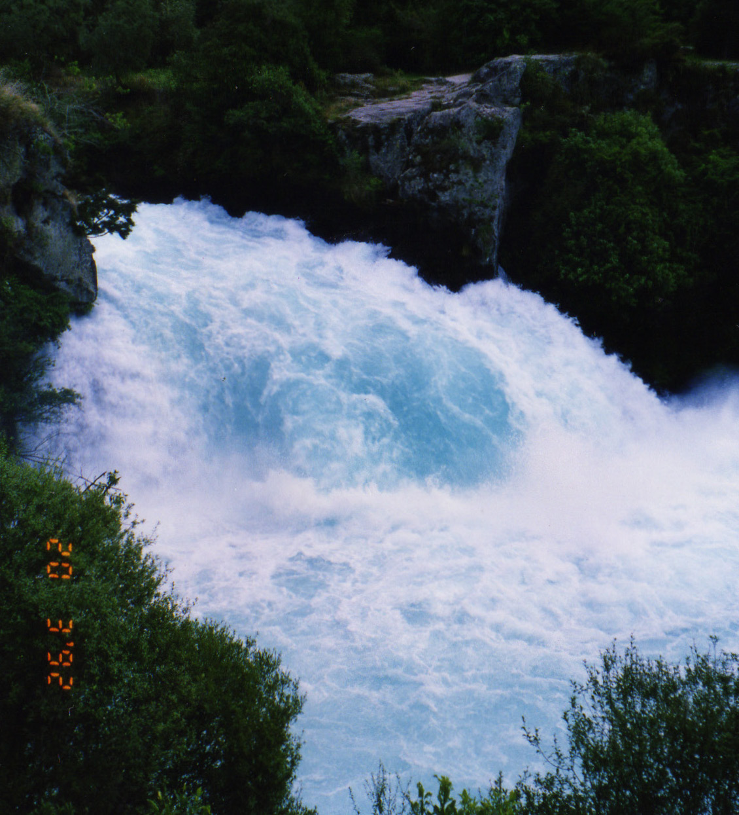
Waterfalls are caused by different things. Some waterfalls are caused by landslides or earthquakes. However most waterfalls are caused by water flowing over the same area and eroding soft rock.
Waterfalls do not stay the same, they change over time. Some waterfalls get bigger. Rocks and debris in the water erode the riverbed and the edge of the waterfall making it bigger. Other waterfalls dry up
because they have no water. This can happen if there is no rain for a long time or if the river changes its
A cataract waterfall in New Zealand, Aratia Falls.
course.

3. Read the text (J) and then tick the ideas below that are main points.
Main points
Earthquakes
Waterfalls change.
- Africa – Victoria Falls
- North America – Niagara Falls
- South America – Angel Falls, Iguazu Falls
- New Zealand – Huka Falls
Types and classes of waterfalls.

4. Now use the main points and supporting details above to complete the table.
Main point | Supporting detail
There are waterfalls in lots of countries | i)
ii) | Types  - block, cascade, cataract, fan, horsetail, plunge, punchbowl, segemented, tiered and multi-step waterfalls  Classes  - class 1 (smallest) to 10 (biggest)
Causes | - landslides  - iii)  - erosion
iv) | - they get bigger  - they dry up

