Our Cultural Village - Philippines
Categories | Links to and description of content
Note | This resource contains links to websites and content on media sharing sites where the public can upload and comment on videos and media. Some sites may have comments or advertisments that may be considered inappropriate for students. Teachers will need to preview the highlighted sites before sharing with students.
History | Located between the South China Sea and Pacific Ocean, the islands of the Philippines have been crossed by many different people, leading to a diverse range of ethnic groups and cultures.  Early history states that what is now the Philippines was first populated through migration from Borneo, Sumatra, and Malaya. Chinese and Japanese merchants would have traded with these people and Muslim Arabs also settled on islands establishing mini-sultanates.  The Spanish conquest of the islands began in the mid 1500's and resulted in the establishment of Manila as the capital and main colonial foothold. Spanish rule remained until independence was fought for around 1898, first against the Spanish, then with the Americans — the end of the Spanish-American war saw the Philippines transfer to US control. Independence remained an issue and was agreed on by US Congress in 1932, but postponed while Japan occupied part of the country during the Second World War. It was finally returned on July 4th 1946 with the creation of the Republic of the Philippines. Independence did not necessarily bring peace to the islands as there was ongoing unrest caused by territorial disputes over Sabah, ongoing American influence and Communist rebellion, dictatorship and assassinations, moviestar presidents, and violent elections.
History | 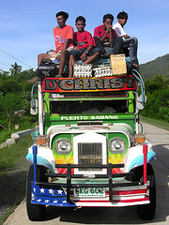  Source: The Jeepney. Ex-US military Jeeps | 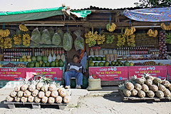  Source: Chico fruit (among others). A Philippine favourite introduced by Mexican immigrants who came with the Spanish | 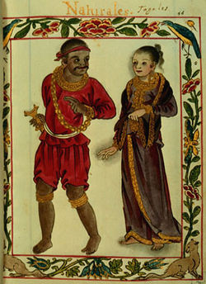  The Boxer Codex includes illustrations of Philippine nobility at the time of Spanish colonistation |  | 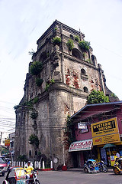  Source: The Sinking Bell Tower in Luzon - 85% of the population is Catholic
History | There is a far more detailed account of the Philippines' history at Pinas as well as on Wikipedia and on Philippine History where some of the key historical characters are discussed. The BBC timeline for the Philippines provides a list of major events.  For a more academic background there are some excellent resources to listen to or read at archives.org by US Scholar David Barrows and many others. |  |  | 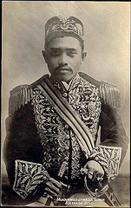  The last Sultan of Sulu
General Information | Pinas has much information about the Philippines, its people, and its history. Wikipedia is also a good source of information.  The CIA World Factbook is another reliable resource for information on the Philippines, as is the BBC Country profile.  A news article by Voice of America on refugees from the Philippines fleeing fighting between government and Islamic separatists. Another earlier article on internally displaced people from the same conflict. |  |  | 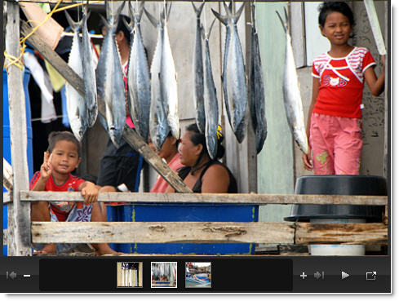  Militants have forced more than 400,000 from their homes in Mindanao  Preview before sharing with students

Categories | Links to and description of content
Online Dictionaries | The national language is called Filipino (also known as Tagalog) while both Filipino and English are the official languages of the country. There are over 100 distinct languages spoken in the Philippines, including indigenous languages such as Tagalog, Cebuano, and Ilokano, and within these languages there are several hundred dialects.  This online dictionary provides translation between Cebuano, English, Hiligaynon, and Tagalog.   Freelang is an English <> Tagalog online dictionary

Categories | Links to and description of content
Maps and Flags | The Philippines is an archipelago comprising over 7,000 islands, located North of Indonesia.
Maps and Flags | 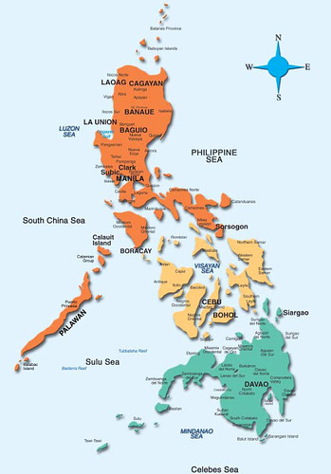  Source | 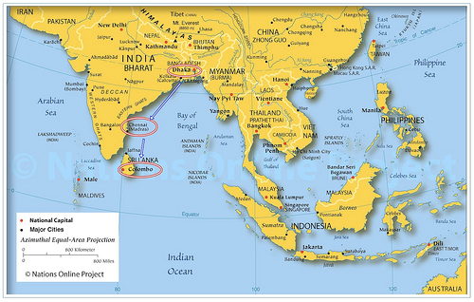  Source
Maps and Flags | There is information on the country and its flag at the The World Flag Database, and below are some images of the flag.
Maps and Flags | 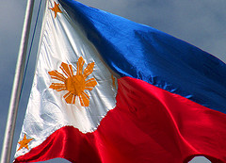  Source | 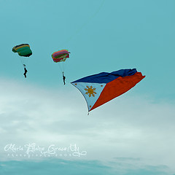  Source
Maps and Flags | More flag and map information can be found at wikimedia, including some history and development of the national flag.

Categories | Links to and description of content
Landscape and People | People  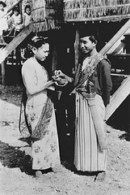  Some wonderful old images from the early and mid 1900s. | Scenery  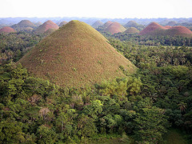  Source The Chocolate Mountains in Bohol | Farming  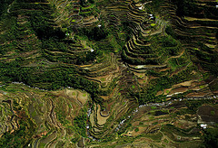  Source | Transport  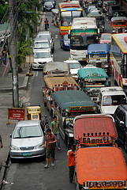  Source
Landscape and People | 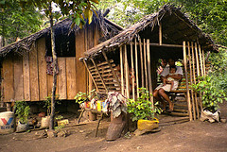  Source Luzon village | 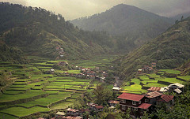  Source Northern Luzon | 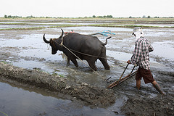  Source | 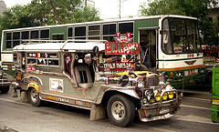  Source
Landscape and People | People  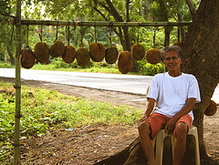  Old man with marang fruit | Scenery  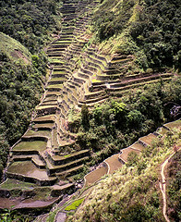  Source Luzon | Farming  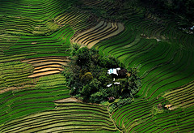  Source | Transport  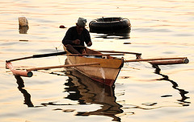  Source
Landscape and People |  |  | 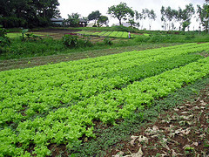  Source | 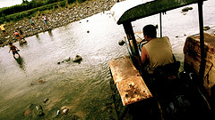  Source

Categories | Links to and description of content
Culture - Food | The location and history of the Philippines has resulted in a vibrant culture reflected in its food. Chinese foods and ingredients such as noodles, bean curd and soy sauce are common alongside Spanish / European garlic, onions, and tomatoes. American dishes and ingredients are also popular.  Click this link to take a look at foodbycountry's entry for the Philippines where they discuss history and ingredients, as well as providing recipes. The dishes below show the influence of different cultures:
Culture - Food | 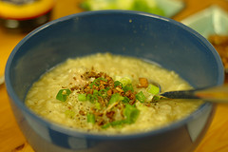  Source Arroz Caldo or Hot Rice |  | 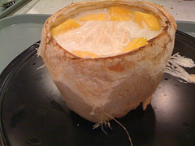  Source Buko Mango, coconut and mango |  | 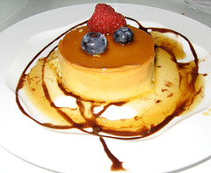  Source Leche Flan or Caramel Flan
Culture - Food | 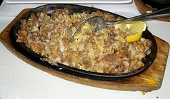  Source Sisig, pork, onions, peppers and egg |  | 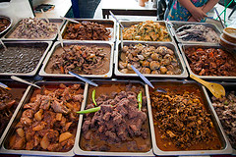  Source |  | 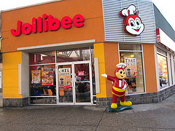  Source: Fast food!
Culture - Etiquette | Philippines’ culture is centred strongly on the family, which is wider than the typical nuclear family of Western / European culture. A good description of cultural values and ettiquette is provided at kwintessential.
Culture - Festivals | There are many festivals in the Philippines and the colour and diversity shown in, for example, the Barrio Fiesta, illustrates the strong Spanish and Mexican influence of colonisation. Wikitravel lists 60 festivals (January to March only).
Culture - Festivals | 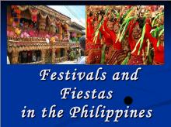 |  |  | This slideshare (Preview before sharing with students) gives an idea of the colour of many of the festivals.  There is plenty of video footage on YouTube (Preview before sharing with students) of Philippine festivals including the stage and street performances for Sinulog, a major festival in Cebu with Catholic, Islamic, and pagan roots. And here is the Ali-Atihan festival.  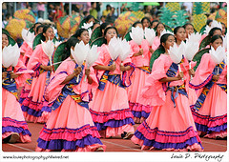  The colours of T'nalak
Culture — Music and Dance | Music and dance are very popular in the Philippines. Traditional folk music and dance has survived through the colonial years and examples can be found by, for instance, the LIKHA Pilipino (sic) Folk Ensemble and Sindaw Philippines Performing Arts Guild among many others. Music, from folk through to contemporary pop, is possibly the nation's greatest passion. MYMP is a very well know group but there are many more including excellent cover bands (here's one picked at random).
Culture — Music and Dance | 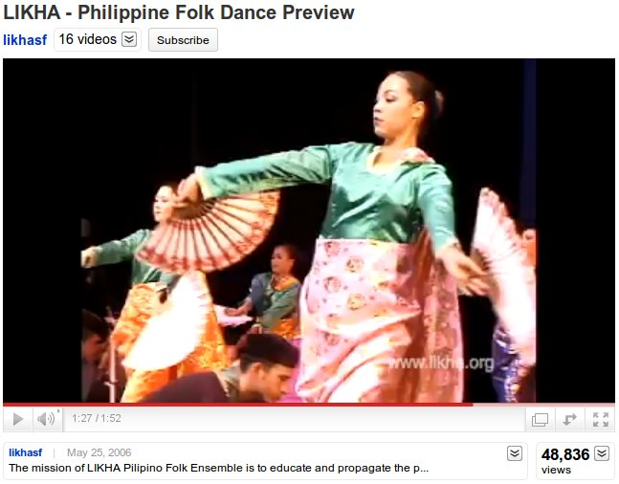  LIKHA Pilipino Folk Ensemble |  |  | 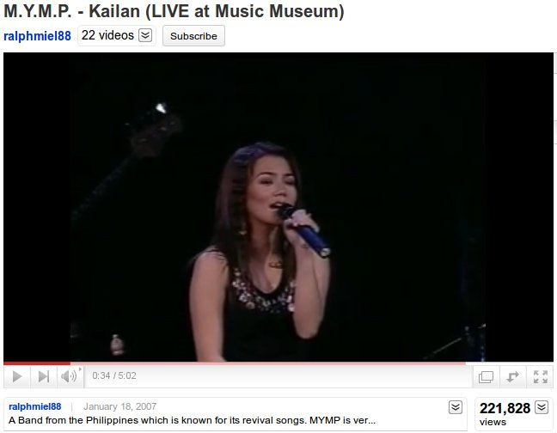  MYMP
Culture — Music and Dance | 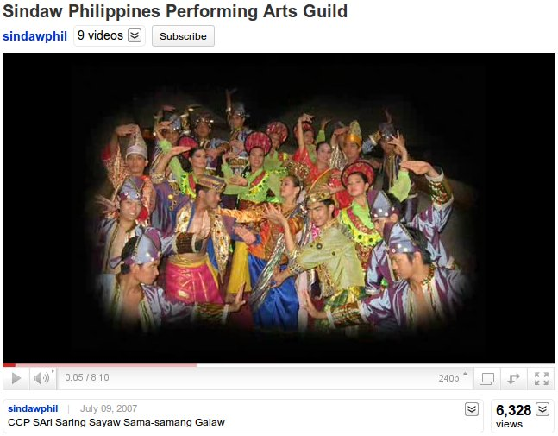  Sindaw |  |  | 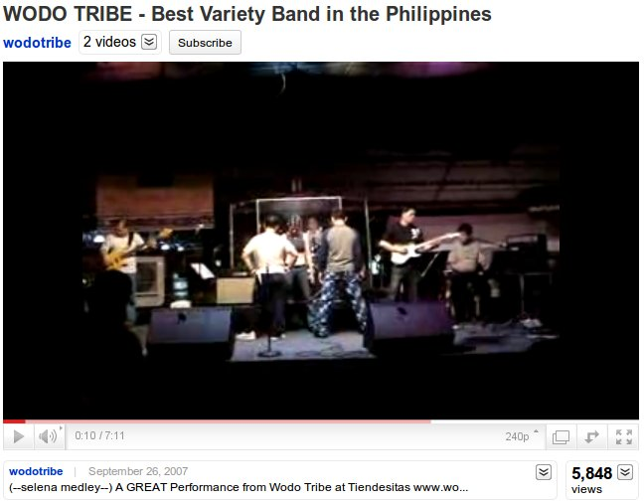  WODO Tribe
Culture — Music and Dance | Preview before sharing with students
Faith | Modern religions were introduced with the arrival of the colonial Spanish, bringing with them Roman Catholicism. In fact, the Philippines is the only Christian nation in Asia. Over 90% of the population is Christian, with the majority (over 85%) said to be Roman Catholic. Islam comprises 5% of the poplulation and the remaining population follow indigenous (non-Western) or Eastern beliefs. Asia Society has a good article on this subject which discusses the pre-colonial indigenous beliefs in some detail.
Faith | 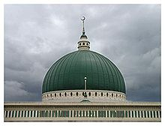  Islamic Center; Marawi City | 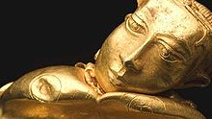  Hindu-Buddhist statue |  | 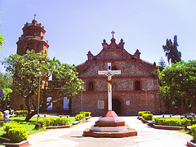  St. Dominic Cathedral |  | 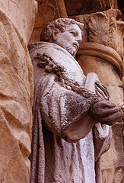  St. James Church, Paete

Categories | Links to and description of content
Education | Pinas provides an introduction to the education systems and links to various government and education sites. On scribd you can find an article that discusses the education system in detail.
Education | 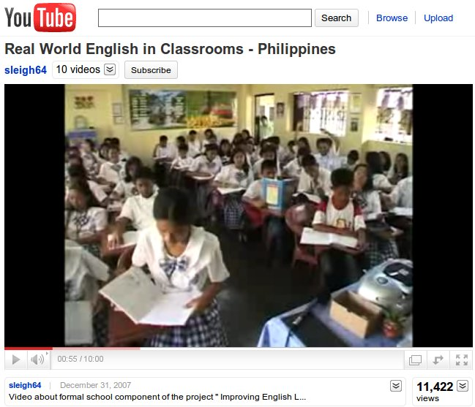 | The video (link) discusses an English language programme and provides a good example of the classroom environment.  Preview before sharing with students
Education | 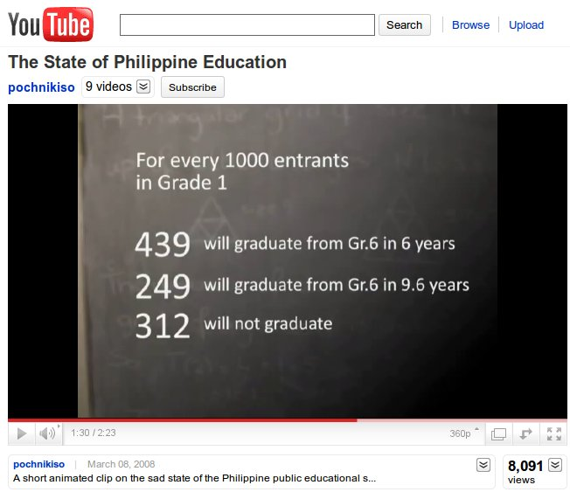 | A link to a video where the current state and success of education in the Philippines is discussed.  Preview before sharing with students
Education | 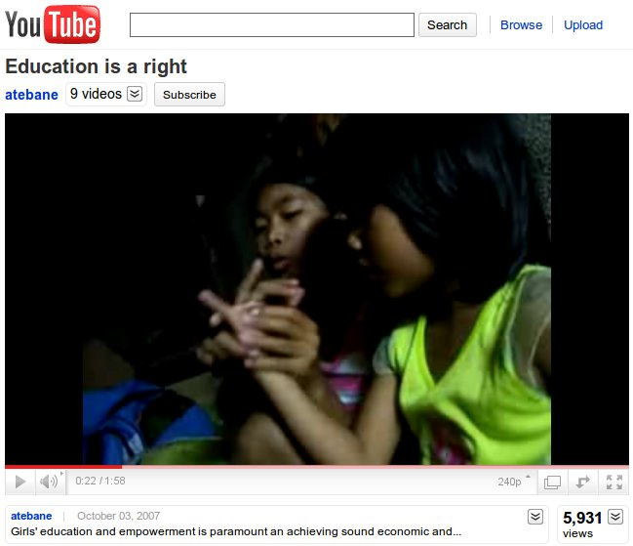 | A large number of children do not go to school for reasons such as poverty and abuse, especially for girls. This video shows one girl who is lucky enough to go to school, teaching another girl the lessons she has learned.  Preview before sharing with students

Categories | Links to and description of content
Politics | 2010 saw the election of Benigno "Noynoy" Aquino as President. Here are some related news articles by the BCC with interviews and some pictures of the election. This article from Al Jazeera discusses some of the political patronage and other issues that continue to plague Philippine politics. | 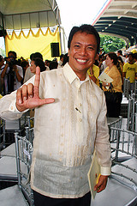  Source
Politics | Corruption is a major issue in the Philippines at all levels. The President, Benigno "Noynoy" Aquino, is the son of former leader Corazon «Cory» Aquino, whose husband was murdered. He is a member of the wealthy elite who control much of the Philippines’ economy. He has vowed to tackle the corruption reported in many newspapers (USAToday, by example).

Categories | Links to and description of content
Publications - Readers, eBooks, Comics, Podcasts | 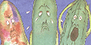 | Ang alamat ng ampalaya, The legend of the bitter gourd.
Publications - Readers, eBooks, Comics, Podcasts |  | There are 25 children's titles in Tagalog at www.childrenslibrary.org with a friendly interface.  Other than the above, it is difficult to locate children's literature in Tagalog or Cebuano. Here is one US site which sells them. There is also a list of children's books here with ISBN, but they may be hard to get in New Zealand.
Publications - Readers, eBooks, Comics, Podcasts | 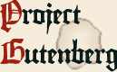 | The Gutenburg project has 54 titles in Tagalog but just 1 in Cebuano.
Publications - Readers, eBooks, Comics, Podcasts |  | Here is a recording of an old folk song about the months of the year.
Publications - Readers, eBooks, Comics, Podcasts | 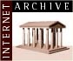 | The Archive has several books on the Philippines including this one on Luzon folklore.
Publications — Newspapers, Magazines |  An online publication for overseas nationals.  The BBC country profile for the Philippines provides a comprehensive list of local newspapers, TV and radio stations. Many of these have streamed content.

